Phase 6 (Parking Areas/Full Route)

Evaluation Report
Author: Cher Carney, Project Research Lead, cher-carney@uiowa.edu
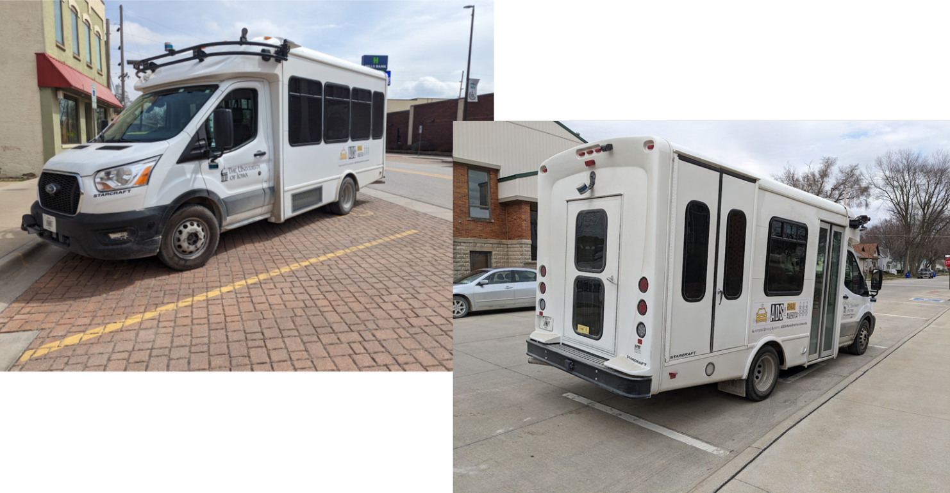

Contents
Introduction 1
Expected Capabilities of the Automation for Phase 6 2
Angle Parking 3
Parallel Parking 4
Parking Lots 6
Vehicle to Vehicle (V2V) Encounters 8
Automation at Intersections 9
Four-Way Stop Intersections 9
Two-Way Stop Intersections 10
Stop-Controlled Intersections 11
Yield-Controlled Intersections 12
Traffic Signals 13
Automation Engagement by Drive 15
Voluntary Takeover of the Automation 27
Forced Takeover of the Automation 29
Encounters with Vulnerable Road Users (VRUs) 29
Safety Critical Events 30
Occupants for Phase 6 30
Demographics 30
Survey Data 31
Biometric Data 37
Anxiety Ratings 37
Safety Drivers 40
Phase 6 Summary 43
Interesting Encounters 44
Accomplishments for Phase 6 45
Lessons Learned/Next Steps 46
Perception 46
Prediction 46
Planning 46

Introduction
This project is comprised of six data collection phases shown in Table 1 that span over a two-year time period. Each phase has attempted to increase the percentage of the route that is driven under automation as well as improve the performance and comfort during those portions of the route that were automated in the previous phases. The defined route has been driven in its entirety for each phase to document this progression and to allow for comparison of automation data from one phase to the next. This report details the experiences and results of the sixth and final phase of the data collection. A final evaluation report will be authored that combines the data from the six phases and examines how the project has met the project objectives.
Phase 1 was completed in November of 2021 on controlled access highways and a divided highway/interstate. A large portion of the route during that phase was able to be driven in automated mode. This was due to a high percentage of the route being interstate/highway driving. However, several issues regarding merging and traveling at highway speeds were identified during that phase.
Phase 2 was completed in March of 2022. The focus of Phase 2 was vehicle navigation along 2-lane undivided highways as well as on- and off-ramps. The traffic on undivided highways travels in opposite directions, has more variable vehicle speeds, and has vehicles that may pass in oncoming traffic lanes. On- and off-ramps were seen as a unique challenge due to the variable geometries and vast differences in speeds of vehicles entering and exiting the highways, as well as the unpredictability of driver behavior that can occur in these locations.
Phase 3 was completed in July of 2022 and focused on driving in automation through cities and towns along the route. These roadways have a wide variety of intersections including 2-way and 4-way stop intersections as well as intersections with lighted traffic signals. The stop-controlled intersections were traversed using input from the high-definition (HD) map as well as the other sensors. The lighted intersections were navigated via automation that used a camera-based system and a traffic light detection software module.
Phase 4 was completed in October of 2022. This phase examined the ability of the automation to drive unmarked paved and gravel roadways. These road types are a challenge both in their design and the way in which they are typically driven. Changes to the HD map allowed the vehicle to drive these roadways in a manner that is more typical of a human driver.
Phase 5 was completed in January of 2023. Of specific interest in this phase were interactions between the automated vehicle and slow-moving vehicles outfitted with on-board telemetry processors, specifically vehicles acting as stopped school buses. Slow moving vehicles pose hazards to other traffic traveling on rural roadways, particularly on steep grades and curves. The processors provided location and speed information to the Transit, enabling it to slow down and stop even without direct line of sight.
Phase 6 examined the ability of automation to successfully park in a variety of different types of spaces: two on-street parking areas and in two parking lots where passengers would typically be picked up and dropped off. Parking areas present unique challenges, as streets and lots each have their own structure and lanes of travel. Parking areas expose AVs to other vehicles and pedestrians in tight spaces.
By adding the ability to park while in automation, the vehicle, as it is in Phase 6, is capable of driving nearly the entire route under automation.
Table 1. Project phases
Phase | Description | Drives Planned | Drives Completed | Date | Status
1 | Controlled Access Roadways | 10 | 10 | 11/2021 | Complete
2 | Highways & Ramps | 20 | 17 | 03/2022 | Complete
3 | Urban Areas | 10 | 13 | 07/2022 | Complete
4 | Unmarked Roads | 10 | 10 | 10/2022 | Complete
5 | V2X | 10 | 10 | 01/2023 | Complete
6 | Parking Areas / Full Route | 20 | 20 | 05/2023 | Complete
Total |  | 80 | 80
Twenty drives were completed as part of Phase 6. These drives took place between April 19 and May 25, 2023. They occurred at different times of day and during varying lighting and weather conditions.
Data of specific interest in Phase 6 includes:
- Ability to angle park and changes necessary to make it work.
- Ability to parallel park and changes to the automation necessary to make it work.
- Ability to stop in parking lots for passenger pickup and drop-off.
- Interactions with pedestrians and other vehicles in unanticipated places.
This report will begin by describing vehicle performance along the entire route, paying particular interest to what was expected for Phase 6 but also describing changes to the map and automation that improved performance when navigating the roadways encountered in Phases 1–5. As in previous reports, the data collected for each drive will be summarized, including mileage in automation and figures showing the location of automation activation. A summary of voluntary takeovers by the safety driver, encounters with vulnerable road users (VRUs), and any safety critical events is provided. Data regarding the occupants of the vehicle includes demographic information, survey data, biometrics, and anxiety ratings. A summary of the safety driver survey results, including their perceptions of the automation’s performance is provided as well.

Expected Capabilities of the Automation for Phase 6
For Phase 6, the vehicle was expected to maintain lateral and longitudinal position and navigate all road types along the route using on-board sensors and an HD map of the route.
Automation was activated by pressing the “Engage” button on the steering wheel. Prior to activation, the safety driver made sure the following conditions were met:
- The vehicle was below the HD map’s speed limit.
- The vehicle was in the center of the lane.
- Safety drivers were not providing any input: steering, braking, accelerating, or shifting.
- Safety drivers deemed it safe. (Considerations for safety include number/proximity of vehicles in the lane and oncoming or adjacent lanes, weather, functionally of automated systems, etc.)
The goal of Phase 6 was to demonstrate the ability to park the Transit in a variety of different parking spots where a vehicle such as this one might need to stop in order to drop off/pick up passengers. In order to accomplish this goal, the map needed to be updated to include the specific parking spaces. Additionally, we needed to learn how the routing module would handle “routing to a parking space.”
The changes to the automation that were necessary to make parking at these places possible, along with the limitations that were encountered, are described in the following sections.

Angle Parking
Angle parking was available at the Hills Community Center (Figure 1). This type of parking is used on streets that have sufficient space. It is a type of parking in which vehicles park in a line at an angle and is usually aligned with the direction that the cars approach the space. The angled nature of this type of parking makes it one of the easiest to perform for human drivers.
The issues encountered when trying to angle park the Transit under automation were:
- Apollo’s (version 5.5) planning module does not natively support parking. Therefore, the vehicle’s software stack had to transition to Open Space Planner <https://github.com/ApolloAuto/apollo/blob/master/modules/planning/README.md>. This transition required the vehicle to come to a complete stop on the roadway and change gears before turning into the parking spot.
- The vehicle pose was not perfectly aligned with the parking spot due to the vehicle’s size and larger than typical turning radius (Figure 2). To enable the maneuver, the parking spot was enlarged within the HD map so it was wider and extended halfway into the hashed area to the right (Figures 1 and 2).
- In many cases, the Transit did not come to a stop early enough and would hit the curb in front. Tuning of configuration parameters improved upon this but still did not alleviate the behavior.
- The AV is not capable of operating in reverse under automation. Therefore, even though we were able to pull into the parking spot, we were unable to back out. This is due to a limitation of the Apollo 5.5 software stack.

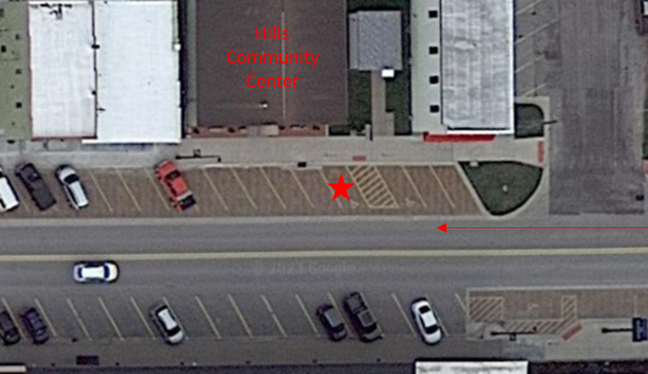
Figure 1. Parking space at Hills Community Center

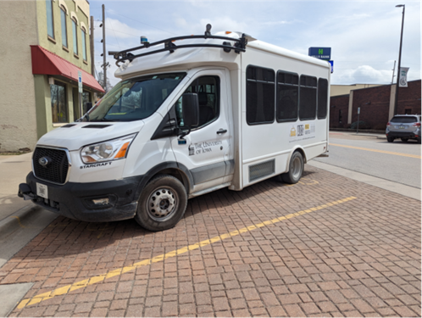 | 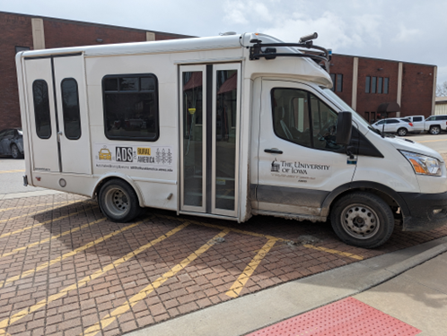
Figure 2. Angle parking at Hills Community Center
The AV was able to successfully park at the Hills Community Center nine out of the twenty drives. The other eleven attempts were unsuccessful for a variety of reasons (Table 1). The majority of the time it was due to a curb strike or failure to stop at the end of the parking maneuver.
Table 1. Parking at Hills Community Center
# of Drives | Outcome
9 | Successful
6 | Hit the curb
1 | Car behind was too close to attempt
1 | Pedestrians in spot
1 | Got too close to the car parked in the spot to the left
1 | Parking spot occupied
1 | Went past the stop line and was not going to make the turn

Parallel Parking
Parallel parking was available at the Kalona Public Library (Figures 3 and 4). This type of parking is used most commonly on streets that are not wide enough for other types of parking. Parallel parking is when vehicles park parallel to the road in line with other parked vehicles facing in the same direction. This type of parking is often thought to be the most challenging for human drivers.
Because the vehicle is not able to drive in reverse in automation, it was not possible to parallel park the AV as a human would typically (i.e., driving alongside the vehicle parked in front of the space and reversing into the space). Therefore, parking the vehicle in these spaces required that the parking spots be changed into a short “additional lane.” We were then able to place the destination waypoint in that “parking lane.” The maneuver is essentially a slow speed lane change to the right.
The limitations to this workaround are:
- The designated parking spot must be vacant.
- The spot ahead of the designated parking spot must also be vacant to provide a minimum clear buffer ahead of the Transit.
- The safety driver was required to drive the vehicle manually in order to exit the parking spot and start the next leg of the route on the HD map.

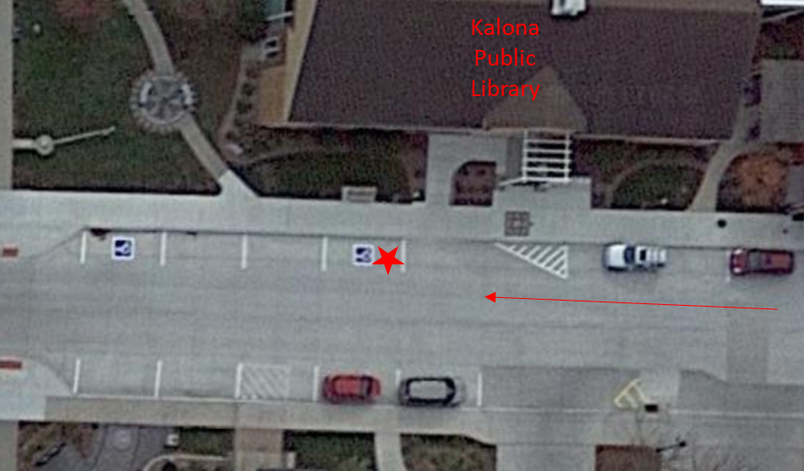
Figure 3. Parking space at the Kalona Public Library
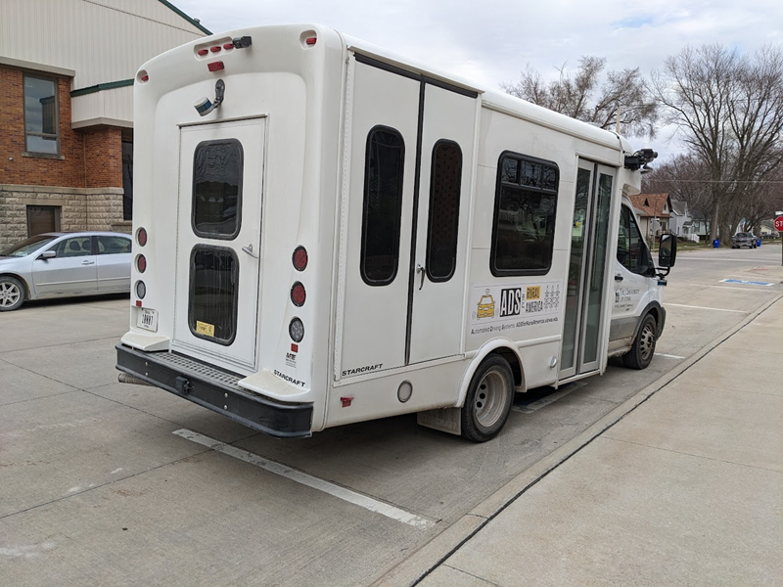
Figure 4. Parallel parking at the Kalona Public Library
The AV was able to successfully park at the Kalona Public Library fourteen out of the twenty drives. The other six attempts were unsuccessful due to other vehicles either being in the actual parking spot or in spots ahead or behind, eliminating the buffer necessary for the “lane change” maneuver.

Parking Lots
There were two parking lots, one at the Riverside Casino (Figures 5 and 6) and another at the Iowa City Marketplace (Figures 7 and 8). Parking at the Riverside Casino was under the canopy in the valet drop off area. The AV was able to park successfully at this location during fourteen of the twenty drives. Unsuccessful attempts were most often due to other vehicles parked in our lane of travel (n=4). Other issues at this location were due to interference with GPS reception from the overhead canopy. The NovAtel receiver has an integrated inertial measurement unit to temporarily compensate for these situations, however extended time under the canopy would cause precise location to worsen. Therefore, for one of the drives, the vehicle missed a waypoint and was not able to park. For another it drove past the parking space.
In order to park and continue the drive without the safety driver having to intervene, the ending and starting waypoints of the two respective routes were changed on the map so that they overlapped. On one occasion the vehicle did not park far enough ahead to overlap the next route, requiring that the safety driver pull ahead manually before engaging automation. The parking maneuver itself was successful, but manual intervention was necessary for the drive to continue in automation.
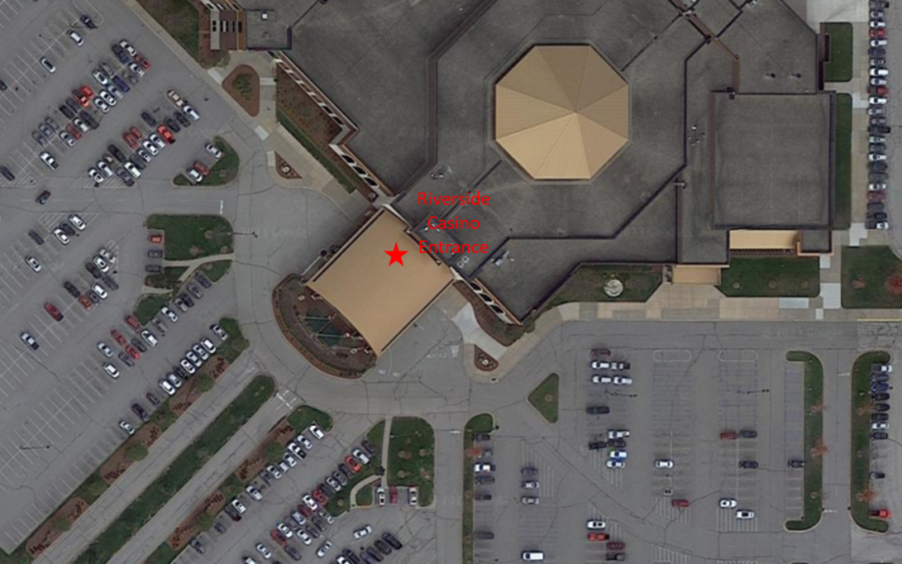
Figure 5. Parking space at the Riverside Casino
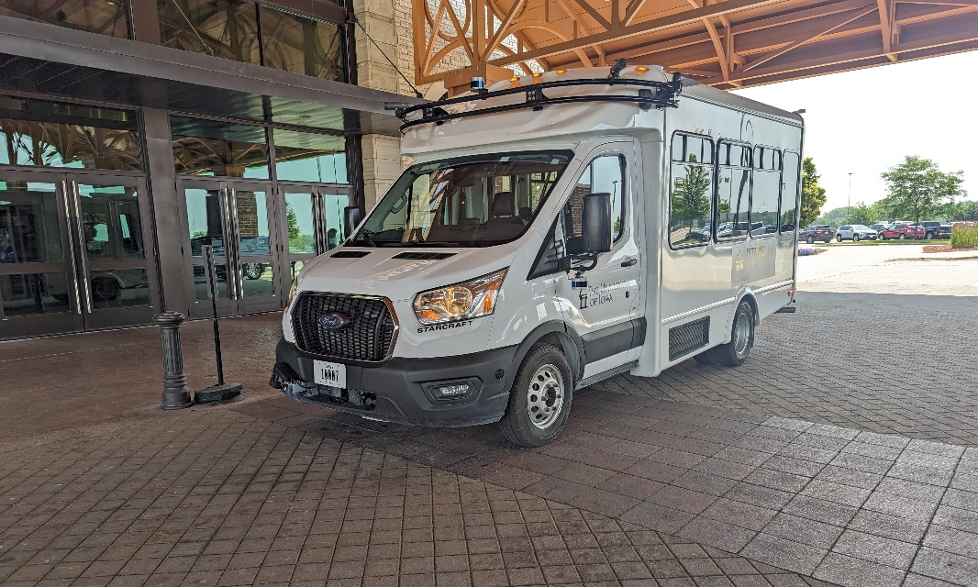
Figure 6. Parking at the Riverside Casino
Parking at the Iowa City Marketplace was along the sidewalk in front of one of the store entrances (Figures 7 and 8). In order to drive through the lot (i.e., the lane between the two parking stall rows), the map was updated by adding virtual speed limit signs to reduce the speed. This was to account for vehicles that may be backing out and pedestrian traffic at various locations. Similar to Riverside, the ending and starting waypoints of the respective routes were made to overlap to allow the AV to park and continue the drive without the safety driver having to intervene. For seventeen of the twenty drives, the AV was able to park successfully. There were vehicles parked along the sidewalk in our lane of travel for three of the drives. For two of the drives the vehicle did not stop far enough ahead to reach the starting waypoint for the next route. So, while the parking maneuver itself was successful, manual intervention was necessary for the drive to continue in automation.
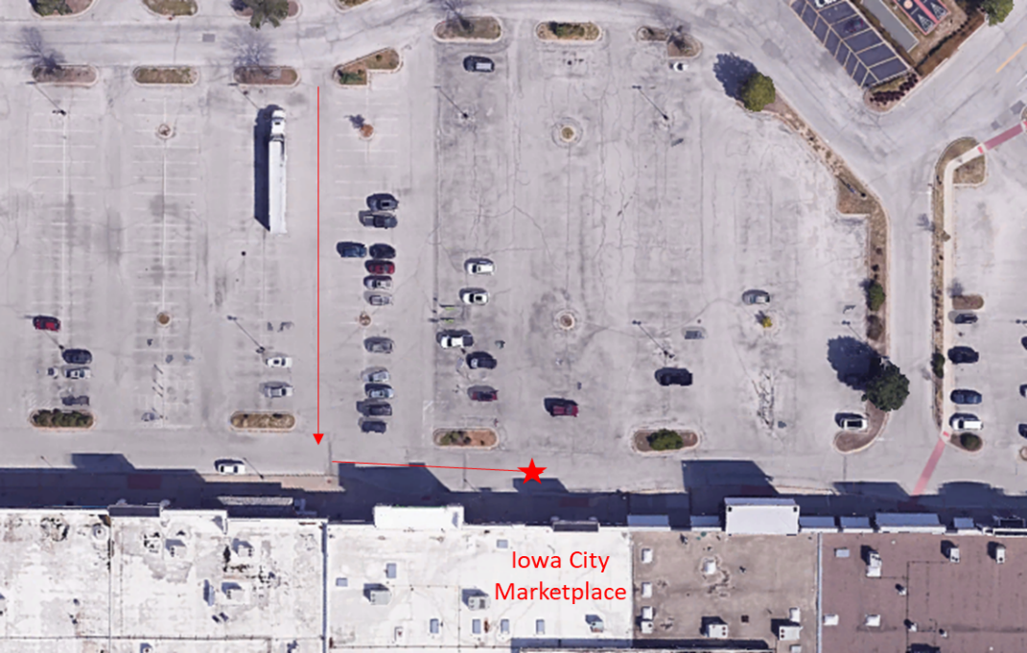
Figure 7. Parking space at Iowa City Marketplace
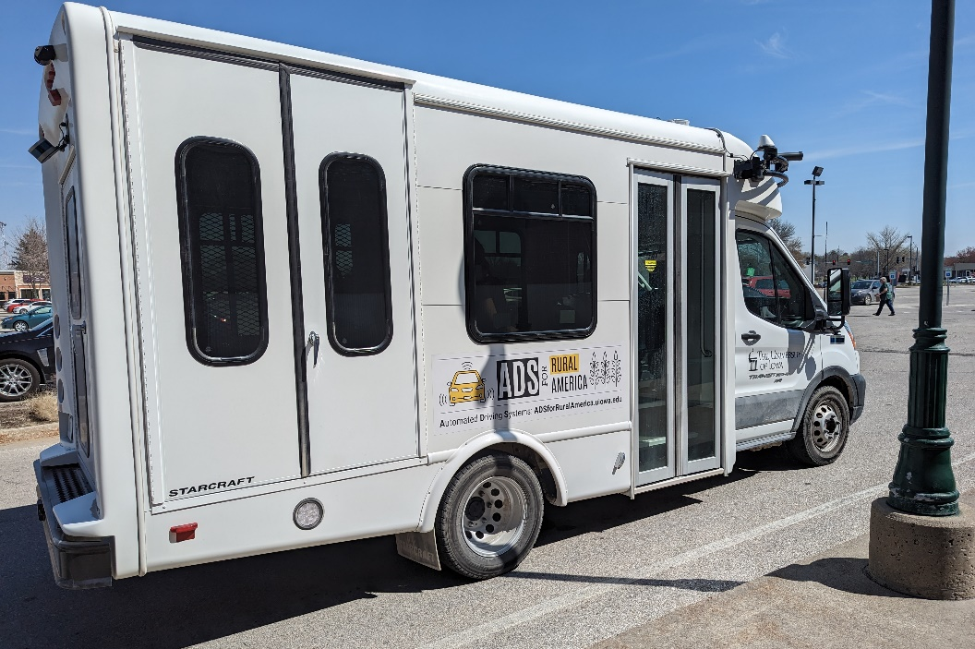
Figure 8. Parking at Iowa City Marketplace

Vehicle to Vehicle (V2V) Encounters
In Phase 6, we continued to use the confederate vehicle, driven by another one of the University of Iowa safety drivers to emulate a stopped school bus along our route, providing real-time alerts to the AV. For descriptions of these interactions and the equipment used to make this possible, see the Phase 5 Evaluation Report.
For eight of the twenty drives in this phase, the Transit encountered the confederate vehicle, and in one of those drives, it encountered it twice (Table 2). Of the eight encounters, there were difficulties during one drive. During Drive 69 (the first attempt at V2V interaction for Phase 6) the Transit identified the “bus” but did not stop. After investigation we discovered that AutonomouStuff (AS) engineers had unintentionally overwritten the automation logic in the Apollo planning module configuration that had been used in Phase 5 for handling the V2V encounters. Therefore, the communication between the vehicles worked as intended, but Apollo did not have the code necessary for parsing the data stream to act upon it. After the problem was noticed and brought to their attention, AS reverted the specific code change for the subsequent drives.
Table 2. Number and type of V2V encounters
Drive # | Encounters | Directionality
Drive 69 | 1 encounter | Same lane as Transit
Drive 72 | 1 encounter | Oncoming lane, facing Transit
Drive 75 | 1 encounter | Oncoming lane, facing Transit
Drive 76 | 1 encounter | Same lane as Transit
Drive 81 | 1 encounter | Oncoming lane, facing Transit
Drive 83 | 2 encounters | Oncoming lane, facing Transit;  Oncoming lane, facing Transit
Drive 84 | 1 encounter | Oncoming lane, facing Transit
Drive 86 | 1 encounter | Oncoming lane, facing Transit

Automation at Intersections
Because each phase builds upon the last, we continued to drive using automation on different roadway types and through cities and towns, navigating many types of intersections: four-way stop, two-way stop, stop controlled, and traffic signal-lighted intersections. For descriptions of these intersections as well as maps showing their locations, see the Phase 3 Evaluation Report.
As always, the safety driver was prepared to take over when they felt that the automation was about to engage in an unsafe maneuver (e.g., pull out in front of oncoming traffic) or if it was taking too long to perform the maneuver and could have potentially caused another vehicle to behave in an unsafe way (e.g., drive aggressively or pass in an intersection). Automation can be intentionally disengaged by the safety driver using multiple methods, which include pressing a button on the steering wheel, taking over steering, pressing the accelerator or brake pedal, or pressing the E-stop button. It is important to note that using the automation at all of these intersections was explored and tested extensively by the safety drivers again, pre-Phase 5, after software changes were made.

Four-Way Stop Intersections
These types of intersections require that the vehicle stop before the intersection. The vehicle must stop regardless of what direction they are coming from. The vehicle must determine which vehicle arrived at the intersection first to determine right-of-way. The vehicle encounters six of these types of intersections. Figure 9 and Table 3 show where they occur along the route.
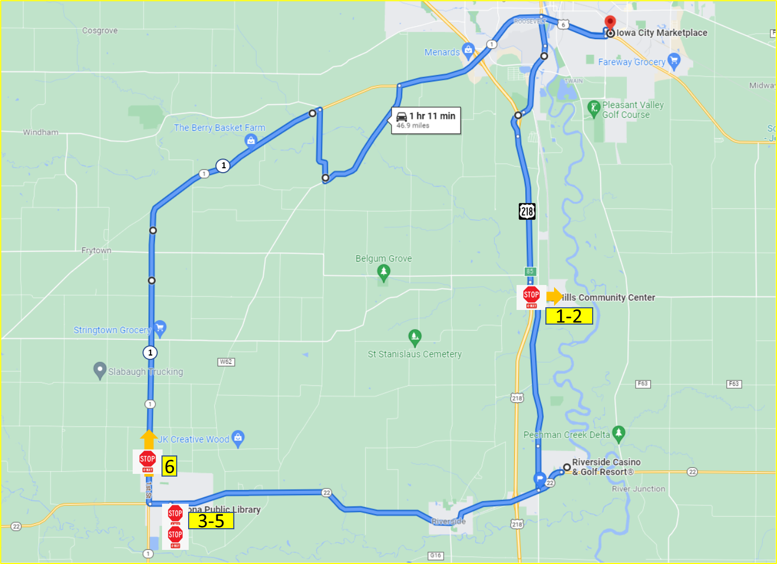Figure 9. 4-way stop intersections
Table 3. Number of 4-way stop intersections completed in automation for Phase 6
 | 4-Way Stop Intersections | Direction of Travel | Number Completed Under Automation
1 | 4-way stop in Hills (travelling east) | Straight | 19
2 | 4-way stop in Hills (travelling west) | Left | 17
3 | 4-way stop in downtown Kalona (B Ave/5th St) | Right | 19
4 | 4-way stop in downtown Kalona (5th St/C Ave) | Right | 18
5 | 4-way stop in downtown Kalona (B Ave/5th St) | Straight | 19
6 | 4-way stop on Hwy 1 | Straight | 20

Two-Way Stop Intersections
These types of intersections are typically used in areas where one street has a much higher traffic volume than the street it intersects. The vehicle on the minor road is required to stop and wait for a gap in traffic on the major road before proceeding. If two vehicles are stopped, the maneuver is complicated by determining which of the stopped vehicles has the right-of-way, particularly if one of the vehicles is left turning. Figure 10 and Table 4 show the locations of the five intersections of this type along the route.

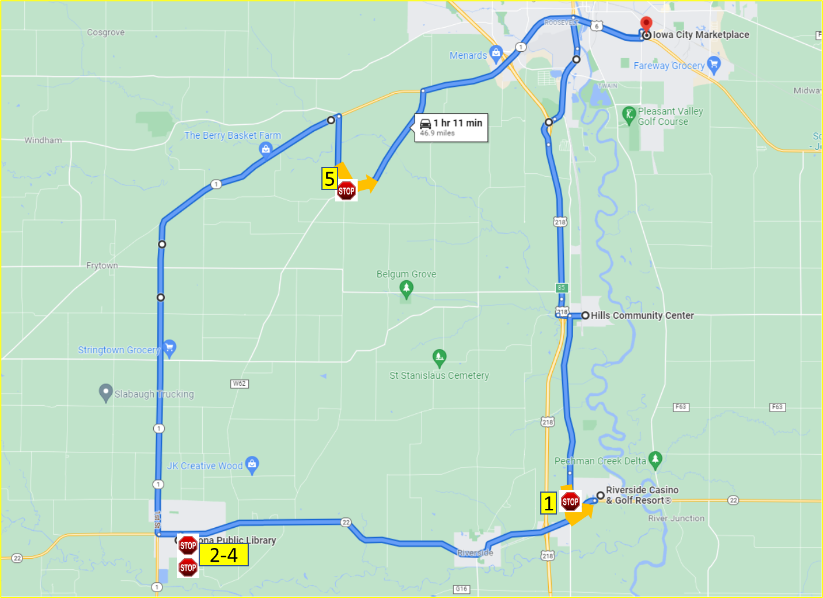Figure 10. 2-way stop intersections

Table 4. Number of 2-way stop intersections completed in automation for Phase 6
 | 2-Way Stop Intersection | Direction of Travel | Number Completed Under Automation
1 | 2-way stop onto Hwy 22 | Left | 10
2 | 2-way stop in downtown Kalona (6th St/B Ave) 1st time | Right | 20
3 | 2-way stop in downtown Kalona (C Ave/6th St) | Right | 15
4 | 2-way stop in downtown Kalona (6th St/B Ave) 2nd time | Right | 19
5 | 2-way stop from Kansas Ave to Sharon Center Rd | Left | 19

The 2-way stop at Hwy 22 is very difficult to complete in automation due to the amount of traffic present and the speed at which the other vehicles are travelling on this roadway (i.e., 55 mph). By the time that the LiDAR picks up an oncoming vehicle, there is not always enough time for the turn to be completed safely. It is possible that the safety driver took it out of automation to stop the vehicle from pulling out when it was unsafe to do so but then engaged the automation for the vehicle to complete the turn. This was not counted as a successful completion.

Stop-Controlled Intersections
These intersections required the vehicle to come to a complete stop and yield to pedestrians crossing the street and to cross-traffic. The vehicle must ensure the intersection is clear and that it will not impede approaching traffic by entering the stop-controlled intersection. There are four intersections of this type along the route. Figure 11 and Table 5 show the location of the intersections along the route.
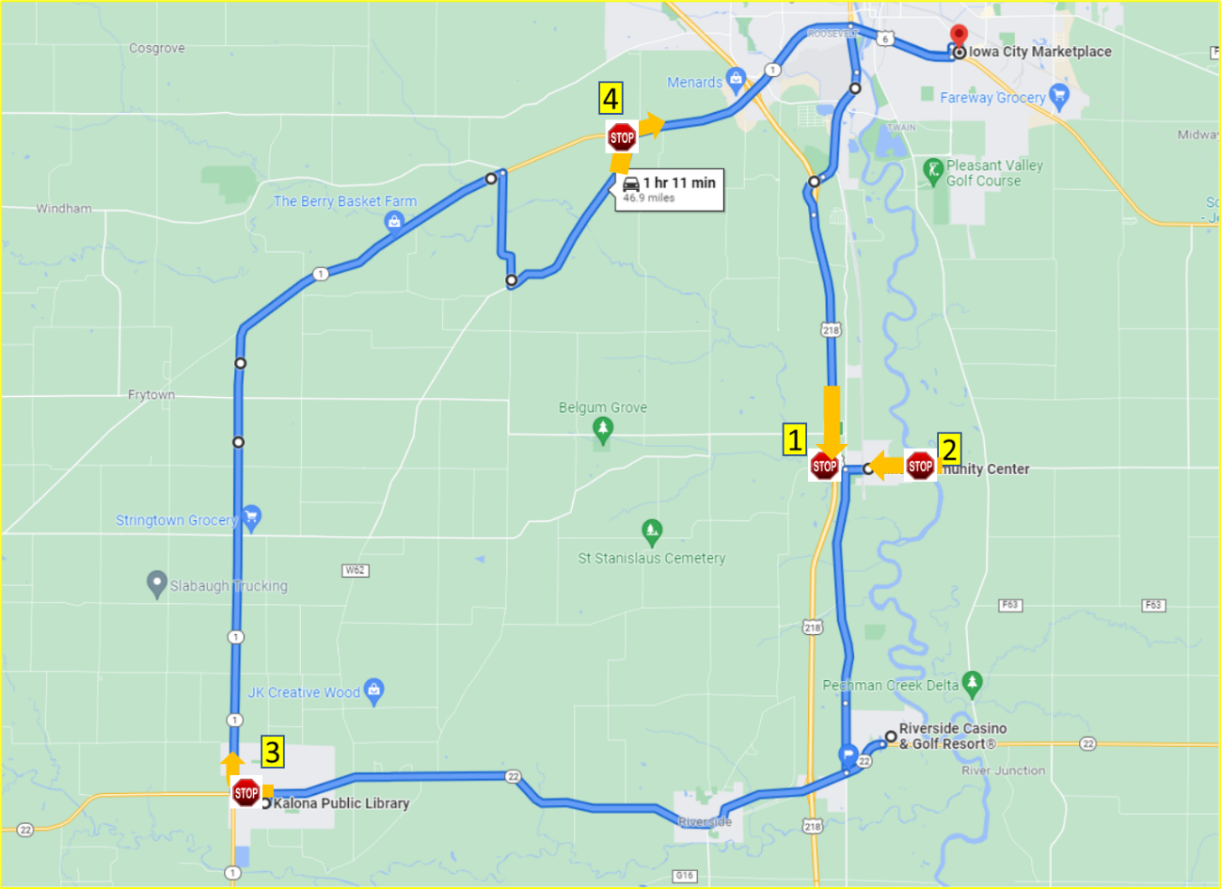
Figure 11. Stop-controlled intersections
Table 5. Number of stop-controlled intersections completed in automation for Phase 6
 | Stop-Controlled Intersections | Direction of Travel | Number Completed Under Automation
1 | Hwy 218 off-ramp to Observatory Ave | Left | 16
2 | 2nd St to Main St | Right | 20
3 | B Ave to Hwy 1 | Right | 18
4 | Sharon Center Rd to Hwy 1 | Right | 13

The turn from Sharon Center Rd onto Hwy 1 is another one that is very difficult to complete in automation due to the amount of traffic present and the speed at which the other vehicles are travelling on this roadway (i.e., 55 mph). This accounts for the low percentage of turns completed in automation (65%).

Yield-Controlled Intersections
This type of intersection requires the vehicle to prepare to stop and yield the right-of-way to other vehicles or pedestrians in or approaching the intersection. However, the vehicle is not required to stop if the path is clear. Therefore, the vehicle must slow to a speed at which it can stop and yield if needed. There are two intersections of this type along the route. Figure 12 and Table 6 show the location of these intersections along the route.
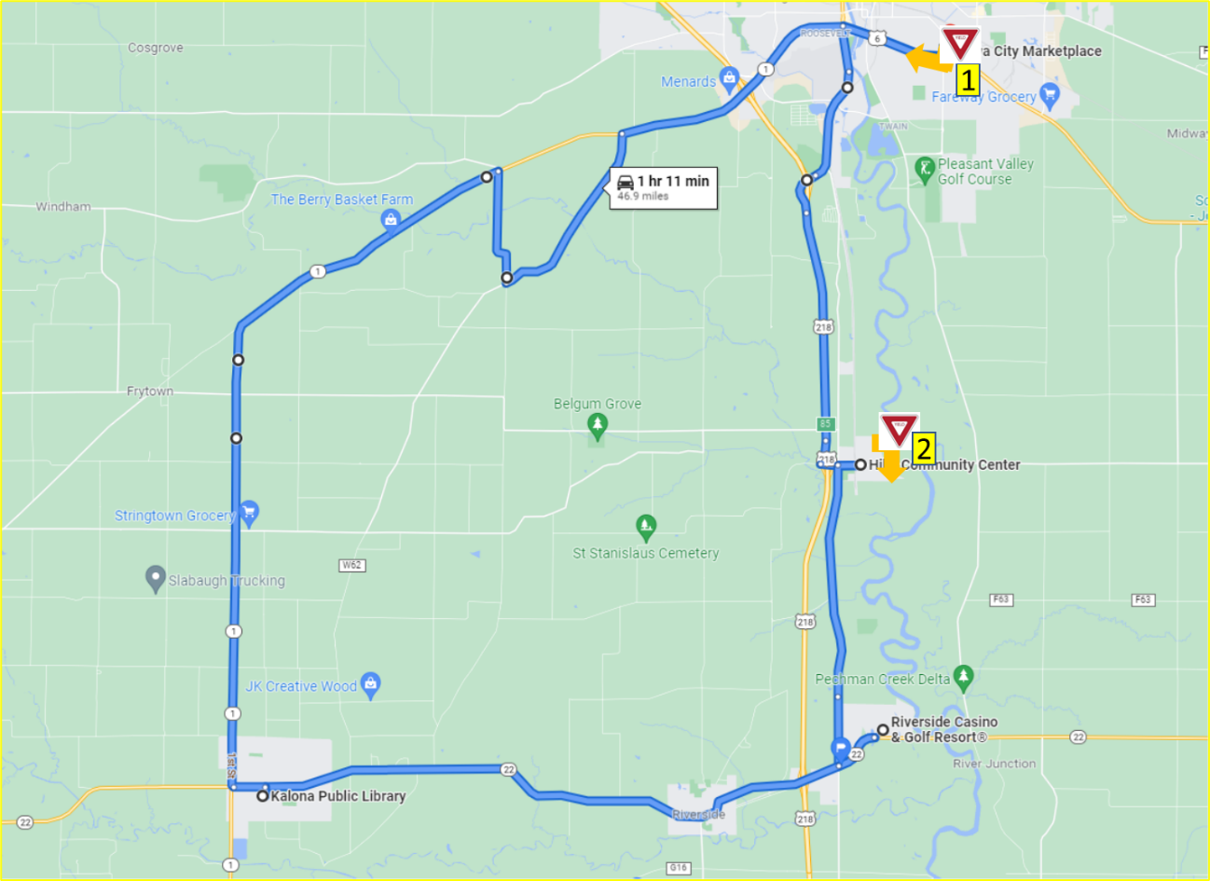
Figure 12. Yield-controlled intersections
Table 6. Number of yield-controlled intersections completed in automation for Phase 6
 | Yield-Controlled Intersections | Direction of Travel | Number Completed Under Automation
1 | S 1st Ave to Hwy 6 | Right | 10
2 | Oak St to 2nd St | Right | 19
The low number of completions for the turn onto Hwy 6 is due to the amount of traffic present and the speed at which the other vehicles are travelling on this roadway (i.e., 55 mph). By the time that the LiDar picks up an oncoming vehicle, there is not always enough time for the turn to be completed safely.

Traffic Signals
For this demonstration we utilized a camera-based system to identify the state of the traffic signals. This allowed us to use automation to navigate all the lighted intersections along the route. Maps showing the locations and descriptions of the lighted intersections can be found in the Phase 3 Evaluation Report. A breakdown of all intersections with traffic signals along the route is shown below in Table 7, as well as the direction of travel and the number of times it was able to navigate the intersection in automation for this phase.

Table 7. Number of intersections with traffic signals the vehicle completed in automation for Phase 6
Traffic Signals in Iowa City (N=23) | Direction of Travel | Number Completed Under Automation
Hwy 1 and Naples Ave SW | Straight | 18
Hwy 1 and Hwy 218 ramps | Straight | 19
Hwy 1 and Mormon Trek Blvd | Straight | 19
Hwy 1 and Sunset St | Straight | 20
Hwy 1 and Westport Plz | Straight | 18
Hwy 1 and Ruppert Rd | Straight | 19
Hwy 1 and Miller Ave | Straight | 20
Hwy 1 and Orchard St | Straight | 20
Hwy 1 and S Riverside Dr | Straight | 19
Hwy 6 and S Gilbert St | Straight | 19
Hwy 6 and Boyrum St | Straight | 20
Hwy 6 and Keokuk St | Straight | 20
Hwy 6 and Broadway St | Straight | 20
Hwy 6 and Sycamore St | Left | 11
Iowa City Marketplace and Lower Muscatine Rd | Right | 15
Lower Muscatine Rd and S 1st Ave | Right | 18
Hwy 6 and Sycamore St | Straight | 19
Hwy 6 and Broadway St | Straight | 18
Hwy 6 and Keokuk St | Straight | 18
Hwy 6 and Boyrum St | Straight | 19
Hwy 6 and S Gilbert St | Straight | 18
Hwy 6 and S Riverside Dr | Left | 15
Old Hwy 218 S and Mormon Trek Blvd | Straight | 20
Traffic Signals in Riverside (N=2) | Direction of Travel | Number Completed Under Automation
Hwy 22 and Entering Riverside Casino | Left | 15
Exiting Riverside Casino and Hwy 22 | Right | 12
Traffic Signals in Kalona (N=1) | Direction of Travel | Number Completed Under Automation
Hwy 22 and S 6th St | Left | 13

The intersections with a low number of completions were those which required the vehicle to make either a left or right turn. These turns are difficult for the automation as it requires that the front or side LiDar pick up the oncoming vehicles, which may be approaching at high speeds. By the time that the LiDar picks up an oncoming vehicle, there is not always enough time for the turn to be completed safely. Therefore, many disengagements at intersections requiring a right or left turn were due to the safety driver being uncomfortable with the vehicle pulling out given the speed at which the other vehicle was approaching.

Automation Engagement by Drive
All twenty drives that were started in this phase were completed and have full data sets with the exception of Drive 81. During replication of the data it was discovered that the Apollo CyberRT recording for this drive had stopped around the 12 minute mark. This data is supplemental and for that reason this drive was not replaced. We were unable to determine the cause for this issue; however, it did not occur again during this phase. Maps showing the locations that automation was engaged are shown below for Drives 67 through 86 (Figures 12 through 33). Roadways where the automation was used are shown in blue. Locations driven manually are shown in green if the safety driver took over from the automation using the button on the steering wheel and in orange if they took over by steering, braking, or accelerating. The percentage of the trip driven using automation varied from 100% in Drive 85 to 96% in Drive 73. At this point in the demonstration, nearly the entire route is capable of being driven in automation, which is reflected in the remarkably high percentages of the drive that are competed in automated mode.
Start Location | Hills
Number of miles recorded | 48.09
Number of miles recorded in automated mode | 47.47
Percent of drive recorded in automated mode | 98.7%
Amount of data collected (GB) | 89.6
Weather conditions | Avg temp: 76(F)  Clouds: 100%  Average wind speed: 13.8 mph
Time of day | Mid-afternoon
Day of week | Weekday
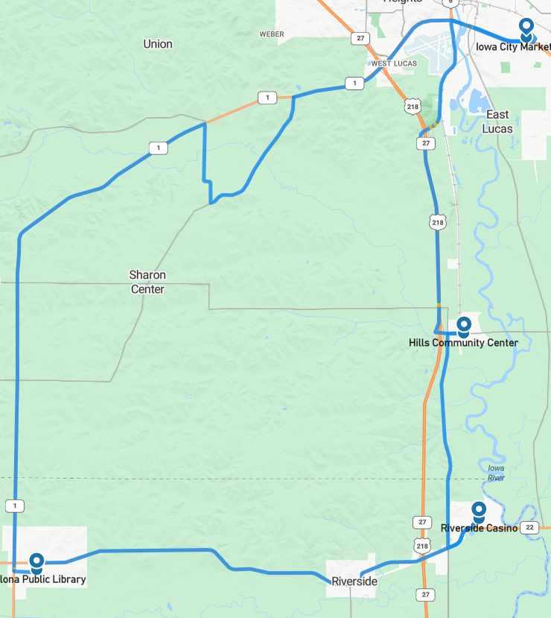
Figure 12. Drive 67 automation engagement (April 19, 2023)

Start Location | Iowa City
Number of miles recorded | 48.09
Number of miles recorded in automated mode | 47.78
Percent of drive recorded in automated mode | 99.4%
Amount of data collected (GB) | 85.9
Weather conditions | Avg temp: 52(F)  Clouds: 100%  Average wind speed: 15.2 mph
Time of day | Night
Day of week | Weekday
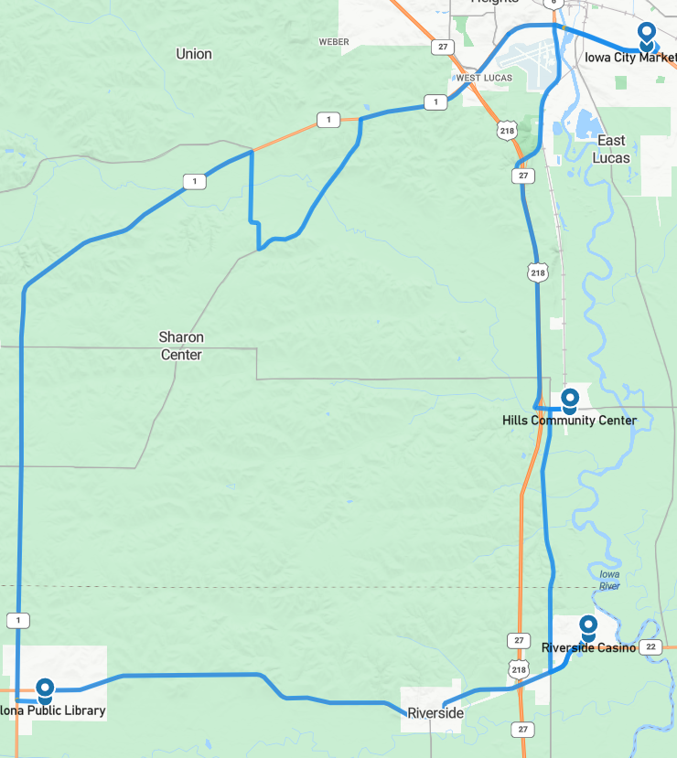Figure 13. Drive 68 automation engagement (April 20, 2023)

Start Location | Kalona
Number of miles recorded | 48.09
Number of miles recorded in automated mode | 47.6
Percent of drive recorded in automated mode | 99.0%
Amount of data collected (GB) | 89.8
Weather conditions | Avg temp: 54(F)  Clear: 97%  Clouds: 3%  Average wind speed: 16.8 mph
Time of day | Mid-morning
Day of week | Weekday
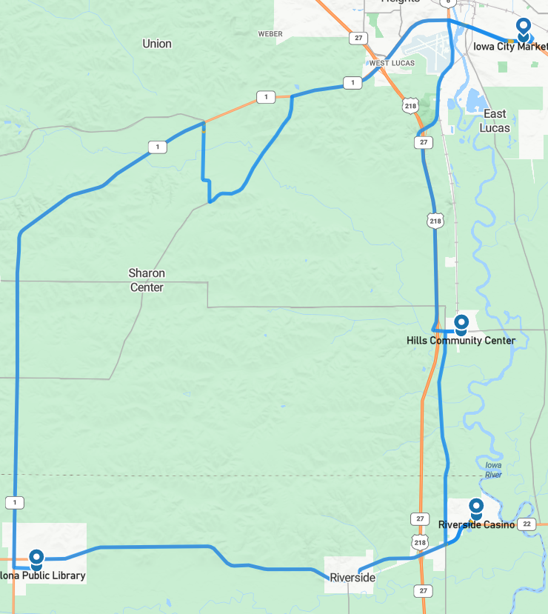Figure 14. Drive 69 automation engagement (April 21, 2023)

Start Location | Hills
Number of miles recorded | 48.09
Number of miles recorded in automated mode | 47.53
Percent of drive recorded in automated mode | 98.8%
Amount of data collected (GB) | 85.0
Weather conditions | Avg temp: 54(F)  Clear: 3%  Clouds: 97%  Average wind speed: 7.6 mph
Time of day | Mid-morning
Day of week | Weekday
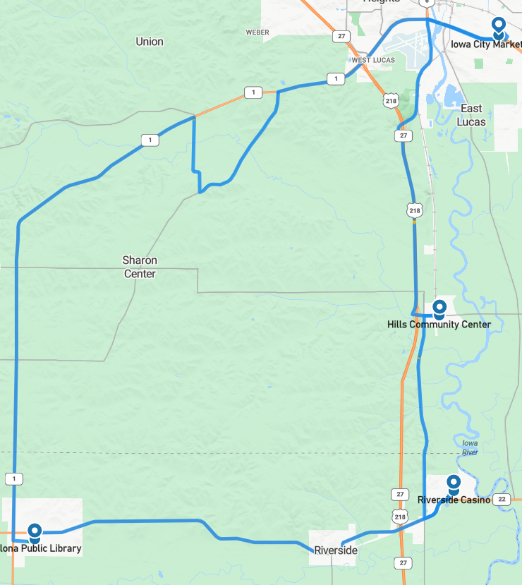
Figure 15. Drive 70 automation engagement (April 24, 2023)
Start Location | Riverside
Number of miles recorded | 48.16
Number of miles recorded in automated mode | 47.66
Percent of drive recorded in automated mode | 99.0%
Amount of data collected (GB) | 87.0
Weather conditions: | Avg temp: 51(F) Clear: 57%  Clouds: 43%  Average wind speed: 2.5 mph
Time of day | Dawn
Day of week | Weekday
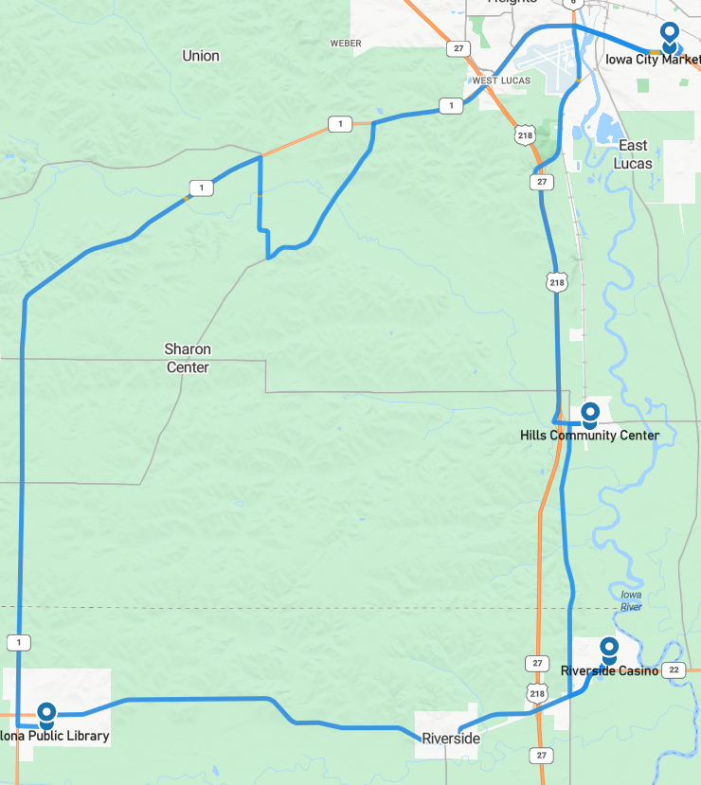
Figure 16. Drive 71 automation engagement (April 28, 2023)

Start Location | Hills
Number of miles recorded | 48.09
Number of miles recorded in automated mode | 47.53
Percent of drive recorded in automated mode | 98.8%
Amount of data collected (GB) | 86.0
Weather conditions | Avg temp: 64(F)  Clear: 79%  Clouds: 21%  Average wind speed: 23.3 mph
Time of day | Noon
Day of week | Weekday
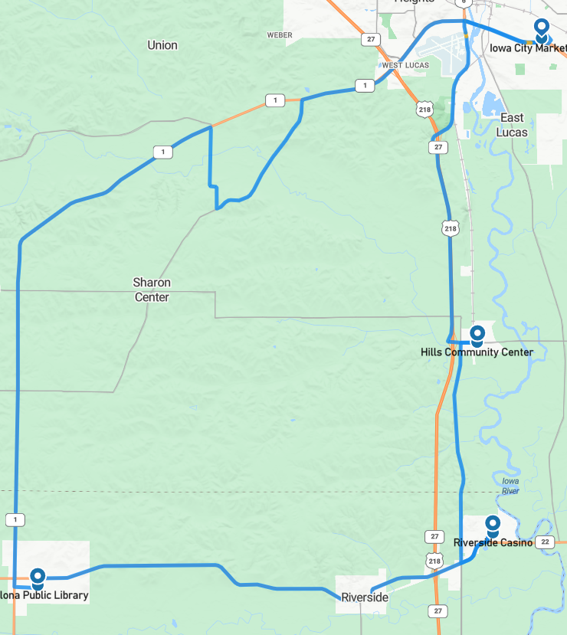
Figure 17. Drive 72 automation engagement (May 2, 2023)

Start Location | Riverside
Number of miles recorded | 48.09
Number of miles recorded in automated mode | 46.17
Percent of drive recorded in automated mode | 96.0%
Amount of data collected (GB) | 79.3
Weather conditions | Avg temp: 67(F)  Clear: 100%  Average wind speed: 2.0 mph
Time of day | Night
Day of week | Weekday
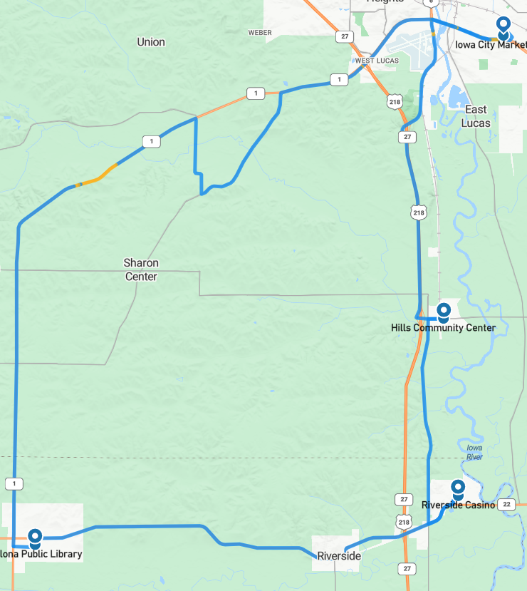
Figure 18. Drive 73 automation engagement (May 3, 2023)
Drive 73 had the lowest percentage completed in automation. A portion of the drive on Hwy 1 (shown in yellow in Figure 19) had to be driven manually due to degradation of the GPS/RTK. This degradation caused the vehicle to drift gradually toward the right lane boundary and eventually crossed over the lane boundary hitting the rumble strips at approximately 6 minutes into the video. The YouTube link (https://www.youtube.com/watch?v=Fp4v520C_Xk) is split into chapters that describe what is happening in the drive.
The lower right portion of the video is a cropped version of the safety driver’s display (Figure 19), showing the GPS RTK solution degrading and what was be seen by the co-pilot at the time. Specifically, looking at the fields labeled “RTK STDEV (LAT, LON, HGT)” where larger numbers are bad. The display also changes from green to yellow for GPS/V2X.
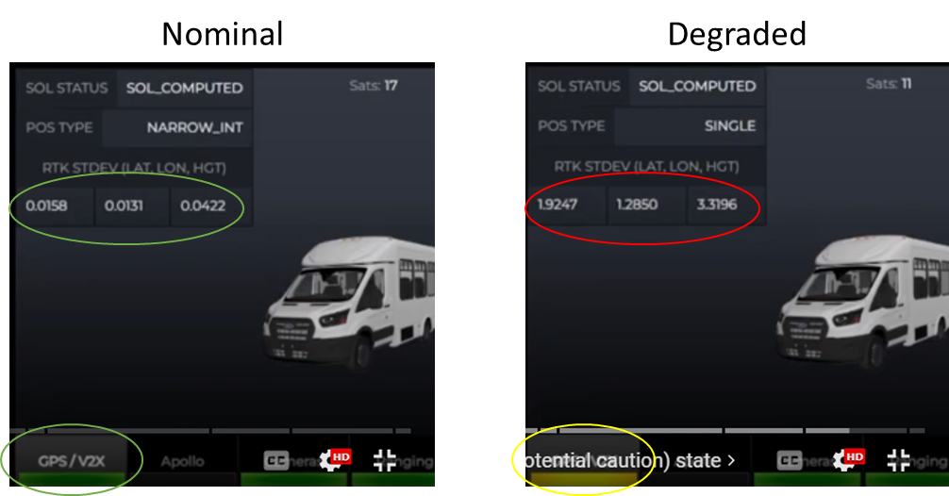
Figure 19. GPS data showing nominal and degraded RTK performance
The upper right portion of the video shows the Mobileye® lane width/position measurements. Because this happened on a marked roadway with visible striping, we were able to get good measurements of exactly how far from the center of the lane the Transit was at any point in time. This data is shown in the blue box (Figure 20, data in meters).
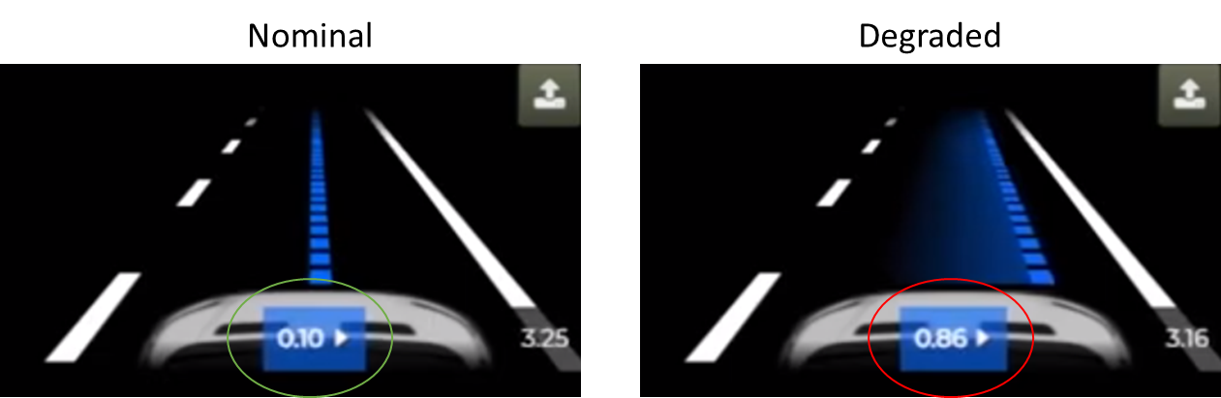
Figure 20. Mobileye data showing nominal and degraded RTK performance
As shown in the video, the driver disengaged automation twice in order to steer back to the center of the lane. The safety driver continued driving manually until the RTK signal was back within nominal range and the GPS indicator on the safety driver and co-pilot displays returned to a nominal state. After this drive, the replacement Cradlepoint (T-Mobile®) arrived. It was installed and tested. This replaced the version from Verizon that had been used for Drives 67 and 68.

Start Location | Iowa City
Number of miles recorded | 48.03
Number of miles recorded in automated mode | 47.78
Percent of drive recorded in automated mode | 99.5%
Amount of data collected (GB) | 85.8
Weather conditions | Avg temp: 81(F)  Clouds: 100%  Average wind speed: 12.8 mph
Time of day | Mid-afternoon
Day of week | Weekend
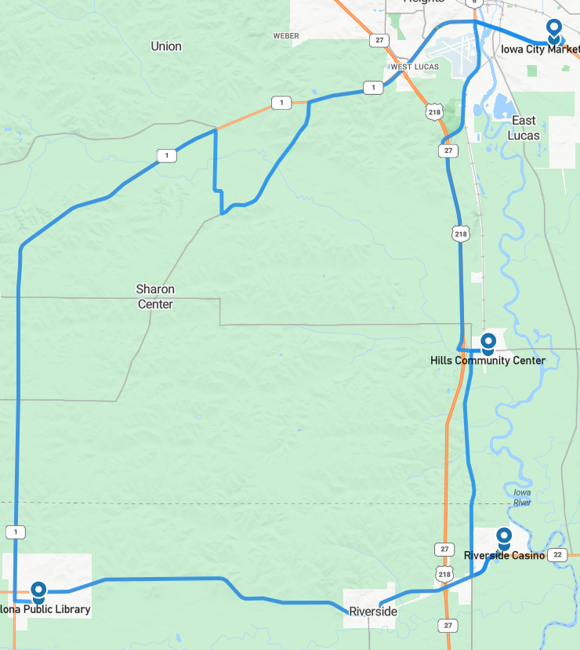
Figure 21. Drive 74 automation engagement (May 6, 2023)

Start Location | Riverside
Number of miles recorded | 48.03
Number of miles recorded in automated mode | 47.35
Percent of drive recorded in automated mode | 98.6%
Amount of data collected (GB) | 85.6
Weather conditions: | Avg temp: 72(F)  Clouds: 100%  Average wind speed: 11.0 mph
Time of day | Noon
Day of week | Weekday
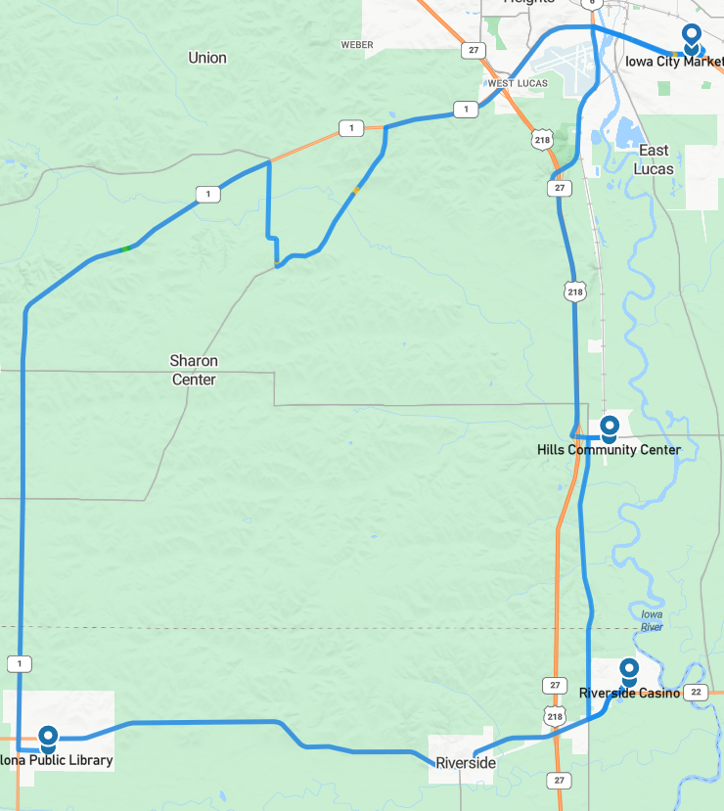
Figure 22. Drive 75 automation engagement (May 8, 2023)

Start Location | Kalona
Number of miles recorded | 48.09
Number of miles recorded in automated mode | 47.60
Percent of drive recorded in automated mode | 99.0%
Amount of data collected (GB) | 83.1
Weather conditions | Avg temp: 75(F)  Clear: 84%  Clouds: 16%  Average wind speed: 10.1 mph
Time of day | Noon
Day of week | Weekday
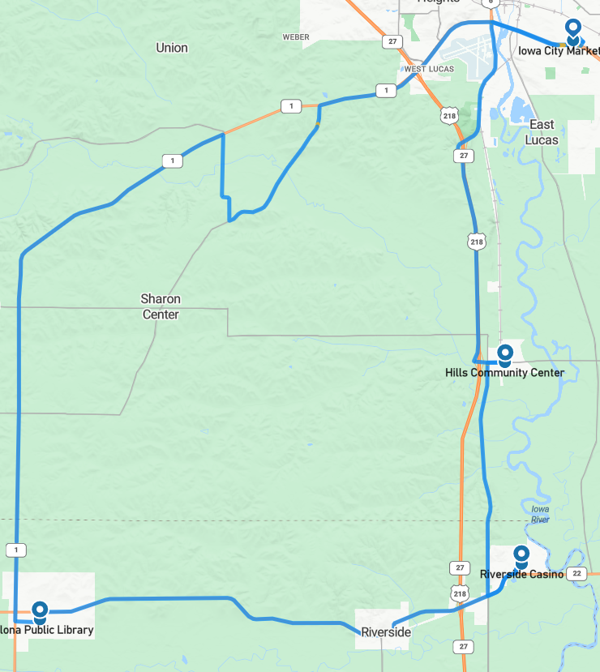Figure 23. Drive 76 automation engagement (May 9, 2023)

Start Location | Iowa City
Number of miles recorded | 48.09
Number of miles recorded in automated mode | 47.85
Percent of drive recorded in automated mode | 99.5%
Amount of data collected (GB) | 88.0
Weather conditions | Avg temp: 73(F)  Clouds: 79%  Mist: 21%  Average wind speed: 6.3 mph
Time of day | Mid-morning
Day of week | Weekday
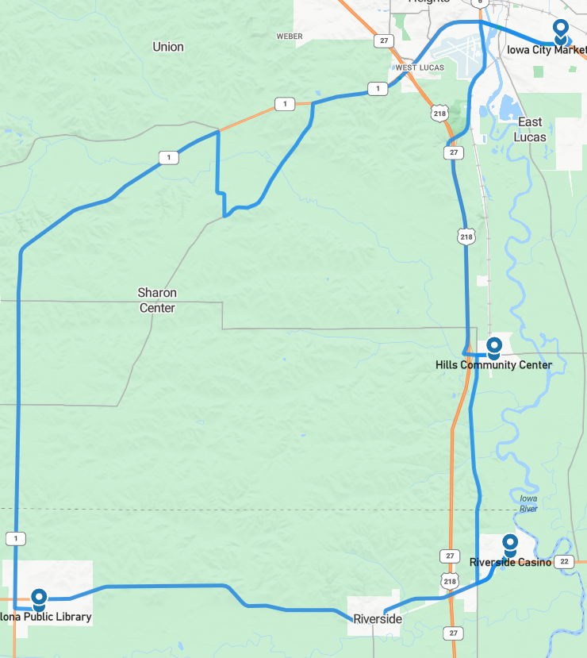
Figure 24. Drive 77 automation engagement (May 12, 2023)
Start Location | Kalona
Number of miles recorded | 48.28
Number of miles recorded in automated mode | 47.78
Percent of drive recorded in automated mode | 99.0%
Amount of data collected (GB) | 83.0
Weather conditions | Avg temp: 66(F)  Clouds: 12%  Mist: 88%  Average wind speed: 11.4 mph
Time of day | Dawn
Day of week | Weekend
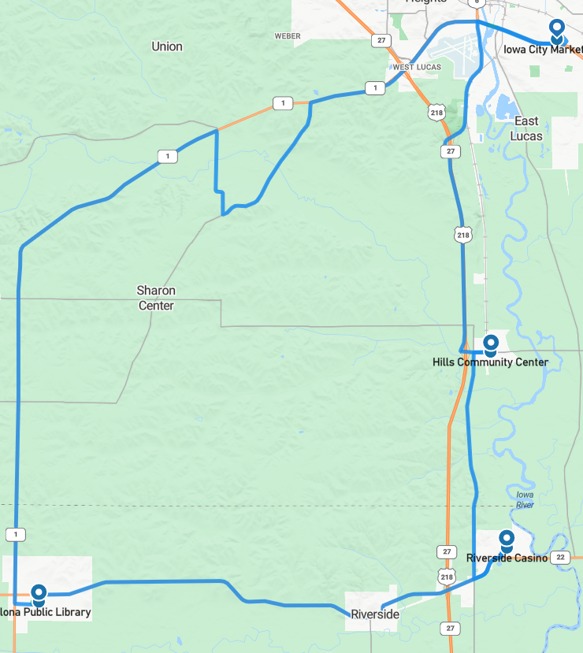
Figure 25. Drive 78 automation engagement (May 13, 2023)

Start Location | Riverside
Number of miles recorded | 48.09
Number of miles recorded in automated mode | 47.78
Percent of drive recorded in automated mode | 99.4%
Amount of data collected (GB) | 83.9
Weather conditions | Avg temp: 83(F)  Clear: 87%  Clouds: 13%  Average wind speed: 7.4 mph
Time of day | Mid-afternoon
Day of week | Weekday
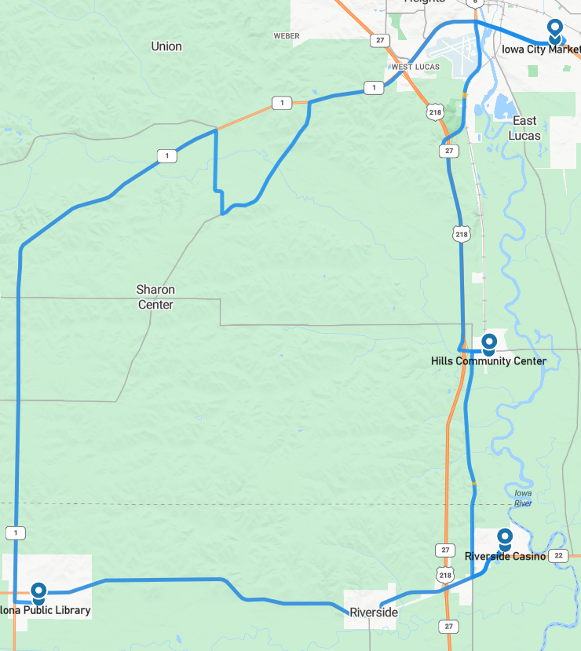
Figure 26. Drive 79 automation engagement (May 16, 2023)
Start Location | Hills
Number of miles recorded | 48.59
Number of miles recorded in automated mode | 47.53
Percent of drive recorded in automated mode | 97.8%
Amount of data collected (GB) | 86.6
Weather conditions | Avg temp: 56(F)  Clear: 100%  Average wind speed: 8.3 mph
Time of day | Dawn
Day of week | Weekday
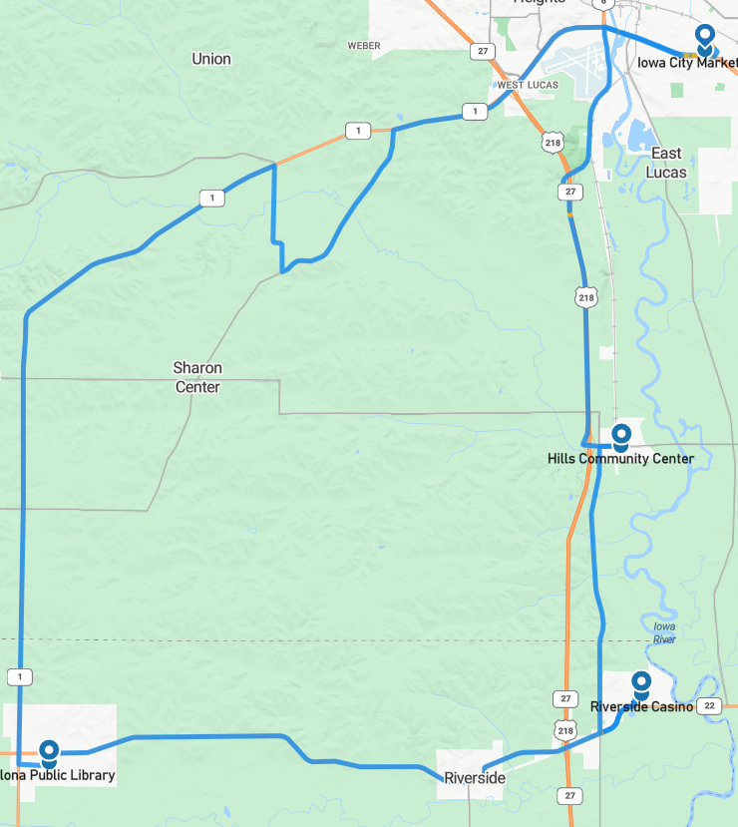
Figure 27. Drive 80 automation engagement (May 17, 2023)

Start Location | Iowa City
Number of miles recorded | 48.09
Number of miles recorded in automated mode | 47.1
Percent of drive recorded in automated mode | 97.9%
Amount of data collected (GB) | 79.8
Weather conditions | Avg temp: 83(F)  Clear: 82%  Clouds: 18%  Average wind speed: 8.7 mph
Time of day | Noon
Day of week | Weekday
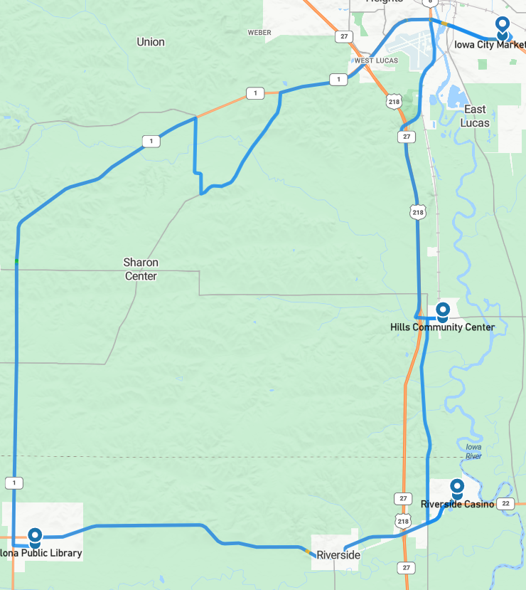
Figure 28. Drive 81 automation engagement (May 18, 2023)
Start Location | Kalona
Number of miles recorded | 48.09
Number of miles recorded in automated mode | 47.04
Percent of drive recorded in automated mode | 97.8%
Amount of data collected (GB) | 88.5
Weather conditions | Avg temp: 70(F)  Clear: 85%  Clouds: 15%  Average wind speed: 13.9 mph
Time of day | Mid-afternoon
Day of week | Weekday
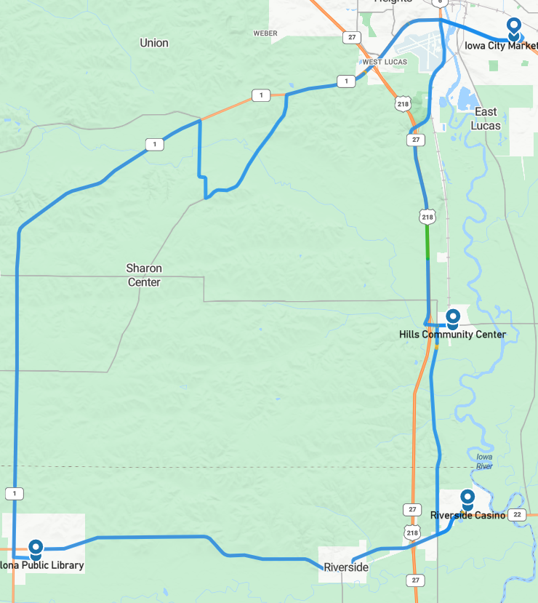
Figure 29. Drive 82 automation engagement (May 19, 2023)

Start Location | Hills
Number of miles recorded | 48.09
Number of miles recorded in automated mode | 47.78
Percent of drive recorded in automated mode | 99.4%
Amount of data collected (GB) | 88.2
Weather conditions | Avg temp: 77(F)  Clear: 85%  Clouds: 15%  Average wind speed: 5.4 mph
Time of day | Night
Day of week | Weekday
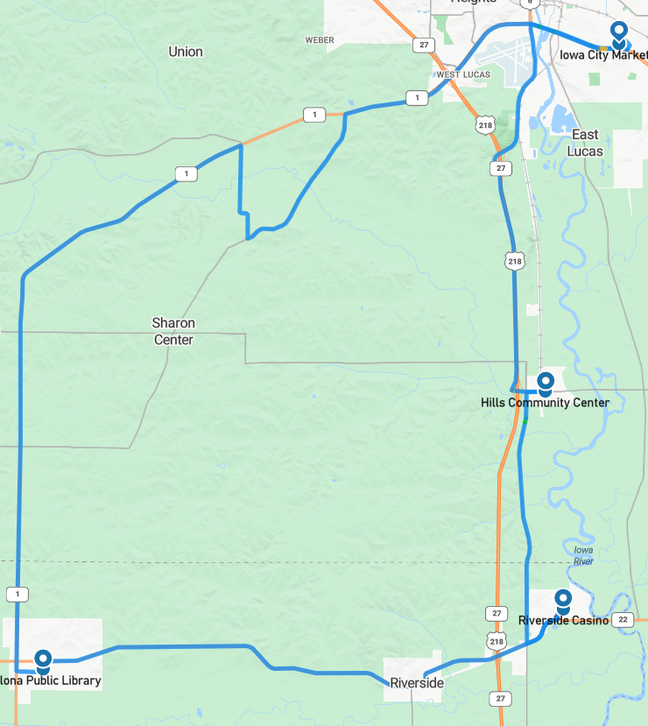
Figure 30. Drive 83 automation engagement (May 22, 2023)
Start Location | Riverside
Number of miles recorded | 48.03
Number of miles recorded in automated mode | 47.22
Percent of drive recorded in automated mode | 98.3%
Amount of data collected (GB) | 86.3
Weather conditions | Avg temp: 79(F)  Clear: 100%  Average wind speed: 2.7 mph
Time of day | Mid-morning
Day of week | Weekday
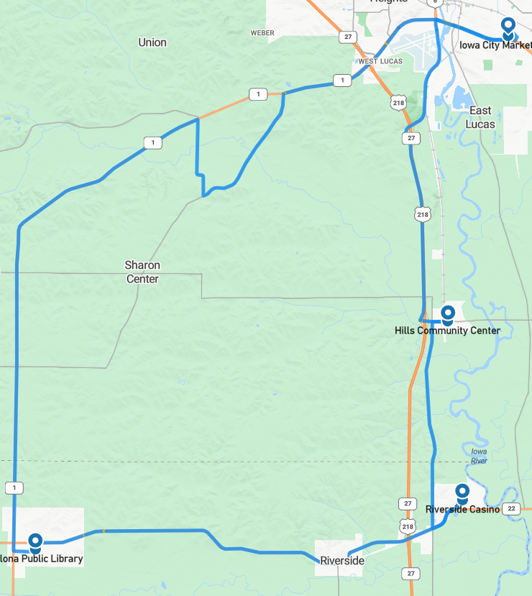
Figure 31. Drive 84 automation engagement (May 23, 2023)

Start Location | Kalona
Number of miles recorded | 48.03
Number of miles recorded in automated mode | 48.03
Percent of drive recorded in automated mode | 100%
Amount of data collected (GB) | 86.7
Weather conditions | Avg temp: 80(F)  Clear: 82%  Clouds: 18%  Average wind speed: 12.1 mph
Time of day | Night
Day of week | Weekday
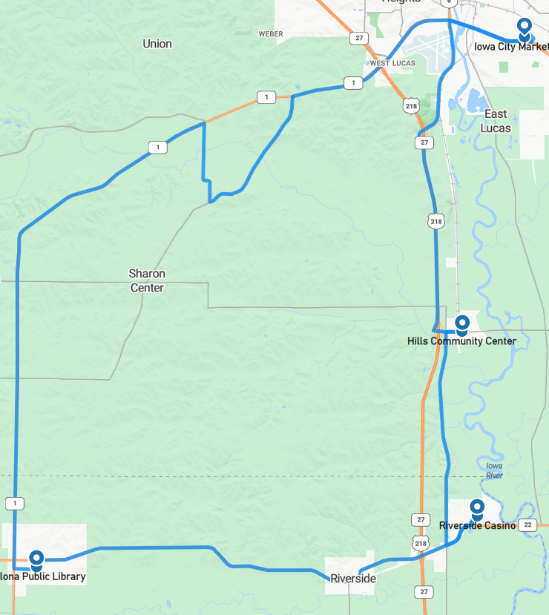
Figure 32. Drive 85 automation engagement (May 24, 2023)
Start Location | Iowa City
Number of miles recorded | 48.16
Number of miles recorded in automated mode | 47.78
Percent of drive recorded in automated mode | 99.2%
Amount of data collected (GB) | 86.4
Weather conditions | Avg temp: 60(F)  Clouds: 100%  Average wind speed: 9.8 mph
Time of day | Dawn
Day of week | Weekday
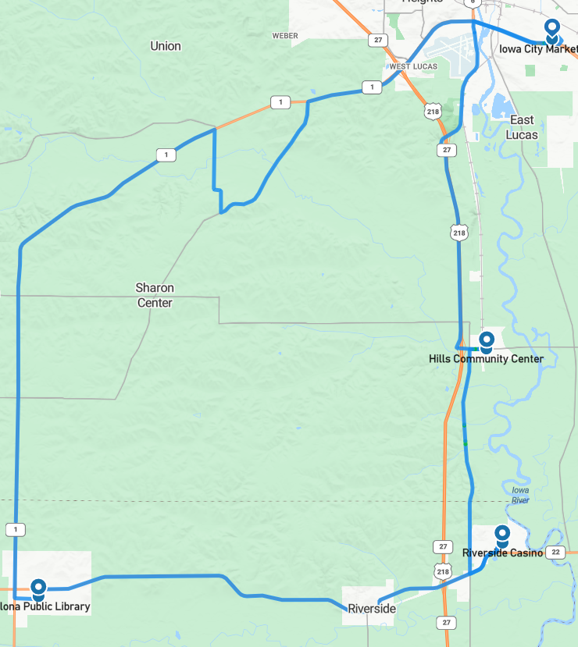
Figure 33. Drive 86 automation engagement (May 25, 2023)

Overall, the number of miles driven in automation by federal function classification (FFC) of road types is shown per drive below (Figure 34). For this phase, more than 90% of the miles for all road types, except for “other,” which is considered parking lots, were driven in automation (Figure 35).

Figure 34. Miles driven in automated mode by FFC road type

Figure 35. Percentage of FFC road type completed in automation (average across Phase 6)

Voluntary Takeover of the Automation
Safety drivers disengaged the automation for a variety of reasons. The preferred method of disengagement was to press the button located on the steering wheel. However, when necessary, turning the steering wheel, pressing the accelerator or brake pedal, or pressing the E-stop button may have been a more suitable and safer method. When the automation was disengaged, the co-pilot would flag the data using the informational display and record the reason for the disengagement using a voice recorder. There were 259 voluntary takeovers flagged by the co-pilot in Phase 6 (=13.0; sd=3.8 per drive) (Table 8).

Table 8. Frequency and type of voluntary takeovers
Reason for disengagement | Number of instances
To complete turn, vehicles approaching, deemed unsafe | 52
Unsafe lane change | 32
Parked vehicle in lane | 27
To park | 20
VRUs | 16
Abrupt braking, unknown reason | 15
To complete turn, vehicle stops in middle of intersection | 13
Other | 13
Abrupt braking, vehicle cut-in | 9
Oversteering during a turn | 9
To stop at a traffic signal | 9
Inappropriate response at traffic light | 7
To proceed through flashing yellow | 7
Another vehicle behaves unsafely | 6
Crosses the right lane boundary | 5
To make a right/left turn | 4
Vehicle indecision at yellow light | 3
To avoid an object on the roadway | 2
To go through 4-way stop, too much traffic, deemed unsafe | 2
A vehicle passing the Transit | 2
Oncoming traffic is in our lane of travel | 2
To slow/stop for traffic ahead | 1
Crosses the centerline | 1
To cross railroad tracks | 1
Travel on gravel road | 1

The largest percentage of the voluntary takeovers (37%) happened because the vehicle’s automation has difficulty with specific traffic situations at intersections or responding either appropriately or in a timely enough manner at traffic signals.
- Some disengagements were due to the vehicle starting to make a turn with traffic approaching from the right or left at a high speed (20%). The safety driver was tasked with making the call as to whether intervention was necessary and had to take into consideration the tentativeness of the Transit with respect to the distance and speed of the approaching traffic.
- Takeovers also occurred when the vehicle stopped in the middle of an intersection (5%). It is possible that, if left long enough, the vehicle would have eventually made its way through the intersection. However, this was considered unsafe, and the vehicle was taken out of automation so that the safety driver could complete the turn without negatively impacting the surrounding traffic.
- There were several instances when the automation did not correctly recognize the state of the traffic signal (e.g., started to move when the light was red or failed to stop at a yellow or red light). In some of these instances, the vehicle may have been picking up the incorrect signal, one to the right or left of the signal for the vehicle’s lane of travel. These instances required immediate takeover from the safety driver.

Completing lane changes in automation was oftentimes not possible due to the amount of surrounding traffic or the speed of traffic approaching from behind in the left lane. In these instances, the safety driver would take over and complete the lane change manually, before re-engaging the automation. Twelve percent of the disengagements occurred due to failed lane change attempts. It was necessary to disengage 32 times during this phase to complete the 80 lane changes (four per drive).

There were also 27 disengagements (10% of the total) due to other vehicles being parked in the Transit’s lane of travel. The vehicle does have the ability to “nudge” itself over slightly to the right or left to pass a vehicle that is extending into the lane but is not able to actually leave the lane to go around.

When compared to other phases, there was a similar number of disengagements due to other vehicles behaving unsafely. These included the following six situations:
- A vehicle backed out of a parking space in front of shuttle. This happened twice during Phase 6: once in downtown Kalona and once in the Iowa City Marketplace parking area.
- A vehicle turned or pulled out in front of the shuttle too closely. This also occurred twice during this phase.
- A vehicle started to change lanes into the Transit.
- A semi was drifting over the center line as it passed.

In the previous phases, disengagements to park the vehicle manually were necessary at each of the four stops, as the automation was not capable of handling these maneuvers. For Phase 6, the vehicle only needed to be disengaged 20 out of the 80 times it reached a dropoff/pickup location. These disengagements were most often due to another vehicle being parked in the mapped spot or lane of travel. These disengagements accounted for 8% of the total number.

Forced Takeover of the Automation
Situations where the automated driving system (ADS) disengages on its own or becomes unavailable and requires the driver to intervene are called forced takeovers. There were no instances of this type of takeover during Phase 6.

Encounters with Vulnerable Road Users (VRUs)
Flags were placed in the data to identify interactions with vulnerable road users (e.g., horse and buggies, ATVs, bicycles, pedestrians) located either within the lane boundary or on the shoulder on either side of the road. There were 253 interactions while the vehicle was traveling in automation and 24 while the vehicle was being driven manually (Table 9).
Table 9. Encounters with VRUs in automated and manual mode
In Automated Mode | In Manual Mode
- 109 pedestrian  - 37 horse and buggy  - 32 bicycle  - 27 other  - 26 farm equipment  - 9 object in roadway  - 6 police/emergency vehicles  - 6 ATV/golf cart  - 1 animal | - 13 pedestrian  - 6 farm equipment  - 3 police/emergency vehicles  - 1 horse and buggy  - 1 bicycle
Identifying where these interactions occur allows a comparison between how these situations are handled by the driver in manual mode and how the automation handles them. Another important reason for identifying the VRU encounters is to be able to investigate how the perception module classifies these objects.

Safety Critical Events
These events include interactions that require abrupt accelerations/decelerations or large steering wheel reversals by the automated vehicle (AV), the safety driver, or another vehicle and may or may not be classified as a near crash. Crashes are also included in this category. There were no safety critical events recorded during Phase 6.

Occupants for Phase 6

Demographics
Thirty-nine adults over age 65 and those over 25 with mobility or visual impairments were recruited to ride the vehicle. Table 10 provides the demographic breakdown by age, gender, and impairment. No one reported using a wheelchair; three reported using a walker, cane, or crutches; and three reported having difficulty walking or climbing stairs. Two of the occupants have a low vision impairment (i.e., visual acuity less than 20/70). Forty-four percent (17 out of 39) have some type of visual restriction on their driver’s license (glasses or corrective lenses). However, these restrictions are not severe enough to cause these occupants to be considered visually impaired. And 28% (11/39) reported having difficulty hearing.
Table 10. Demographics of occupants
Age | Unimpaired |  | Mobility Impaired |  | Visually Impaired |  | Hearing Impaired
 | Male | Female | Male | Female | Male | Female | Male | Female
25–34
35–44
45–54
55–64
65–74 | 9 | 16 |  | 2 |  |  |  | 3
75–84 | 4 | 3 | 3 | 1 | 2 |  | 5 | 2
85–94 | 1 |  |  |  |  |  | 1
95+
Total | 14 | 19 | 3 | 3

The sample is highly educated, with 85% of occupants having some education beyond a high school degree, and 64% (25 out of the 39 who responded) have a household income greater than $50,000. All but two riders own or have access to a vehicle. Typically, occupants drive themselves where they need to go with 51% reporting driving themselves daily and 28% driving themselves a few times a week. All but two have a valid driver’s license. Those who did not have access to a vehicle or have a driver’s license reported getting a ride from a friend, using either paratransit, van/shuttle services, or private services (e.g., Uber or Lyft).
Fifty-one percent of the occupants in Phase 6 own or have access to a vehicle that has either adaptive cruise control (ACC) and/or lane keeping/lane centering. About 65% of those with ACC and about 50% with lane keeping reported using it often or frequently. A majority (72%) also reported that when it comes to trying new technology, they generally fall in the middle (e.g., not the first or last to try). About 87% reported owning or using a smart phone. Eighty-five percent reported that they own a desktop or laptop computer, and 95% reported having access to the internet. A majority, 67%, reported that they use some form of social media, and 69% own or use a tablet. Occupants agreed that they like to use technology to make tasks easier (74%), and a slight majority reported that they wanted a car with all the latest technology features (54%).

Survey Data
Occupants were asked to complete both a pre- and post-drive survey regarding their trust and acceptance of highly automated vehicles. This type of vehicle was defined as one that is “capable of driving on its own in some situations but is aware of its limitations and calls for the driver to take over when necessary.” When asked to indicate how they felt about different statements, a greater percentage of occupants after their ride in the vehicle “somewhat or strongly agreed” that automated vehicles are reliable (64% pre-drive vs. 85% post-drive, Figure 36). However, there was no change in the level of trust. Sixty-four percent reported that they could trust highly automated vehicles both pre- and post-drive (Figure 37).

Figure 36 Reliability of highly automated vehicles, pre- and post-drive

Figure 37. Trust in highly automated vehicles, pre- and post-drive
There was a slight increase in the percentage of occupants (10% pre-drive vs. 18% post-drive) who reported being worried about riding in a highly automated vehicle (i.e., disagreed with the statement “I am not worried…”, Figure 38). Additionally, after riding in the vehicle, a lower percentage of occupants reported that they believed that automated vehicles are safer than manually driven vehicles (39% pre-drive vs. 26% post-drive, Figure 39).

Figure 38. Worried about riding in a highly automated vehicle, pre- and post-drive

Figure 39. AVs safer than manual vehicles, pre- and post-drive
In Phase 6, automation was used to drive on all the different types of roadways along the route. As has been the case throughout the project, the safety driver used the automation whenever they deemed it safe to do so. These results examine the riders’ trust in the automation to drive on these roadways both before and after they had the chance to experience it.
The percentage of occupants who indicated that they agreed either “strongly” or “somewhat” that they would trust a highly automated vehicle on the interstate or highway after the drive was complete, increased with exposure (82% pre-drive vs. 95% post-drive, Figure 40).

Figure 40. Trust of highly automated vehicle to drive on interstate/highway pre- and post-drive
Trust in the ability of the vehicle to drive in automation on city streets increased from 67% pre-drive to 82% post-drive (Figure 41). And trust in the automation’s ability to respond to traffic lights/signs increased significantly (75% pre-drive vs. 100% post-drive, Figure 42).

Figure 41. Trust of highly automated vehicle to drive on city streets

Figure 42. Trust of highly automated vehicle to respond to traffic lights/signs
A significant change in trust was also seen for the gravel road portion of the route. Fifty-six percent of occupants agreed either “strongly” or “somewhat” that they would trust a highly automated vehicle on gravel roadways pre-drive. However, post-drive, after experiencing the Transit drive the gravel roadway in automation, that percentage increased to 80% (Figure 43).

Figure 43. Trust of highly automated vehicle to drive on gravel roads
Trust in the vehicle’s ability to navigate a parking lot and park itself did not change pre- vs. post-drive (85% vs. 84%, Figure 44). And rider’s trust in the vehicle’s ability to parallel park decreased from 92% pre-drive to 67% post-drive (Figure 45).

Figure 44. Trust of highly automated vehicles to navigate a parking lot and park itself

Figure 45. Trust of highly automated vehicles to parallel park
Occupants were also asked questions about perceived usefulness and their intention to use highly automated vehicles. When asked to report whether they were “open to the idea of riding in a highly automated vehicle,” 95% of occupants before and 92% after the ride indicated that they somewhat or strongly agreed with the statement (Figure 46).

Figure 46. Openness to riding in a highly automated vehicle
When asked whether they thought highly automated vehicles would allow them to stay active or more involved in their communities, there were no real differences between how they felt pre- and post-drive (64% pre-drive vs. 64% post-drive and 59% pre-drive vs. 62% post-drive, respectively).

Biometric Data
A medical grade wearable device was worn by each of the occupants as well as the safety driver for each of the 20 drives. The device has a sensor which measures blood volume pulse (BVP), from which heart rate variability can be derived, as well as a sensor that measures the constantly fluctuating changes in certain electrical properties of the skin (galvanic skin response or GSR). Ten minutes of baseline data was collected before the start of each drive.

Heart Rate Variability (HRV)
Heart rate variability is said to indicate physiological stress or arousal, with increased stress being indicated by a low HRV.

Galvanic Skin Response (GSR)
Increases in GSR activity can indicate stress/anxiety as well as other emotions such as anger, disgust, fear, happiness, surprise, and extreme sadness.
This data was not analyzed for this summary report; however, it will be available in its raw form through the data access portal.

Anxiety Ratings
Occupants were also asked to provide a rating of their anxiety level from 0 to 10, with 0 being “not at all anxious.” These ratings were given at nine specific locations along the drive and were the same for each participant, although they did vary in the order they were given depending on the starting location for the drive. Figure 47 is a map showing where each of these ratings occur along the drive. A pre-drive anxiety rating was obtained for everyone before the drive began. Rating locations included the following:
- Hwy 6 in Iowa City
- After merge onto Hwy 218
- After turn onto Hwy 22
- Business district of Riverside
- Downton Kalona
- Hwy 1 rural
- Gravel road
- Unmarked blacktop road
- Hwy 1 intersection
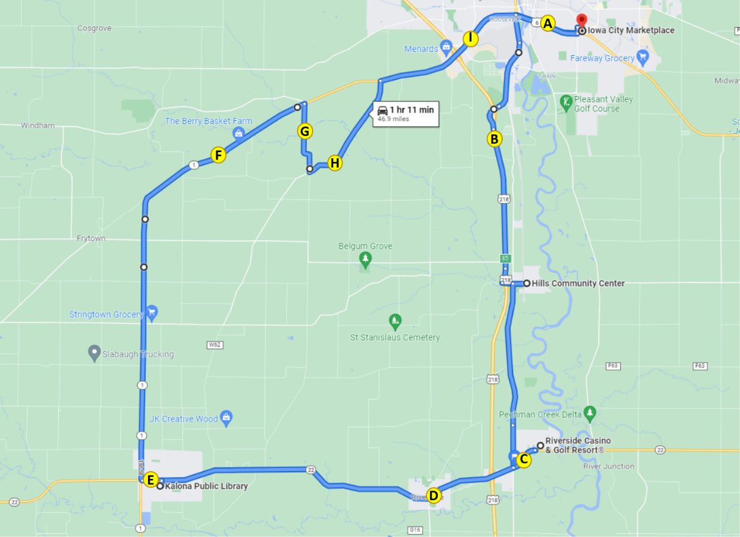
Figure 47. Map indicating locations of anxiety ratings
The average ratings of anxiety across the drive for each participant ranged from 0 to 5.5 with an average across all participants of 0.8 (Figure 48). The locations with the highest average ratings of anxiety were after the turn onto Hwy 22 (1.18) and after the merge onto Hwy 218 (1.16). These ratings were nearly double the average baseline rating of anxiety that was given pre-drive (Figure 49). Both of these situations were interactions with other traffic traveling at high speeds.
Figure 48. Average ratings of anxiety by occupant
Figure 49. Average ratings of anxiety by location on route
Anxiety ratings were also examined for each occupant based on time of day and starting location; there were no adverse weather conditions for this phase (Figure 50). Environmental conditions such as driving at night may have impacted anxiety ratings. On average, males and females had similar levels of anxiety (0.9 vs. 0.8, respectively). The average rating of anxiety for the night drives was 1.3, twice the average baseline rating (0.67).
Figure 50. Average anxiety rating by occupant, starting location, and environmental conditions (N = Night; H = Hills; IC = Iowa City; K = Kalona; R = Riverside)
It is important to remember that things like surrounding traffic and weather conditions may affect these ratings. Also, we are only looking at the data from this phase, which includes a small number of drives and riders. Therefore, additional analyses are needed at the end of the project, taking into account all of the variables that could impact anxiety.

Safety Drivers
There were three dedicated safety drivers for Phase 6. All three drivers are staff at the University of Iowa and have completed our safety driver training. Driver 1 drove eight of the 20 drives, Driver 2 drove seven, and the third driver, Driver 4, drove five. Each was asked to complete a post-drive survey immediately following their drive. These questions were related to their comfort using the automation at different points along the route or during certain environmental conditions.
Results of the survey showed that, for the most part, the drivers were comfortable using the automation on all of the different types of roadways. For 90% of the drives, they reported being comfortable driving on the freeway portion, on the roads through the city, as well as driving through parking lots (Figures 51, 52, and 53 respectively). For 100% of the drives, they reported being comfortable driving on the gravel roadway (Figure 54).

Figure 51. Safety driver perception of automation while driving on the freeway/highway

Figure 52. Safety driver perception of automation while driving on urban roadways through cities/towns

Figure 53. Safety driver perception of automation while driving through parking lots

Figure 54. Safety driver perception of automation while driving on gravel roads

The safety drivers were also asked to indicate how concerned they were about different issues related to highly automated vehicles. Results showed that they were most concerned about the system being confused by unexpected situations and the ability of the system to interact with non-self-driving vehicles (Table 11).
Table 11. Safety driver concerns regarding the automation
How concerned are you about the safety consequences of equipment or system failure? | Percent of drives
Not at all concerned | 25%
Slightly concerned | 75%
Extremely concerned | 0%
How concerned are you about the vehicle's ability to interact with non-self-driving vehicles? | Percent of drives
Not at all concerned | 10%
Slightly concerned | 80%
Extremely concerned | 10%
How concerned are you about the vehicle's ability to interact with pedestrians and cyclists? | Percent of drives
Not at all concerned | 5%
Slightly concerned | 95%
Extremely concerned | 0%
How concerned are you about the system's performance in poor weather? | Percent of drives
Not at all concerned | 75%
Slightly concerned | 25%
Extremely concerned | 0%
How concerned are you about the system being confused by unexpected situations? | Percent of drives
Not at all concerned | 0%
Slightly concerned | 85%
Extremely concerned | 15%
How concerned are you about the system not driving as well as human drivers? | Percent of drives
Not at all concerned | 5%
Slightly concerned | 90%
Extremely concerned | 5%

Phase 6 Summary
Phase 6 is the final phase of the project, and the vehicle is now capable of driving the entire 47-mile route in automation. Therefore, a substantial portion of the route during this phase was completed in automated mode, greater than 98% on average.
Data of specific interest for Phase 6 included the vehicle being able to navigate parking lots and park itself in a variety of parking spots. Angle parking at the Hills Community Center was the least successful and occurred during only 45% of the drives. Parallel parking at the Kalona Library and parking in the valet spot at the Riverside Casino both occurred during 70% of the drives, and parking at the Iowa City Marketplace occurred during 85% of the drives. The most common reason for disengagements to park was that other vehicles were already parked in the mapped parking location or along the route necessary to get to the spot.
Of the 122 ADS encounters with pedestrians, 41 happened in the parking lots or near one of the designated parking spots. For only 11 (27%) of these encounters did the safety driver feel like it was necessary to disengage the automation. The vehicle was able to respond to pedestrians standing along the sidewalk and even slowed or stopped for pedestrians crossing in front of the shuttle in the parking lots.

Interesting Encounters
During Phase 6 (Drive 73) there was an instance of the automation “seeing” an obstacle: a dust cloud kicked up by a tractor and wagon driving on the oncoming shoulder. The wind was blowing in just the right direction to blow dust toward the Transit (https://www.youtube.com/watch?v=22GehVXR5pA). Figure 55 shows the raw point cloud on the bottom left and Apollo on the bottom right. As the dust drifts across the road, it is perceived by Apollo and the vehicle responds with slight steering and braking.
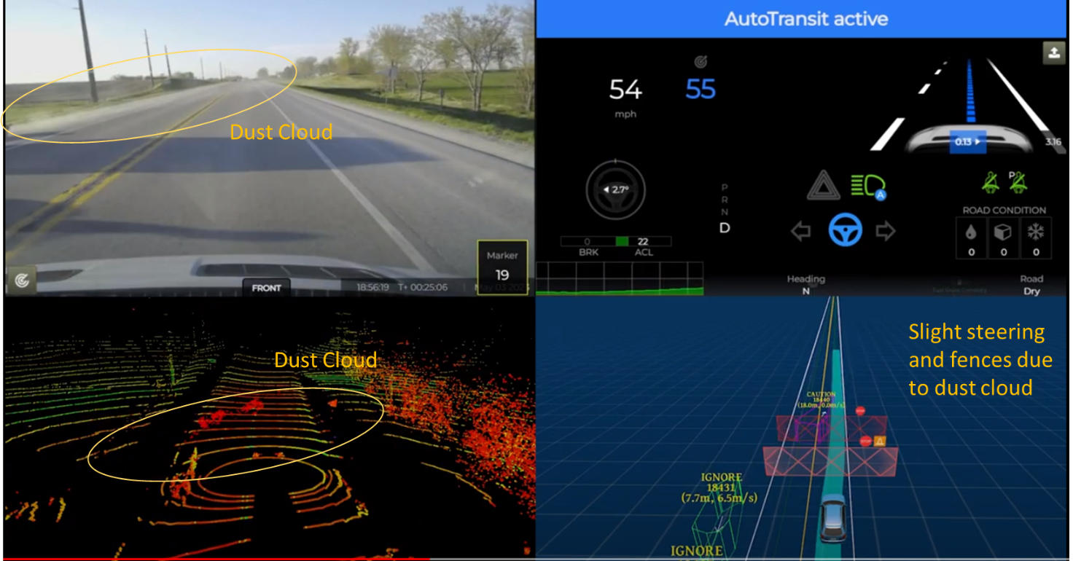
Figure 55. Swerve for a dust cloud
Interestingly, during Drive 80, the Transit encountered a turkey running across the gravel road ahead (https://www.youtube.com/watch?v=JooExCfYnlk). The turkey shows in the point cloud visualization, but Apollo didn’t classify it or seem to do any steering/braking (Figure 56).
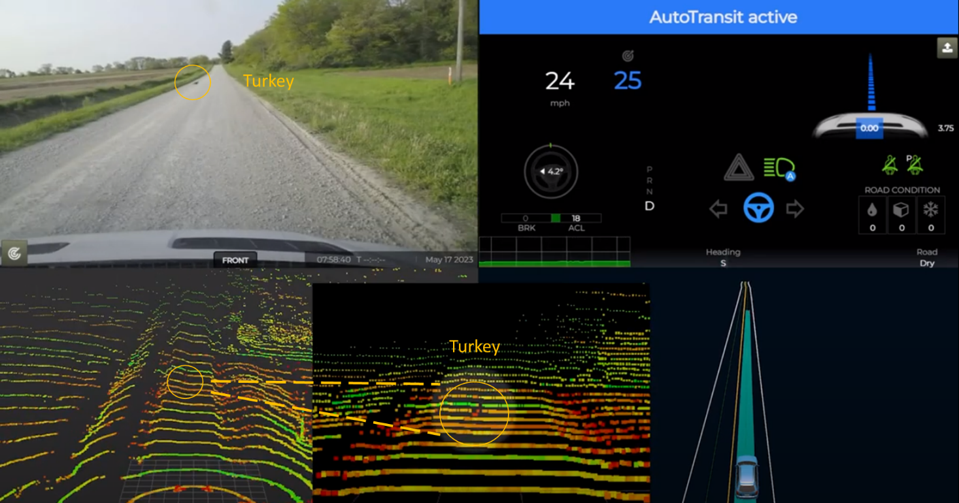
Figure 56. Turkey in roadway

Accomplishments for Phase 6
The following improvements were made to the ADS in Phase 6:
- Added the references in the map for parking spaces in Kalona and Hills.
- The parking lot at Hills was slightly widened to allow the Transit to enter without having to reverse.
- We moved the endpoints of the routes for the Iowa City Marketplace and the Riverside Casino so that they overlapped slightly (about a bus length) to avoid having to drive forward manually a few meters before planning was available on the ensuing route. This allowed the safety driver to disengage automation (shift to P), select the next route, then push enable button on steering wheel and begin driving the next route in automation.
- Moved the final waypoint in Hills closer to the parking spot and tuned configuration parameters to help it come to a stop sooner, trying to avoid hitting the curb.
- Updated radar rotational transforms to improve misalignment in radar obstacle pose that caused stop fences to be thrown in front of ego vehicle.
- Tuned the speed-based lateral controller at lower speeds to help prevent oversteering at low-speed, high-curvature turns.
- Adjusted the controller gains and reduced the speed limit on particular connecting lanes to improve the steering tracking for all tight turns.
- The speed limits for certain lane segments near Iowa City Marketplace and Casino were modified to enhance steering control while making turns and changing lanes. Our investigation revealed that a significant difference in speed limits between two adjacent lanes was responsible for sudden steering movements during lane changes on Riverside heading south.
- Configured the planning module to disregard any free-moving vehicles that are outside the map. Our on-road testing near the Marketplace demonstrated that this adjustment reduced instances of unexpected slow downs of the ego vehicle.
- Certain configuration parameters related to stop sign scenarios were fine-tuned to improve the stopping behavior of the Transit.
  - Fixed the incorrectly defined traffic light near the Iowa City Marketplace in the map.
  - Lowered the speed limit in downtown Kalona from 15 mph to 10 mph due to proximity of the Transit to angle-parked vehicles.
  - Increased the speed in the Riverside Casino parking area from 11 mph to 15 mph to reflect changes made to the posted speed limit.
  - Corrected the missing turn type at the intersection of Hwy 1 and Kansas Ave to cause activation of the turn signal for the entire right turn.
  - Eliminated duplicate points near the intersection of Hwy 1 and S. Riverside Dr, which caused incorrect heading estimation for prediction.
  - Added two speed bumps to the HD map at the Iowa City Marketplace.

Lessons Learned/Next Steps

Perception
Reducing end-to-end latency, especially in processing LiDAR data, is a major challenge for the perception module. When the processing of LiDAR data is not sufficiently fast, it can lead to delays in perceiving and understanding the surrounding environment. By optimizing the perception code, latency can be reduced to under 100 ms in most scenarios. However, when encountering busy intersections, there are instances where the latency occasionally exceeds the 100 ms limit. This latency can create significant challenges for the subsequent planning module, resulting in unexpected slowdowns and delayed responses. To address this issue, further optimizations are necessary. This could involve more time efficient deep learning models, fine-tuning the perception algorithms, exploring more hardware acceleration options, or considering alternative processing techniques.

Prediction
The prediction models require improvement to enhance their accuracy and reliability. For example, these models often produce multiple trajectories for on road vehicles. Each of these predicted trajectories is associated with a confidence probability. Unfortunately, this probability estimation is not consistently reliable which increases the complexity for the planning module to generate an optimal trajectory to follow. Furthermore, the accuracy of the high-definition (HD) map plays a significant role in the prediction process. Mapping complex junctions precisely presents substantial challenges. Even with a precise map of the junction, it is common for drivers to slightly deviate from their designated lanes during turns. This slight deviation can lead to the generation of unrealistic or impractical trajectories. By improving the prediction models to consider a wider range of potential driver actions and incorporating more flexible trajectory planning, the system can generate predictions that are more realistic and feasible, even in scenarios where the vehicle is slightly off its intended lane.

Planning
The Apollo 5.5.0 had a hard-coded maximum speed limit of 22.5 m/s (approximately 50 mph) in the planning module. This predetermined value significantly influenced the default settings of various variables. Increasing the max speed limit to 30 m/s (approximately 67 mph) made it necessary to identify and modify all the relevant variables to ensure their compatibility with the higher speed. One of main challenges in the planning module is to generate a comfortable speed profile. The speed optimizer occasionally struggles to handle simple scenarios as the ego vehicle approaches the speed limit with a high acceleration rate, revealing limitations in the existing parameter configuration. Also, setting the penalty weight too high for the road curvature can result in the vehicle failing to reach the speed limit on slightly curved roads, such as highway merging lanes, or taking an excessive amount of time to do so. Conversely, if the penalty weight is set too low, the planned speed for tight turns may be too high, compromising safety. The current design of the speed optimizer can lead to slow speed recovery in cases where the autonomous vehicle unexpectedly slows down due to cut-in vehicles. To address these challenges, it is essential to increase the number of parameters used in the speed profile generation process. By incorporating additional parameters and refining their configuration, the speed optimizer can better handle scenarios where the ego vehicle approaches the speed limit and striking a better balance between comfort and practicality across various road curvatures. Careful experimentation, testing, and fine-tuning of the parameterization of the speed profile generator will be instrumental in enhancing its overall performance. This will enable the generation of more effective speed profiles for a wider range of driving scenarios, ultimately improving the safety and efficiency of the autonomous driving system.

For more information, please refer to the ADS for Rural America Safety Management Plan at adsforruralamerica.uiowa.edu/ADS-safety-plan

