Phase 5 (Connected Vehicles)

Evaluation Report
Author: Cher Carney, Project Research Lead, cher-carney@uiowa.edu
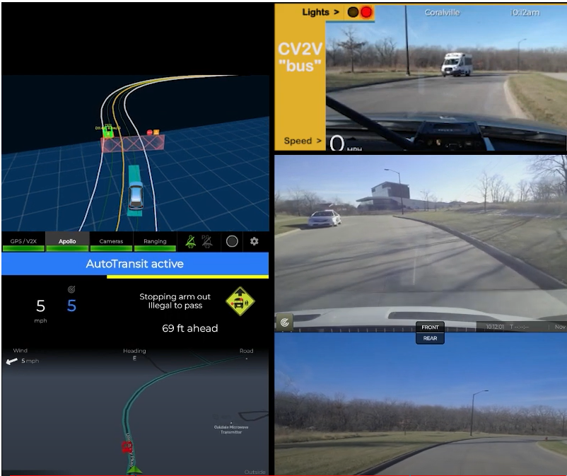

Contents
Introduction 1
Expected Capabilities of the Automation for Phase 5 2
Automation at Intersections 5
Four-Way Stop Intersections 5
Two-Way Stop Intersections 6
Stop-Controlled Intersections 8
Yield-Controlled Intersections 8
Traffic Signals 9
Automation Engagement by Drive 11
Voluntary Takeover of the Automation 17
Forced Takeover of the Automation 19
Encounters with Vulnerable Road Users (VRUs) 21
Safety Critical Events 21
Occupants for Phase 5 23
Demographics 23
Survey Data 23
Biometric Data 29
Anxiety Ratings 29
Safety Drivers 32
Phase 5 Summary 35
Forced Takeovers 36
Apollo and Route Options at Intersections 37
Accomplishments for Phase 5 37
Next Steps 39
Map Issues to be Addressed 39
Other Issues to be Addressed 39

Introduction
This project is comprised of six data collection phases shown in Table 1 that span over a two-year time period. Each phase has attempted to increase the percentage of the route that is driven under automation as well as improve the performance and comfort during those portions of the route that were automated in the previous phases. The defined route has been driven in its entirety for each phase to document this progression and to allow for comparison of automation data from one phase to the next.
Phase 1 was completed in November of 2021 on controlled access highways and a divided highway/interstate. A large portion of the route during that phase was able to be driven in automated mode. This was due to a high percentage of the route being interstate/highway driving. However, several issues regarding merging and traveling at highway speeds were identified during that phase.
Phase 2 was completed in March of 2022. The focus of Phase 2 was vehicle navigation along 2-lane undivided highways as well as on- and off-ramps. The traffic on undivided highways travels in opposite directions, has more variable vehicle speeds, and has vehicles that may pass in oncoming traffic lanes. On- and off-ramps were seen as a unique challenge due to the variable geometries and vast differences in speeds of vehicles entering and exiting the highways, as well as the unpredictability of driver behavior that can occur in these locations.
Phase 3 was completed in July of 2022 and focused on driving in automation through cities and towns along the route. These roadways have a wide variety of intersections including 2-way and 4-way stop intersections as well as intersections with lighted traffic signals. The stop-controlled intersections were traversed using input from the high-definition (HD) map as well as the other sensors. The lighted intersections were navigated via automation that used a camera-based system and a traffic light detection software module.
Phase 4 was completed in October of 2022. This phase examined the ability of the automation to drive unmarked paved and gravel roadways. These road types are a challenge both in their design and the way in which they are typically driven. Changes to the HD map allowed the vehicle to drive these roadways in a manner that is more typical of a human driver.
Phase 5 was meant to examine interactions between the automated vehicle and slow-moving vehicles outfitted with on-board telemetry processors, specifically vehicles acting as stopped school buses. Slow moving vehicles pose hazards to other traffic traveling on rural roadways, particularly on steep grades and curves. The processors provided location and speed information to the Transit, enabling it to slow down and stop even without direct line of sight.
Table 1. Project phases
Phase | Description | Drives Planned | Drives Completed | Date | Status
1 | Controlled Access Roadways | 10 | 10 | 11/2021 | Complete
2 | Highways & Ramps | 20 | 17 | 03/2022 | Complete
3 | Urban Areas | 10 | 13 | 07/2022 | Complete
4 | Unmarked Roads | 10 | 10 | 10/2022 | Complete
5 | V2X | 10 | 10 | 01/2023 | Complete
6 | Parking Areas / Full Route | 20 |  | 05/2023 | Planning
Total |  | 80 | 60
Ten drives were completed as part of Phase 5. These drives took place between January 5 and January 24, 2023. They occurred at different times of day and during varying lighting and weather conditions.
Data of specific interest in Phase 5 includes:
- Interactions with slow/stopped vehicles along the route using cellular vehicle-to-vehicle (V2V) communications
This report will begin by describing vehicle performance along the entire route, paying particular interest to what was expected for Phase 5 but also describing changes to the map and automation that improved performance when navigating the roadways encountered in Phases 1-4. As in previous reports, the data collected for each drive will be summarized, including mileage in automation and figures showing the location of automation activation. A summary of voluntary takeovers by the safety driver, encounters with vulnerable road users (VRUs), and any safety critical events is provided. Data regarding the occupants of the vehicle includes demographic information, survey data, biometrics, and anxiety ratings. A summary of the safety driver survey results, including their perceptions of the automation’s performance is provided as well.

Expected Capabilities of the Automation for Phase 5
For Phase 5, the vehicle was expected to maintain lateral and longitudinal position and navigate all road types along the route using on-board sensors and an HD map of the route. The only exception are the parking areas, which is the goal of Phase 6, the final phase of the project.
Automation was activated by pressing the “Engage” button on the steering wheel. Prior to activation, the safety driver made sure the following conditions were met:
- The vehicle was below the HD map’s speed limit.
- The vehicle was in the center of the lane.
- Safety drivers were not providing any input; steering, braking, accelerating, or shifting.
- Safety drivers deemed it safe. (Considerations for safety include number/proximity of vehicles in the lane and oncoming or adjacent lanes, weather, functionally of automated systems, etc.)
The goal of Phase 5 was to demonstrate the ability to provide real-time driver alerts for slow-moving or stopped vehicles along a route and to have the AV respond to these alerts. We had originally sought to instrument two school buses from districts that would travel along our route but were unsuccessful in this endeavor. Therefore, to accomplish our goal for this phase, a confederate vehicle (Figure 1), driven by another one of the UI safety drivers, was equipped with flashers to emulate a stopped school bus along our route.
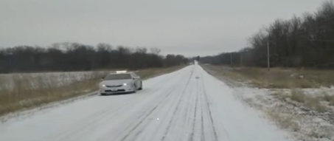
Figure 1. Confederate vehicle
Additionally, both the Transit and the confederate vehicle were instrumented with an on-board telemetry processor (Figure 2). This processor could be easily mounted inside the vehicles and needed no external user interaction. It started when the vehicle’s ignition was turned on and shut down when the engine was turned off.
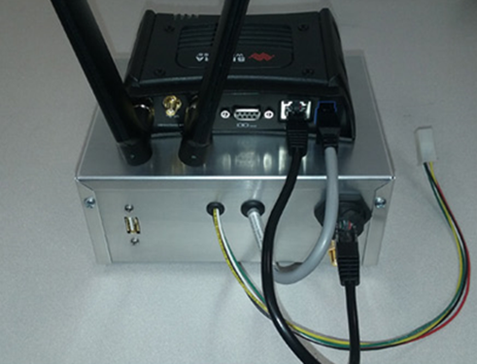
Figure 2. On-board telemetry processor
Using this processor, the vehicles connected to a cloud-based vehicle service developed in-house named Prism. When connected, the vehicles provide real-time information about their current state in terms of vehicle telemetry (position, heading, speed, lighting states, pedal/steering positions), sensor states, video, etc. As each vehicle broadcasts its positional data, the system measures the “as-the-crow-flies” distance between each known vehicle. When the vehicle comes within a given proximity radius of another, Prism begins sending the affected vehicle (i.e., the local vehicle) a list of data about vehicles within its alerting radius or the local traffic cloud (LTC) vehicles (Figure 3).
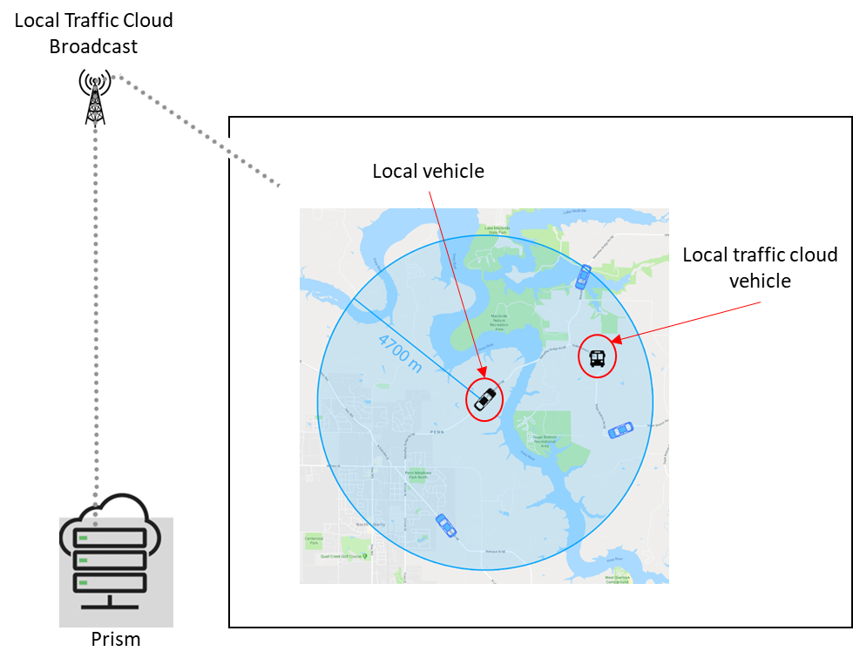
Figure 3. Local Traffic Cloud Broadcast
For each vehicle, the shortest route road distance was calculated. A “time-to-arrival” calculation was made using the calculated road distance, the speed and heading of the Transit, and the speed and heading of the “school bus” (i.e., the confederate vehicle). An alert was given to the Transit if the following conditions were met:
- The “school bus” was within 95 degrees of the heading of the Transit
- The caution lights (e.g., yellow or red flashers) were active on the “school bus”
- The “school bus” was the closest alert-worthy vehicle
- The time-to-arrival fell within the pre-determined range
If all four of the conditions were met, a visual alert was shown in the safety driver display, and an audio alert was played (Figure 4). The audio and visual alerts increased in specificity, as shown in Figure 4, as the vehicle’s time-to-arrival approached zero. The vehicle software managed the slowing of the vehicle and the distance at which it would stop.
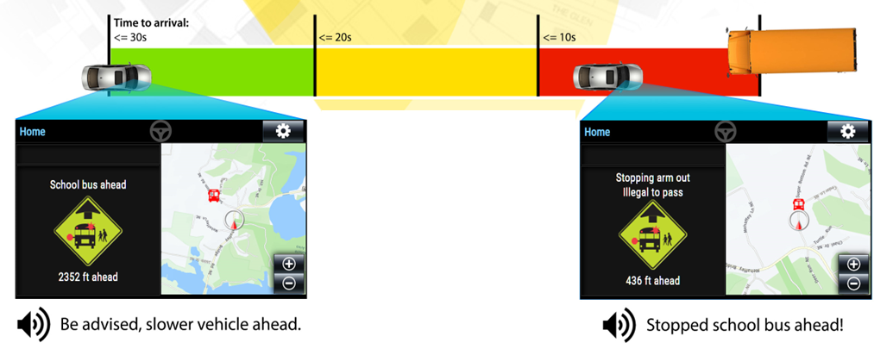
Figure 4. Stages of alerts based on time to arrival
The visual alert cleared when the “school bus” turned off its flashers or when it left the vehicle’s alerting location. The icon presented on the display faded out, the system returned to normal operation, and the Transit resumed travel. A video of the V2V interaction between the Transit and our confederate vehicle acting as a school bus can be found at this link (https://www.youtube.com/watch?v=kCu5WZDSq-M). An additional video of an interaction on our test loop shows the interaction from both the Transit and the “school bus” perspective (https://www.youtube.com/watch?v=lcRClMHznm4).
The gravel road was chosen as the location for the “school bus” encounter for a couple of reasons. First, for safety concerns as other drivers coming upon this interaction may have been confused by the demonstration. There was less of a chance of interaction with other traffic on the gravel road. Second, we chose to place the “school bus” at a point that was on the edge of the cell coverage area to test in an area that the automation might have the most difficulty with.
For five of the ten drives in this phase, the Transit encountered the confederate vehicle, and in two of those drives, it encountered it twice (Table 2). Of the seven encounters, there were difficulties with two, both occurring during the same drive. This was during Drive 60; the cellular connection for both the Transit and the “school bus” had weak connections. While the Transit did stop both times it encountered the stopped “school bus,” the cell links dropped in and out, leading the Transit to believe that the last known position and light state of the “school bus” had not changed. Because of this, the Transit remained at a stop while the “school bus” turned off its lights and resumed travel. The safety driver had to temporarily disengage automation for the Transit to proceed. In both instances, cellular connectivity resumed to normal farther down the road.
Table 2. Number and type of V2V encounters
Drive # | Encounters | Directionality
Drive 57 | 1 encounter | Oncoming lane, facing Transit
Drive 60 | 2 encounters | Same lane as Transit
Drive 61 | 1 encounter | Oncoming lane, facing Transit
Drive 64 | 1 encounter | Oncoming lane, facing Transit
Drive 65 | 2 encounters | Same lane as Transit

Automation at Intersections
Because each phase builds upon the last, we continued to drive using automation on different roadway types and through cities and towns, navigating many types of intersections: four-way stop, two-way stop, stop controlled, and traffic signal-lighted intersections. For descriptions of these intersections as well as maps showing their locations, see the Phase 3 Evaluation Report.
As always, the safety driver was prepared to take over when they felt that the automation was about to engage in an unsafe maneuver (e.g., pull out in front of oncoming traffic) or if it was taking too long to perform the maneuver and could have potentially caused another vehicle to behave in an unsafe way (e.g., drive aggressively or pass in an intersection). Automation can be intentionally disengaged by the safety driver using multiple methods, which include pressing a button on the steering wheel, taking over steering, pressing the accelerator or brake pedal, or pressing the E-stop button. It is important to note that using the automation at all of these intersections was explored and tested extensively by the safety drivers again, pre-Phase 5, after software changes were made.

Four-Way Stop Intersections
These types of intersections require that the vehicle stop before the intersection. The vehicle must stop regardless of what direction they are coming from. The vehicle must determine which vehicle arrived at the intersection first to determine right-of-way. The vehicle encounters six of these types of intersections. Figure 5 and Table 3 show where they occur along the route.
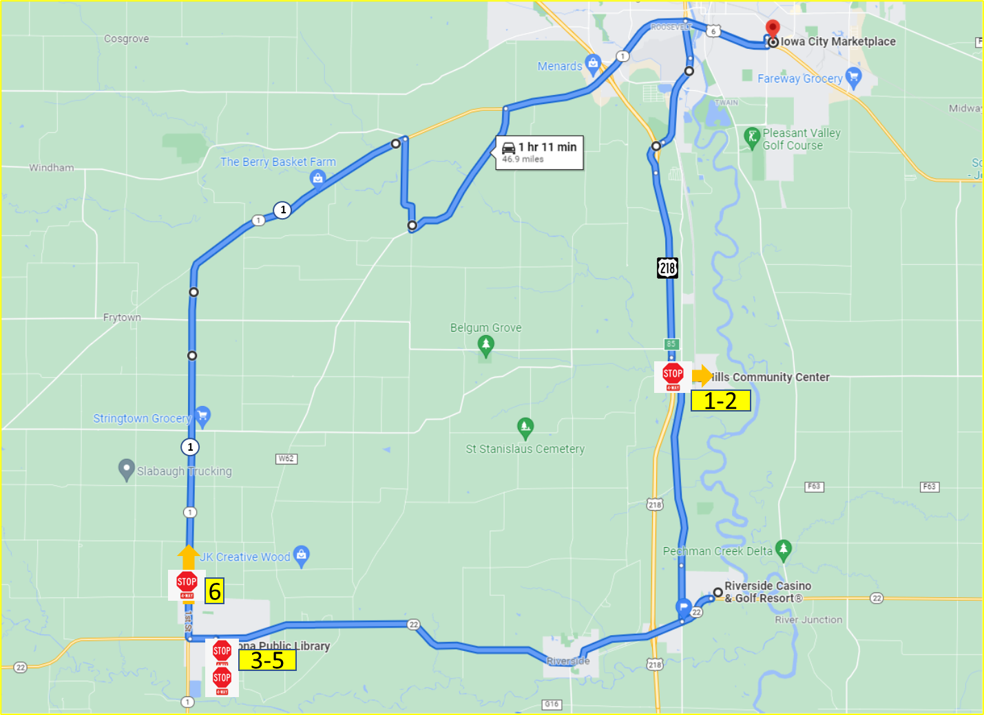Figure 5. 4-way stop intersections
Table 3. Number of 4-way stop intersections completed in automation for Phase 5
 | 4-Way Stop Intersections | Direction of Travel | Number Completed Under Automation
1 | 4-way stop in Hills (travelling east) | Straight | 8
2 | 4-way stop in Hills (travelling west) | Left | 9
3 | 4-way stop in downtown Kalona (B Ave/5th St) | Right | 10
4 | 4-way stop in downtown Kalona (5th St/C Ave) | Right | 10
5 | 4-way stop in downtown Kalona (B Ave/5th St) | Straight | 9
6 | 4-way stop on Hwy 1 | Straight | 9

A correction was made to the map for Phase 5, which improved the vehicle’s performance at the 4-way stop entering Hills from 40% completion in Phase 4 to 80% in Phase 5. Performance at the other 4-way stops along the route was similar to what we saw in the previous phase.

Two-Way Stop Intersections
These types of intersections are typically used in areas where one street has a much higher traffic volume than the street it intersects. The vehicle on the minor road is required to stop and wait for a gap in traffic on the major road before proceeding. If two vehicles are stopped, the maneuver is complicated by determining which of the stopped vehicles has the right-of-way, particularly if one of the vehicles is left turning. Figure 6 and Table 4 show the locations of the five intersections of this type along the route.

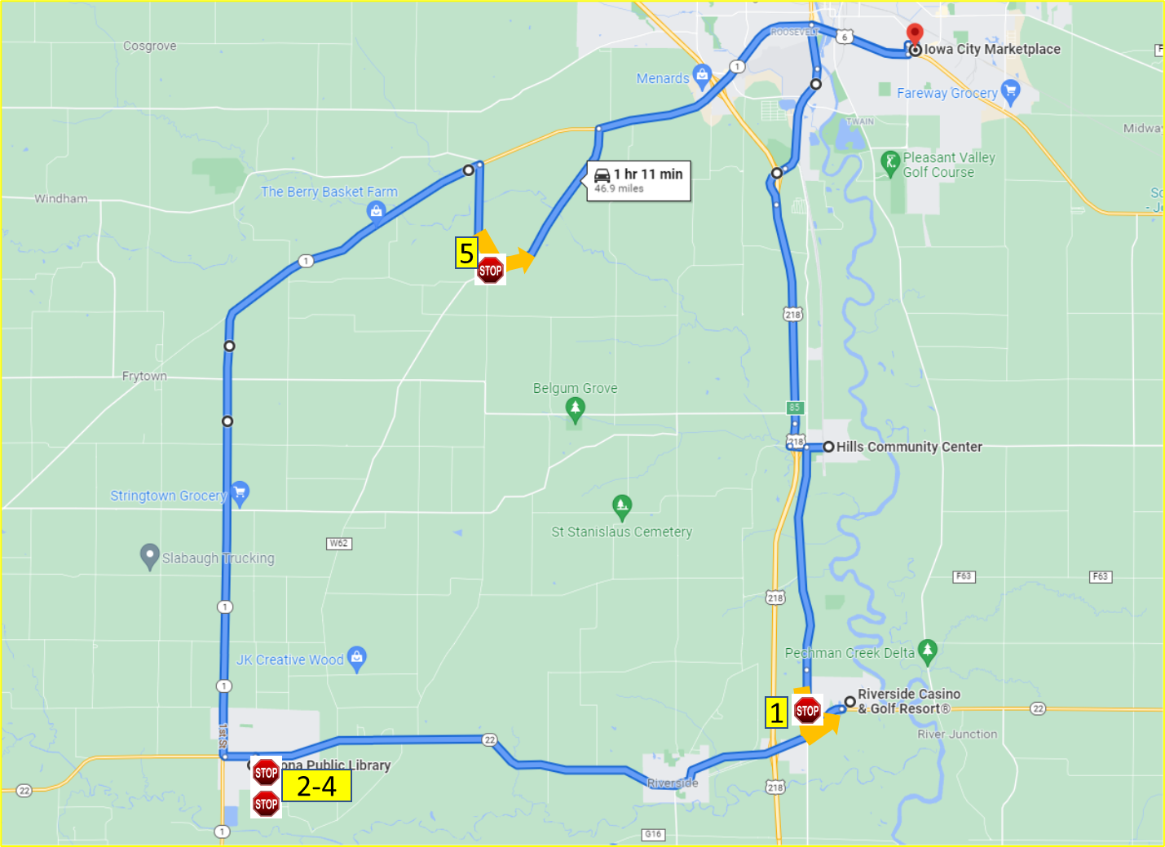Figure 6. 2-way stop intersections
Table 4. Number of 2-way stop intersections completed in automation for Phase 5
 | 2-Way Stop Intersection | Direction of Travel | Number Completed Under Automation
1 | 2-way stop onto Hwy 22 | Left | 0
2 | 2-way stop in downtown Kalona (6th St/B Ave) 1st time | Right | 10
3 | 2-way stop in downtown Kalona (C Ave/6th St) | Right | 10
4 | 2-way stop in downtown Kalona (6th St/B Ave) 2nd time | Right | 8
5 | 2-way stop from Kansas Ave to Sharon Center Rd | Left | 8

The 2-way stop at Hwy 22 is very difficult to complete in automation due to the amount of traffic present and the speed at which the other vehicles are travelling on this roadway (i.e., 55 mph). By the time that the LiDAR picks up an oncoming vehicle, there is not always enough time for the turn to be completed safely. For this phase, the safety driver did not feel comfortable allowing the vehicle to handle the intersection on its own. It is possible that the safety driver took it out of automation to stop the vehicle from pulling out when it was unsafe to do so but then engaged the automation for the vehicle to complete the turn. This was not counted as a successful completion.

Stop-Controlled Intersections
These intersections required the vehicle to come to a complete stop and yield to pedestrians crossing the street and to cross-traffic. The vehicle must ensure the intersection is clear and that it will not impede approaching traffic by entering the stop-controlled intersection. There are four intersections of this type along the route. Figure 7 and Table 5 show the location of the intersections along the route.
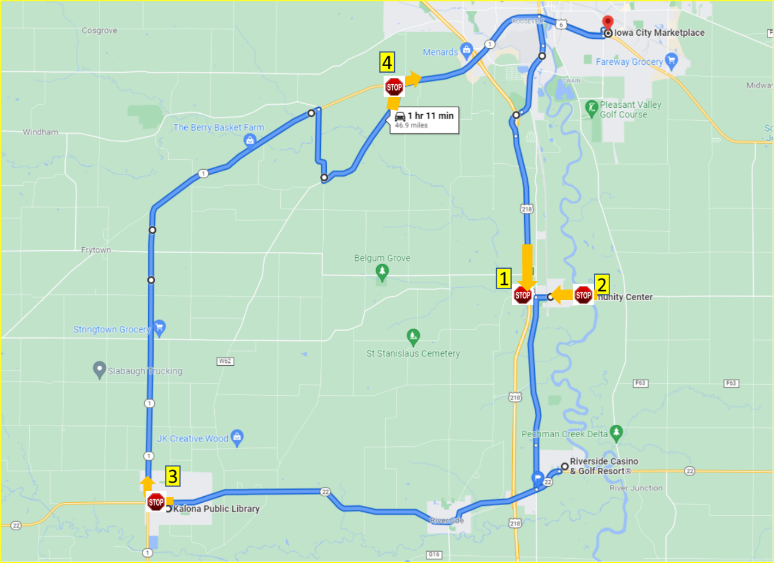
Figure 7. Stop-controlled intersections
Table 5. Number of stop-controlled intersections completed in automation for Phase 5
 | Stop-Controlled Intersections | Direction of Travel | Number Completed Under Automation
1 | Hwy 218 off-ramp to Observatory Ave | Left | 8
2 | 2nd St to Main St | Right | 10
3 | B Ave to Hwy 1 | Right | 8
4 | Sharon Center Rd to Hwy 1 | Right | 6

Yield-Controlled Intersections
This type of intersection requires the vehicle to prepare to stop and yield the right-of-way to other vehicles or pedestrians in or approaching the intersection. However, the vehicle is not required to stop if the path is clear. Therefore, the vehicle must slow to a speed at which it can stop and yield if needed. There are two intersections of this type along the route. Figure 8 and Table 6 show the location of these intersections along the route.

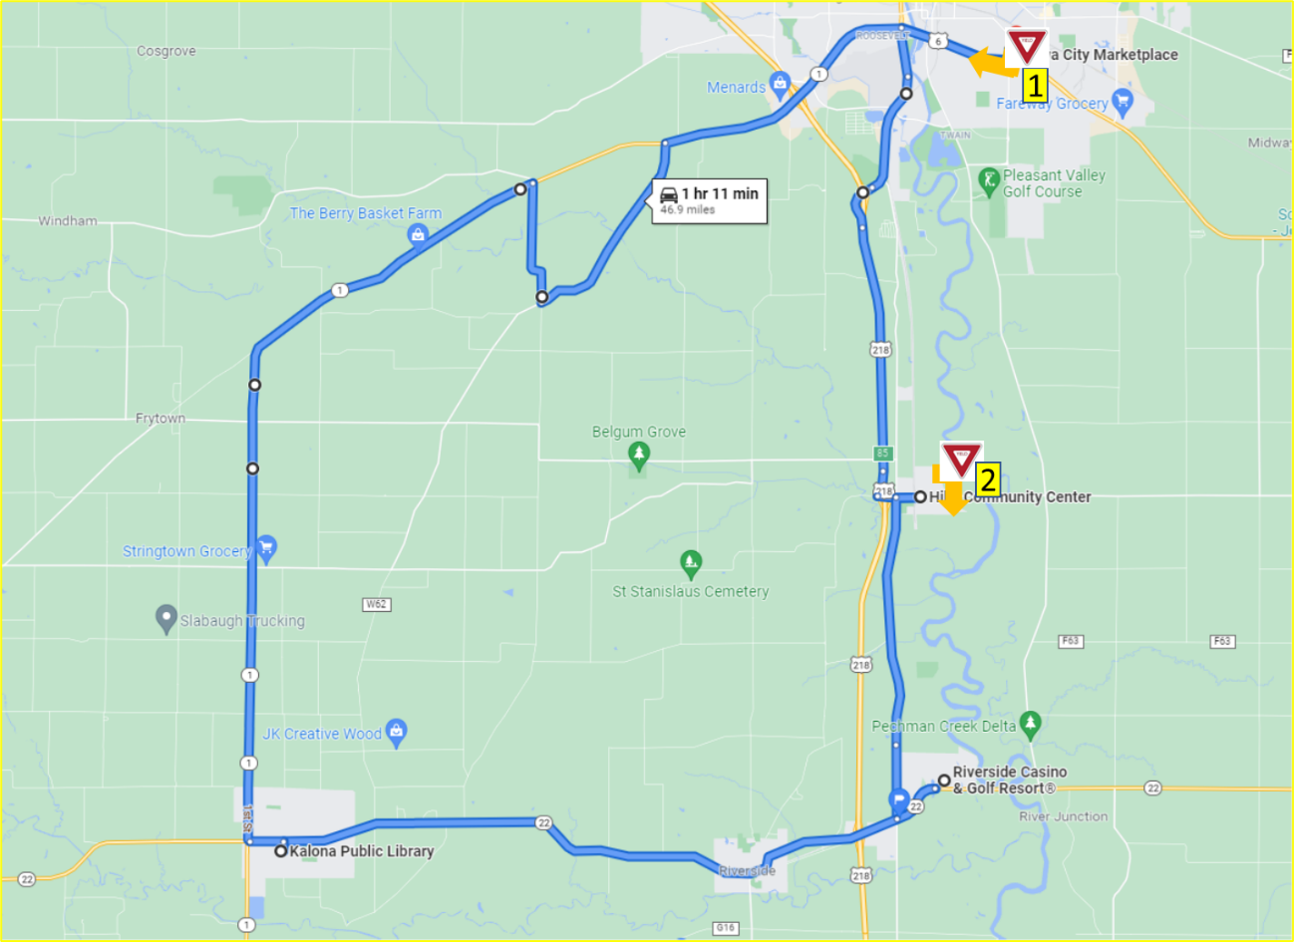
Figure 8. Yield-controlled intersections
Table 6. Number of yield-controlled intersections completed in automation for Phase 5
 | Yield-Controlled Intersections | Direction of Travel | Number Completed Under Automation
1 | S 1st Ave to Hwy 6 | Right | 7
2 | Oak St to 2nd St | Right | 10

Traffic Signals
For this demonstration we utilized a camera-based system to identify the state of the traffic signals. This allowed us to use automation to navigate all the lighted intersections along the route. Maps showing the locations and descriptions of the lighted intersections can be found in the Phase 3 Evaluation Report. A breakdown of all intersections with traffic signals along the route is shown below in Table 7, as well as the direction of travel and the number of times it was able to navigate the intersection in automation for this phase.

Table 7. Number of intersections with traffic signals the vehicle completed in automation for Phase 5
Traffic Signals in Iowa City (N=23) | Direction of Travel | Number Completed Under Automation
Hwy 1 and Naples Ave SW | Straight | 9
Hwy 1 and Hwy 218 ramps | Straight | 9
Hwy 1 and Mormon Trek Blvd | Straight | 6
Hwy 1 and Sunset St | Straight | 9
Hwy 1 and Westport Plz | Straight | 9
Hwy 1 and Ruppert Rd | Straight | 9
Hwy 1 and Miller Ave | Straight | 9
Hwy 1 and Orchard St | Straight | 9
Hwy 1 and S Riverside Dr | Straight | 7
Hwy 6 and S Gilbert St | Straight | 8
Hwy 6 and Boyrum St | Straight | 9
Hwy 6 and Keokuk St | Straight | 9
Hwy 6 and Broadway St | Straight | 8
Hwy 6 and Sycamore St | Left | 5
Iowa City Marketplace and Lower Muscatine Rd | Right | 8
Lower Muscatine Rd and S 1st Ave | Right | 8
Hwy 6 and Sycamore St | Straight | 7
Hwy 6 and Broadway St | Straight | 8
Hwy 6 and Keokuk St | Straight | 9
Hwy 6 and Boyrum St | Straight | 9
Hwy 6 and S Gilbert St | Straight | 9
Hwy 6 and S Riverside Dr | Left | 8
Old Hwy 218 S and Mormon Trek Blvd | Straight | 9
Traffic Signals in Riverside (N=2) | Direction of Travel | Number Completed Under Automation
Hwy 22 and Entering Riverside Casino | Left | 6
Exiting Riverside Casino and Hwy 22 | Right | 6
Traffic Signals in Kalona (N=1) | Direction of Travel | Number Completed Under Automation
Hwy 22 and S 6th St | Left | 7

Automation Engagement by Drive
All ten drives that were started in this phase were completed and have full data sets. Maps showing the locations that automation was engaged are shown below for Drives 57 through 66 (Figures 9 through 18). Roadways where the automation was used are shown in blue. Locations driven manually are shown in green if the safety driver took over from the automation using the button on the steering wheel and in orange if they took over by steering, braking, or accelerating. The percentage of the trip driven using automation varied from 99.5% in Drive 65 to 94.1% in Drive 60. At this point in the demonstration, the only portions of the route that are not able to be driven in automation are the parking lots, which is reflected in the remarkably high percentages of the drive that are competed in automated mode.
Start Location | Iowa City
Number of miles recorded | 48.22
Number of miles recorded in automated mode | 47.6
Percent of drive recorded in automated mode | 98.7%
Amount of data collected (GB) | 89.3
Weather conditions | Avg temp: 31(F)  Clouds: 100%  Average wind speed: 15.0 mph
Time of day | Noon
Day of week | Weekday
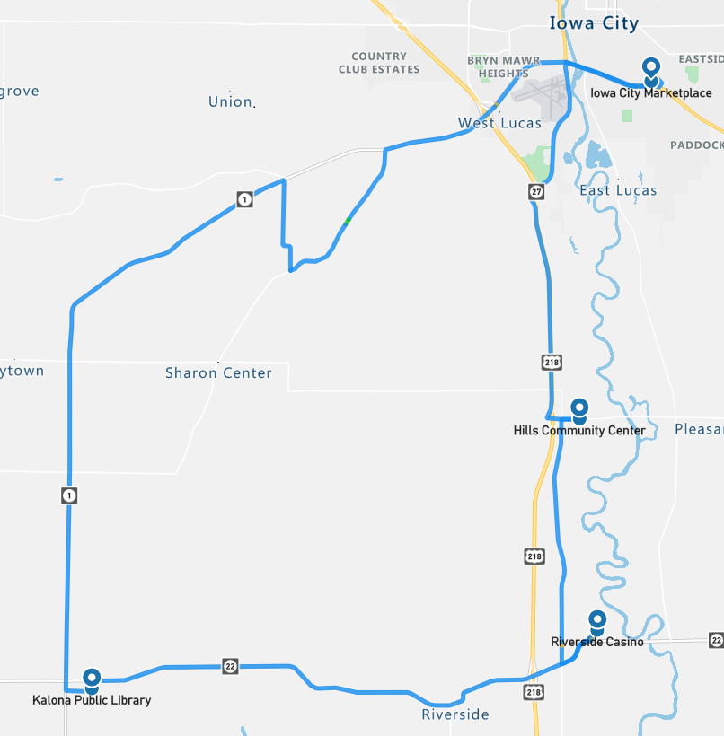
Figure 9. Drive 57 automation engagement (Jan. 5, 2023)

Start Location | Hills
Number of miles recorded | 48.16
Number of miles recorded in automated mode | 47.16
Percent of drive recorded in automated mode | 97.90%
Amount of data collected (GB) | 92.5
Weather conditions | Avg temp: 32(F)  Clear: 65%, Clouds: 35%  Average wind speed: 7.8 mph
Time of day | Mid-afternoon
Day of week | Weekday
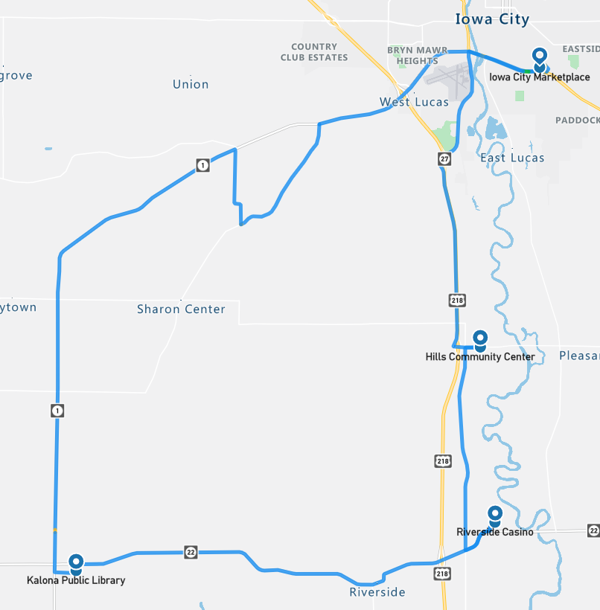Figure 10. Drive 58 automation engagement (Jan. 6, 2023)

Start Location | Riverside
Number of miles recorded | 48.16
Number of miles recorded in automated mode | 46.48
Percent of drive recorded in automated mode | 96.5%
Amount of data collected (GB) | 86.8
Weather conditions | Avg temp: 25(F)  Haze: 2%  Clear: 30%  Mist: 68%  Average wind speed: .9 mph
Time of day | Night
Day of week | Weekend
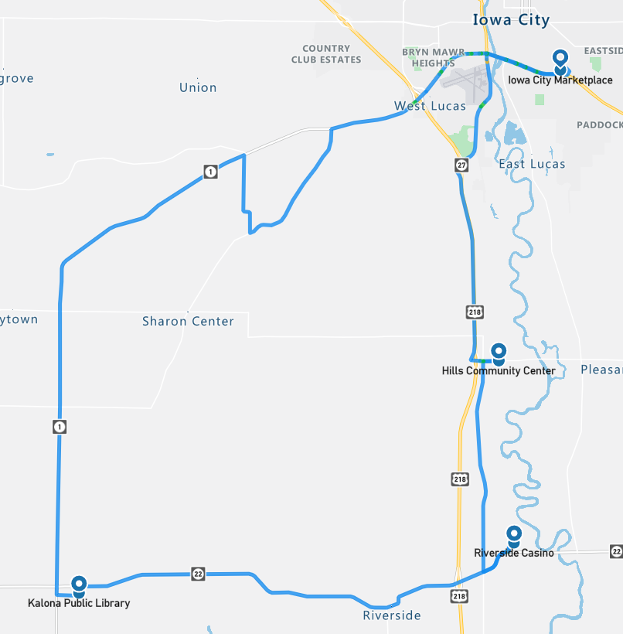Figure 11. Drive 59 automation engagement (Jan. 8, 2023)

During Drive 59, the co-pilot reported that the Transit was not registering the state of the traffic lights. Because the rest of the system appeared to be operational, the decision was made to continue the drive but to take the vehicle out of automation for the lighted intersections. After the drive, the two Spectra PCs that manage the Apollo software were checked. One showed a full system disk and an incomplete configuration file. Under normal operation, a custom script is used by the operations team to set/change the active HD map. It was determined that the disk being full on the PC that is responsible for “perception” prevented the normal map changing script from completing, corrupting the local system configuration, and preventing normal localization for perception and traffic light subsystems. The system disk was cleaned, and the configuration file restored. Testing was done on the local test loop showing that the issue was cleared, with traffic lights being detected.
Start Location | Riverside
Number of miles recorded | 48.09
Number of miles recorded in automated mode | 45.24
Percent of drive recorded in automated mode | 94.10%
Amount of data collected (GB) | 87.6
Weather conditions | Avg temp: 46(F)  Clear: 77%  Clouds: 23%  Average wind speed: 9.4 mph
Time of day | Mid-afternoon
Day of week | Weekday
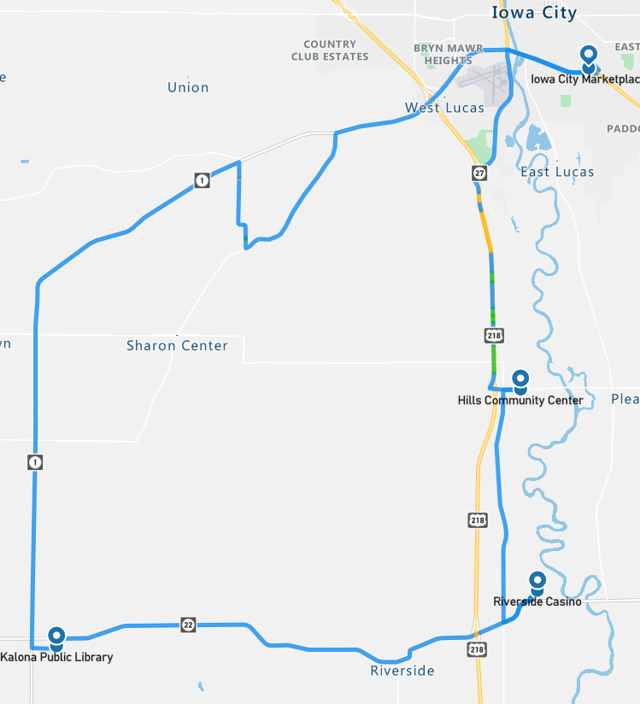
Figure 12. Drive 60 automation engagement (Jan. 11, 2023)

Start Location | Kalona
Number of miles recorded | 48.16
Number of miles recorded in automated mode | 47.53
Percent of drive recorded in automated mode | 98.7%
Amount of data collected (GB) | 83.8
Weather conditions: | Avg temp: 27(F) Clouds: 100%  Average wind speed: 11.9 mph
Time of day | Night
Day of week | Weekday
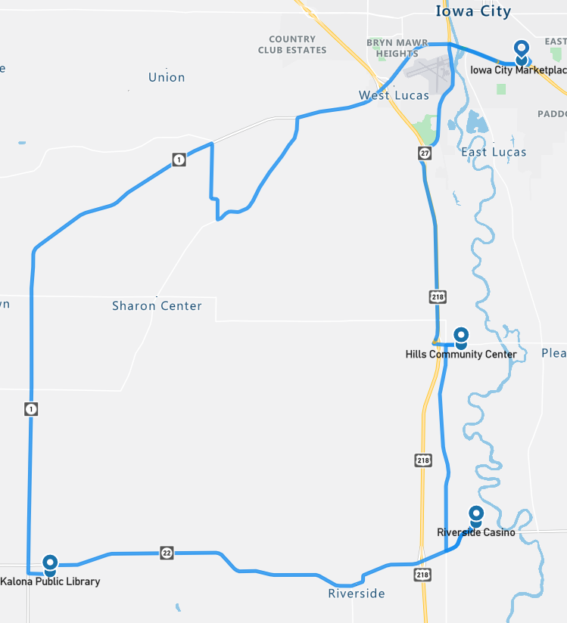Figure 13. Drive 61 automation engagement (Jan. 12, 2023)

Start Location | Hills
Number of miles recorded | 48.16
Number of miles recorded in automated mode | 47.72
Percent of drive recorded in automated mode | 99.10%
Amount of data collected (GB) | 88.0
Weather conditions | Avg temp: 29(F)  Clear: 34%  Clouds: 66%  Average wind speed: 9.2 mph
Time of day | Mid-morning
Day of week | Weekend
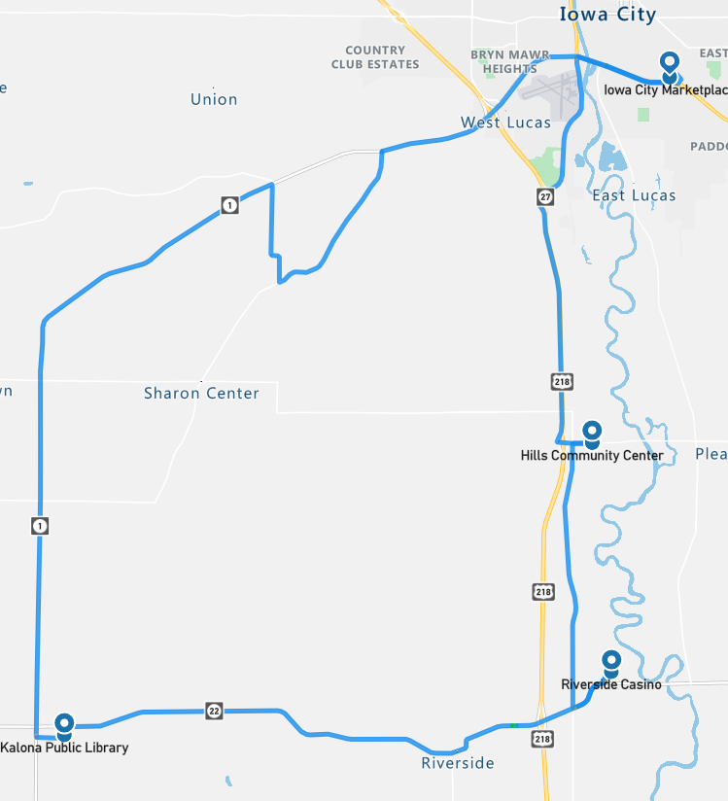Figure 14. Drive 62 automation engagement (Jan. 14, 2023)

Start Location | Iowa City
Number of miles recorded | 48.16
Number of miles recorded in automated mode | 47.53
Percent of drive recorded in automated mode | 98.70%
Amount of data collected (GB) | 84.5
Weather conditions | Avg temp: 37(F) Clouds: 100%  Average wind speed: 14.3 mph
Time of day | Dawn
Day of week | Weekday
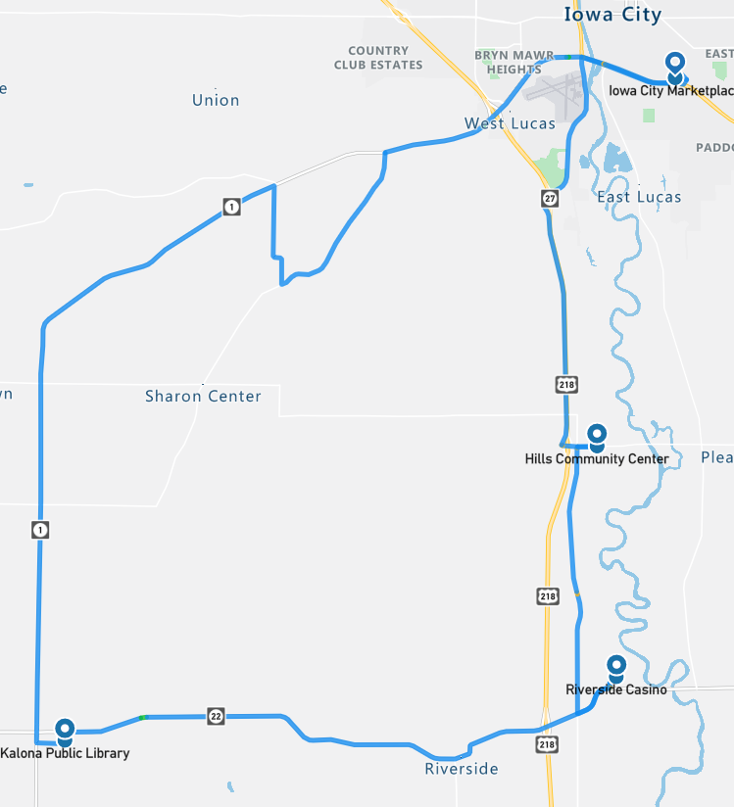Figure 15. Drive 63 automation engagement (Jan. 17, 2023)

Start Location | Hills
Number of miles recorded | 48.16
Number of miles recorded in automated mode | 47.35
Percent of drive recorded in automated mode | 98.30%
Amount of data collected (GB) | 88.7
Weather conditions | Avg temp: 37(F)  Clouds: 100%  Average wind speed: 11.4 mph
Time of day | Noon
Day of week | Weekday
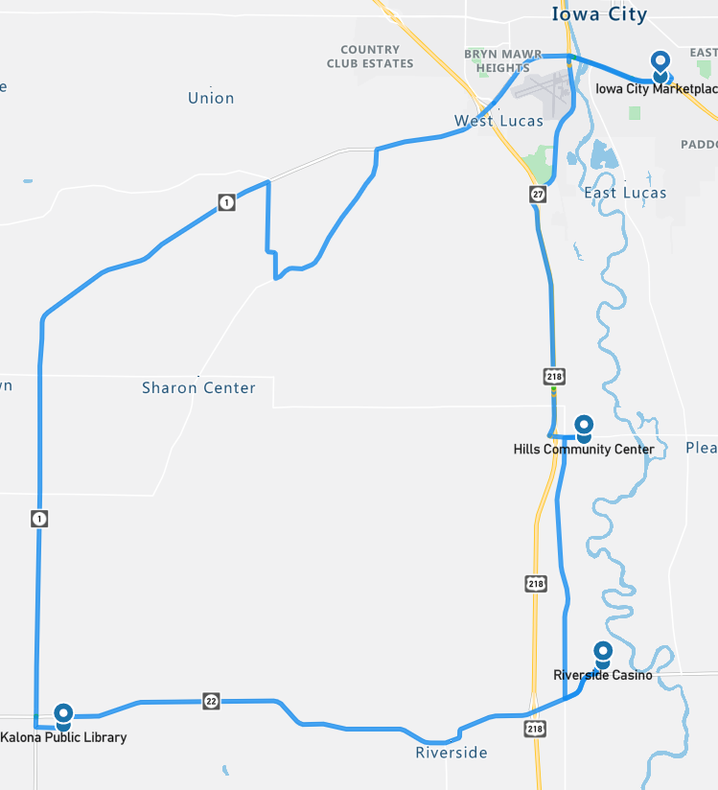Figure 16. Drive 64 automation engagement (Jan. 18, 2023)

Start Location | Kalona
Number of miles recorded | 48.16
Number of miles recorded in automated mode | 47.91
Percent of drive recorded in automated mode | 99.50%
Amount of data collected (GB) | 86.3
Weather conditions: | Avg temp: 29(F) Clear: 15%  Clouds: 85%  Average wind speed: 15.0 mph
Time of day | Dawn
Day of week | Weekday
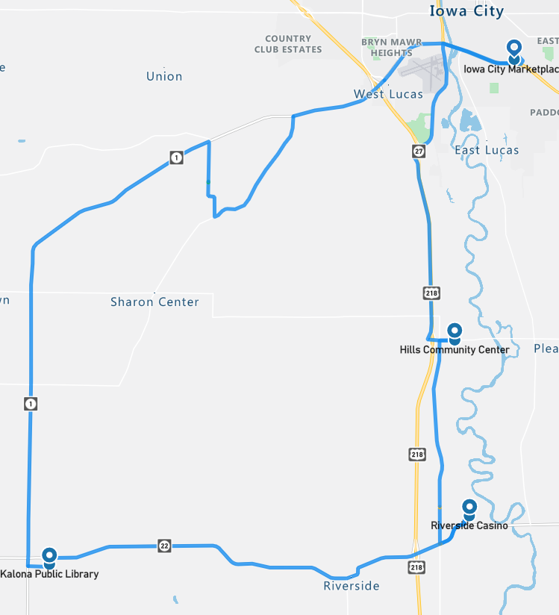Figure 17. Drive 65 automation engagement (Jan. 20, 2023)

Start Location | Iowa City
Number of miles recorded | 48.16
Number of miles recorded in automated mode | 47.35
Percent of drive recorded in automated mode | 98.30%
Amount of data collected (GB) | 85.9
Weather conditions | Avg temp: 37(F)  Mist: 19%  Clear: 60%  Clouds: 21%  Average wind speed: 5.1 mph
Time of day | Mid-morning
Day of week | Weekday
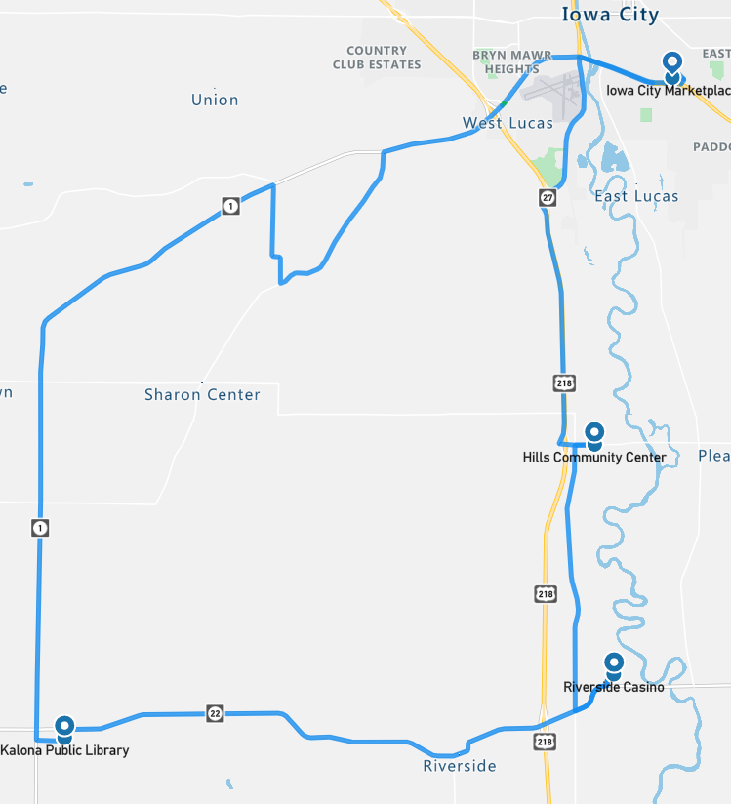Figure 18. Drive 66 automation engagement (Jan. 24, 2023)

Overall, the number of miles driven in automation by federal function classification (FFC) of road types is shown per drive below (Figure 19). For this phase, more than 90% of the miles for all road types, except for “other,” which is considered parking lots, were driven in automation (Figure 20).

Figure 19. Miles driven in automated mode by FFC road type

Figure 20. Percentage of FFC road type completed in automation (average across Phase 5)

Voluntary Takeover of the Automation
Safety drivers disengaged the automation for a variety of reasons. The preferred method of disengagement was to press the button located on the steering wheel. However, when necessary, turning the steering wheel, pressing the accelerator or brake pedal, or pressing the E-stop button may have been a more suitable and safer method. When the automation was disengaged, the copilot would flag the data using the informational display and record the reason for the disengagement using a voice recorder. There were 187 voluntary takeovers flagged by the co-pilot (Table 8).

Table 8. Frequency and type of voluntary takeovers
Reason for disengagement | Number of instances
To park | 40
To complete turn – vehicles approaching – deemed unsafe | 27
To cross railroad tracks | 21
Traffic signal not recognized | 20
To complete turn – vehicle stops in middle of intersection | 11
Unsafe lane change | 9
Abrupt braking – vehicle cut-in | 5
Another vehicle behaves unsafely | 5
To stop at a traffic signal | 5
Inappropriate response at traffic light | 4
To make a right/left turn | 4
To proceed through flashing yellow | 4
Automation failed for unknown reason | 4
Parked vehicle in lane | 3
To avoid crossing center line when make a right turn | 3
VRU | 3
Abrupt braking – unknown reason | 2
Crosses the centerline | 2
To go through 4-way stop – too much traffic – deemed unsafe | 2
To slow/stop for traffic ahead | 2
Vehicle indecision at yellow light | 2
Cell issues during V2V interactions | 2
A vehicle passing the Transit | 1
Map crossover issue | 1
Oncoming traffic is in our lane of travel | 1
To avoid an object on the roadway | 1
To make a right turn on red | 1
To make a left turn at flashing red light | 1
Other | 1

The largest percentage of the voluntary takeovers (34%) happened because the vehicle’s automation has difficulty with specific traffic situations at intersections or responding either appropriately or in a timely enough manner at traffic signals.
- Some disengagements were due to the vehicle starting to make a turn with traffic approaching from the right or left at a high speed (14%). The safety driver was tasked with making the call as to whether intervention was necessary and had to take into consideration the tentativeness of the Transit with respect to the distance and speed of the approaching traffic.
- Takeovers also occurred when the vehicle stopped in the middle of an intersection (6%). It is possible that, if left long enough, the vehicle would have eventually made its way through the intersection. However, this was considered unsafe, and the vehicle was taken out of automation so that the safety driver could complete the turn without negatively impacting the surrounding traffic.
- There were several instances when the automation did not correctly recognize the state of the traffic signal (e.g., started to move when the light was red or failed to stop at a yellow or red light). In some of these instances, the vehicle may have been picking up the incorrect signal, one to the right or left of the signal for the vehicle’s lane of travel. These instances required immediate takeover from the safety driver.

In this phase, there were twenty disengagements due to the Transit not registering the state of the traffic light. These all happened during Drive 59 and were due to an overloaded system disk, which prevented the map changing script from completing and prevented traffic lights from being detected. Once the safety driver realized that the automation was not “seeing” the lights, they took the Transit out of automation when approaching lighted intersections. These disengagements accounted for 11 percent of the voluntary takeovers for this phase.

When compared to other phases, we saw a larger number of disengagements due to other vehicles behaving unsafely. These included the following five situations:
- A vehicle backed out of a parking space in front of shuttle. This happened twice during Phase 5 in downtown Kalona.
- A vehicle pulled out in front of the shuttle at an intersection. The forward collision warning system was activated (see section on “Safety Critical Events” page 21 for more details).
- A vehicle illegally passed the Transit on the on-ramp.
- A vehicle passed the Transit on a narrow bridge.

Traveling through parking lots or having the vehicle park itself is not something that the automation is capable of handling yet. We will attempt this in Phase 6 of the project (Table 1). Therefore, when parking lots were approached or the vehicle was being parked at specific destinations, the system was disengaged. These disengagements accounted for 21% of the total number.

The urban section of roadway on U.S. Hwy 6 required the driver to make two lane changes, one traveling east and one west. Completing lane changes in automation was oftentimes not possible due to the amount of surrounding traffic or the speed of traffic approaching from behind in the left lane. In these instances, the safety driver would take over and complete the lane change manually, before re-engaging the automation. Five percent of the disengagements occurred due to failed lane change attempts.

Forced Takeover of the Automation
Situations where the automated driving system (ADS) disengages on its own or becomes unavailable and requires the driver to intervene are called forced takeovers. There were four instances of this type of takeover during Phase 5: three occurred at different locations on Vine Avenue (Figure 21) and one that occurred on State Hwy 1 (Figure 22). In each of these instances the driver was warned with an auditory beep. In the previous phase, this type of failure happened once on Vine Ave (see the Phase 4 report for additional details). It was hypothesized that the failure may be due to electromagnetic interference with the PACMod system. Therefore, the PACMod was wrapped with materials to shield the internal electronics from electromagnetic interference, and this type of unexpected disengagement did not happen for the remainder of Phase 4. However, the return of this failure in Phase 5 means that interference was likely not the cause and the reason for these forced takeovers is still under investigation.
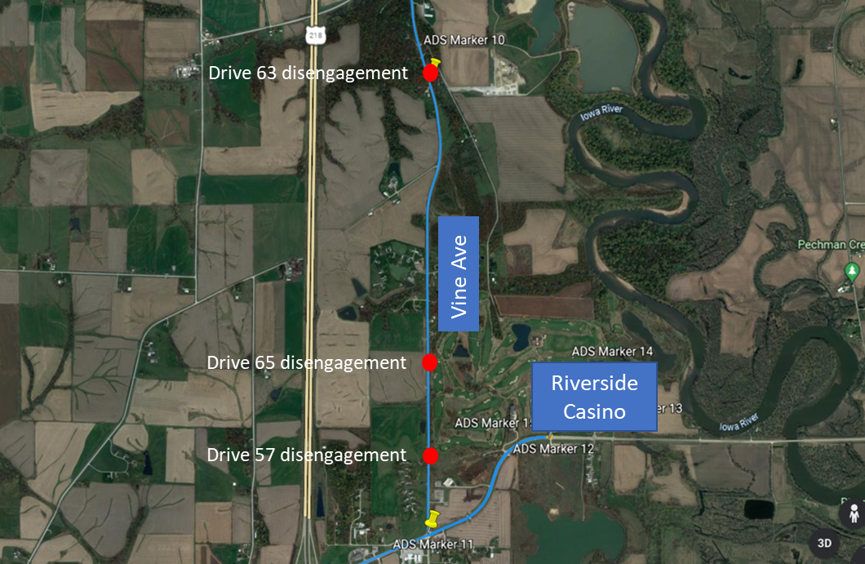
Figure 21. Forced takeovers on Vine Ave
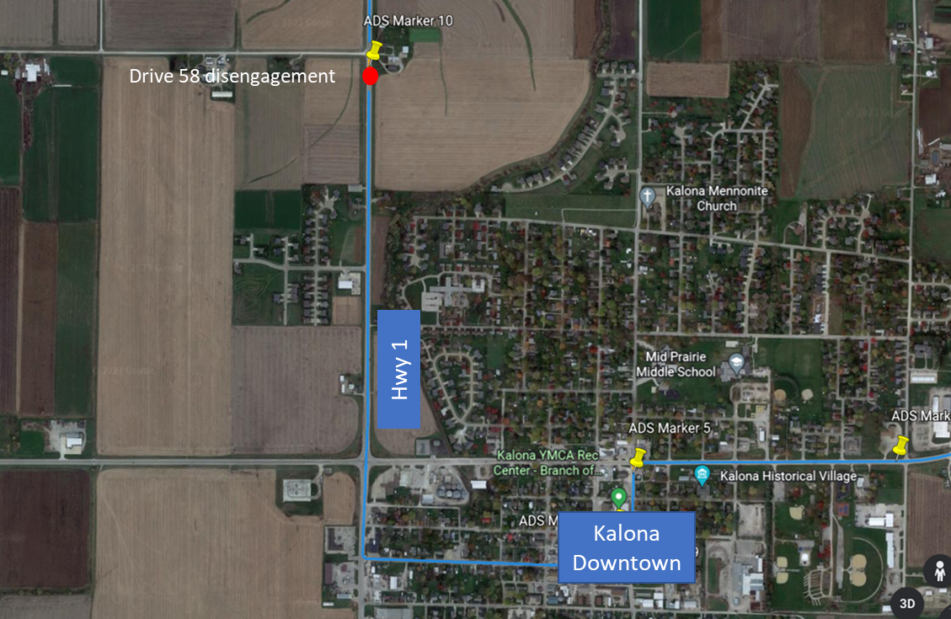
Figure 22. Forced takeover on Hwy 1

Encounters with Vulnerable Road Users (VRUs)
Flags were placed in the data to identify interactions with vulnerable road users (e.g., horse and buggies, ATVs, bicycles, pedestrians) located either within the lane boundary or on the shoulder on either side of the road. There were 52 interactions while the vehicle was traveling in automation and 11 while the vehicle was being driven manually (Table 9).
Table 9. Encounters with VRUs in automated and manual mode
In Automated Mode | In Manual Mode
- 23 pedestrian  - 10 horse and buggy  - 7 other  - 5 bicycle  - 4 farm equipment  - 2 police/emergency  - 1 ATV/golf cart | - 7 pedestrian  - 1 object in roadway  - 2 VRUs
Identifying where these interactions occur allows a comparison between how these situations are handled by the driver in manual mode and how the automation handles them. Another important reason for identifying the VRU encounters is to be able to investigate how the perception module classifies these objects.

Safety Critical Events
These events include interactions that require abrupt accelerations/decelerations or large steering wheel reversals by the automated vehicle (AV), the safety driver, or another vehicle and may or may not be classified as a near crash. Crashes are also included in this category. There were two safety critical events recorded during Phase 5. The first safety critical event occurred during Drive 60 (Figure 23). After leaving the Riverside Casino and heading west on State Hwy 22, a vehicle that had been stopped at the stop sign at the intersection of the Hwy 218 off ramp and Hwy 22 pulled out to head west in front of the Transit. The forward collision warning, part of the Mobileye system, was activated, and the safety driver was required to brake hard to avoid a collision.
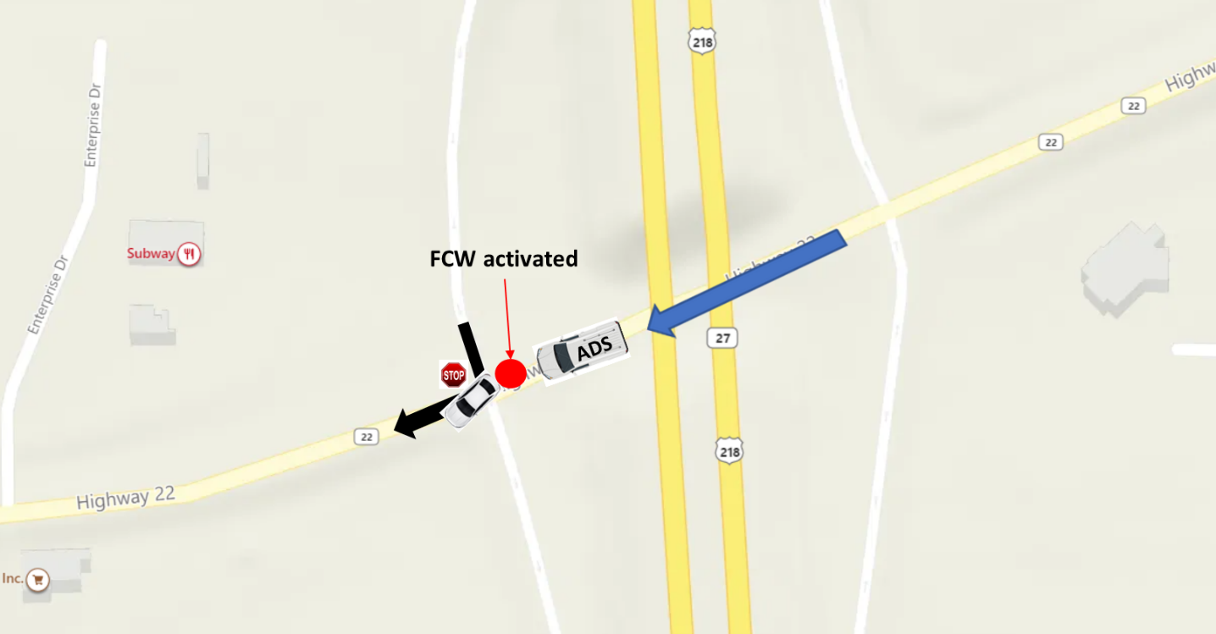
Figure 23. Drive 60 safety critical event with forward collision warning (FCW) activation
The second safety critical event occurred during Drive 63 (Figure 24). The Transit was traveling 50 mph heading east on Hwy 1 coming into the Iowa City area. There was a semi stopped at the red light at the intersection of Hwy 1 and Naples Ave SW. The FCW system went off when the vehicle failed to slow, and the safety driver was required to brake hard to avoid a rear end collision. There are two potential conditions that, either individually or combined, may have led to this event. First, the high profile of the semi most likely obscured the traffic head. And second, because of the higher speed at which the Transit was travelling, the LiDAR perceived the semi later and thus there was less time or distance to achieve the necessary braking to stop smoothly behind the semi.
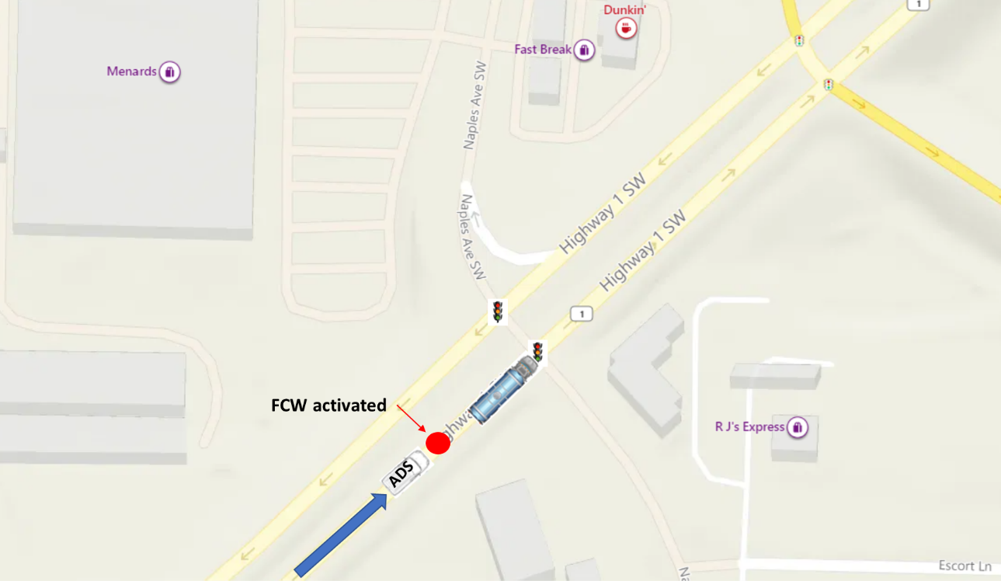
Figure 24. Drive 63 safety critical event with forward collision warning activation

Occupants for Phase 5

Demographics
Nineteen adults over age 65 and those over 25 with mobility or visual impairments were recruited to ride the vehicle. Table 10 provides the demographic breakdown by age, gender, and impairment. No one reported using a wheelchair, and one reported using a walker, cane, or crutches; one reported having difficulty walking or climbing stairs. None of the occupants have a low vision impairment (i.e., visual acuity less than 20/70). Fifty-three percent (10 out of 19) have some type of visual restriction on their driver’s license (glasses or corrective lenses). However, these restrictions are not severe enough to cause these occupants to be considered visually impaired. And 16% (3/19) reported having difficulty hearing.
Table 10. Demographics of occupants
Age | Unimpaired |  | Mobility Impaired |  | Visually Impaired |  | Hearing Impaired
 | Male | Female | Male | Female | Male | Female | Male | Female
25-34
35-44
45-54
55-64
65-74 | 8 | 6 | 1 | 1 |  |  | 1
75-84 | 2 | 1 |  |  |  |  | 1 | 1
85-94
95+
Total | 10 | 7 | 1 | 1

The sample is highly educated, with 89% of occupants having some education beyond a high school degree, and 84% (16 out of the 19 who responded) have a household income greater than $50,000. All occupants own or have access to a vehicle. Typically, occupants drive themselves where they need to go with 53% reporting driving themselves daily and 42% driving themselves a few times a week. All occupants have a valid driver’s license.
Forty-seven percent of the occupants in Phase 5 own or have access to a vehicle that has either adaptive cruise control (ACC) and/or lane keeping/lane centering. About 78% of those with ACC and about 75% with lane keeping reported using it often or frequently. A majority (79%) also reported that when it comes to trying new technology, they generally fall in the middle (e.g., not the first or last to try). About 89% reported owning or using a smart phone. Ninety-five percent reported that they own a desktop or laptop computer, and 89% reported having access to the internet. A majority, 74%, reported that they use some form of social media, and 74% own or use a tablet. Occupants agreed that they like to use technology to make tasks easier (79%) but were more split regarding whether they wanted a car with all the latest technology features (21% disagree vs. 47% agree).

Survey Data
Occupants were asked to complete both a pre- and post-drive survey regarding their trust and acceptance of highly automated vehicles. This type of vehicle was defined as one that is “capable of driving on its own in some situations but is aware of its limitations and calls for the driver to take over when necessary.” When asked to indicate how they felt about different statements, a greater percentage of occupants after their ride in the vehicle “somewhat or strongly agreed” that they could trust highly automated vehicles (42% pre-drive vs. 68% post-drive, Figure 25) and believed that they were reliable (58% pre-drive vs. 89% post-drive, Figure 26).

Figure 25. Trust in highly automated vehicles, pre- and post-drive

Figure 26. Reliability of highly automated vehicles, pre- and post-drive
There was a slight difference pre- and post-drive in the percentage of occupants who reported being afraid to ride in a highly automated vehicle. Eighty-four percent pre-drive vs 89% post-drive disagreed with the statement “I am afraid…” (Figure 27). Those who agreed that they were not worried about riding in a highly automated vehicle increased from 74 % pre-drive to 84% post-drive (Figure 28). Additionally, after riding in the vehicle, a higher percentage of occupants reported that they believed that automated vehicles are safer than manually driven vehicles (42% pre-drive vs 48% post-drive, Figure 29).

Figure 27. Afraid to ride in a highly automated vehicle, pre- and post-drive

Figure 28. Worried about riding in a highly automated vehicle, pre- and post-drive

Figure 29. AVs safer than manual vehicles, pre- and post-drive
In Phase 5, automation was used to drive on all the different types of roadways along the route. As has been the case throughout the project, the safety driver used the automation whenever they deemed it safe to do so. These results examine the riders’ trust in the automation to drive on these roadways both before and after they had the chance to experience it.
The percentage of occupants who indicated that they agreed either “strongly” or “somewhat” that they would trust a highly automated vehicle on the interstate or highway after the drive was complete, increased with exposure (74% pre-drive vs. 89% post-drive, Figure 30).

Figure 30. Trust of highly automated vehicle to drive on interstate/highway pre- and post-drive
Trust in the ability of the vehicle to drive in automation on city streets increased from 63% pre-drive to 74% post-drive (Figure 31). Trust in the automation’s ability to respond to traffic lights/signs started off surprisingly high (89% pre-drive) and did not change significantly after the drive (84% post-drive) (Figure 32).

Figure 31. Trust of highly automated vehicle to drive on city streets

Figure 32. Trust of highly automated vehicle to respond to traffic lights/signs
The greatest change in trust was seen for the gravel road portion of the route. Thirty-seven percent of occupants agreed either “strongly” or “somewhat” that they would trust a highly automated vehicle on gravel roadways pre-drive. However, post-drive, after experiencing the Transit drive nearly 100% of the gravel roadway in automation, that percentage doubled to 79% (Figure 33).

Figure 33. Trust of highly automated vehicle to drive on gravel roads
Occupants were also asked questions about perceived usefulness and their intention to use highly automated vehicles. When asked to report whether they were “open to the idea of riding in a highly automated vehicle,” 100% of occupants before and 95% after the ride indicated that they somewhat or strongly agreed with the statement (Figure 34).

Figure 34. Openness to riding in a highly automated vehicle
When asked whether they thought highly automated vehicles would allow them to stay more involved in their communities, there were no real differences between how they felt pre- and post-drive (64% pre-drive vs. 63% post-drive.

Biometric Data
A medical grade wearable device was worn by each of the occupants as well as the safety driver for each of the ten drives. The device has a sensor which measures blood volume pulse (BVP), from which heart rate variability can be derived, as well as a sensor that measures the constantly fluctuating changes in certain electrical properties of the skin (galvanic skin response or GSR). Ten minutes of baseline data was collected before the start of each drive.

Heart Rate Variability (HRV)
Heart rate variability is said to indicate physiological stress or arousal, with increased stress being indicated by a low HRV.

Galvanic Skin Response (GSR)
Increases in GSR activity can indicate stress/anxiety as well as other emotions such as anger, disgust, fear, happiness, surprise, and extreme sadness.
This data was not analyzed for this summary report; however, it will be available in its raw form through the data access portal.

Anxiety Ratings
Occupants were also asked to provide a rating of their anxiety level from 0 to 10, with 0 being “not at all anxious.” These ratings were given at nine specific locations along the drive and were the same for each participant, although they did vary in the order they were given depending on the starting location for the drive. Figure 35 is a map showing where each of these ratings occur along the drive. A pre-drive anxiety rating was obtained for everyone before the drive began. Rating locations included the following:
- Hwy 6 in Iowa City
- After merge onto Hwy 218
- After turn onto Hwy 22
- Business district of Riverside
- Downton Kalona
- Hwy 1 rural
- Gravel road
- Unmarked blacktop road
- Hwy 1 intersection
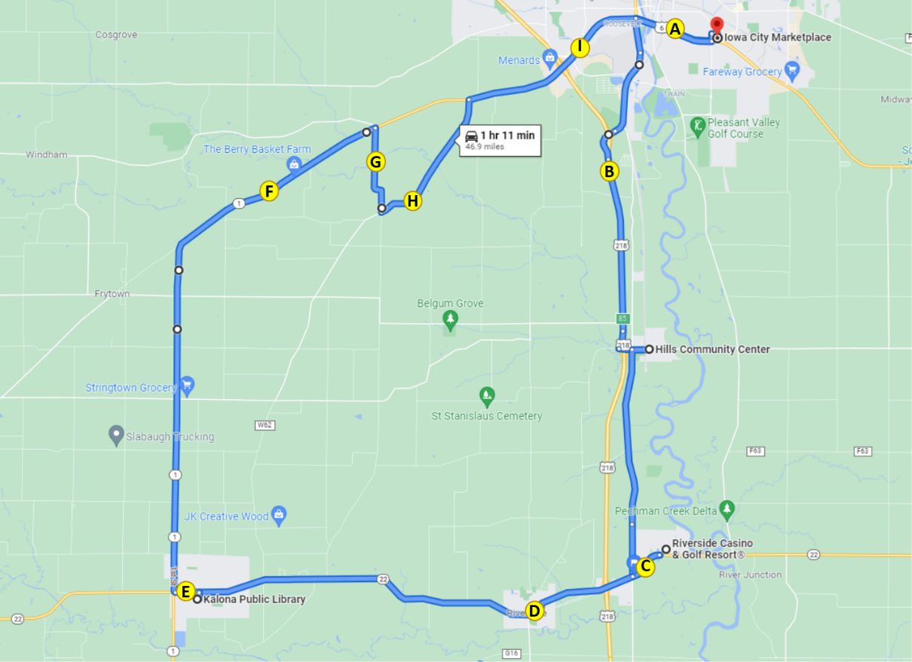
Figure 35. Map indicating locations of anxiety ratings
The average ratings of anxiety across the drive for each participant ranged from 0 to 2.9 with an average across all participants of 0.4 (Figure 36). The location with the highest average ratings of anxiety was after the turn onto Hwy 22 (0.47). However, this rating was identical to the average baseline rating of anxiety that was given pre-drive. All other ratings given throughout the drive were lower than the baseline or pre-drive rating (Figure 37).
Figure 36. Average ratings of anxiety by occupant
Figure 37. Average ratings of anxiety by location on route
Anxiety ratings were also examined for each occupant based on time of day and starting location; there were no adverse weather conditions for this phase (Figure 38). Environmental conditions such as driving at night may have impacted anxiety ratings. On average, males rated their anxiety higher than females (0.5 vs. 0.2, respectively). This could be because more males rode at night. The average rating of anxiety for the night drives was 1.0, over twice the average baseline rating (0.47).

Figure 38. Average anxiety rating by occupant, starting location, and environmental conditions (H = Hills; IC = Iowa City; K = Kalona; R = Riverside)
It is important to remember that things like surrounding traffic and weather conditions may affect these ratings. Also, we are only looking at the data from this phase, which includes a small number of drives and riders. Therefore, additional analyses are needed at the end of the project, taking into account all of the variables that could impact anxiety.

Safety Drivers
There were three dedicated safety drivers for Phase 5. All three drivers are staff at the University of Iowa and have completed our safety driver training. Driver 1 drove four of the 10 drives, Driver 2 drove three, and the third driver, Driver 4, drove three. Each was asked to complete a post-drive survey immediately following their drive. These questions were related to their comfort using the automation at different points along the route or during certain environmental conditions.
Results of the survey showed that, for the most part, the drivers were comfortable using the automation on all of the different types of roadways. For 80% of the drives on the freeway, the drivers either somewhat or strongly agreed they were comfortable (Figure 39) and 90% of the drives on the roads through the city and on the gravel (Figures 40 and 41). Additionally, there were two drives completed at night. The safety drivers—there were two different ones—somewhat agreed that they were comfortable driving under nighttime conditions.

Figure 39. Safety driver perception of automation while driving on the freeway/highway

Figure 40. Safety driver perception of automation while driving on urban roadways through cities/towns

Figure 41. Safety driver perception of automation while driving on gravel roads
The safety drivers were also asked to indicate how concerned they were about different issues related to highly automated vehicles. Results showed that they were most concerned about the system being confused by unexpected situations and the ability of the system to drive as well as a human driver (Table 11).
Table 11. Safety driver concerns regarding the automation
How concerned are you about the safety consequences of equipment or system failure? | Percent of drives
Not at all concerned | 10%
Slightly concerned | 90%
Extremely concerned | 0%
How concerned are you about the vehicle's ability to interact with non-self-driving vehicles? | Percent of drives
Not at all concerned | 0%
Slightly concerned | 90%
Extremely concerned | 10%
How concerned are you about the vehicle's ability to interact with pedestrians and cyclists? | Percent of drives
Not at all concerned | 20%
Slightly concerned | 80%
Extremely concerned | 0%
How concerned are you about the system's performance in poor weather? | Percent of drives
Not at all concerned | 50%
Slightly concerned | 50%
Extremely concerned | 0%
How concerned are you about the system being confused by unexpected situations? | Percent of drives
Not at all concerned | 0%
Slightly concerned | 70%
Extremely concerned | 30%
How concerned are you about the system not driving as well as human drivers? | Percent of drives
Not at all concerned | 10%
Slightly concerned | 70%
Extremely concerned | 20%

Phase 5 Summary
A substantial portion of the route during this phase was able to be driven in automated mode, greater than 95%. This was possible because the entire route—except for the parking areas—now has the potential to be driven in automation.
Data of specific interest for Phase 5 included the interactions with slow/stopped vehicles along the route using V2V communications. For five of the seven interactions with our confederate vehicle acting as a stopped school bus, the automation was able to respond appropriately. The success of this interaction greatly depended on the ability of the vehicles to communicate using cellular connection. Therefore, before the start of the phase, testing was done to examine the strength of the signal along our route. Information was gathered regarding the 5G coverage along our route for both T-Mobile and Verizon (Table 12).
Table 12. Signal strength by location along the ADS route
 | Download Speed (Mbps) |  | Upload Speed (Mbps)
 | Verizon | T-Mobile | Verizon | T-Mobile
DSRI | 6.5 | 79.3 | 7.6 | 3.5
Hills | 9.9 | 22.8 | 5.34 | 10.6
Riverside | 3.5 | 59.9 | 1.1 | 30.6
Kalona | 7.7 | 240.3 | 1.1 | 11.8
ICMP | 8.5 | 232.2 | 5 | 14.2

In order to get the best possible cellular performance along our route for this phase, we chose to switch our coverage to T-Mobile. A nationwide map of their coverage can be found at https://www.t-mobile.com/coverage/coverage-map?icid=MGPO_TMO_P_5GNETWORK_1Q1203I5JTEV42AG30718 and is shown for the location along route in Figure 42.
We should note that 5G wasn’t a necessity for this phase. There are many places along the route where 5G is not an option and the signal will revert to 4G. However, our existing cellular modem wasn’t supported by T-Mobile, and 5G and 4G plans are essentially the same cost. Given that we were already investing in a new modem, it made sense to purchase one with 5G capabilities. One advantage of the 5G it that we were able to reliably send large amounts of data to/from the Transit while traversing 5G-equipped areas.

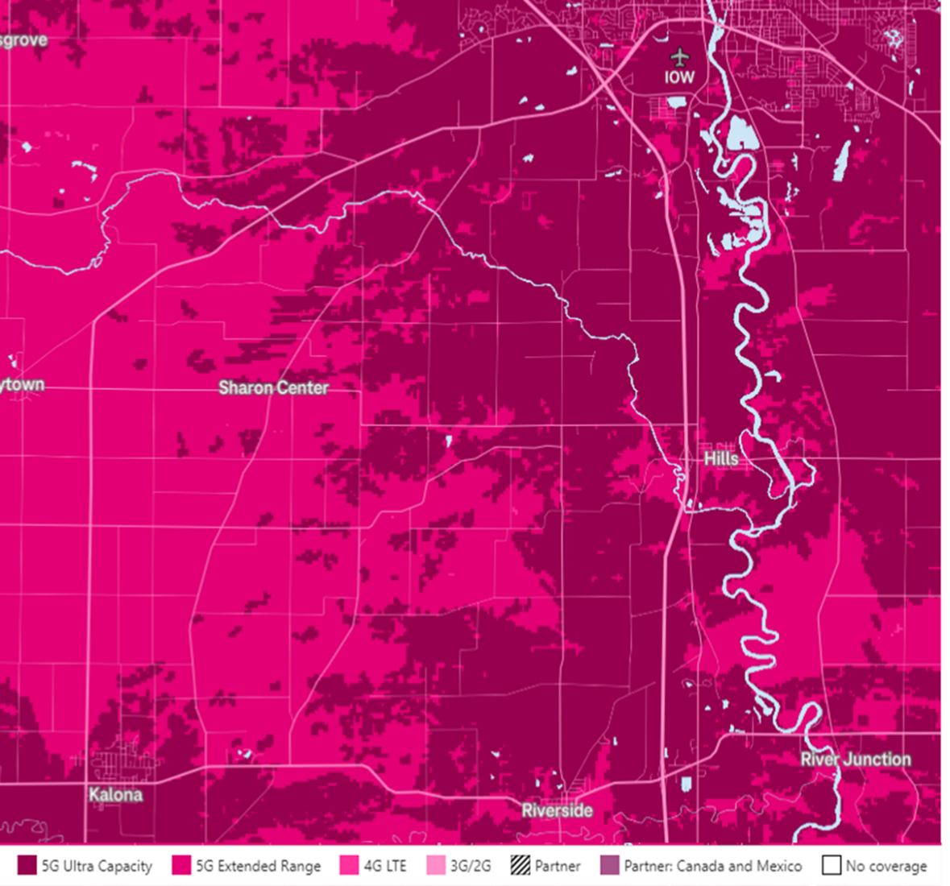
Figure 42. Cellular coverage along the ADS route using T-Mobile
It is important to note that even though we spent time optimizing our cellular provider to get the best possible cellular performance along our route, we chose to place the V2V vehicle at a point where the coverage was weaker to test the system
As discussed previously in this report, there were two instances where cellular services dropped out. This resulted in leading the Transit to believe that the last known position and light state of the “school bus” had not changed. Because of this, the Transit remained at a stop while the “school bus” turned off its lights and resumed travel. The safety driver had to temporarily disengage automation in order for the Transit to proceed. In both instances, cellular connectivity resumed to normal farther down the road.
It is important to note that a great deal of testing was done with the confederate vehicle and identifying the safest locations for this V2V testing to take place, as well as identifying the correct distances for the Transit to begin slowing and to stop relative to the location of the “school bus.”

Forced Takeovers
During safety driver testing leading up to Phase 5, there was one instance of the vehicle drifting out of its lane without any indication to the driver that an Apollo module had failed. To mitigate this, the system’s health from a software perspective is now monitored, and an audible warning prompt is given if the delay for the Localization or Perception modules is over 1.5 seconds. During Phase 5, there were four occasions where this alert was necessary. The driver was able to takeover before any lane drift or reduction in speed occurred, and automation was reengaged when it was deemed safe. The reason for the system failure was originally thought to be atmospheric interference; however, that has been ruled out as the cause and the issue is still under investigation.

Apollo and Route Options at Intersections
There is still an issue with the Transit wanting to turn right at the intersection of Main St and Oakcrest Hill Rd SE when entering Hills. During Phase 4, the route was split into four segments, requiring the co-pilot to select the appropriate route at each of the four stops. After much testing, we discovered that the reason for the confusion at this intersection is due to the Transit not “touching” a lane change waypoint much earlier in the route on S Riverside Dr. When this occurs, it will try to navigate its way back around the loop to “touch” this waypoint.

Accomplishments for Phase 5
The following improvements were made to the ADS in Phase 5:
- The field-of-view (FOV) settings of Velodyne side LiDARs were found to negatively affect perception, causing vehicles on the side to grow to a point at which they were almost hitting the Transit, causing the Transit to shift sideways in the lane unnecessarily.
Example: As the Transit drove next to the parked vehicle(s) on Main St entering downtown Kalona, the detection shifted from the Velodyne LiDAR (VLP32) on the roof to the Velodyne LiDAR (VLP16) on the right mirror. The vehicle(s) detected became noticeably larger, which caused planning/prediction/perception to think there was an imminent collision and made an abrupt shift left. Figure 43 shows an enlarged vehicle parked on the right in the frame that the enlargement first occurs. The second image is two frames later when the planning line (blue) first shows the shift left; meanwhile, the same parked vehicle is back to “normal” size.
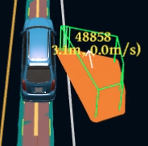
Figure 43. Vehicle size increase when next to Transit
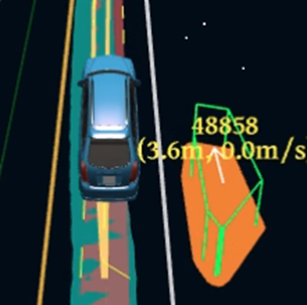
Figure 44. Abrupt lane shift due to vehicle size increase (as shown in Figure 43)
We worked around this by configuring the side LiDARs to return the full field of view and limit the points used in Apollo’s perception module to exclude the reflections from the Transit.
- Various speed limit changes were made to account for typical road traffic in situations near Riverside Dr.
- V2V integration – the planning module was added to receive V2V data from the ROS-to-Cyber bridge to be able to stop for a simulated school bus.
- The stop distance from the “school bus” was adjusted to 20 meters.
- The position of the “school bus” was not always accurate since it did not have any RTK corrections. Because of this, it was not always recognized as being on the roadway, and the Apollo planning module would then ignore it. This was fixed by adding +/- 15 meter lateral tolerance buffer from the center of the lane.
- The ROS-to-Cyber direction of data flow was configured, and a message type added for the V2V data to be shared with Apollo from the existing ROS driver provided by the University of Iowa.
- Dynamic speed-based lane change was implemented to shorten or lengthen the lane change distance depending on the speed. This was done to reduce the chance of the Transit executing a "two step lane change" (i.e., it stays near the center line for an extended period of time).
- Fixed a bug in Apollo’s planning code which caused unexpected slowdowns on the highway when near speed limit.
- Fixed a path optimization issue by adjusting some constraints in order to allow the Transit to successfully navigate the exit from the Riverside Casino. This had been an ongoing problem due to the specifics of the location.
- Moved a waypoint on the map farther south on Riverside Dr, causing the lane change to occur later. The previous location was directly after the left turn onto Riverside Dr. Moving it gave other vehicles the opportunity to turn into the plaza before the Transit attempted the lane change. An additional benefit of moving this waypoint was to reduce the chance of Apollo failing to reach the waypoint and wanting to do a full circle to accomplish this.
- Added audible notification if any module fails to publish after a period of time. This was done after perception failed to continue publishing during one of the test drives.
- Added a turning lane on Hwy 1 when approaching the turn onto Kansas Ave SW to the map. There is not technically a lane there, but a large shoulder that is typically used to improve traffic flow for other road users on the highway.
- The stop time duration for stop signs was reduced from 3s to 1s. And the creep time duration for yield signs was reduced from 3s to 1s. Durations were adjusted based on the University of Iowa team input. The goal was to reduce the fully stopped time so that other road users could predict the Transit’s motion more accurately.
- Switched cell service provider to T-Mobile and upgraded the Cradlepoint R1900 (i.e., the hardware that allows for connection to the Internet via a service provider).

Next Steps
As the project continues, we will introduce additional functionality to the vehicle that will improve performance through cities and towns and the gravel road. We will build upon the previous phases and augment the automation with connected vehicle data. The final phase integrates parking areas, which present unique challenges for ADS. The parking areas along our route include both on-street (angle and parallel) and parking lots. We anticipate slow-speed maneuvering in tight spaces as well as interactions with pedestrians crossing in unanticipated places. To be successful in these endeavors, we have discussed making the following changes with our technology partners, AutonomouStuff and Mandli Communications, to the automation and digital map to help meet the needs of the next phase.

Map Issues to be Addressed
- Update to include parking spaces in Kalona and Hills.
- Lower the speed limit on B Ave and 5th Ave in downtown Kalona due to the proximity of the Transit to the angle-parked vehicles.
- Change the speed limit in the Riverside Casino parking lot from 11 to 15 mph.
- Move the waypoint in the Riverside Casino parking lot to cause lane change to occur sooner.
- Add the two speed bumps in the Iowa City Marketplace parking lot and reduce speed limit on various lane segments to help cornering and drivability in parking stall rows.
- Correct the issue of duplicated points at the intersection of Hwy 1 and Riverside Dr which causes incorrect heading estimation for prediction.
- On S Riverside Dr, move the waypoint for the lane change farther south.
- Add yield sign to the second railroad crossing (in each direction) in Hills to enable automation through this section.

Other Issues to be Addressed
- Working on lateral control improvement to reduce wide turns where the Transit doesn’t track the center line as it should.
- Continue to investigate issue of unexpected slow down on highway when the Transit is passed by other vehicles.

For more information, please refer to the ADS for Rural America Safety Management Plan at adsforruralamerica.uiowa.edu/ADS-safety-plan

