Phase 4 (Unmarked Roads)

Evaluation Report
Author: Cher Carney, Project Research Lead, cher-carney@uiowa.edu
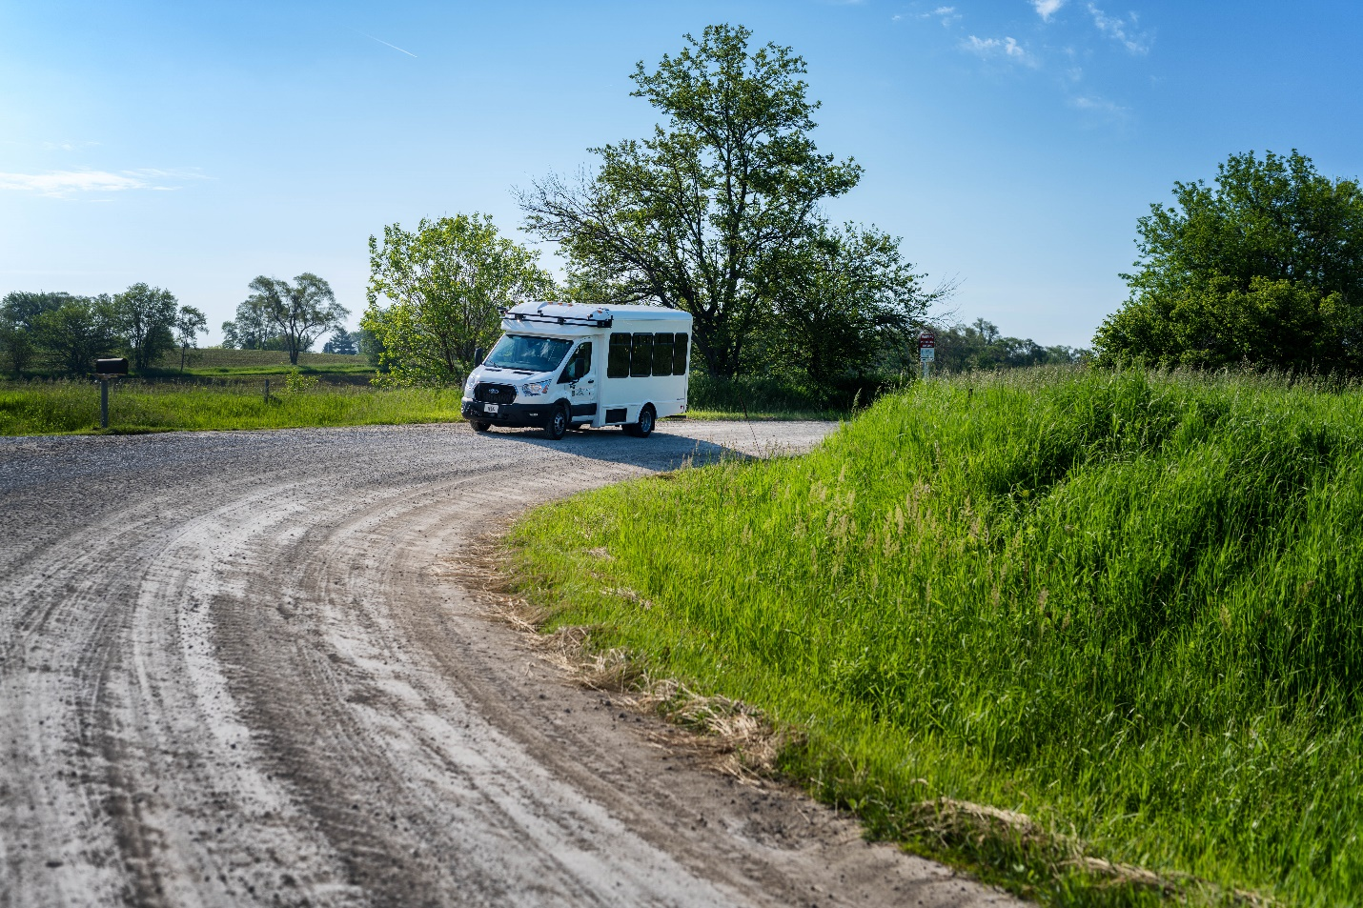
Contents
Introduction 1
Expected Capabilities of the Automation for Phase 4 2
Unmarked Pavement (Sharon Center Rd) 3
Gravel Road (Kansas Ave SW) 3
Improvements to the Automation 5
Four-Way Stop Intersections 6
Two-Way Stop Intersections 7
Stop-Controlled Intersections 8
Yield-Controlled Intersections 9
Traffic Signals 10
Automation Engagement by Drive 12
Voluntary Takeover of the Automation 18
Forced Takeover of the Automation 19
Encounters with Vulnerable Road Users (VRUs) 20
Safety Critical Events 20
Occupants for Phase 4 20
Demographics 20
Survey Data 21
Biometric Data 27
Anxiety Ratings 27
Safety Drivers 30
Phase 4 Summary 33
Module Failure Alert 36
Apollo and Route Options at Intersections 36
Accomplishments for Phase 4 36
Next Steps 37
Map Issues to be Addressed 37
Other Issues to be Addressed 37

Introduction
This project is comprised of six data collection phases shown in Table 1 that span over a two-year time period. Each phase has attempted to increase the percentage of the route that is driven under automation as well as improve the performance and comfort during those portions of the route that were automated in the previous phases. The defined route has been driven in its entirety for each phase to document this progression and to allow for comparison of automation data from one phase to the next.
Phase 1 was completed in November of 2021 on controlled access highways and a divided highway/interstate. A large portion of the route during that phase was able to be driven in automated mode. This was due to a high percentage of the route being interstate/highway driving. However, several issues regarding merging and traveling at highway speeds were identified during that phase.
Phase 2 was completed in March of 2022. The focus of Phase 2 was vehicle navigation along 2-lane undivided highways as well as on- and off-ramps. The traffic on undivided highways travels in opposite directions, has more variable vehicle speeds, and has vehicles that may pass in oncoming traffic lanes. On- and off-ramps were seen as a unique challenge due to the variable geometries and vast differences in speeds of vehicles entering and exiting the highways, as well as the unpredictability of driver behavior that can occur in these locations.
Phase 3 was completed in July of 2022 and focused on driving in automation through cities and towns along the route. These roadways have a wide variety of intersections including 2-way and 4-way stop intersections as well as intersections with lighted traffic signals. The stop-controlled intersections were traversed using input from the HD map as well as the other sensors. The lighted intersections were navigated via automation that used a camera-based system and a traffic light detection software module.
Phase 4 was meant to test the ability of the automation to drive unmarked paved and gravel roadways. These road types are a challenge both in their design and the way in which they are typically driven. This document is the evaluation report for this phase of data collection.
Table 1. Project phases
Phase | Description | Drives Planned | Drives Completed | Date | Status
1 | Controlled Access Roadways | 10 | 10 | 11/2021 | Complete
2 | Highways & Ramps | 20 | 17 | 03/2022 | Complete
3 | Urban Areas | 10 | 13 | 07/2022 | Complete
4 | Unmarked Roads | 10 | 10 | 10/2022 | Complete
5 | V2X | 10 |  | 01/2023 | Planning
6 | Parking Areas / Full Route | 20 |  | 05/2023 | Planning
Total |  | 80 | 50
Ten drives were completed as part of Phase 4. These drives took place between October 5 and October 19, 2022. They occurred at different times of day and during varying lighting and weather conditions.
Data of specific interest in Phase 4 includes:
- How the vehicle handles roads with no lane markings or centerlines
- How the vehicle handles unpaved narrow roadways and adopts a path more typical of these types of roadways
- Interactions with oncoming traffic on the gravel road
- Impact of driving on gravel on the automation
This report will begin by describing vehicle performance along the entire route, paying particular interest to what was expected for Phase 4 but also describing changes to the map and automation that improved performance when navigating the roadways encountered in Phases 1-3. As in previous reports, the data collected for each drive will be summarized, including mileage in automation and figures showing the location of automation activation. A summary of voluntary takeovers by the safety driver, encounters with vulnerable road users (VRUs), and any safety critical events is provided. Data regarding the occupants of the vehicle includes demographic information, survey data, biometrics, and anxiety ratings. A summary of the safety driver survey results, including their perceptions of the automation’s performance is provided as well.

Expected Capabilities of the Automation for Phase 4
For Phase 4, the vehicle was expected to maintain lateral and longitudinal position and navigate unmarked paved and unpaved roads via automation that utilized on-board sensors and a high-definition (HD) map of the route.
Automation was activated by pressing the “Engage” button on the steering wheel. Prior to activation, the safety driver made sure the following conditions were met:
- The vehicle was below the HD map’s speed limit.
- The vehicle was in the center of the lane.
- Safety drivers were not providing any input; steering, braking, accelerating, or shifting.
- Safety drivers deemed it safe. (Considerations for safety include number/proximity of vehicles in the lane and oncoming or adjacent lanes, weather, functionally of automated systems, etc.)
The goal of Phase 4 was to use automation to safely navigate the unmarked roads (i.e., Kansas Ave SW and Sharon Center Rd SW). As shown in Figure 1, the automation was able to drive Sharon Center Rd in previous phases of the project. However, this report will focus on the vehicle’s performance and changes to the map that made driving on these roadways possible.
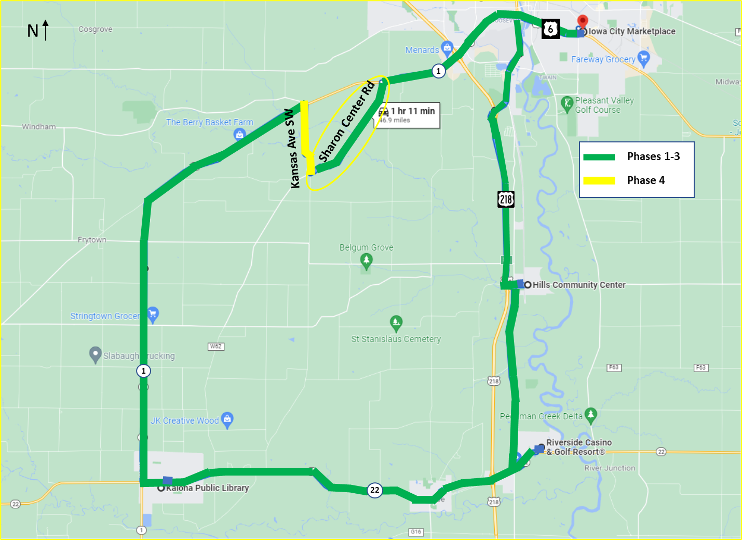
Figure 1. Expected capabilities of the automation (combination of Phases 1 through 4)

Unmarked Pavement (Sharon Center Rd)
The automation stack used for this demonstration project relies on a high-definition map in order to navigate the route. It does not rely on cameras to identify pavement markings like many lane-keeping ADAS systems on consumer vehicles. Therefore, Sharon Center Rd was able to be driven in automated mode much earlier than initially planned. However, there were several challenges that needed to be addressed to make travelling on this type of roadway safe and comfortable. During Phase 1, automation was engaged only on the short, straight sections of Sharon Center Rd. The speed for this roadway is 45 mph, which was determined to be too fast for the curves as well as the blind hill. For Phase 2, changes were made to the HD map, placing virtual speed limit signs before the curves to slow the vehicle to a more comfortable speed. And changes were made to the map to slow for the blind hill prior to the start of Phase 3. Therefore, for Phase 4, Sharon Center Rd was able to be safely driven in automation 99% of the miles on this roadway. There was one disengagement that was due to an oncoming vehicle (i.e., farm tractor carrying a wide load) approaching a narrow bridge at the same time as the Transit.

Gravel Road (Kansas Ave SW)
The ability of an automated vehicle to simply drive on a gravel road is not difficult. However, there are many nuances to driving a gravel road that make driving it in automation extremely difficult. First, gravel roadways are typically driven down the center to avoid the loose gravel and soft shoulder that are characteristic of the edges of the roadway. Also, when oncoming traffic approaches, it is commonplace for both vehicles to slow and move over to the right as they pass. Therefore, for this phase the center of our lane of travel was shifted approximately 18 inches to the left on the gravel road portion of the map. This results in the vehicle traveling closer to the center line of the roadway. In addition, the vehicle does have the ability to “nudge” itself to the right (or left) when obstacles are in its path. It was thought that this might allow the Transit to move over as oncoming vehicles approached. However, because the LiDAR does not see far enough ahead, there is little time for the Transit to make adjustments due to the differential speed and closing distance of the vehicles.
The vehicle was able to navigate the gravel road in automation 99% of the miles driven on this roadway. It encountered an oncoming vehicle twice during the ten drives. For one of those encounters (Drive 53), the vehicle encountered a large semi and was able to remain in automated mode and successfully pass (Figure 2). The other encounter (Drive 56) happened on the S-curve on a hill. This is one of the most challenging locations, in general. And with the glare and the location that the passing would take place, the safety driver felt that it was unsafe to leave it in automation for this encounter (Figure 3).
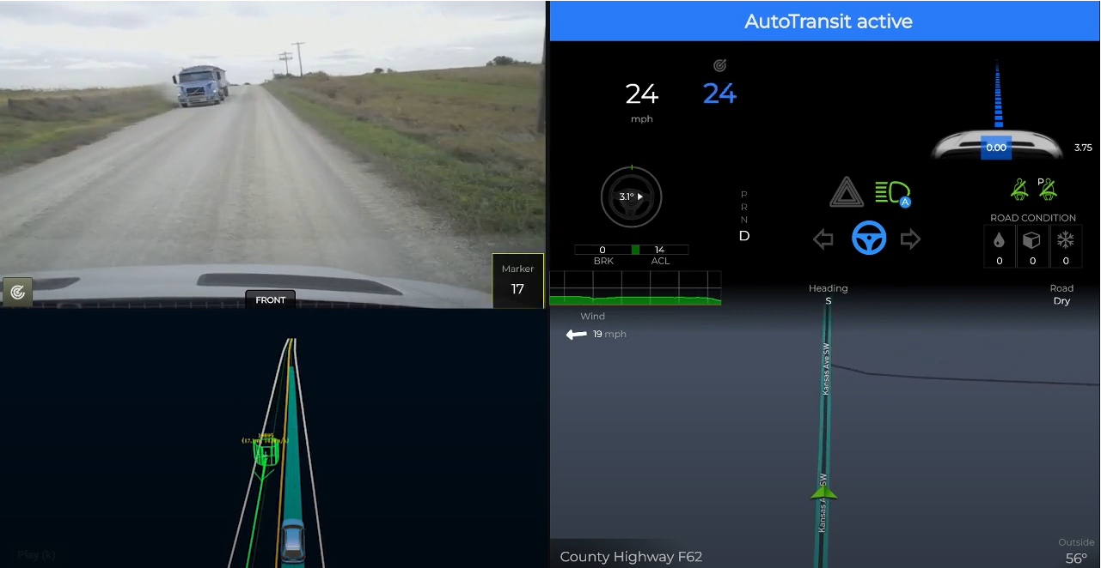
Figure 2. Vehicle encounter with semi on gravel road (Drive 53), https://www.youtube.com/watch?v=AJfyx3H50vQ
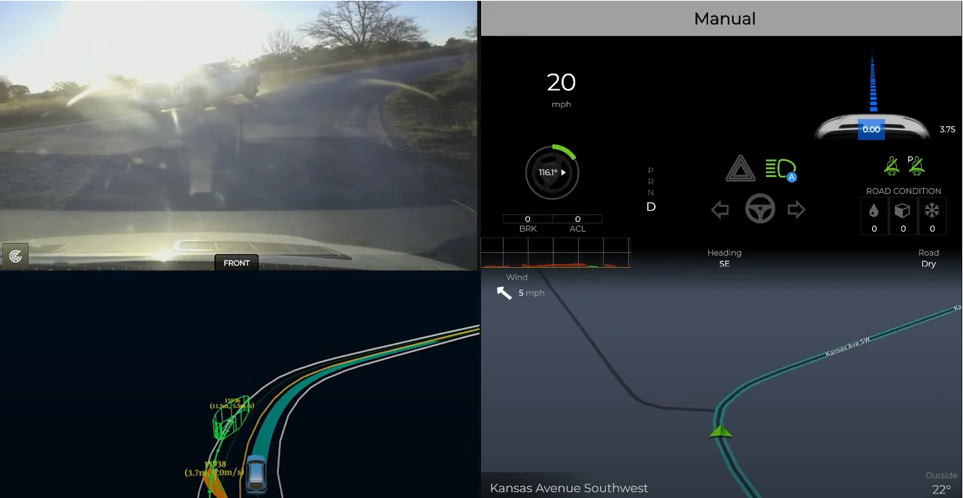
Figure 3. Vehicle encounter with pickup on S-curve on gravel road (Drive 56), https://www.youtube.com/watch?v=ldujaEljy5g

Improvements to the Automation
Because each phase builds upon the last, we continued to drive using automation through cities and towns and navigate many types of intersections; four-way stops, two-way stop, stop controlled, as well as lighted intersections. For descriptions of these intersections as well as maps showing their location, see the Phase 3 Evaluation Report. Changes to the software to better navigate the intersections included:
- Stop and creep time reduced from 5 seconds to 3 seconds
When the Transit comes to a stop sign there are four stages that it goes through, with specific time values associated with each:
- PRE_STOP or APPROACH: Arriving at the stop sign. The automation will perceive all other cars or obstacles that are currently waiting at other stop signs.
- STOP: Come to a complete stop. The automation will monitor to see if the other cars that were previously stationary at other stop signs have moved or not. It is essential that the cars that arrived before have all left.
- CREEP: Move forward slightly. The automation will check to see if any other car is moving or in the case of an unprotected stop, check to see if there are any oncoming vehicles on either side of the lane.
- INTERSECTION_CRUISE: Safely move through the crossroad.
After much pre-phase testing, both the STOP and CREEP times were decreased from 5 seconds to 3 seconds. This change had the potential to increase safety by reducing the uncertainty of other drivers regarding the intentions of the Transit at an intersection. The longer the Transit stayed stopped or creeped without completing the maneuver, the more likely another vehicle was to enter the intersection out of turn.
- Max throttle reduced from 0.6 to 0.4
In previous phases, we had experienced situations where the Transit would accelerate more aggressively than one would expect for a larger vehicle. This was particularly problematic when there were short distances and high speed limits (>35 mph) between stoplights (i.e., U.S. Hwy 6 and State Hwy 1 in Iowa City) and was manifested by hard braking followed by aggressive acceleration. Testing was done to reduce this aggressive acceleration. Reducing the max throttle from 0.6 to 0.4 made for a much smoother ride for this phase. It should be noted that the values are not g forces but simply a value that ranges from 0 to 1.
- Turn right on red configuration flag enabled.
In Phase 3, the vehicle was not able to complete a right turn on red and had to wait until the signal cycled to green. For Phase 4, if the vehicle stopped at a red light and a right turn was required, the red light was treated as a stop sign. There are three stop lights where right turns on red are possible (i.e., one exiting the Riverside Casino and two leaving the Iowa City Marketplace). Enabling this feature reduced the number of voluntary disengagements needed to complete the turn and negative interactions with the traffic behind the Transit.
As always, the safety driver was prepared to take over when they felt that the automation was about to engage in an unsafe maneuver (e.g., pull out in front of oncoming traffic) or if it was taking too long to perform the maneuver and could have potentially caused another vehicle to behave in an unsafe way (e.g., drive aggressively or pass in an intersection). Automation can be intentionally disengaged by the safety driver using multiple methods, which include pressing a button on the steering wheel, taking over steering, pressing the accelerator or brake pedal, or pressing the E-stop button. It is important to note that using the automation at all of these intersections was explored and tested extensively by the safety drivers again, Pre-Phase 4, after software changes were made.

Four-Way Stop Intersections
These types of intersections require that the vehicle stop before the intersection. The vehicle must stop regardless of what direction they are coming from. The vehicle must determine which vehicle arrived at the intersection first to determine right-of-way. The vehicle encounters six of these types of intersections. Figure 4 shows where they occur along the route.

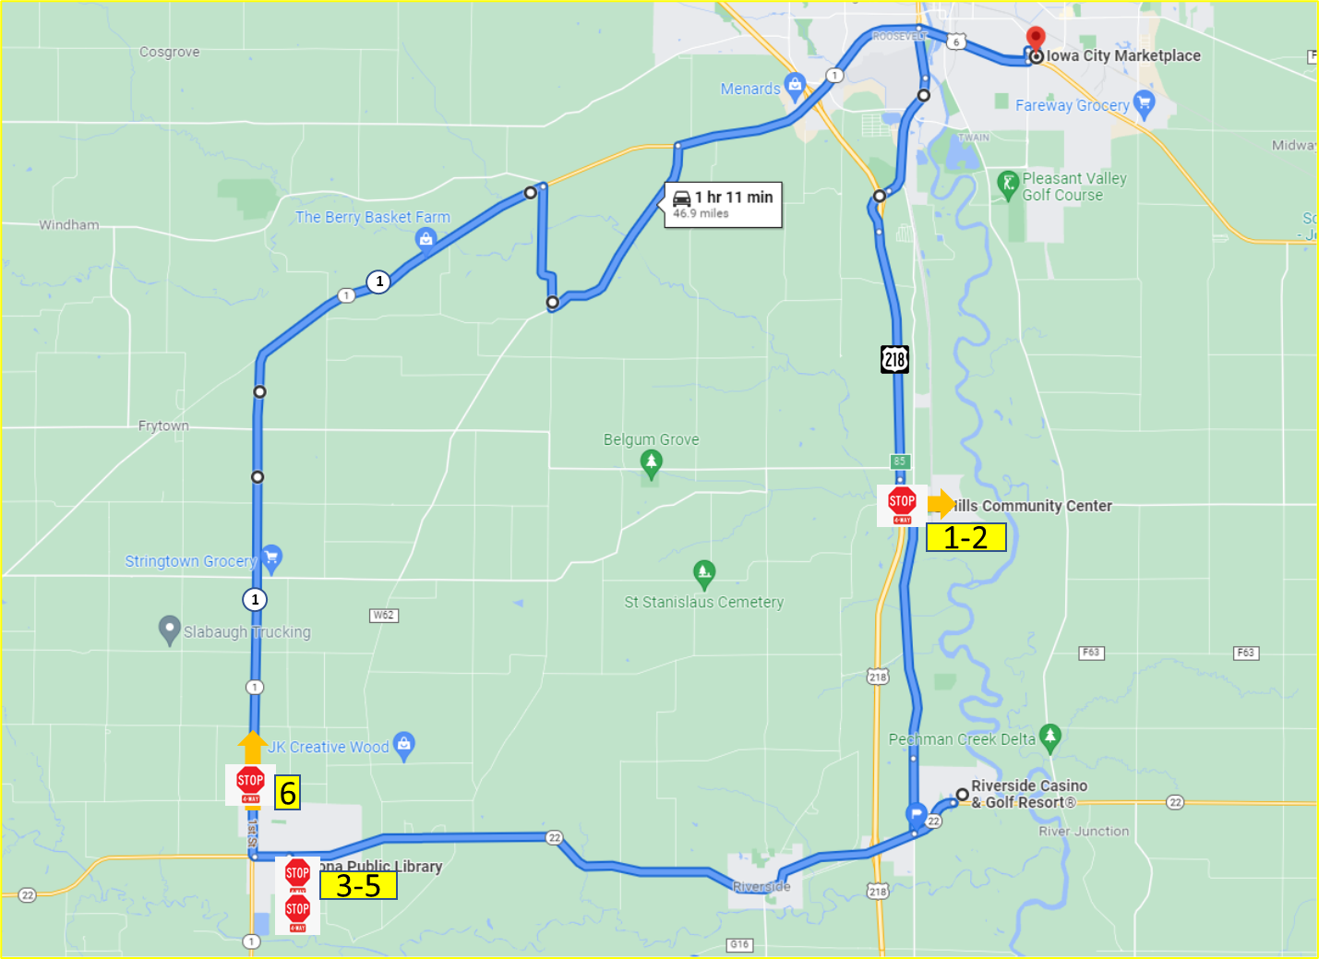Figure 4. 4-way stop intersections
Table 2. Number of 4-way stop intersections completed in automation for Phase 4
 | 4-Way Stop Intersections | Direction of Travel | Number Completed Under Automation
1 | 4-way stop in Hills (travelling east) | Straight | 4
2 | 4-way stop in Hills (travelling west) | Left | 10
3 | 4-way stop in downtown Kalona (B Ave/5th St) | Right | 8
4 | 4-way stop in downtown Kalona (5th St/C Ave) | Right | 8
5 | 4-way stop in downtown Kalona (B Ave/5th St) | Straight | 10
6 | 4-way stop on Hwy 1 | Straight | 10

The small number of completions at the 4-way stop in Hills (travelling east) was due to mapping issues (i.e., the vehicle not touching the waypoint on S. Riverside Dr).

Two-Way Stop Intersections
These types of intersections are typically used in areas where one street has a much higher traffic volume than the street it intersects. The vehicle on the minor road is required to stop and wait for a gap in traffic on the major road before proceeding. If two vehicles are stopped, the maneuver is complicated by determining which of the stopped vehicles has the right-of-way, particularly if one of the vehicles is left turning. Figure 5 shows the locations of the five intersections of this type along the route.

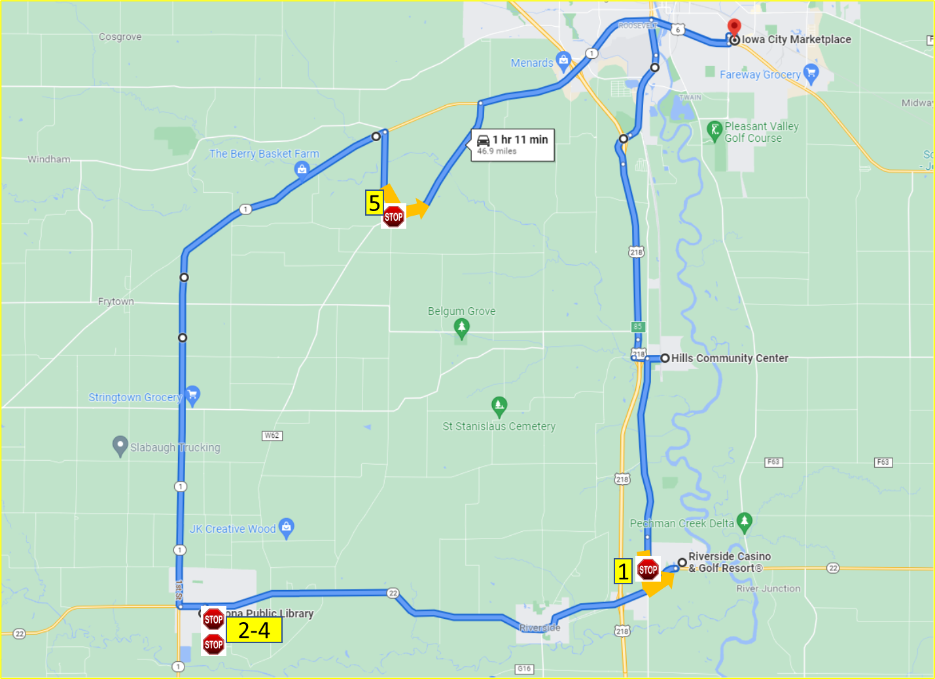Figure 5. 2-way stop intersection
Table 3. Number of 2-way stop intersections completed in automation for Phase 4
 | 2-Way Stop Intersection | Direction of Travel | Number Completed Under Automation
1 | 2-way stop Hwy 22 | Left | 4
2 | 2-way stop in downtown Kalona (6th St/B Ave) 1st time | Right | 9
3 | 2-way stop in downtown Kalona (C Ave/6th St) | Right | 9
4 | 2-way stop in downtown Kalona (6th St/B Ave) 2nd time | Right | 10
5 | 2-way stop from Kansas Ave to Sharon Center Rd | Left | 10

The lower number of completions for the 2-way stop at Hwy 22 is due to amount of traffic present and the speed at which the other vehicles are travelling on this roadway (i.e., 55 mph). By the time that the LiDar picks up an oncoming vehicle, there is not always enough time for the turn to be completed safely.

Stop-Controlled Intersections
These intersections required the vehicle to come to a complete stop and yield to pedestrians crossing the street and cross-traffic. The vehicle must ensure the intersection is clear and that it will not impede approaching traffic by entering the stop-controlled intersection. There are four intersections of this type along the route. Figure 6 shows the location of the intersections along the route.
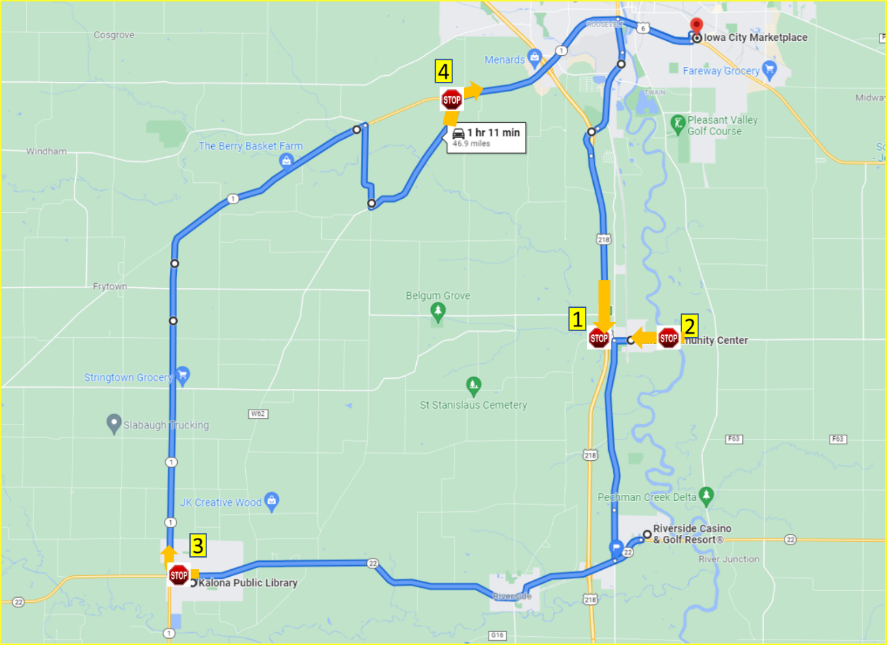
Figure 6. Stop-controlled intersections
Table 4. Number of stop-controlled intersections completed in automation for Phase 4
 | Stop-Controlled Intersections | Direction of Travel | Number Completed Under Automation
1 | Hwy 218 off-ramp to Observatory Ave | Left | 7
2 | 2nd St to Main St | Right | 7
3 | B Ave to Hwy 1 | Right | 8
4 | Sharon Center Rd to Hwy 1 | Right | 7

Yield-Controlled Intersections
This type of intersection requires the vehicle to prepare to stop and yield the right-of-way to other vehicles or pedestrians in or approaching the intersection. However, the vehicle is not required to stop unless there are vehicles approaching. Therefore, the vehicle must slow to a speed at which it can stop and yield if needed. There are two intersections of this type along the route. Figure 7 shows the location of these intersections along the route.

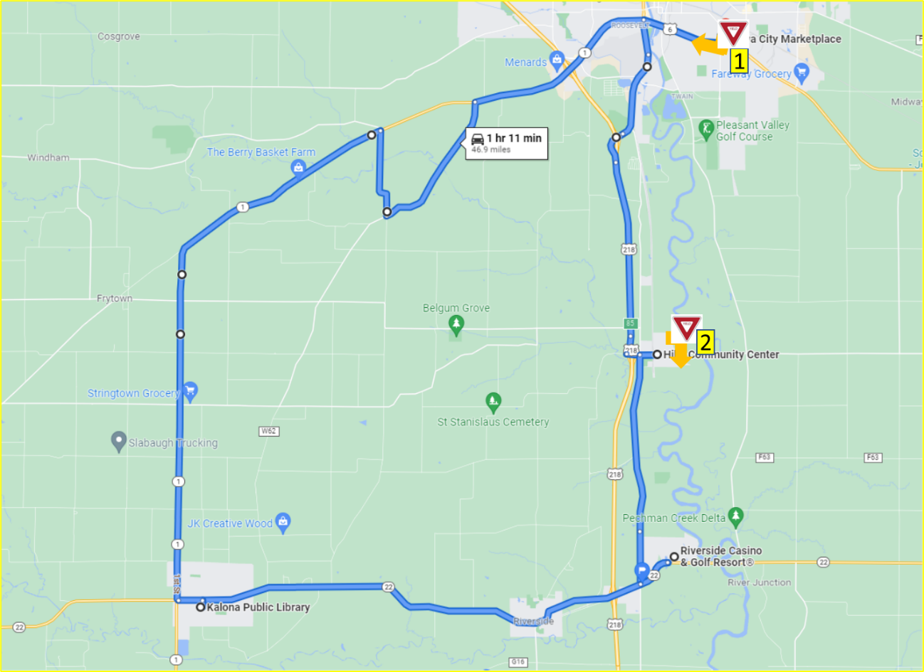
Figure 7. Yield-controlled intersections
Table 5. Number of yield-controlled intersections completed in automation for Phase 4
 | Yield-Controlled Intersections | Direction of Travel | Number Completed Under Automation
1 | S 1st Ave to Hwy 6 | Right | 6
2 | Oak St to 2nd St | Right | 8

Traffic Signals
For this demonstration we utilized a camera-based system to identify the state of the traffic signals. This allowed us to use automation to navigate all the lighted intersections along the route. Maps showing the locations and descriptions of the lighted intersections can be found in the Phase 3 Evaluation Report. A breakdown of all intersections with traffic signals along the route is shown below in Table 6, as well as the direction of travel and the number of times it was able to navigate the intersection in automation for this phase.
Table 6. Number of intersections with traffic signals the vehicle completed in automation for Phase 4
Traffic Signals in Iowa City (N=23) | Direction of Travel |  |  | Number Completed Under Automation
Hwy 1 and Naples Ave SW | Straight |  |  | 9
Hwy 1 and Hwy 218 ramps | Straight |  |  | 10
Hwy 1 and Mormon Trek Blvd | Straight |  |  | 9
Hwy 1 and Sunset St | Straight |  |  | 7
Hwy 1 and Westport Plz | Straight |  |  | 10
Hwy 1 and Ruppert Rd | Straight |  |  | 10
Hwy 1 and Miller Ave | Straight |  |  | 9
Hwy 1 and Orchard St | Straight |  |  | 9
Hwy 1 and S Riverside Dr | Straight |  |  | 9
Hwy 6 and S Gilbert St | Straight |  |  | 10
Hwy 6 and Boyrum St | Straight |  |  | 9
Hwy 6 and Keokuk St | Straight |  |  | 9
Hwy 6 and Broadway St | Straight |  |  | 9
Hwy 6 and Sycamore St | Left |  |  | 5
Iowa City Marketplace and Lower Muscatine Rd | Right |  |  | 8
Lower Muscatine Rd and S 1st Ave | Right |  |  | 6
Hwy 6 and Sycamore St | Straight |  |  | 7
Hwy 6 and Broadway St | Straight |  |  | 10
Hwy 6 and Keokuk St | Straight |  |  | 9
Hwy 6 and Boyrum St | Straight |  |  | 8
Hwy 6 and S Gilbert St | Straight |  |  | 10
Hwy 6 and S Riverside Dr | Left |  |  | 4
Old Hwy 218 S and Mormon Trek Blvd | Straight |  |  | 10
Traffic Signals in Riverside (N=2) |  | Direction of Travel | Number Completed Under Automation
Hwy 22 and Entering Riverside Casino |  | Left | 7
Exiting Riverside Casino and Hwy 22 |  | Right | 4
Traffic Signals in Kalona (N=1) |  | Direction of Travel | Number Completed Under Automation
Hwy 22 and S 6th St |  | Left | 5

Automation Engagement by Drive
All ten drives that were started in this phase were completed and have full data sets. Maps showing the locations that automation was engaged are shown below for Drives 47 through 56 (Figures 8 through 17). Roadways where the automation was used are shown in blue. Locations driven manually are shown in green if the safety driver took over from the automation using the button on the steering wheel and in orange if they took over by steering, braking, or accelerating. The percentage of the trip driven using automation varied from 99.0% in Drive 55 to 96.1% in Drive 50. At this point in the demonstration, the only portions of the route that are not able to be driven in automation are the parking lots, which is reflected in the remarkably high percentages of the drive that are competed in automated mode.
Start Location | Iowa City
Number of miles recorded | 48.16
Number of miles recorded in automated mode | 46.98
Percent of drive recorded in automated mode | 97.50%
Amount of data collected (GB) | 88.7
Weather conditions | Avg temp: 62 (F)  Clouds: 100%  Average wind speed: 4.5 mph
Time of day | Night
Day of week | Weekday
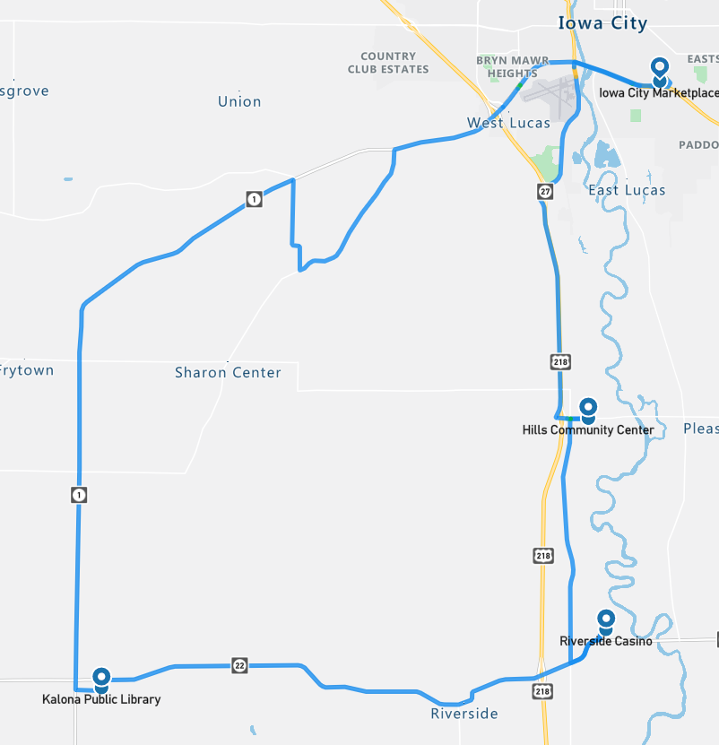
Figure 8. Drive 47 automation engagement (Oct 5, 2022)

Start Location | Kalona
Number of miles recorded | 48.16
Number of miles recorded in automated mode | 47.04
Percent of drive recorded in automated mode | 97.70%
Amount of data collected (GB) | 99.1
Weather conditions | Avg temp: 66 (F)  Clear: 20%, Clouds: 80%  Average wind speed: 15.7 mph
Time of day | Mid-Afternoon
Day of week | Weekday
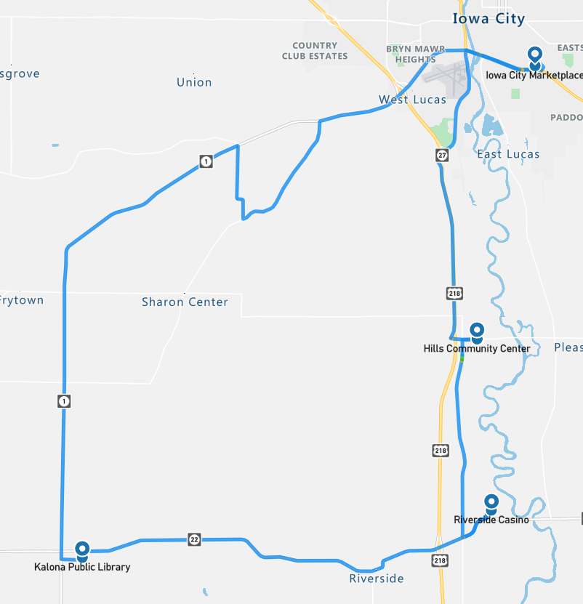
Figure 9. Drive 48 automation engagement (Oct 6, 2022)

Start Location | Hills
Number of miles recorded | 48.16
Number of miles recorded in automated mode | 47.35
Percent of drive recorded in automated mode | 98.30%
Amount of data collected (GB) | 92.7
Weather conditions | Avg temp: 45 (F)  Clear: 69%  Clouds: 31%  Average wind speed: 10.3 mph
Time of day | Dawn
Day of week | Weekday
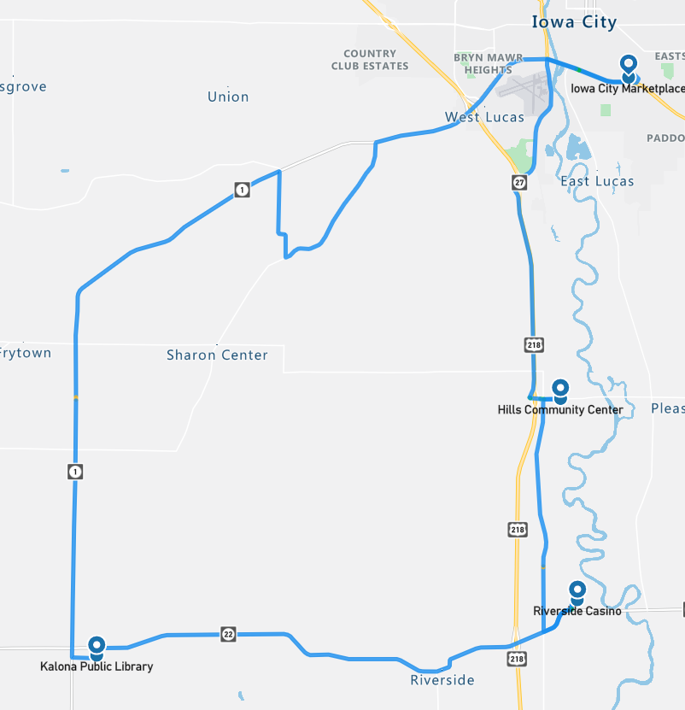
Figure 10. Drive 49 automation engagement (Oct 7, 2022)
Start Location | Iowa City
Number of miles recorded | 48.09
Number of miles recorded in automated mode | 46.23
Percent of drive recorded in automated mode | 96.10%
Amount of data collected (GB) | 93.2
Weather conditions | Avg temp: 75 (F)  Clear: 100%,  Average wind speed: 5.6 mph
Time of day | Mid-Afternoon
Day of week | Weekday
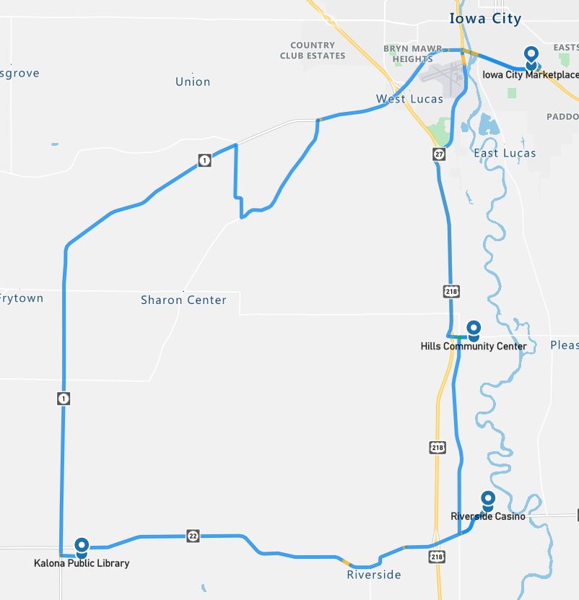
Figure 11. Drive 50 automation engagement (Oct 10, 2022)
Start Location | Riverside
Number of miles recorded | 48.16
Number of miles recorded in automated mode | 46.98
Percent of drive recorded in automated mode | 97.50%
Amount of data collected (GB) | 98.5
Weather conditions: | Avg temp: 61 (F) Clear: 29%, Clouds: 71%  Average wind speed: 12.5 mph
Time of day | Mid-Morning
Day of week | Weekday
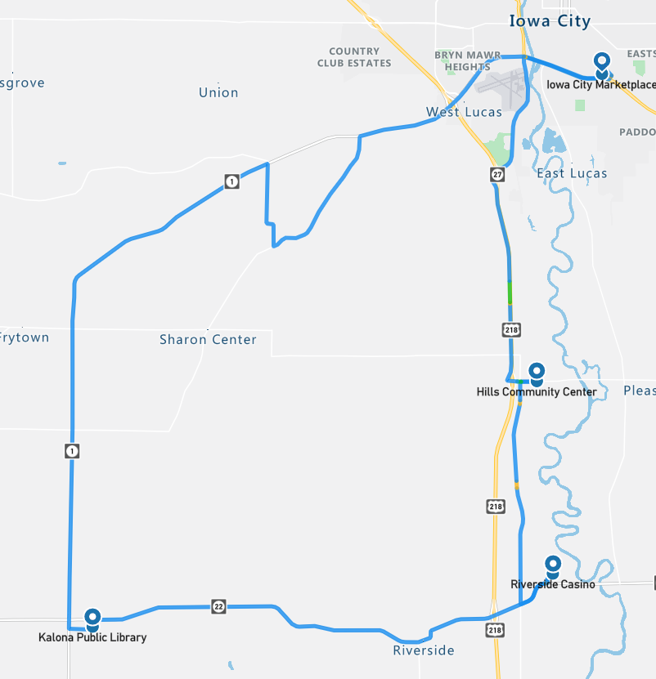
Figure 12. Drive 51 automation engagement (Oct 12, 2022)

Start Location | Kalona
Number of miles recorded | 48.16
Number of miles recorded in automated mode | 47.29
Percent of drive recorded in automated mode | 98.20%
Amount of data collected (GB) | 89.5
Weather conditions | Avg temp: 53 (F)  Clear: 94%, Clouds: 6%  Average wind speed: 19.2 mph
Time of day | Mid-Morning
Day of week | Weekday
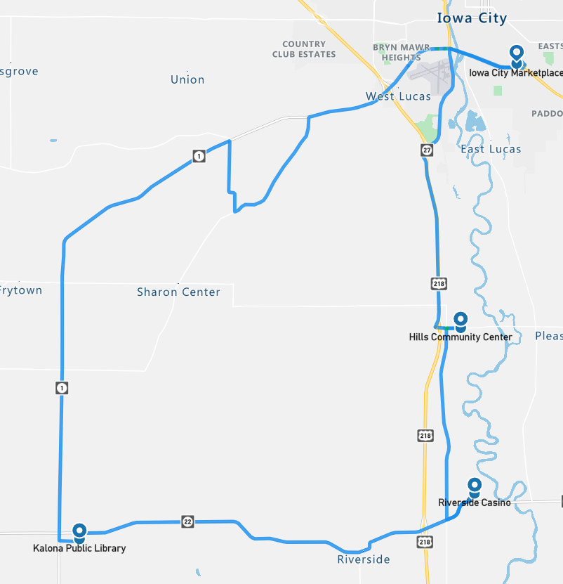
Figure 13. Drive 52 automation engagement (Oct 13, 2022)

Start Location | Riverside
Number of miles recorded | 48.09
Number of miles recorded in automated mode | 46.73
Percent of drive recorded in automated mode | 97.20%
Amount of data collected (GB) | 91.8
Weather conditions | Avg temp: 60 (F) Clear: 19%, Clouds: 81%  Average wind speed: 20.6 mph
Time of day | Noon
Day of week | Weekday
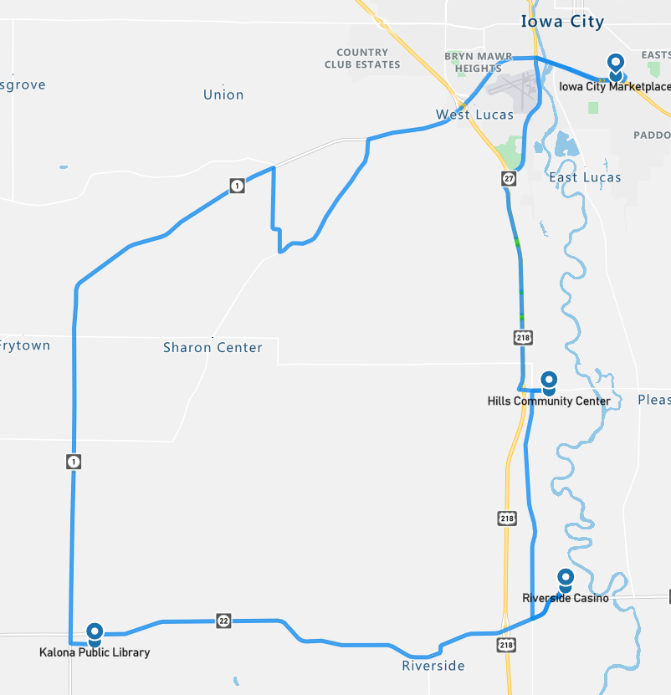
Figure 14. Drive 53 automation engagement (Oct 14, 2022)

Start Location | Kalona
Number of miles recorded | 48.09
Number of miles recorded in automated mode | 46.35
Percent of drive recorded in automated mode | 96.40%
Amount of data collected (GB) | 86.6
Weather conditions | Avg temp: 57 (F)  Clear: 73%, Clouds: 27%  Average wind speed: 11.9 mph
Time of day | Noon
Day of week | Weekend
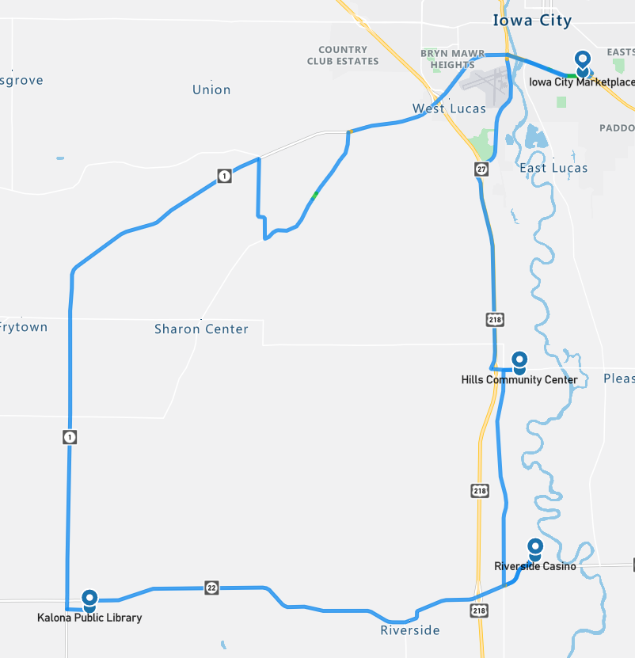
Figure 15. Drive 54 automation engagement (Oct 15, 2022)

Start Location | Hills
Number of miles recorded | 48.16
Number of miles recorded in automated mode | 47.66
Percent of drive recorded in automated mode | 99.00%
Amount of data collected (GB) | 85.2
Weather conditions: | Avg temp: 40 (F) Clear: 100%  Average wind speed: 13.0 mph
Time of day | Night
Day of week | Weekday
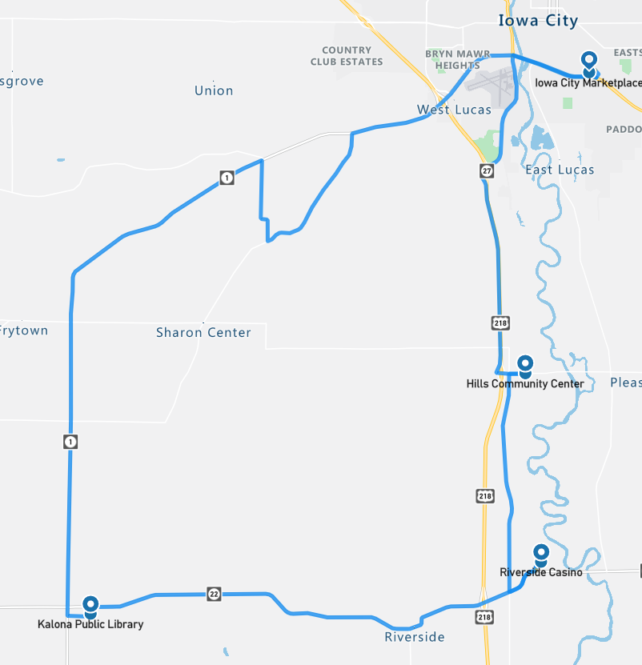
Figure 16. Drive 55 automation engagement (Oct 18, 2022)

Start Location | Riverside
Number of miles recorded | 48.22
Number of miles recorded in automated mode | 47.16
Percent of drive recorded in automated mode | 97.80%
Amount of data collected (GB) | 87.5
Weather conditions | Avg temp: 25 (F)  Clear: 88%, Clouds: 12%  Average wind speed: 5.8 mph
Time of day | Dawn
Day of week | Weekday
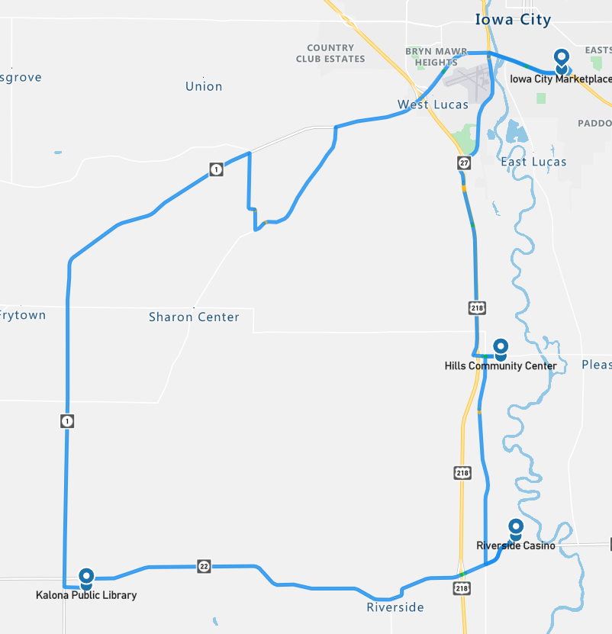
Figure 17. Drive 56 automation engagement (Oct 19, 2022)

Overall, the number of miles driven in automation by federal function classification (FFC) of road types is shown per drive below (Figure 18). For this phase, more than 90% of the miles for all road types, except for “other,” which is considered parking lots, were driven in automation (Figure 19).

Figure 18. Miles driven in automated mode by FCC road type

Figure 19. Percentage of FCC road type completed in automation (average across Phase 4)

Voluntary Takeover of the Automation
Safety drivers disengaged the automation for a variety of reasons. The preferred method of disengagement was to press the button located on the steering wheel. However, when necessary, turning the steering wheel, pressing the accelerator or brake pedal, or pressing the E-stop button may have been a more suitable and safer method. When the automation was disengaged, the copilot would flag the data using the informational display and record the reason for the disengagement using a voice recorder. There were 180 voluntary takeovers flagged by the co-pilot (Table 7).

Table 7. Frequency and type of voluntary takeovers
Reason for disengagement | Number of instances
To park | 37
To make a right/left turn | 29
To cross railroad tracks | 19
To complete turn, vehicles approaching, deemed unsafe | 18
To stop at a traffic signal | 16
Unsafe lane change | 12
To complete turn, vehicle stops in middle of intersection | 9
Map crossover issue | 6
Vulnerable road user | 6
To proceed through flashing yellow | 5
Parked vehicle in lane | 4
To slow/stop for traffic ahead | 4
Transit indecision at yellow light | 4
To avoid an object on the roadway | 2
Unsafe merge | 2
Abrupt braking, vehicle cut-in | 1
Another vehicle behaves unsafely | 1
Transit crosses the centerline | 1
To pass a slow-moving vehicle | 1
To stop at a stop sign | 1
Transit stalled at traffic light | 1
Oncoming vehicle on gravel road | 1

The largest percentage of the voluntary takeovers (36%) happened in instances where the automation was not mature enough to handle specific traffic situations at intersections or traffic signals.
- Some disengagements were due to the vehicle starting to make a turn with traffic approaching from the right or left at a high speed. The safety driver was tasked with making the call as to whether intervention was necessary and had to take into consideration the tentativeness of the Transit with respect to the distance and speed of the approaching traffic.
- Takeovers also occurred when the vehicle stopped abruptly in the middle of an intersection. It is possible that, if left long enough, the vehicle would have eventually made its way through the intersection. However, this was considered unsafe and taken out of automation so that the safety driver could complete the turn without negatively impacting the surrounding traffic.
- There were several instances when the automation did not correctly recognize the state of the traffic signal (e.g., started to move when the light was red or failed to stop at a yellow/red light). In some of these instances, the vehicle may have been picking up the incorrect signal, one to the right or left of the signal for the vehicle’s lane of travel. These instances required immediate takeover from the safety driver.

Traveling through parking lots or having the vehicle park itself is not something that the automation is capable of handling yet. We will attempt this in Phase 6 of the project (Table 1). Therefore, when parking lots were approached or the vehicle was being parked at specific destinations, the system was disengaged. These disengagements accounted for 21% of the total number.
The urban section of roadway on Hwy 6 required the driver to make two lane changes, one traveling east and one west. Completing lane changes in automation was oftentimes not possible due to the amount of surrounding traffic or the speed of traffic approaching from behind in the left lane. In these instances, the safety driver would take over and complete the lane change manually, before re-engaging the automation.

Forced Takeover of the Automation
Situations where the automation disengages on its own or becomes unavailable and requires the driver to intervene are called forced takeovers. There was only one instance of this during Phase 4: an unexpected disengagement that occurred on Vine Avenue. This was investigated, and the hypothesis is that it was due to electromagnetic interference with the PACMod system. Therefore, the PACMod was wrapped with materials to shield the internal electronics from electromagnetic interference, and this type of unexpected disengagement has not occurred again.

Encounters with Vulnerable Road Users (VRUs)
Flags were placed in the data to identify interactions with vulnerable road users (e.g., horse and buggies, ATVs, bicycles, pedestrians) located either within the lane boundary or on the shoulder on either side of the road. There were 96 interactions while the vehicle was traveling in automation and 22 while the vehicle was being driven manually (Table 8).
Table 8. Encounters with VRUs in automated and manual mode
In Automated Mode | In Manual Mode
- 26 pedestrian  - 16 horse and buggy  - 16 object in roadway  - 16 parked vehicle on shoulder  - 11 farm equipment  - 9 bicycle  - 1 ATV/golf cart  - 1 police/emergency vehicle | - 13 pedestrian  - 3 object in roadway  - 2 parked vehicle on shoulder  - 1 truck carrying a wide load  - 1 bicycle  - 1 farm equipment  - 1 police/emergency vehicle
Identifying where these interactions occur allows a comparison between how these situations are handled by the driver in manual mode and how the automation handles them. Another important reason for identifying the VRU encounters is to be able to investigate how the perception module classifies these objects.

Safety Critical Events
These events include interactions that require abrupt accelerations/decelerations or large steering wheel reversals by the automated vehicle (AV), the safety driver, or another vehicle and may or may not be classified as a near crash. Crashes are also included in this category. There were two safety critical events recorded during Drive 48. The first event occurred as the Transit approached Boyrum St while traveling on Hwy 6 E. The safety driver and co-pilot felt as though the level of braking necessary to stop behind vehicles present at the red light was abrupt enough that it reached the threshold of a safety critical event. The second event occurred in Kalona, on 1st St, when another vehicle unexpectedly turned left across our lane of travel. For each of these events, the safety driver was able to take over from the automation and avoid a near-crash or a crash.

Occupants for Phase 4

Demographics
Twenty adults over 65 and those over 25 with mobility or visual impairments were recruited to ride the vehicle. Table 9 provides the demographic breakdown by age, gender, and impairment. No one reported using a wheelchair and one reported using a walker, cane, or crutches; one reported having difficulty walking or climbing stairs. None of the occupants have a low vision impairment (i.e., visual acuity less than 20/70). Thirty-five percent (7 out of 20) have some type of visual restriction on their driver’s license (glasses or corrective lenses). However, these restrictions are not severe enough to cause these occupants to be considered visually impaired. And 25% (5/20) reported having difficulty hearing.

Table 9. Demographics of occupants
Age | Unimpaired |  | Mobility Impaired |  | Visually Impaired |  | Hearing Impaired
 | Male | Female | Male | Female | Male | Female | Male | Female
25-34
35-44
45-54
55-64
65-74 | 6 | 7 | 1 | 1 |  |  | 1 | 2
75-84 | 2 | 1 |  |  |  |  | 1
85-94 | 2 |  |  |  |  |  | 1
95+
Total | 10 | 8 | 1 | 1

The sample is highly educated, with 85% of occupants having some education beyond a high school degree, and 70% (14 out of the 20 who responded) have a household income greater than $50,000. All occupants own or have access to a vehicle. Typically, occupants drive themselves where they need to go with 60% reporting driving themselves daily and 30% driving themselves a few times a week. All occupants have a driver’s license.
Thirty percent of the occupants in Phase 4 own or have access to a vehicle that has either adaptive cruise control (ACC) and/or lane keeping/lane centering. About 50% of those with ACC and about 75% with lane keeping reported using it often or frequently. A majority (80%) also reported that when it comes to trying new technology, they generally fall in the middle (e.g., not the first or last to try). About 85% reported owning or using a smart phone. Eighty-five percent reported that they own a desktop or laptop computer, and 90% reported having access to the internet. A majority, 70%, reported that they use some form of social media, and 70% own or use a tablet. Occupants agreed that they like to use technology to make tasks easier (85%) but were more split regarding whether they wanted a car with all the latest technology features (20% disagree vs. 40% agree).

Survey Data
While riding in the AV, occupants were asked to complete both a pre- and post-drive survey regarding their trust and acceptance of highly automated vehicles. This type of vehicle was defined as one that is “capable of driving on its own in some situations but is aware of its limitations and calls for the driver to take over when necessary.” When asked to indicate how they felt about different statements, a greater percentage of occupants after their ride in the vehicle “somewhat or strongly agreed” that they could trust highly automated vehicles (60% pre-drive vs. 75% post-drive, Figure 20) and believed that they were reliable (55% pre-drive vs. 75% post-drive, Figure 21).

Figure 20. Trust in highly automated vehicles, pre- and post-drive

Figure 21. Reliability of highly automated vehicles, pre- and post-drive
There was no difference pre- and post-drive in the percentage of occupants who reported being afraid to ride or being worried about riding in a highly automated vehicle, with 90% of occupants disagreeing with the statement “I am afraid…” and 90% agreeing with the statement “I am not worried…” (Figures 22 and 23). However, after riding in the vehicle, fewer occupants reported that they believed that automated vehicles are safer than manually driven vehicles (50% pre-drive vs 40% post-drive, Figure 24).

Figure 22. Afraid to ride in a highly automated vehicle, pre- and post-drive

Figure 23. Worried about riding in a highly automated vehicle, pre- and post-drive

Figure 24. AVs safer than manual vehicles, pre- and post-drive
Phase 4 specifically focused on the ability to use automation on gravel roadways. The safety driver used the automation on this road type whenever they deemed it safe to do so which, for this phase, was nearly 100% of the time. The Transit was only taken out of automation twice on gravel (i.e., while passing an oncoming vehicle). The percentage of occupants who indicated that they agreed either “strongly” or “somewhat” that they would trust a highly automated vehicle on gravel roads after the drive was complete, changed a great deal with exposure (45% pre-drive vs. 80% post-drive, Figure 25).

Figure 25. Trust of highly automated vehicle to drive on gravel roads pre- and post-drive
The ability of the vehicle to drive in automation and on city roads and the interstate has been the focus of previous phases. However, we are still driving and capturing data on these types of roadways and continue to make changes and improvements that affect the performance of the automation. For Phase 4, trust in the automation to drive on the interstate/highway was high pre-drive (80%) and increased post-drive to 100% (Figure 26).

Figure 26. Trust of highly automated vehicle to drive on the interstate/highway pre- and post-drive
Trust of the automation to drive on city streets and to respond to traffic lights/signs increased slightly (70% pre-drive vs 80% post-drive and 75% pre-drive vs 90% post-drive, respectively) (Figures 27 and 28).

Figure 27. Trust of highly automated vehicle to drive on city streets pre- and post-drive

Figure 28. Trust of highly automated vehicle to respond to traffic light/sign pre- and post-drive
Occupants were also asked questions about perceived usefulness and their intention to use highly automated vehicles. When asked to report whether they were “open to the idea of riding in a highly automated vehicle,” 85% of occupants before and 95% after the ride indicated that they somewhat or strongly agreed with the statement (Figure 29).

Figure 29. Openness to riding in a highly automated vehicle
When asked whether they thought highly automated vehicles would allow them to stay more involved in their communities or enhance their quality of life/well being, there were no real differences between how they felt pre- and post-drive (60% pre-drive vs. 55% post-drive and 60% pre-drive vs. 65% post-drive, respectively).

Biometric Data
A medical grade wearable device was worn by each of the occupants as well as the safety driver for each of the ten drives. The device has a sensor which measures blood volume pulse (BVP), from which heart rate variability can be derived, as well as a sensor that measures the constantly fluctuating changes in certain electrical properties of the skin (galvanic skin response or GSR). Ten minutes of baseline data was collected before the start of each drive.

Heart Rate Variability (HRV)
Heart rate variability is said to indicate physiological stress or arousal, with increased stress being indicated by a low HRV.

Galvanic Skin Response (GSR)
Increases in GSR activity can indicate stress/anxiety as well as other emotions such as anger, disgust, fear, happiness, surprise, and extreme sadness.
This data will not be analyzed for this summary report; however, it will be available in its raw form through the data access portal.

Anxiety Ratings
Occupants were also asked to provide a rating of their anxiety level from 0 to 10, with 0 being “not at all anxious.” These ratings were given at nine specific locations along the drive and were the same for each participant, although they did vary in the order they were given depending on the starting location for the drive. Figure 30 is a map showing where each of these ratings occur along the drive. A pre-drive anxiety rating was obtained for everyone before the drive began. Rating locations included the following:
- Hwy 6 in Iowa City
- After merge onto Hwy 218
- After turn onto Hwy 22
- Business district of Riverside
- Downton Kalona
- Hwy 1 rural
- Gravel road
- Unmarked blacktop road
- Hwy 1 intersection
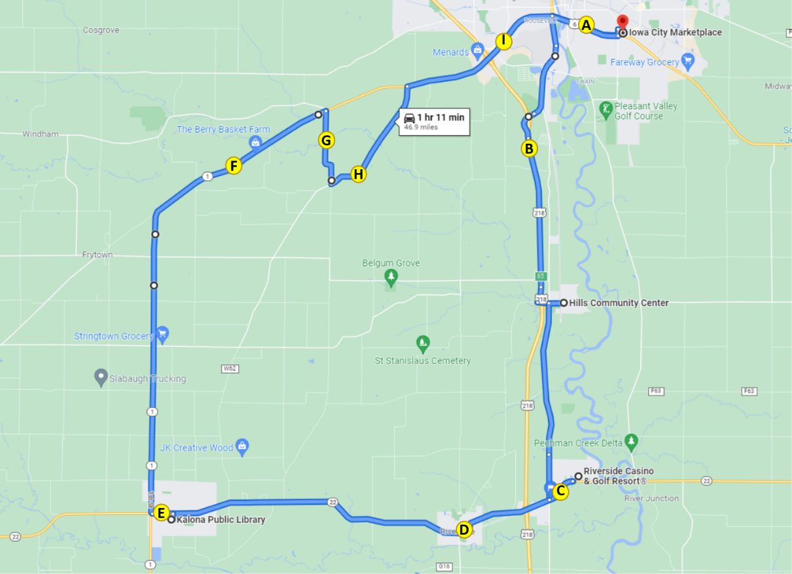
Figure 30. Map indicating locations of anxiety ratings
The average ratings of anxiety across the drive for each participant ranged from 0 to 2.8 with an average across all participants of 0.98 (Figure 31). The location with the highest average ratings of anxiety was after the turn onto Hwy 22 (1.5) and the merge onto Hwy 218 (1.3), locations C and B, respectively. However, the urban portion of the route that contained most of the traffic and lighted intersections (Highway 6 and Highway 1 in Iowa City, locations A and I) had the next highest average ratings (1.258 and 1.0, respectively, Figure 32).

Figure 31. Average ratings of anxiety by occupant

Figure 32. Average ratings of anxiety by location on route
Anxiety ratings were also examined for each occupant based on time of day and starting location; there were no adverse weather conditions for this phase, Figure 33. Environmental conditions such as driving at night may have impacted anxiety ratings. On average, females rated their anxiety higher than males (1.22 vs. 0.78, respectively).

Figure 33. Average anxiety rating by occupant, starting location, and environmental conditions (H = Hills; IC = Iowa City; K = Kalona; R = Riverside)
It is important to remember that things like surrounding traffic and weather conditions may affect these ratings. Also, we are only looking at the data from this phase, which includes a small number of drives and riders. Therefore, additional analyses are needed at the end of the project, taking into account all of the variables that could impact anxiety.

Safety Drivers
There were three dedicated safety drivers for Phase 4. All three drivers are staff at NADS and have completed our safety driver training. Driver 1 drove four of the 10 drives, Driver 2 drove three, and the third driver, Driver 4, drove three. Each was asked to complete a post-drive survey immediately following their drive. These questions were related to their comfort using the automation at different points along the route or during certain environmental conditions.
Results of the survey showed that the drivers were comfortable using the automation on the freeway/highway portion of the route (Figure 34) but felt less comfortable during the more urban roadway segments (Figures 35) as well as on the gravel road (Figure 36). Additionally, there were two drives completed at night. The safety drivers either somewhat or strongly agreed that they were comfortable driving under these conditions.

Figure 34. Safety driver perception of automation while driving on the freeway/highway

Figure 35. Safety driver perception of automation while driving on urban roadways through cities/towns

Figure 36. Safety driver perception of automation while driving on gravel roads
The safety drivers were also asked to indicate how concerned they were about different issues related to highly automated vehicles. Results showed that they were most concerned about the system being confused by unexpected situations and the ability of the system to drive as well as a human driver (Table 10).
Table 10. Safety driver concerns regarding the automation
How concerned are you about the safety consequences of equipment or system failure? | Percent of drives
Not at all concerned | 0%
Slightly concerned | 100%
Extremely concerned | 0%
How concerned are you about the vehicle's ability to interact with non-self-driving vehicles? | Percent of drives
Not at all concerned | 0%
Slightly concerned | 100%
Extremely concerned | 0%
How concerned are you about the vehicle's ability to interact with pedestrians and cyclists? | Percent of drives
Not at all concerned | 30%
Slightly concerned | 70%
Extremely concerned | 0%
How concerned are you about the system's performance in poor weather? | Percent of drives
Not at all concerned | 50%
Slightly concerned | 20%
Extremely concerned | 30%
How concerned are you about the system being confused by unexpected situations? | Percent of drives
Not at all concerned | 0%
Slightly concerned | 60%
Extremely concerned | 40%
How concerned are you about the system not driving as well as human drivers? | Percent of drives
Not at all concerned | 0%
Slightly concerned | 70%
Extremely concerned | 30%

Phase 4 Summary
A substantial portion of the route during this phase was able to be driven in automated mode, greater than 95%. This was possible because the entire route—except for the parking areas—now has the potential to be driven in automation.
Data of specific interest for this phase included:
- How the vehicle handles roads with no lane markings or centerlines and adopts a path more typical of these types of roadways
- Interactions with oncoming traffic
- Impact of driving on gravel on the automation
The ability of the vehicle to drive on roads with no lane markings or centerlines was not an issue for the Transit as it uses high accuracy Global Positioning System with Real Time Kinetic correction, enhancing the precision of the position data and aiding the vehicle’s ability to stay within its lane. On the other hand, getting the vehicle to drive on the gravel road as a human would (i.e., more in the center, to avoid loose gravel on the edges) was a challenge. This was achieved by moving the center line of the lane 18 inches toward the center of the road, which causes the Transit to drive more toward the center line. There were no changes to the lane boundaries or edge of road necessary. Thorough testing of this method showed that it was successful in getting the vehicle to drive in a more naturalistic way.
Still another issue was related to vehicle behavior when oncoming traffic was approaching on the gravel. Typical (and courteous) behavior when driving a gravel road is for both parties to slow and move to the edge of the roadway. The automation can “nudge” itself slightly to the right or left when it encounters an object in its path. It is this feature that we were relying on to address this issue. Figure 37 is the visual element shown in Apollo when a “nudge object decision” is necessary (https://github.com/ApolloAuto/apollo/blob/r5.5.0/docs/specs/dreamview_usage_table.md). The orange zone indicates the area to avoid. For example, Figure 38 shows the view of Apollo from Drive 56, when the Transit encountered the oncoming vehicle on the S-curve. You can see the orange zone that has been identified as an area to avoid. It is important to note that the driver made the decision to disengage the automation for this encounter using their own personal judgement and not relying on the Apollo display. Figure 39 shows the view of Apollo from Drive 53, when the Transit encountered an oncoming vehicle on the straight segment. Notice that for this encounter the automation was not disengaged by the safety driver. Again, the display was only examined after the fact. Disengagements are made in the moment and based on the judgement of the highly trained safety drivers.
It is important to note that a great deal of testing with a confederate vehicle driven by NADS staff took place before the start of this phase to evaluate the system performance and allow the safety drivers to experience the state of the automation. As for every phase, the comfort of the safety driver was paramount, and it was left up to them to determine whether disengagement was necessary.
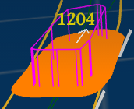
Figure 37. Visual Element – Nudge Object Decision
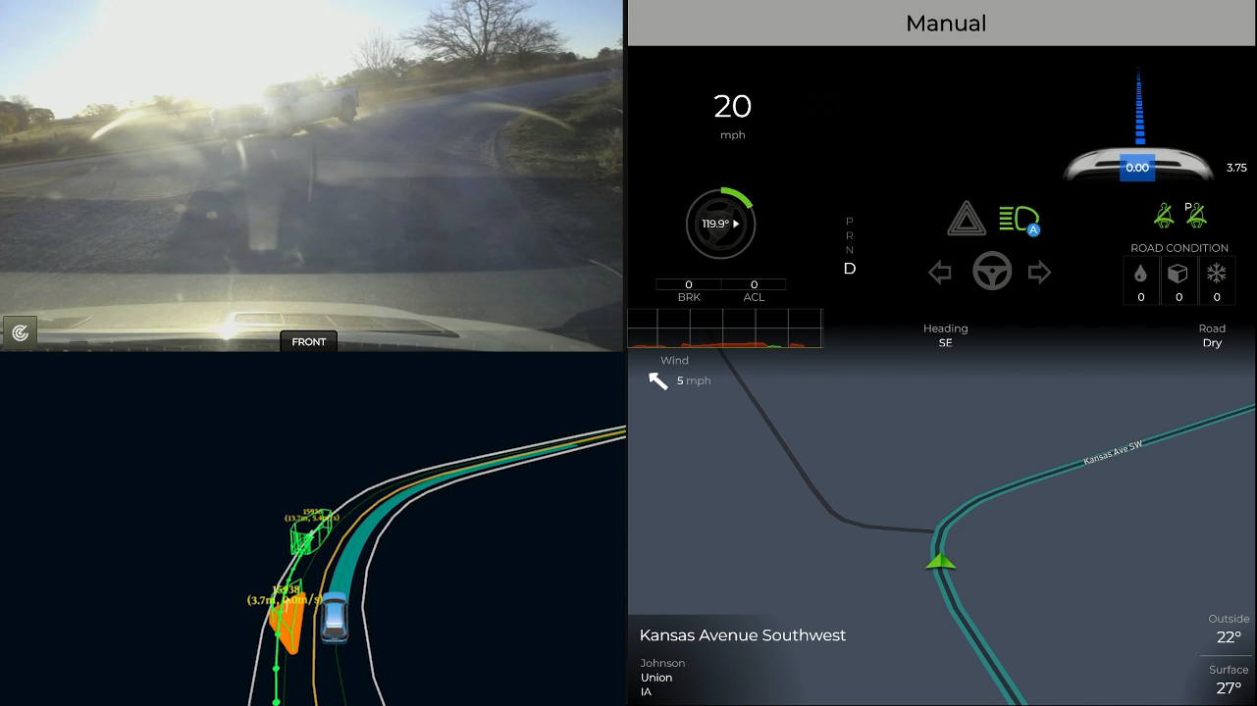
Figure 38. Apollo view from Drive 56 as seen on the co-pilot display (https://www.youtube.com/watch?v=ldujaEljy5g)

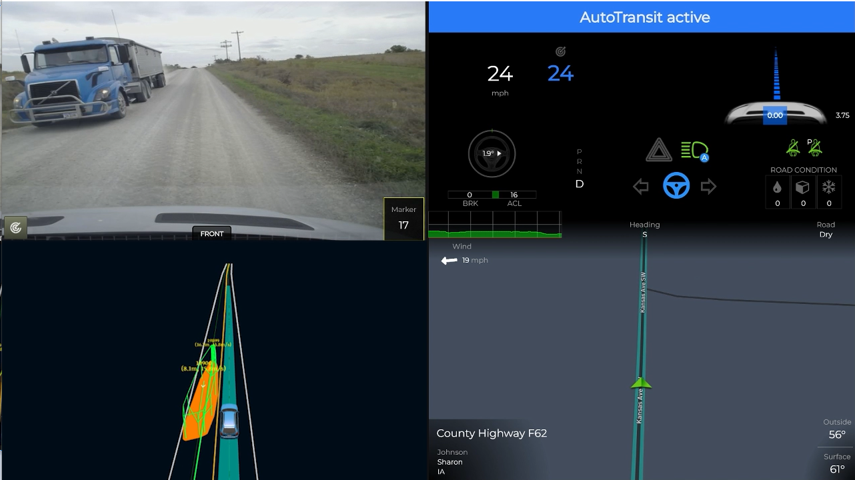
Figure 39. Apollo view from Drive 53 as seen on the co-pilot display (https://www.youtube.com/watch?v=glT6VneWKAg)
Similar to the water spray from Phase 3, gravel dust could be an issue for the LiDAR. The screenshot (Figure 40) was taken from a video recorded during one of the practice drives before the start of Phase 4. It shows the dust being detected by the LiDAR. The top right portion of the screenshot shows that the vehicle does some rather hard braking (see the red arrow) due to the unknown “obstruction” that was being perceived in the road ahead.
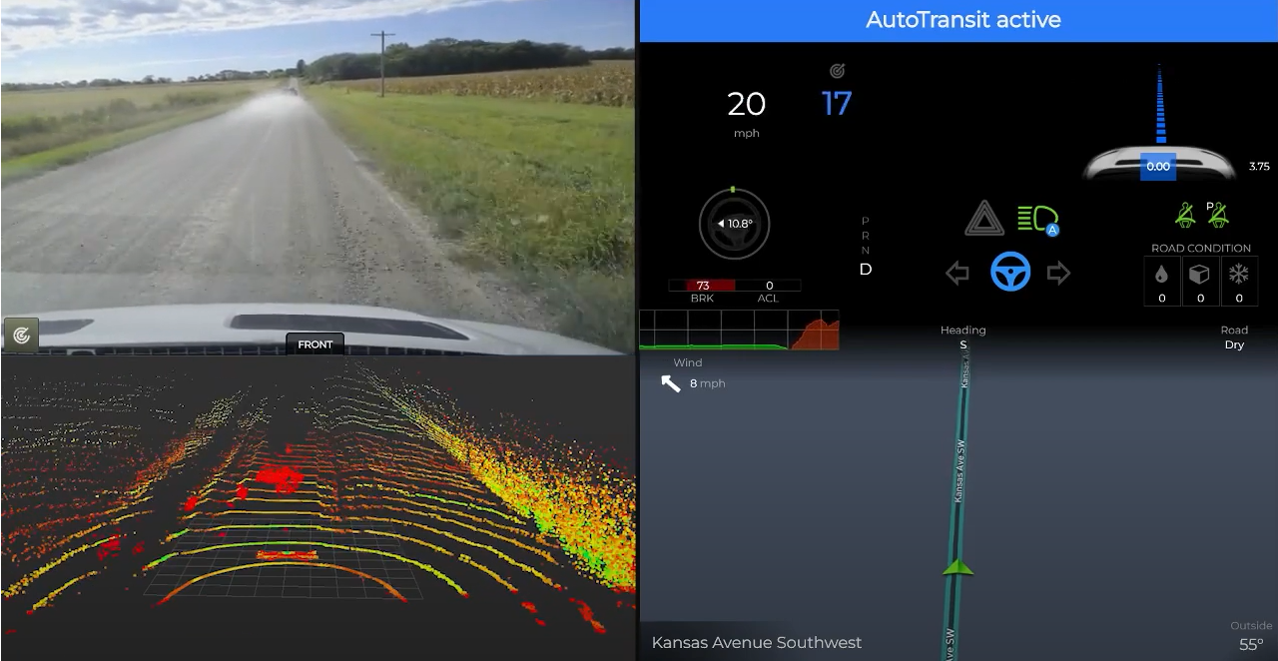
Figure 40. Point cloud showing gravel dust
(https://www.youtube.com/watch?v=TnvRcIBG1rg)

Module Failure Alert
During safety driver testing leading up to Phase 4, there was one instance of the vehicle drifting out of its lane without any indication to the driver that an Apollo module had failed. To mitigate this, the system’s health from a software perspective is now monitored. Apollo’s web-based HMI and interface tool, Dreamview, can subscribe to the output topics (messages) of every Apollo module. The delay in between two consecutive messages is computed and displayed in Dreamview (Figure 41). If the module’s delay is higher than a predefined threshold, the number will be rendered in a red color as a warning to the user. Normally they are rendered in a white color. In this phase, our technology partner AutonomouStuff added an audible warning prompt if the delay for Localization or Perception modules is over 1.5 seconds.
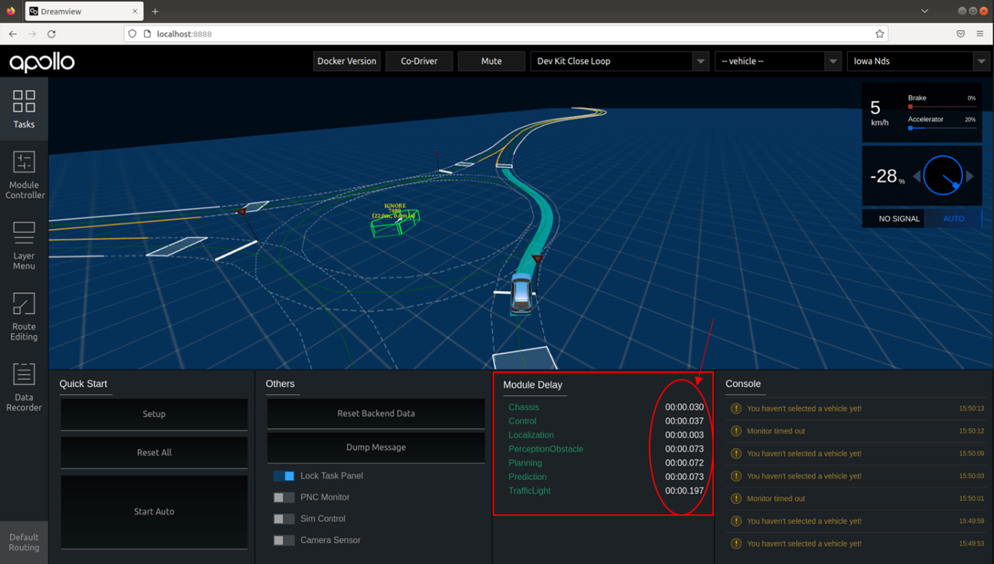
Figure 41. Dreamview showing the delay calculated between consecutive messages

Apollo and Route Options at Intersections
During Phase 3, the route was split into two unique route segments. While this worked to eliminate the loss of automation in Kalona, additional issues were seen in Phase 3 that were due to map crossover or multiple route options at intersections. Therefore, for Phase 4 the route was split further into four segments, requiring the co-pilot to select the appropriate route at each of the four stops. Even with these changes, however, issues were still seen in Hills (Figure 42). This issue resulted in the vehicle wanting to turn right at the intersection during several of the drives. The safety driver would have to take the vehicle out of automation to proceed straight through the 4-way intersection.
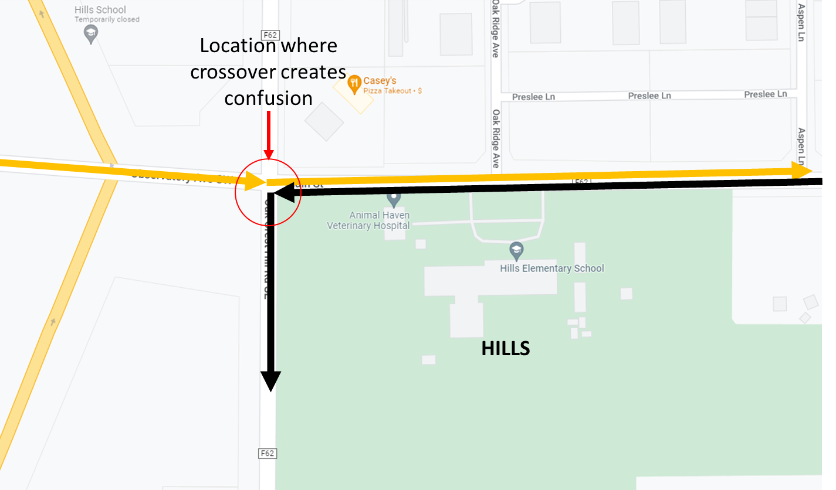
Figure 42. Map crossover issue in Hills

Accomplishments for Phase 4
The following improvements were made to the ADS in Phase 4:
- Full route was broken up into four – one between each stop to avoid the vehicle wanting to turn when the route (i.e., map) crosses itself.
- Widened the lane at the Casino exit to Hwy 22 to aid the vehicle in navigating due to a tight turn radius at that point
- Fixed location of stop line on Hwy 1 at Naples Ave SW (previously 30 m behind)
- Speed in Hills was reduced by 5 mph
- Reduced the speed to 35 mph near Welsh United Church on Sharon Center Rd due to blind hill
- Reduced the speed entering Iowa City on eastbound Hwy 1 from 50 mph to 40 mph
- Max throttle changed from 0.6 to 0.4 to avoid aggressive accelerations/decelerations
- Stop time reduced from 5 to 3 s to improve driver interactions at intersections

Next Steps
As the project continues, we will introduce additional functionality to the vehicle that will improve performance through cities and towns and the gravel road. We will build upon the previous phases and augment the automation with connected vehicle data. Slow-moving and stopped vehicles pose hazards across our nation’s rural roads, particularly on steep grades and around curves. We are attempting to partner with one of the school districts along our route to instrument two of their school buses with on-board telemetry processors. During the drives, the processors will provide location and speed information to the shuttle, enabling it to slow down and/or stop even without direct line of sight. To be successful in these endeavors, we have discussed making the following changes with our technology partners, AutonomouStuff and Mandli Communications, to the automation and digital map to help meet the needs of the next phase.

Map Issues to be Addressed
- Increase speed limit from 25 mph to 35 mph for the lane-change maneuver into the left turn lane going into the casino.
- Initiate turn signal sooner and slow down earlier for the right turn from Hwy 1 to gravel road.
- Two instances of the Transit not “seeing” the traffic light soon enough (Hwy 6 westbound at Sycamore St and Hwy 1 northbound at Naples Ave SW). Reduce speed limits.
- Slow the speed of travel on gravel road through S-curve from 25 mph to 20 mph.

Other Issues to be Addressed
- Acceleration is overly aggressive from driver perspective (RPM) and rider comments.
- Modifications still need to be made to reduce the stop time.

For more information, please refer to the ADS for Rural America Safety Management Plan at adsforruralamerica.uiowa.edu/ADS-safety-plan

