Phase 3 (Urban Driving – Roads through Cities and Towns)

Evaluation Report
Author: Cher Carney, Project Research Lead, cher-carney@uiowa.edu
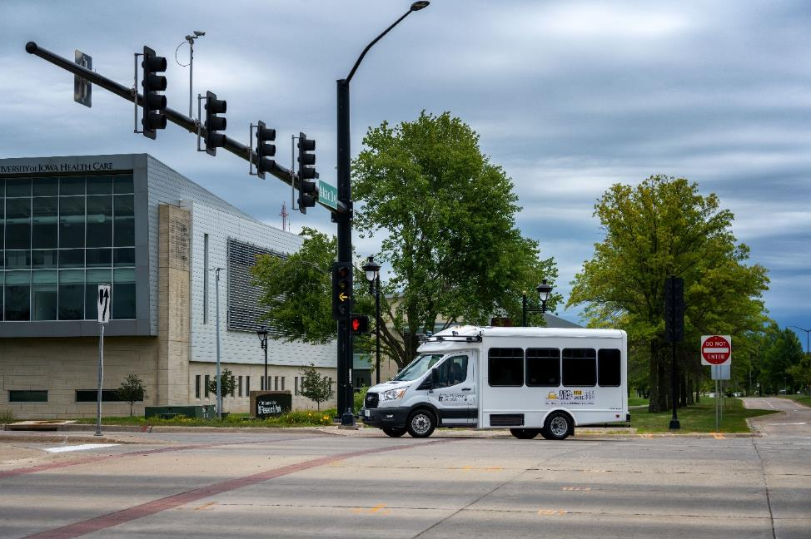
Contents
Introduction 1
Expected Capabilities of the Automation for Phase 3 2
Four-Way Stop Intersections 3
Two-Way Stop Intersections 6
Stop-Controlled Intersections 8
Traffic Signals 11
Automation Engagement by Drive 18
Voluntary Takeover of the Automation 28
Forced Takeover of the Automation 30
Encounters with Vulnerable Road Users (VRUs) 31
Safety Critical Events 31
Occupants for Phase 3 31
Demographics 31
Survey Data 32
Biometric Data 37
Anxiety Ratings 37
Safety Drivers 40
Phase 3 Summary 42
PACMod and Brake Booster Faults 44
Reductions in Data Rate 44
Apollo and Route Options at Intersections 44
Point Cloud 46
Road Construction Along Route 47
Accomplishments for Phase 3 47
Next Steps 47
Map Issues to be Addressed 48
Other Issues to be Addressed 48

Introduction
This project is comprised of six phases shown in Table 1. Each phase will attempt to increase the percentage of the route that is driven under automation. The defined route will be driven in its entirety for each of the project’s phases to show how automation is increasing and to allow for comparison from one phase to the next. During each new phase, the ADS for Rural America project team will also be assessing the automation’s performance and using the data collected to inform improvements in successive project phases.
Phase 1 was completed in November of 2021 on controlled access highways and a divided highway/interstate. A large portion of the route during that phase was able to be driven in automated mode. This was due to a high percentage of the route being interstate/highway driving. However, several issues regarding merging and traveling at highway speeds were identified during that phase.
Phase 2 was completed in March of 2022. The focus of Phase 2 was vehicle navigation along 2-lane undivided highways as well as on- and off-ramps. The traffic on undivided highways travels in opposite directions, has more variable vehicle speeds, and has vehicles that may pass in oncoming traffic lanes. On- and off-ramps were seen as a unique challenge due to the variable geometries and vast differences in speeds of vehicles entering and exiting the highways as well as the unpredictability of driver behavior that can occur in these locations.
Phase 3 built upon Phases 1 and 2, introducing automation on urban roadways and intersections. This included a wide variety of controlled intersections and higher traffic densities across multiple lanes of traffic.
Table 1. Project phases
Phase | Description | Drives Planned | Drives Completed | Date | Status
1 | Controlled Access Roadways | 10 | 10 | 11/2021 | Complete
2 | Highways & Ramps | 20 | 17 | 03/2022 | Complete
3 | Urban Areas | 10 | 13* | 07/2022 | Complete
4 | Unmarked Roads | 10 |  | 10/2022 | Planning
5 | V2X | 10 |  | 01/2023 | Planning
6 | Parking Areas / Full Route | 20 |  | 05/2023 | Planning
Total |  | 80 | 40
*A total of sixteen drives were started in this phase. However, three are missing a portion of the data (Drive 35, 37, and 42). Therefore, only 13 drives were counted for Phase 3.
Thirteen drives were completed as part of Phase 3. These drives took place between June 22 and July 28. They occurred at different times of day and during varying lighting and weather conditions.
Data of specific interest in Phase 2 includes:
- How the vehicle responded to higher traffic densities across multiple lanes of traffic
- Vehicle performance at controlled intersections with traffic signals
- Interactions at controlled intersections with 2-way and 4-way stops
This report will begin by describing vehicle performance along the entire route, both what was expected for Phase 3, as well as what additional capabilities were seen. The data collected for each drive will be summarized, including mileage in automation and figures showing the location of automation activation. A summary of voluntary takeovers by the safety driver, encounters with vulnerable road users (VRUs), and any safety critical events is provided. Data regarding the occupants of the vehicle includes demographic information, survey data, biometrics, and anxiety ratings. A summary of the safety driver survey results, including their perceptions of the automation’s performance is provided as well.

Expected Capabilities of the Automation for Phase 3
For Phase 3, the vehicle was expected to maintain lateral and longitudinal position and navigate intersections via automation that utilized on-board sensors and a high-definition (HD) map of the route and a camera-based system that used a traffic light detection software module.
Automation was activated by pressing the “Engage” button on the steering wheel. Prior to activation, the driver made sure the following conditions were met:
- The vehicle was just below Apollo’s target speed to avoid excessive braking or accelerations.
- The vehicle was in the center of the lane.
- The driver was not providing any input; steering, braking, accelerating, or shifting.
- The driver deemed it safe to engage the automated driving system (ADS). (Considerations for safety include number/proximity of vehicles in the lane and oncoming or adjacent lanes, weather, functionally of automated systems, etc.)
The goal of Phase 3 was to use automation to safely navigate the urban roadways (i.e., State Highway 1 and U.S. Highway 6 in Iowa City) as well as roadways through the cities and towns along the route (Figure 1).

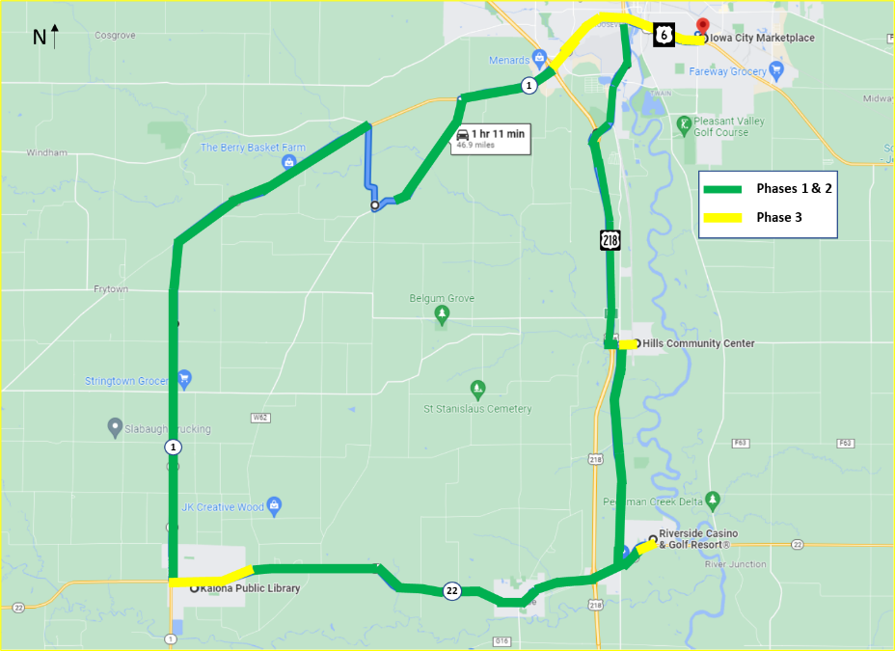
Figure 1. Expected capabilities of the automation (combination of Phases 1 through 3)

As part of Phase 3, the automation was also expected to navigate many types of intersections, including activation of the turn signal. The following sections describe the locations and types of intersections along the route. It is important to note that the safety driver was prepared to take over when they felt that the automation was about to engage in an unsafe maneuver (e.g., pull out in front of oncoming traffic) or if it was taking too long to perform the maneuver and could have potentially caused another vehicle to behave in an unsafe way (e.g., drive aggressively or pass in an intersection). Automation can be intentionally disengaged by the safety driver using multiple methods, which include pressing a button on the steering wheel, taking over steering, pressing the accelerator or brake pedal, or pressing the E-stop button. It is important to note that using the automation at all of these intersections was explored and tested extensively by the safety drivers during pre-Phase 3 test drives. The intersections included are shown in Figures 2 through 20 and are described below. Recall, only 13 drives were counted as complete for this phase. However, data from all 16 of the drives are used in the evaluation when available.

Four-Way Stop Intersections
These types of intersections require that the vehicle stop before the intersection. The vehicle must stop regardless of what direction they are coming from. The vehicle must determine which vehicle arrived at the intersection first to determine right-of-way. The vehicle encounters four of these types of intersections. Figure 2 shows where they occur along the route. Figures 3, 4, and 5 are downloaded images from Google Maps showing the actual intersection.

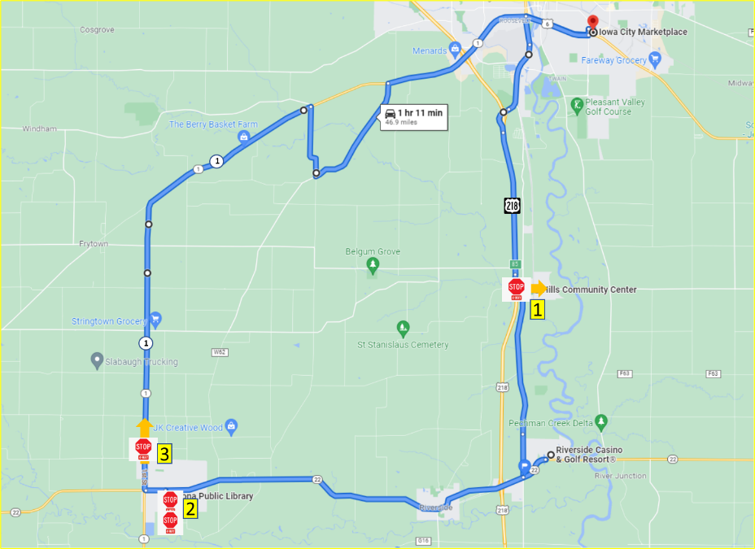Figure 2. 4-way stop intersections in Phase 3

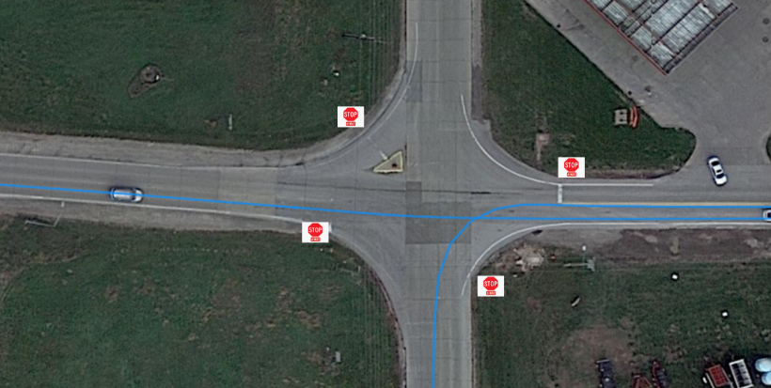
- After the turn onto Observatory Avenue SW, the vehicle stopped at the 4-way stop sign at the intersection of W Main St and Oakcrest Hill Rd SE. If it was considered safe to allow it to do so, the vehicle traveled through the intersection under automation. If not, automation was disengaged. Automation was re-engaged once it was safely through the intersection. Automation was then used for the drive through Hills before it came back to this intersection and stopped at the 4-way stop sign at the intersection of W Main and Oakcrest Hill Rd SE. If it was considered safe to allow it to do so, the vehicle made the left turn from W Main heading south on Oakcrest Hill Rd SE in automation. If not, automation was disengaged and re-engaged once it reached the appropriate speed.
Observatory Ave SW
W Main St
Oakcrest Hill Rd SE

N
Figure 3. 4-way stop in Hills

- In downtown Kalona, the vehicle stopped at the 4-way stop sign at the intersection of B Ave and 5th St. If it was considered safe to allow it to do so, the vehicle made a right turn under automation. If not, automation was disengaged. Automation was re-engaged once the vehicle completed the turn. The vehicle stopped at the next block for the 4-way stop sign at the intersection of 5th St and C Ave. If it was considered safe to allow it to do so, the vehicle made the right turn onto C Ave in automation. If not, automation was disengaged and re-engaged once the turn was complete. After stopping at the Kalona Library, the vehicle went around the block to exit Kalona on B Ave. The vehicle stopped again at the 4-way stop sign at the B Ave and 5th St. This time, if it was considered safe, the vehicle would travel straight through the intersection. If not, the automation was disengaged and re-engaged once it had passed through the intersection.
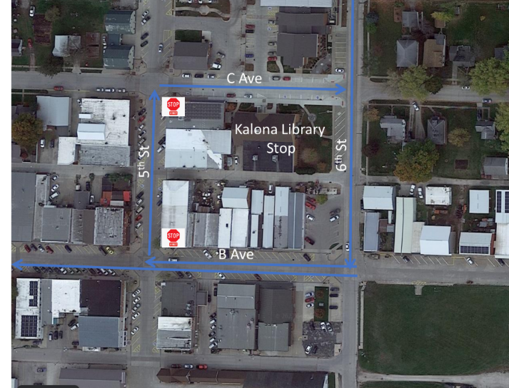
Figure 4. 4-way stops in downtown Kalona
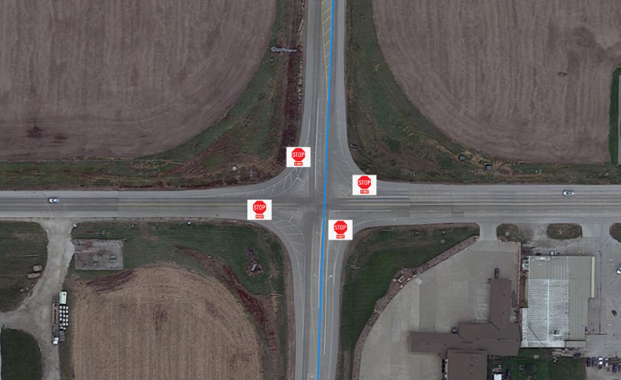
- After the turn onto Hwy 1, the vehicle stopped at the 4-way stop sign at the intersection of Hwy 1 and State Hwy 22/E Ave. If it was considered safe to allow it to do so, the vehicle may have traveled through the intersection. If not, automation was disengaged. It was re-engaged once it reached the appropriate speed.
Hwy 22/E Ave
N
Hwy 1

Figure 5. 4-way stop on Hwy 1

Table 2. Number of 4-way stop intersections completed in automation
4-Way Stop Intersections | Direction of Travel | Number Completed Under Automation/Total Attempted
4-way stop in Hills (travelling east) | Straight | 11/13
4-way stop in Hills (travelling west) | Left | 11/13
4-way stop in downtown Kalona (B Ave/5th St) | Right | 10/14
4-way stop in downtown Kalona (5th St/C Ave) | Right | 14/14
4-way stop in downtown Kalona (B Ave/5th St) | Straight | 11/14
4-way stop on Hwy 1 | Straight | 11/14

Two-Way Stop Intersections
These types of intersections are typically used in areas where one street has a much higher traffic volume than the street it intersects. The vehicle on the minor road is required to stop and wait for a gap in traffic on the major road before proceeding. If two vehicles are stopped the maneuver is complicated by determining which of the stopped vehicles has the right-of-way, particularly if one of the vehicles is left turning. Figure 6 shows the locations of the intersections along the route. Figures 7, 8, and 9 are downloaded images from Google Maps showing the actual intersections.

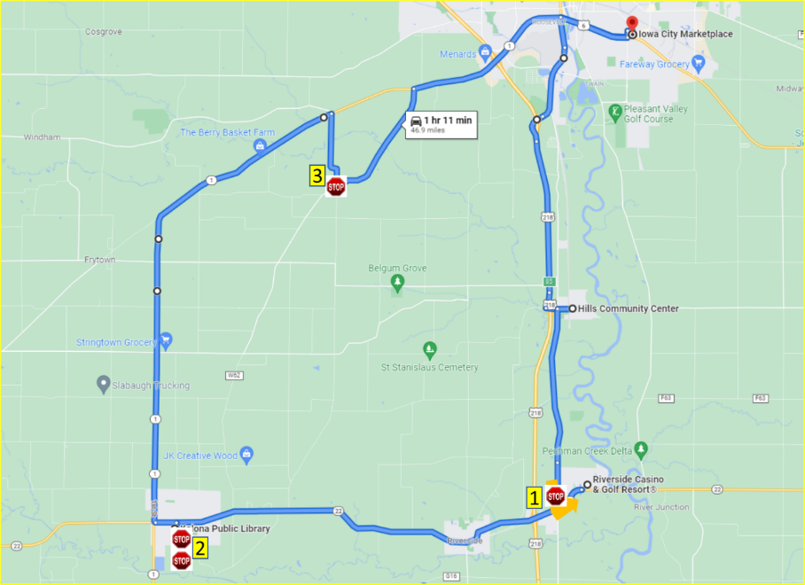
Figure 6. Two-way stop intersection
- The vehicle activated the turn signal and stopped at the stop sign at the intersection of Vine Ave and Hwy 22. If it was considered safe to allow it to do so, the vehicle may have completed the left turn onto Highway 22. If not, the automation was disengaged and re-engaged after the turn.
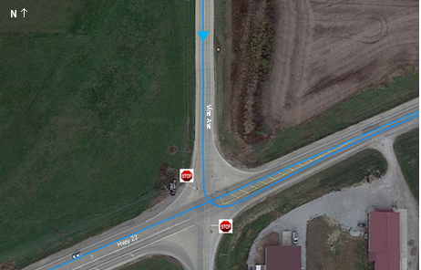
Figure 7. Left turn onto Highway 22
- In downtown Kalona, the vehicle stopped at the 2-way stop sign at the intersection of 6th St and B Ave. If it was considered safe to allow it to do so, the vehicle made a right turn under automation. If not, automation was disengaged. Automation was re-engaged once the vehicle completed the turn. The vehicle made a brief stop at the Kalona Library before continuing along the route. At C Ave and 6th St, the vehicle stopped at the 2-way intersection and if it was considered safe to allow it to do so, the vehicle made the right turn onto 6th St in automation. If not, automation was disengaged and re-engaged once the turn was complete. The vehicle stopped for a second time at the 2-way stop sign at the intersection of 6th St and B Ave and made the right turn in automation if it was considered safe to do so. If not, the automation was disengaged and re-engaged once the turn was complete.
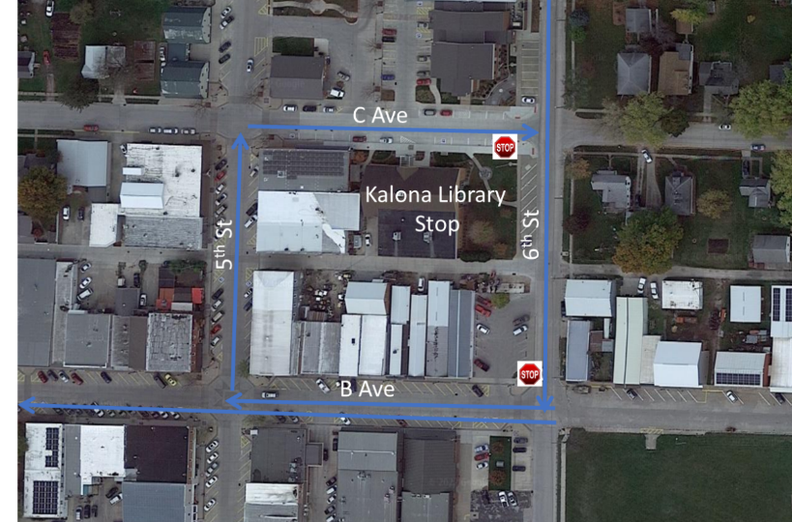
Figure 8. Turns in downtown Kalona
- The vehicle activated the turn signal and stopped at the stop sign at the intersection of Kansas Ave and Sharon Center Rd. If it was considered safe to allow it to do so, the vehicle may have completed the left turn onto Sharon Center Rd. If not, the automation was disengaged and re-engaged once the vehicle reached the appropriate speed.
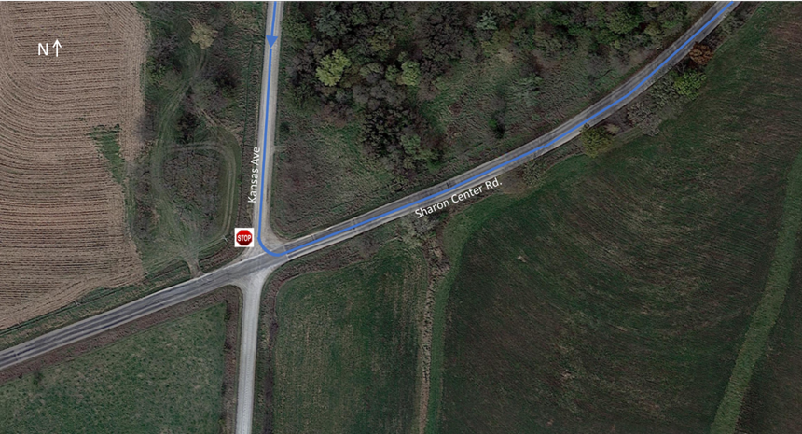
Figure 9. Left turn onto Sharon Center Rd

Table 3. Number of 2-way stop intersections completed in automation
2-Way Stop Intersection | Direction of Travel | Number Completed Under Automation/Total Attempted
2-way stop from Vine Ave to Hwy 22 | Left | 3/13
2-way stop in downtown Kalona (6th St/B Ave) 1st time | Right | 13/14
2-way stop in downtown Kalona (C Ave/6th St) | Right | 11/14
2-way stop in downtown Kalona (6th St/B Ave) 2nd time | Right | 14/14
2-way stop from Kansas Ave to Sharon Center Rd | Left | 11/14
The low number of turns that were completed in automation from Vine Ave to Hwy 22 was due to the limited sight distance of the LiDAR and the speed of the traffic approaching from the left and right (i.e., 55 mph).

Stop-Controlled Intersections
These intersections required the vehicle to come to a complete stop and yield to pedestrians crossing the street and cross-traffic. The vehicle must ensure the intersection is clear and that it will not impede approaching traffic by entering the stop-controlled intersection. There are four intersections of this type along the route. Figure 10 shows the location of the intersections along the route. Figures 11, 12, and 13 are downloaded images from Google Maps showing the actual intersections.
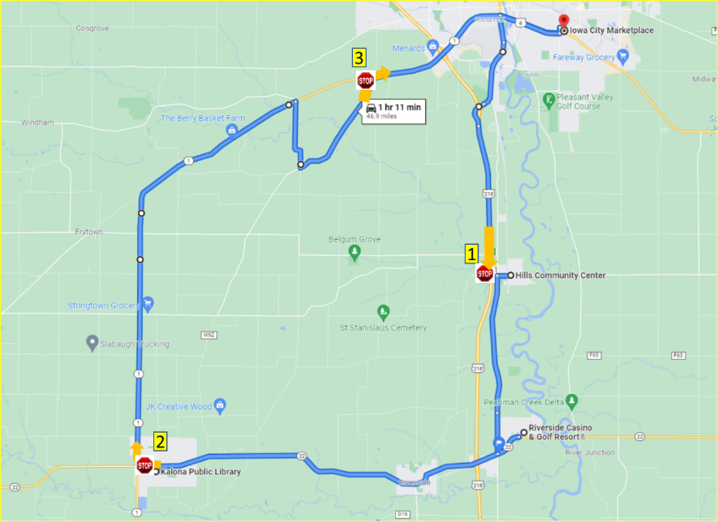
Figure 10. Stop-controlled intersections in Phase 3
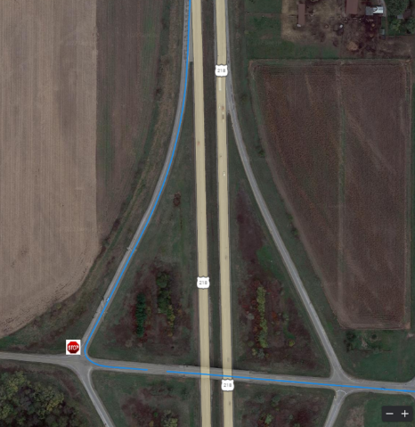
- The vehicle activated the turn signal and exited U.S. Hwy 218. At the end of the off-ramp, the vehicle stopped at the stop sign. If it was considered safe to allow it to do so, the vehicle may have completed the left turn onto Observatory Avenue SW. If not, the automation was disengaged and re-engaged after the turn.
Observatory Ave SW
Figure 11. Left turn after off-ramp
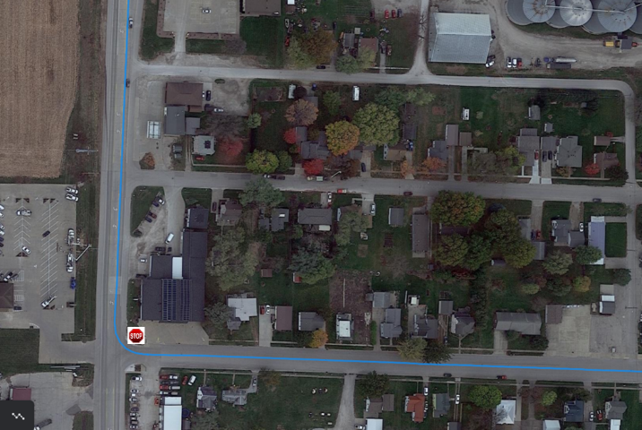
- The vehicle activated the turn signal and stopped at the stop sign at the intersection of B Ave and Hwy 1 while leaving the town of Kalona. If it was considered safe to allow it to do so, the vehicle may have completed the right turn onto Hwy 1. If not, the automation was disengaged and re-engaged after the turn.
Hwy 1

B Ave
N
Figure 12. Right turn onto Hwy 1

- The vehicle activated the turn signal and stopped at the stop sign at the intersection of Sharon Center Rd and Hwy 1. If it was considered safe to allow it to do so, the vehicle may have completed the right turn onto Highway 1. If not, the automation was disengaged and re-engaged once the vehicle reached the appropriate speed.
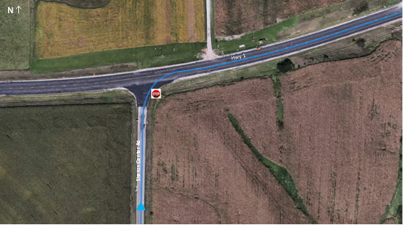
Figure 13. Right turn onto Hwy 1
Table 4. Number of stop-controlled intersections completed in automation
Stop-Controlled Intersections | Direction of Travel | Number Completed Under Automation/Total Attempted
Hwy 218 off-ramp to Observatory Ave | Left | 12/13
2nd St, t Main St | Right | 13/14
B Ave to Hwy 1 | Right | 11/14
Sharon Center Rd to Hwy 1 | Right | 9/14

Traffic Signals
It should be noted that the initial plan was to instrument four lighted intersections with SPaT signals; however, due to changes in the FCC regulations on V2I devices as well as resistance from the municipalities regarding the use of road-side units (RSU), we utilized a camera-based system to identify the state of the traffic signals. This allowed us to use automation to navigate all of the lighted intersections along the route. As part of the camera calibration, it was discovered that the map data had heights of ‘0’ meters for all elements of the map. For 99% of the elements, this is correct, as Apollo does not deal with 3D space in terms of heights correctly. However, traffic light data is an element, and is the only element of an Apollo map that should have positive height values. This is so that the camera/traffic light detection module can draw the correct region of interest (ROI) box on the 2D image plan and thus locate the traffic light bulbs. Therefore, height data was collected, and the necessary changes were made to the HD map to accommodate this phase.

Traffic signals in Iowa City
The vehicle encountered 24 traffic signals when traveling through the Iowa City portion of the route. There are nine traffic signals on Hwy 1 entering Iowa City (Figure 14). For all of these intersections, the vehicle travels straight through the intersection.
- Hwy 1 and Naples Ave SW
- Hwy 1 and the on/off ramps to Hwy 218
- Hwy 1 and Mormon Trek Blvd
- Hwy 1 and Sunset St
- Hwy 1 and Westport Plz
- Hwy 1 and Ruppert Rd
- Hwy 1 and Miller Ave
- Hwy 1 and Orchard St
- Hwy 1 and S Riverside Dr

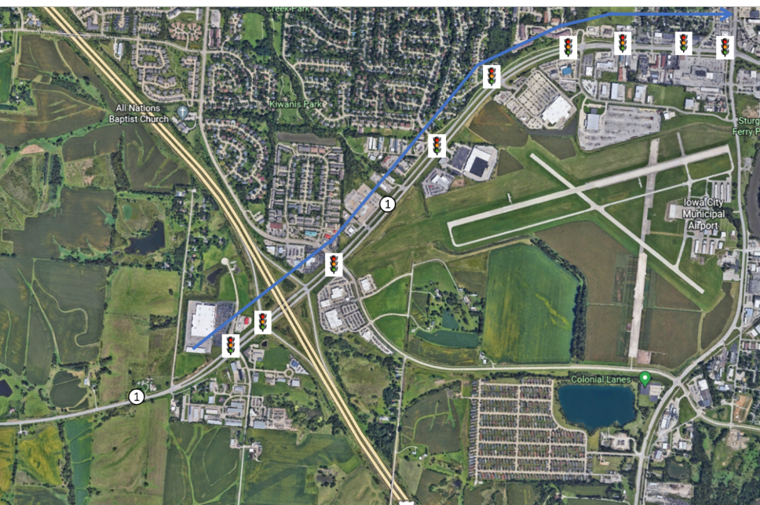Figure 14. Traffic signals on Hwy 1

Once the vehicle travels east past S Riverside Dr, Highway 1 becomes Highway 6 (Figure 15). There are four traffic signals that the vehicle travels straight through while traveling east toward the Iowa City Marketplace and then again after they have completed the stop at the Iowa City Marketplace and are heading west.
- Hwy 6 and S Gilbert St
- Hwy 6 and Boyrum St
- Hwy 6 and Keokuk St
- Hwy 6 and Broadway St
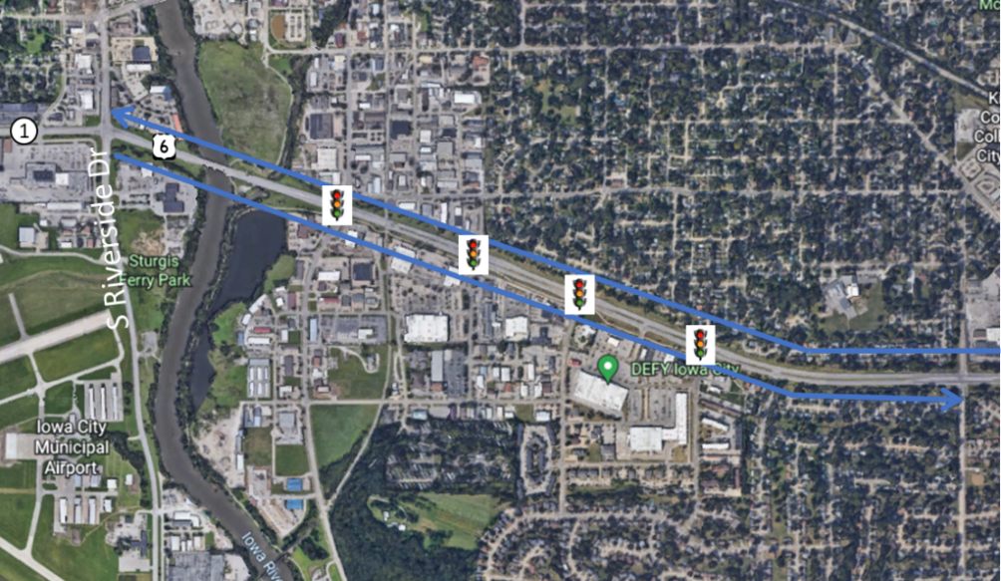Figure 15. Traffic signals on Hwy 6 (driven both east and west)
At the intersection of Hwy 6 and Sycamore St, while heading east, the vehicle encounters a traffic signal with a flashing yellow arrow option in addition to the standard red, yellow, and green (Figure 16). The flashing yellow arrow means drivers are allowed to turn left after yielding to all oncoming traffic and to any pedestrians in the crosswalk. Drivers must wait for a safe gap in oncoming traffic before turning. The vehicle was not able to discern a yellow light from a flashing yellow arrow and therefore would not turn left unless the traffic light was green. When the vehicle approached this light with traffic behind it, the safety driver would take the vehicle out of automation in order to avoid frustrating the driver(s) behind and proceed through the intersection in manual mode.
Leaving the Iowa City Marketplace parking lot, the vehicle turns right at the traffic light onto Lower Muscatine Rd. and then turns right at the next traffic light onto S 1st Avenue. The vehicle then encounters an intersection where traffic turning left must wait for the light, but traffic turning right has only a yield sign (Figure 16).
Additional traffic signals include one at the intersection of Hwy 6 and S Riverside Dr where the vehicle had previously gone straight when heading east, but the route requires that the vehicle make a left turn to head south onto S Riverside Dr (Figure 17).
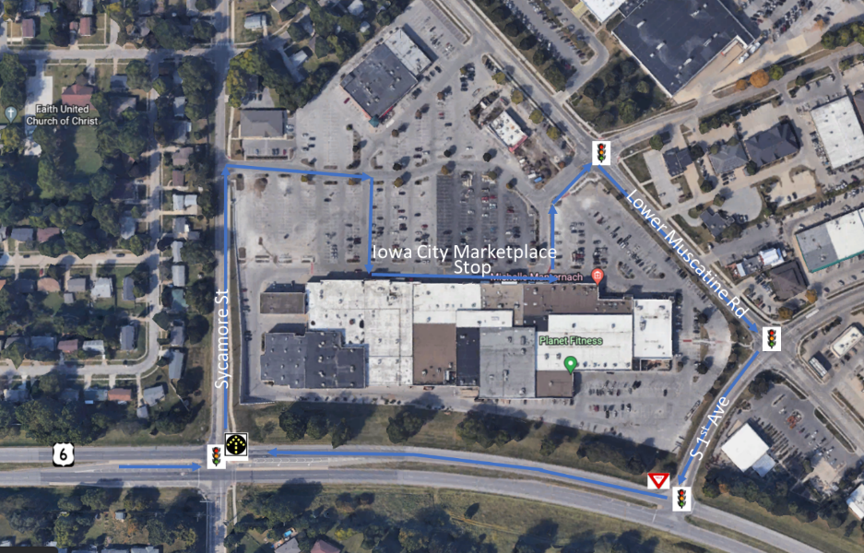Figure 16. Traffic signals around the Iowa City Marketplace
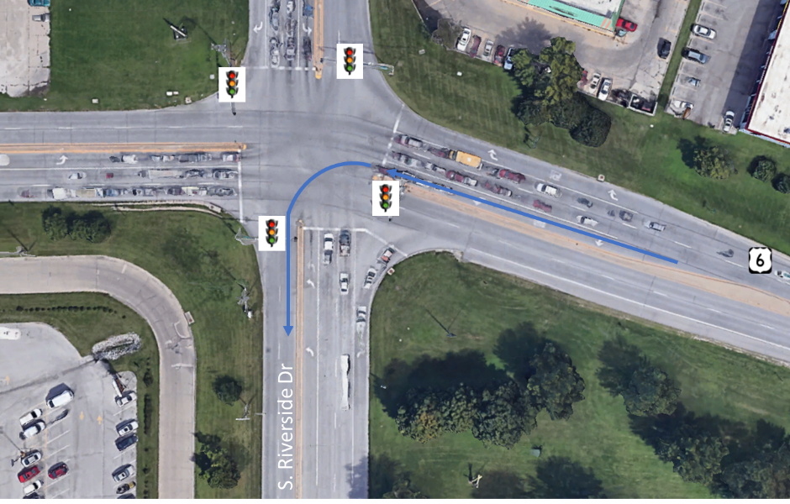
Figure 17. Traffic signal at Hwy 6 and S Riverside Dr
One additional traffic signal was encountered while traveling south on Old Hwy 218 S (previously S Riverside Dr) at the intersection of Mormon Trek (Figure 18). The vehicle traveled straight through this intersection.
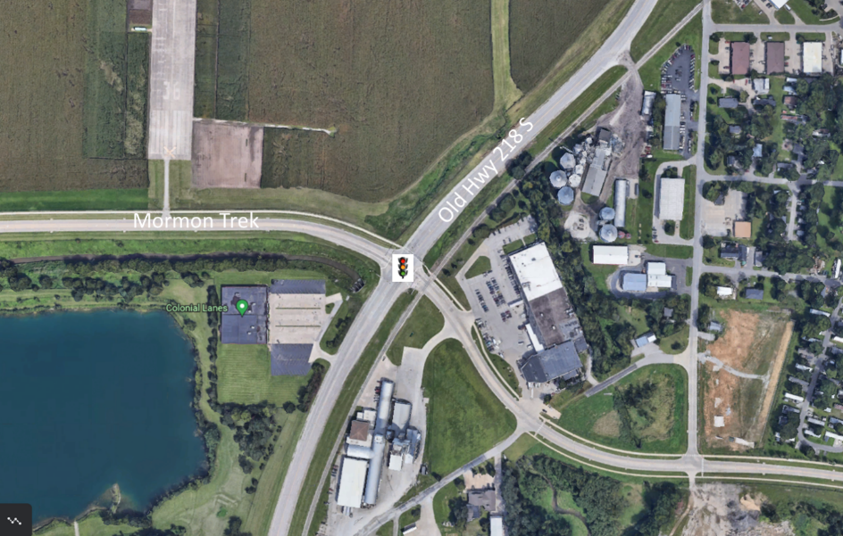
Figure 18. Traffic signal at Old Hwy 218 S and Mormon Trek Blvd

Traffic signals in Riverside
The vehicle encountered a traffic signal on the corner of Hwy 22 and the entrance/exit to Riverside Casino (Figure 19). When entering the casino parking area, the vehicle was expected to make a left turn on solid green, which required it to yield to oncoming traffic. When exiting, the vehicle had to make a right turn back onto Hwy 22. It is important to note that the vehicle is not able to turn right on red. Therefore, it was necessary to sit at the intersection and wait for a green light or, if there was traffic behind the vehicle, it was taken out of automation to take the right turn and red and avoid frustrating the driver(s) behind the vehicle.
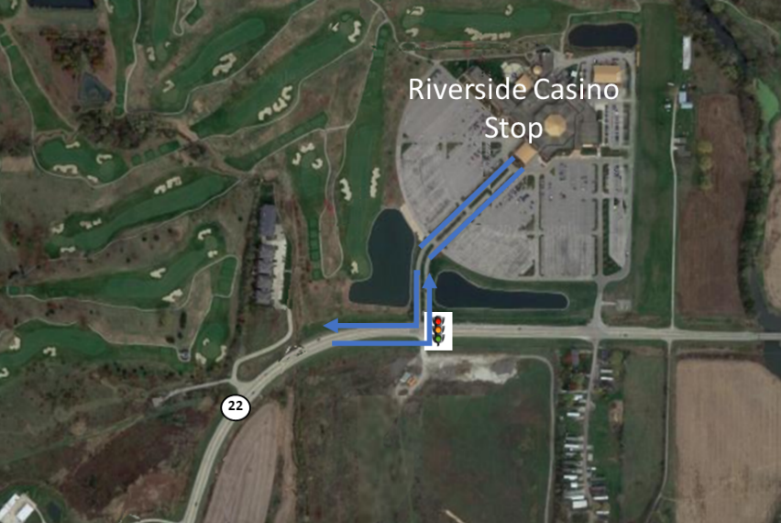
Figure 19. Traffic signal at Riverside Casino

Lighted intersection in Kalona
The vehicle encountered a traffic signal in Kalona at the intersection of E Ave (Hwy 22) and 6th St. The vehicle was expected to make a left turn across traffic.
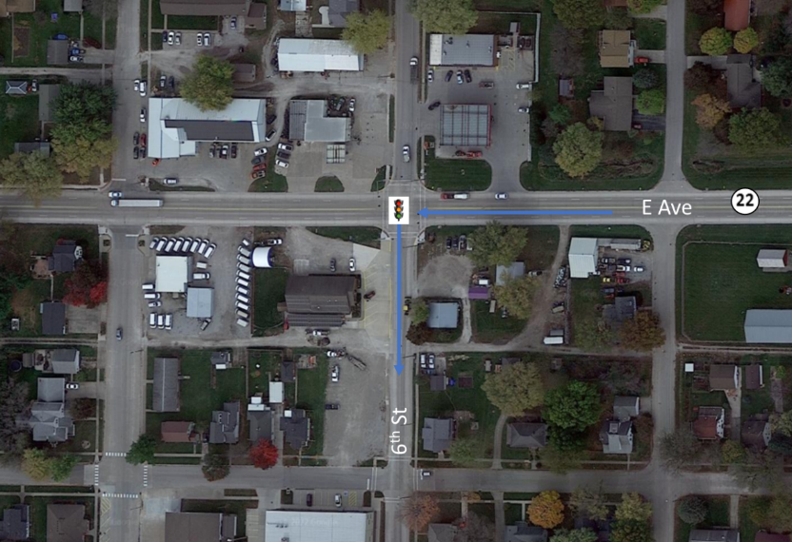
Figure 20. Traffic signal in Kalona
A breakdown of all intersections with traffic signals along the route is shown below in Table 5 as well as the direction of travel and the number of times it was able to navigate the intersection in automation for this phase. As shown, those intersections that require a right or left turn were less likely to be completed under automation. This was most often due the radius/angle of the turn or location of the route on the map.
Table 5. Number of intersections with traffic signals the vehicle completed in automation
Traffic Signals in Iowa City (N=23) |  | Direction of Travel | Number Completed Under Automation/Total Attempted
Hwy 1 and Naples Ave SW |  | Straight | 12/14
Hwy 1 and Hwy 218 ramps |  | Straight | 11/14
Hwy 1 and Mormon Trek Blvd |  | Straight | 13/14
Hwy 1 and Sunset St |  | Straight | 12/14
Hwy 1 and Westport Plz |  | Straight | 14/14
Hwy 1 and Ruppert Rd |  | Straight | 14/14
Hwy 1 and Miller Ave |  | Straight | 12/13
Hwy 1 and Orchard St |  | Straight | 13/13
Hwy 1 and S Riverside Dr |  | Straight | 13/13
Hwy 6 and S Gilbert St |  | Straight | 13/13
Hwy 6 and Boyrum St |  | Straight | 13/13
Hwy 6 and Keokuk St |  | Straight | 12/13
Hwy 6 and Broadway St |  | Straight | 13/13
Hwy 6 and Sycamore St |  | Left | 6/13
Iowa City Marketplace and Lower Muscatine Rd |  | Right | 7/13
Lower Muscatine Rd and S 1st Ave |  | Right | 9/13
S 1st Ave and Hwy 6 |  | Right | 7/13
Hwy 6 and Sycamore St |  | Straight | 12/13
Hwy 6 and Broadway St |  | Straight | 13/13
Hwy 6 and Keokuk St |  | Straight | 13/13
Hwy 6 and Boyrum St |  | Straight | 12/13
Hwy 6 and S Gilbert St |  | Straight | 13/13
Hwy 6 and S Riverside Dr |  | Left | 10/13
Old Hwy 218 S and Mormon Trek Blvd |  | Straight | 11/13
Traffic Signals in Riverside (N=2) | Direction of Travel |  |  | Number Completed Under Automation/Total Attempted
Hwy 22 and Entering Riverside Casino | Left |  |  | 11/13
Exiting Riverside Casino and Hwy 22 | Right |  |  | 3/14
Traffic Signals in Kalona (N=1) | Direction of Travel |  |  | Number Completed Under Automation/Total Attempted
Hwy 22 and S 6th St | Left |  |  | 10/14

Automation Engagement by Drive
Of the sixteen drives that were started in this phase, three are missing a portion of the data (Drives 35, 37, and 42). Therefore, only 13 drives were counted for Phase 3 (see Table 1). However, data from all 16 of the drives will be included in the publicly available dataset and are used in the evaluation of this phase.
Maps showing the locations that automation was engaged are shown below for Drives 31 through 46 (Figures 21 through 36). Roadways where the automation was used are shown in blue. Locations driven manually are shown in green if the safety driver took over from the automation using the button on the steering wheel and in orange if they took over by steering, braking, or accelerating. The percentage of the trip driven using automation varied from 89.3% in Drive 32 to 94.6% in Drive 37.
Start Location | Hills
Number of miles recorded | 48.03
Number of miles recorded in automated mode | 43.81
Percent of drive recorded in automated mode | 91.20%
Amount of data collected (GB) | 103.6
Weather conditions | Avg temp: 91 (F)  Clear: 91%, Clouds: 9%  Average wind speed: 10.7 mph
Time of day | Noon
Day of week | Weekday
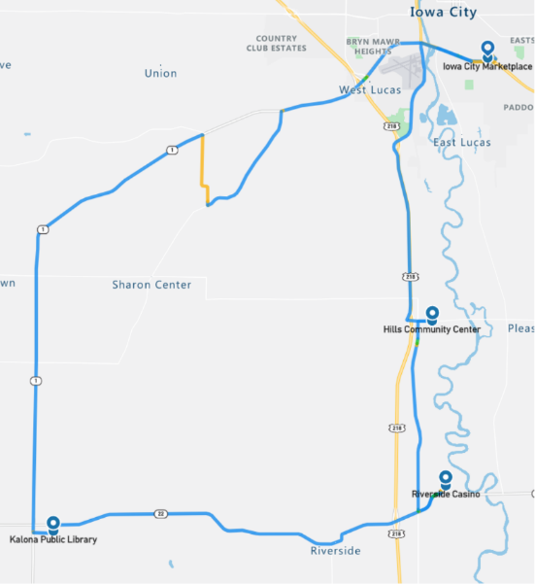
Figure 21. Drive 31 automation engagement (June 22, 2022)

Start Location | Iowa City
Number of miles recorded | 48.03
Number of miles recorded in automated mode | 42.87
Percent of drive recorded in automated mode | 89.30%
Amount of data collected (GB) | 92.0
Weather conditions | Avg temp: 74 (F)  Clear: 82%, Clouds: 18%  Average wind speed: 0.9 mph
Time of day | Dawn
Day of week | Weekday
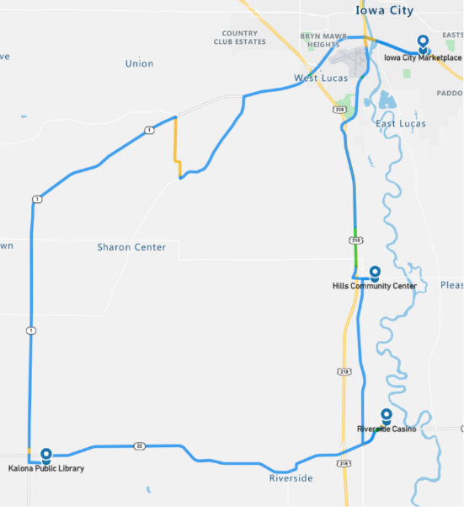
Figure 22. Drive 32 automation engagement (June 23, 2022)

Start Location | Iowa City
Number of miles recorded | 48.03
Number of miles recorded in automated mode | 44.86
Percent of drive recorded in automated mode | 93.40%
Amount of data collected (GB) | 98.9
Weather conditions | Avg temp: 82 (F)  Clear: 100%  Average wind speed: 13.0 mph
Time of day | Mid-morning
Day of week | Weekday
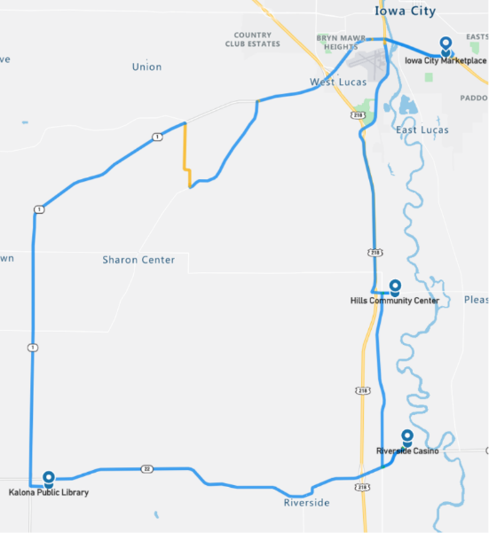
Figure 23. Drive 33 automation engagement (June 28, 2022)
Start Location | Kalona
Number of miles recorded | 48.09
Number of miles recorded in automated mode | 44.24
Percent of drive recorded in automated mode | 92.00%
Amount of data collected (GB) | 96.5
Weather conditions | Avg temp: 74 (F)  Clear: 68%, Clouds: 32%  Average wind speed: 8.7 mph
Time of day | Dawn
Day of week | Weekday
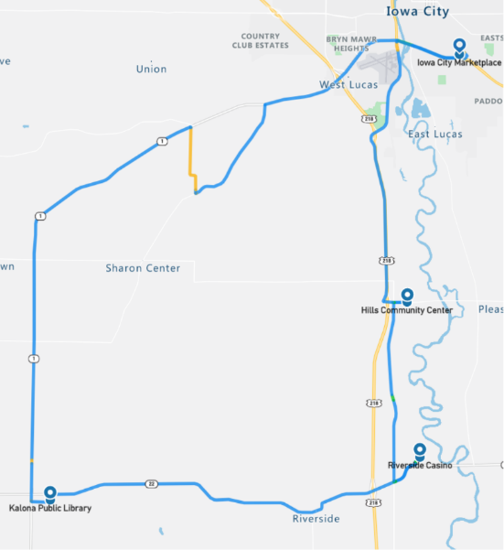
Figure 24. Drive 34 automation engagement (June 30, 2022)
Start Location | Iowa City
Number of miles recorded | 48.03
Number of miles recorded in automated mode | 44.8
Percent of drive recorded in automated mode | 93.30%
Amount of data collected (GB) | 61.1
Weather conditions: | Avg temp: 77 (F) Clouds: 34%, Rain: 66%  Average wind speed: 4.7 mph
Time of day | Noon
Day of week | Weekday
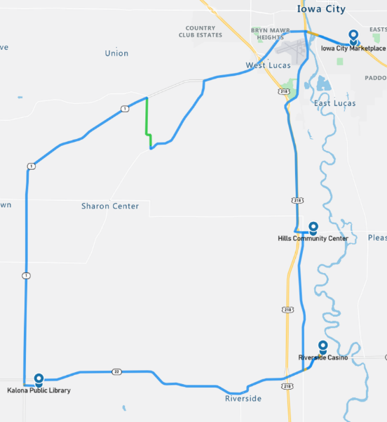
Figure 25. Drive 35 automation engagement (July 1, 2022)
As shown in the map in Figure 25, this drive was completed in its entirety. However, as can be seen in the associated table, the amount of data collected was much less than the other drives in this phase. It was discovered after the drive the ROS bag recording had issues maintaining a normal data rate, manifesting as dropped frames of various pieces of information throughout the drive. Troubleshooting after the drive led us to believe that there may have been an issue during startup that led to CPU overload. Subsequent tests did not manifest a problem.

Start Location | Riverside
Number of miles recorded | 48.03
Number of miles recorded in automated mode | 45.11
Percent of drive recorded in automated mode | 93.90%
Amount of data collected (GB) | 87.8
Weather conditions | Avg temp: 96 (F)  Clear: 88%, Clouds: 12%  Average wind speed: 7.8 mph
Time of day | Night
Day of week | Weekday
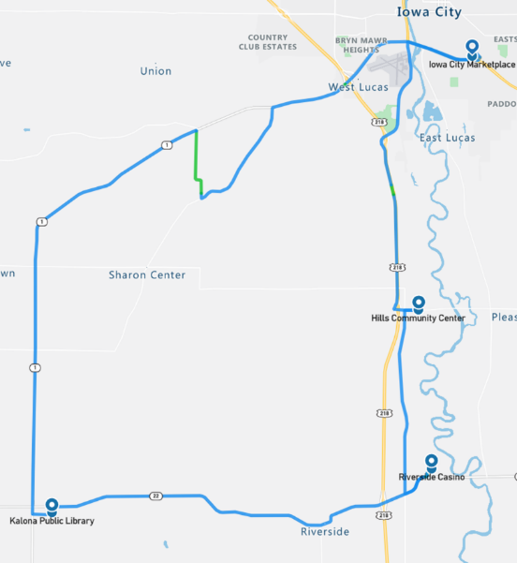
Figure 26. Drive 36 automation engagement (July 5, 2022)

Start Location | Kalona
Number of miles recorded | 48.03
Number of miles recorded in automated mode | 45.42
Percent of drive recorded in automated mode | 94.60%
Amount of data collected (GB) | 51.8
Weather conditions | Avg temp: 85(F) Clouds: 55%, Clear: 45%  Average wind speed: 3.1 mph
Time of day | Night
Day of week | Weekday
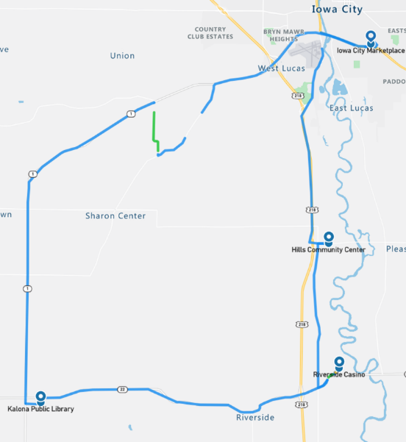
Figure 27. Drive 37 automation engagement (July 6, 2022)
As shown in the map in Figure 27 and the associated table, the issue seen in Drive 35 appeared again, with data frames being dropped and missing from the ROS bag recording. The UI team spent time exploring ways to increase the write buffer and size used in the ROS record call. After a couple of days testing using different settings, it was determined that setting the write buffer to “infinite” would alleviate the issues we saw during Drives 35 and 37.

Start Location | Hills
Number of miles recorded | 48.03
Number of miles recorded in automated mode | 44.99
Percent of drive recorded in automated mode | 93.70%
Amount of data collected (GB) | 100.6
Weather conditions | Avg temp: 76 (F)  Mist: 10%, Haze: 15%, Rain: 1%, Clouds: 74%  Average wind speed: 6.5 mph
Time of day | Mid-morning
Day of week | Weekday
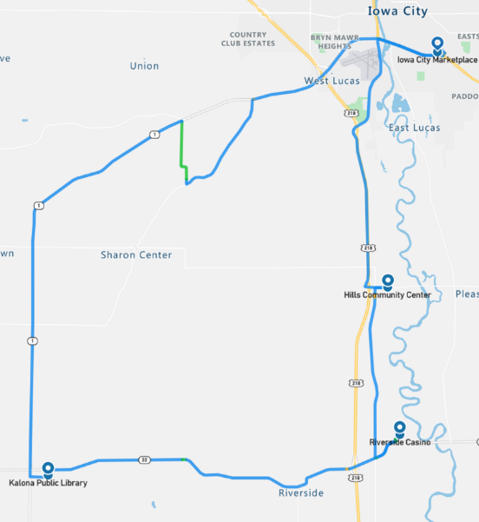

Figure 28. Drive 38 automation engagement (July 8, 2022)

Start Location | Hills
Number of miles recorded | 48.03
Number of miles recorded in automated mode | 45.24
Percent of drive recorded in automated mode | 94.20%
Amount of data collected (GB) | 97
Weather conditions: | Avg temp: 85 (F) Clouds: 63%, Clear: 37%  Average wind speed: 6.7 mph
Time of day | Mid-Afternoon
Day of week | Weekend
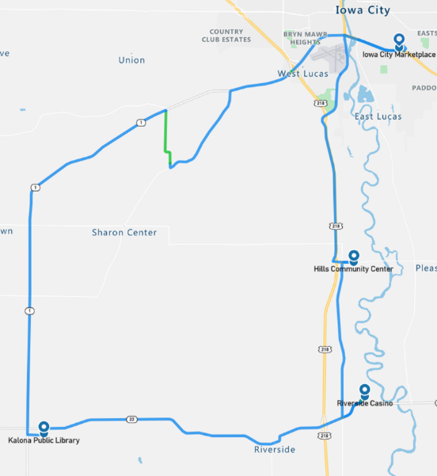
Figure 29. Drive 39 automation engagement (July 9, 2022)

Start Location | Riverside
Number of miles recorded | 48.03
Number of miles recorded in automated mode | 45.17
Percent of drive recorded in automated mode | 94.00%
Amount of data collected (GB) | 88.7
Weather conditions | Avg temp: 76 (F)  Clear: 78%, Clouds: 22%  Average wind speed: 5.8 mph
Time of day | Night
Day of week | Weekday
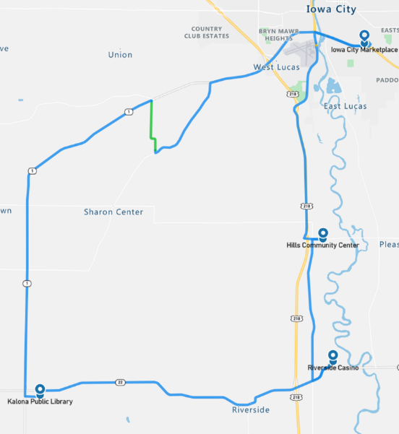
Figure 30. Drive 40 automation engagement (July 12, 2022)
Start Location | Hills
Number of miles recorded | 48.03
Number of miles recorded in automated mode | 44.68
Percent of drive recorded in automated mode | 93.00%
Amount of data collected (GB) | 90.4
Weather conditions | Avg temp: 78 (F) Clouds: 56%, Clear: 44%  Average wind speed: 6.7 mph
Time of day | Night
Day of week | Weekday
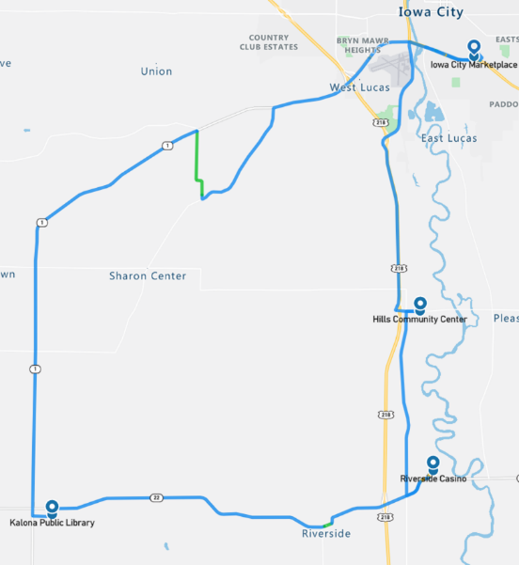
Figure 31. Drive 41 automation engagement (July 13, 2022)

Start Location | Riverside
Number of miles recorded | 30.26
Number of miles recorded in automated mode | 28.21
Percent of drive recorded in automated mode | 93.20%
Amount of data collected (GB) | 78.1
Weather conditions | Avg temp: 82 (F)  Clouds: 100%  Average wind speed: 9.2 mph
Time of day | Mid-afternoon
Day of week | Weekday
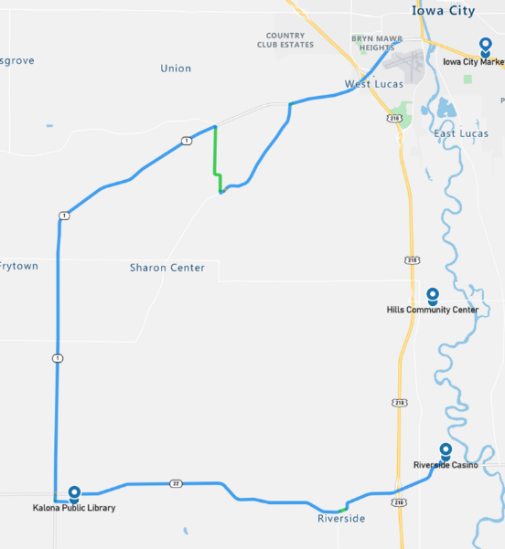Figure 32. Drive 42 automation engagement (July 15, 2022)
As shown in the map in Figure 32, Drive 42 was incomplete, with only 30.26 miles of the approximately 48 miles loop being recorded. Through testing it was determined that once the ROS buffer would overflow (a direct result of an “infinite” buffer), not only would the recording fail, but the TCP/IP stack of the host PC would quickly reset. This would cause subsystems like Apollo’s localization to temporarily go offline. Removing the specified buffer from the ROS record command fixed the possibility of the overflow but meant that there was the potential to have the same issues that occurred during Drives 35 and 37. Therefore, additional testing was done using the logical drives as storage, specifically testing the rates of different data transports. Testing confirmed that a locally-attached solid state drive cleared all recording problems. The rest of the drives in Phase 3 were recorded using the local drive instead of the Network Attached Storage (NAS) unit, mounted using the Network File System (NFS) protocol that had been previously used.

Start Location | Kalona
Number of miles recorded | 48.03
Number of miles recorded in automated mode | 44.49
Percent of drive recorded in automated mode | 92.60%
Amount of data collected (GB) | 86.1
Weather conditions | Avg temp: 84 (F)  Clear: 66%, Clouds: 34%  Average wind speed: 8.5 mph
Time of day | Night
Day of week | Weekday
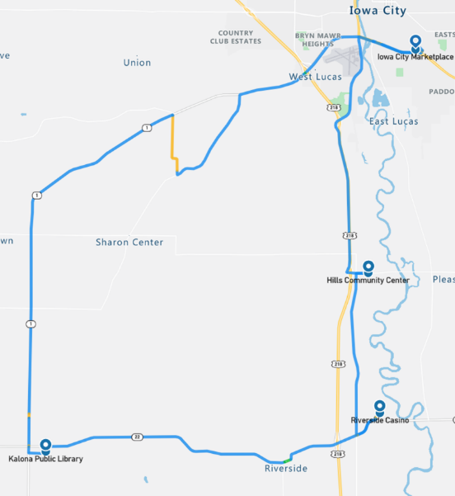

Figure 33. Drive 43 automation engagement (July 19, 2022)

Start Location | Iowa City
Number of miles recorded | 47.97
Number of miles recorded in automated mode | 43.62
Percent of drive recorded in automated mode | 90.90%
Amount of data collected (GB) | 102.9
Weather conditions | Avg temp: 92 (F)  Clear: 68%, Clouds: 32%  Average wind speed: 11.4 mph
Time of day | Noon
Day of week | Weekday
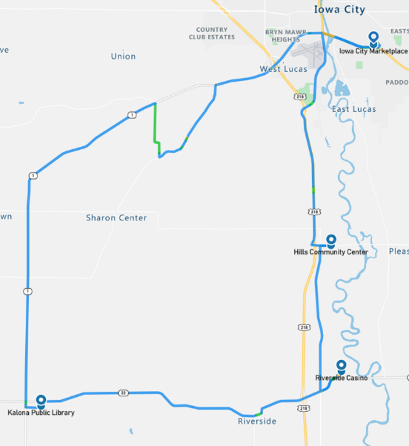
Figure 34. Drive 44 automation engagement (July 22, 2022)

Start Location | Iowa City
Number of miles recorded | 48.03
Number of miles recorded in automated mode | 44.43
Percent of drive recorded in automated mode | 92.50%
Amount of data collected (GB) | 90.8
Weather conditions | Avg temp: 83 (F)  Clear: 100%  Average wind speed: 7.2 mph
Time of day | Dawn
Day of week | Weekend
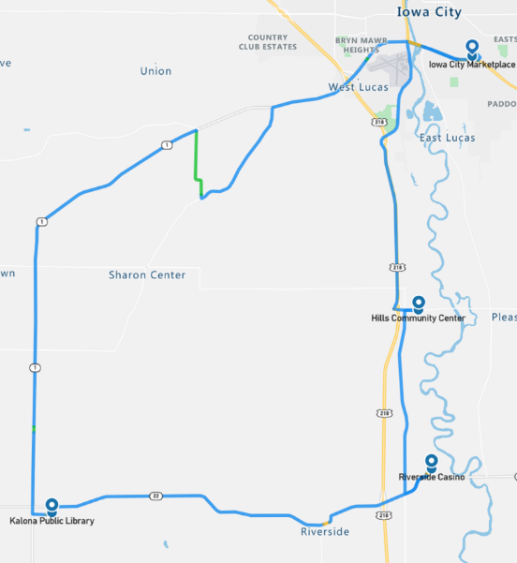Figure 35. Drive 45 automation engagement (July 23, 2022)

Start Location | Riverside
Number of miles recorded | 48.03
Number of miles recorded in automated mode | 43.87
Percent of drive recorded in automated mode | 91.30%
Amount of data collected (GB) | 100
Weather conditions | Avg temp: 81 (F) Clouds: 84%, Clear: 16%  Average wind speed: 12.3 mph
Time of day | Mid-afternoon
Day of week | Weekday
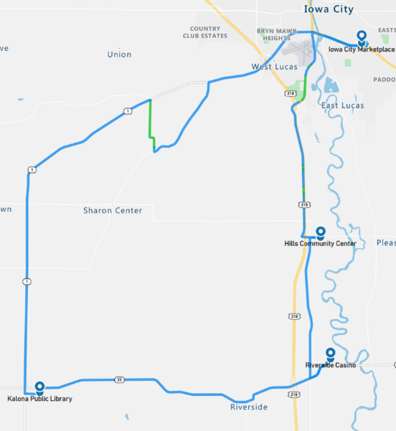
Figure 36. Drive 46 automation engagement (July 28, 2022)

Overall, the number of miles driven in automation by federal function classification (FFC) of road types is shown per drive below (Figure 37). For this phase, approximately 90% or more of the miles classified as principal and minor arterials and major and minor collectors were driven in automation (Figure 38). The exception to this is Drive 42 were the automation dropped out for a large part of the drive that included the roadways classified as principal arterials and major collectors. The roads through the towns of Hills and Kalona are considered local and are being driven in automation when possible. However, note that the gravel road and parking lots, which are considered “local” and “other,” respectively, were not expected to be driven in automation for this phase, explaining the lower percentage of completion for these road types (Figure 38).
Figure 37. Miles driven in automated mode by FCC road type

Figure 38. Percentage of FCC road type completed in automation (average across phase)

Voluntary Takeover of the Automation
Safety drivers disengaged the automation for a variety of reasons. The preferred method of disengagement was to press the button located on the steering wheel. However, when necessary, turning the steering wheel, pressing the accelerator or brake pedal, or pressing the E-stop button may have been a more suitable and safer method. When the automation was disengaged, the copilot would flag the data using the informational display and record the reason for the disengagement using a voice recorder. There were 283 voluntary takeovers flagged by the co-pilot (Table 6).
Table 6. Frequency and type of voluntary takeovers
Reason for disengagement | Number of instances
To complete turn - vehicles approaching | 31
To park | 30
To cross RR tracks | 29
To complete turn - Transit stops in middle of intersection | 24
Unsafe lane change | 23
Drive through parking lot | 18
Parked vehicle in lane | 18
To make a right/left turn | 16
To stop at a traffic signal | 15
To travel on gravel road | 14
Abrupt braking - unknown reason | 11
Inappropriate response at traffic light | 10
To slow/stop for traffic ahead | 7
Map crossover issue | 6
Work zone | 6
To make a right turn on red | 5
Abrupt braking - vehicle cut-in | 4
A vehicle passing the transit | 3
Oncoming traffic is in our lane of travel | 2
To avoid an object on the roadway | 2
To avoid crossing center line when making a right turn | 2
To proceed through flashing yellow | 2
Vehicle crossing path | 2
Vulnerable road user | 2
To pass a slow-moving vehicle | 1

The majority of the voluntary takeovers (31%) happened in instances where the automation was not mature enough to handle specific traffic situations at intersections or traffic signals.
- The largest number of disengagements were due to the vehicle starting to make a turn with traffic approaching from the right or left at a high speed. The safety driver was tasked with making the call as to whether intervention was necessary and had to take into consideration the tentativeness of the Transit with respect to the distance and speed of the approaching traffic.
- Other disengagements were due to the vehicle’s inability to make a right turn on red or a left turn on flashing yellow. Many times, the safety driver waited for the light to cycle to a solid green to allow the vehicle to take the turn in automation. However, when there was traffic behind the vehicle, it was sometimes necessary to takeover and make the turn manually to avoid annoying the surrounding driver(s).
- Takeovers also occurred when the vehicle stopped abruptly in the middle of an intersection. It is possible that, if left long enough, the vehicle would have eventually made its way through the intersection. However, this was considered unsafe and was therefore taken out of automation so that the safety driver could complete the turn without negatively impacting the surrounding traffic.
- There were several instances when the automation did not correctly recognize the state of the traffic signal (e.g., started to move when the light was red or failed to stop at a yellow light). In some of these instances, the vehicle may have been picking up the incorrect signal, one to the right or left of the signal for the vehicle’s lane of travel. These instances required immediate takeover from the safety driver.

The urban section of roadway on Hwy 6 required the driver to make two lane changes, one traveling east and one west. Completing lane changes in automation was oftentimes not possible due to the amount of surrounding traffic or the speed of traffic approaching from behind in the left lane. In these instances, the safety driver would take over and complete the lane change manually, before re-engaging the automation.
While driving through downtown Kalona, it was often necessary to disengage automation. The angle parking in this area combined with narrow streets meant that some vehicles, particularly large pickup trucks, extended into the vehicle’s lane of travel causing it to brake abruptly. It would occasionally be able to continue very slowly, but more often than not it required the safety driver to disengage and cross the center line in order to steer around the parked vehicle.
Traveling through parking lots or having the vehicle park itself is not something that the automation is capable of handling yet. We will attempt this in Phase 6 of the project (Table 1). Therefore, when parking lots were approached or the vehicle was being parked at specific destinations, the system was disengaged. This was also the case for the gravel road, which is not planned to be driven by the automation until Phase 4.
The urban section of roadway on Highways 1 and 6 has multiple traffic signals and a speed limit of 50 mph for most of it. This was problematic because the vehicle would attempt to achieve the speed limit between each traffic light, even if the light ahead was red. This caused a lot of aggressive acceleration followed by aggressive braking between traffic signals. Also, traffic already stopped at the light made the stopping distance shorter and the braking even more aggressive. Therefore, the safety driver would take over and stop more gradually for the traffic signal. A similar situation occurred between the consecutive railroad crossing in Hills and due to the short amount of distance between them. It was determined that automation would not be used to cross the railroad tracks in this phase.

Forced Takeover of the Automation
Situations where the automation disengages on its own or becomes unavailable and requires the driver to intervene are called forced takeovers. There were three instances of these during Phase 3. On two occasions, after engaging the automation the vehicle put itself into “park”. Both instances occurred at different locations and under varying environmental conditions. The other instance requiring a takeover occurred during a left turn from Kansas Ave to Sharon Center Rd (i.e., the gravel road to the unmarked blacktop road). The vehicle failed to come to a complete stop at the intersection and was in the middle of the turn when the automation disengaged itself. All three instances were investigated and the reason for the disengagements is still unknown.

Encounters with Vulnerable Road Users (VRUs)
Flags were placed in the data to identify interactions with vulnerable road users (e.g., horse and buggies, ATVs, bicycles, pedestrians) located either within the lane boundary or on the shoulder on either side of the road. There were 127 interactions while the vehicle was traveling in automation and 40 while the vehicle was being driven manually (Table 7).
Table 7. Encounters with VRUs in automated and manual mode
In Automated Mode | In Manual Mode
- 49 pedestrian  - 19 bicycle  - 12 farm equipment  - 11 parked vehicle on shoulder  - 10 horse and buggy  - 5 construction  - 5 ATV/golf cart  - 5 object in roadway  - 4 utility vehicle  - 3 police/emergency vehicle  - 2 animal  - 1 scooter  - 1 vulnerable road user (unknown) | - 32 pedestrian  - 3 construction  - 2 farm equipment  - 1 police/emergency vehicle  - 1 animal  - 1 parked vehicle on shoulder

Identifying where these interactions occur allows a comparison between how these situations are handled by the driver in manual mode and how the automation handles them. Another important reason for identifying the VRU encounters is to be able to investigate how the perception module classifies these objects.

Safety Critical Events
These events include interactions that require abrupt accelerations/decelerations or large steering wheel reversals by the automated vehicle (AV), the safety driver, or another vehicle and may or may not be classified as a near crash. Crashes are also included in this category. There were no safety critical events recorded in Phase 3, and no near-crashes or crashes.

Occupants for Phase 3

Demographics
Thirty-two adults over the age of 65 as well as those over the age of 25 with mobility or visual impairments were recruited to ride the vehicle. Table 8 provides the demographic breakdown by age, gender, and impairment. One occupant used a wheelchair and three reported using a walker, cane, or crutches; the remaining two reported having difficulty walking or climbing stairs. Two participants required hand controls to drive. One of the occupants had a low vision impairment (i.e., visual acuity less than 20/70). Thirty-eight percent (12 out of 32) have some type of visual restriction on their driver’s license (glasses or corrective lenses). However, these restrictions are not severe enough to cause these occupants to be considered visually impaired. And 34% (11/32) reported having difficulty hearing.
Table 8. Demographics of occupants
Age | Unimpaired |  | Mobility Impaired |  | Visually Impaired |  | Hearing Impaired
 | Male | Female | Male | Female | Male | Female | Male | Female
25-34 |  |  | 1
35-44
45-54
55-64
65-74 | 7 | 6 |  | 3 |  | 1 | 3 | 2
75-84 | 6 | 5 |  |  | 1 |  | 3 | 1
85-94 | 2 |  | 1 |  |  |  | 1
95+ |  |  |  | 1 |  |  |  | 1
Total | 15 | 11 | 2 | 4

The sample is highly educated, with 94% of occupants having some education beyond a high school degree, and 67% (20 out of the 30 who responded) have a household income greater than $50,000. All occupants own or have access to a vehicle. Typically, occupants drive themselves where they need to go with approximately 59% reporting driving themselves daily and 28% driving themselves a few times a week. All of the occupants have a driver’s license.
Nearly 35% of the occupants in Phase 3 own or have access to a vehicle that has either adaptive cruise control (ACC) and/or lane keeping/lane centering. About 64% of those with ACC and about 40% with lane keeping reported using it frequently. A majority (59%) also reported that when it comes to trying new technology, they generally fall in the middle (e.g., not first or last to try). About 88% reported owning or using a smart phone. Ninety-seven percent reported that they own a desktop or laptop computer, and everyone reported having access to the internet. A majority, 66%, reported that they use some form of social media, and 59% own or use a tablet. Occupants agreed that they like to use technology to make tasks easier (84%) but were more split regarding whether they wanted a car with all the latest technology features (31% disagree vs. 44% agree).

Survey Data
While riding in the AV, occupants were asked to complete both a pre- and post-drive survey regarding their trust and acceptance of highly automated vehicles. This type of vehicle was defined as one that is “capable of driving on its own in some situations but is aware of its limitations and calls for the driver to take over when necessary.” When asked to indicate how they felt about different statements, a greater percentage of occupants after their ride in the vehicle “somewhat or strongly agreed” that they could trust highly automated vehicles (60% pre-drive vs. 75% post-drive, Figure 39) and believed that they were reliable (63% pre-drive vs. 81% post-drive, Figure 40).

Figure 39. Trust in highly automated vehicles, pre- and post-drive

Figure 40. Reliability of highly automated vehicles, pre- and post-drive
After their ride in the vehicle, a greater percentage of occupants reported that they are not worried about riding in a highly automated vehicle (78% pre-drive vs. 94% post-drive, Figure 41) and believed that they are safer than manually driven vehicles (40% pre-drive vs 57% post-drive, Figure 42). Interestingly though, a slightly higher percentage believed that automated vehicles might cause crashes (25% pre-drive vs. 34% post-drive, Figure 43).

Figure 41. Worried about riding in a highly automated vehicle, pre- and post-drive

Figure 42. AVs safer than manual vehicles, pre- and post-drive

Figure 43. AVs might cause crashes, pre- and post-drive
Phase 3 specifically focused on the ability to use automation on urban roadways, driving through cities and towns. The safety driver used the automation on these road types whenever they deemed it safe to do so. Therefore, occupants were able to experience traveling on this type of road under both automated and manual driving during their trip. The percentage of occupants who indicated that they agreed either “strongly” or “somewhat” that they would trust a highly automated vehicle on city streets after the drive was complete did not change much with exposure (78% pre-drive vs. 82% post-drive, Figure 44). Nor was there a change in trust of the automation to drive in congested traffic (59% pre-drive vs. 60% post-drive, Figure 45). However, the percentage who “strongly agreed” increased by 15% and 16% post-drive, respectively.

Figure 44. Trust of highly automated vehicle to drive on city streets pre- and post-drive

Figure 45. Trust of highly automated vehicle to drive in congested traffic pre- and post-drive
The only significant difference in the occupants’ trust in automation pre-drive vs. post-drive was regarding the automation’s ability to drive on the interstate/highway (78% pre-drive vs. 97% post-drive, Figure 46).

Figure 46. Trust of highly automated vehicle to drive on the interstate/highway pre- and post-drive
Occupants were also asked questions about perceived usefulness and their intention to use highly automated vehicles. When asked to report whether they were “open to the idea of riding in a highly automated vehicle,” 91% of occupants both before and after the ride indicated that they somewhat or strongly agreed with the statement. However, the percentage who “strongly agreed” decreased by 22% post-drive (Figure 47).

Figure 47. Openness to riding in a highly automated vehicle
When asked whether they thought highly automated vehicles would allow them to stay more involved in their communities or enhance their quality of life/well being, there were no differences between how they felt pre- and post-drive (69% pre-drive vs. 66% post-drive and 65% pre-drive vs. 65% post-drive, respectively).

Biometric Data
A medical grade wearable device was worn by each of the occupants as well as the safety driver for each of the eighteen drives. The device has a sensor which measures blood volume pulse (BVP), from which heart rate variability can be derived, as well as a sensor that measures the constantly fluctuating changes in certain electrical properties of the skin (galvanic skin response or GSR). Ten minutes of baseline data was collected before the start of each drive.

Heart Rate Variability (HRV)
Heart rate variability is said to indicate physiological stress or arousal, with increased stress being indicated by a low HRV.

Galvanic Skin Response (GSR)
Increases in GSR activity can indicate stress/anxiety as well as other emotions such as anger, disgust, fear, happiness, surprise, and extreme sadness.
This data will not be analyzed for this summary report; however, it will be available in its raw form through the data access portal.

Anxiety Ratings
Occupants were also asked to provide a rating of their anxiety level from 0 to 10, with 0 being “not at all anxious.” These ratings were given at nine specific locations along the drive that were the same for each participant, although they did vary in the order they were given depending on the starting location for the drive. Figure 48 is a map showing where each of these ratings occur along the drive. A pre-drive anxiety rating was obtained for everyone before the drive began. Rating locations included the following:
- Hwy 6 in Iowa City
- After merge onto Hwy 218
- After turn onto Hwy 22
- Business district of Riverside
- Downton Kalona
- Hwy 1 rural
- Gravel road
- Unmarked blacktop road
- Hwy 1 intersection
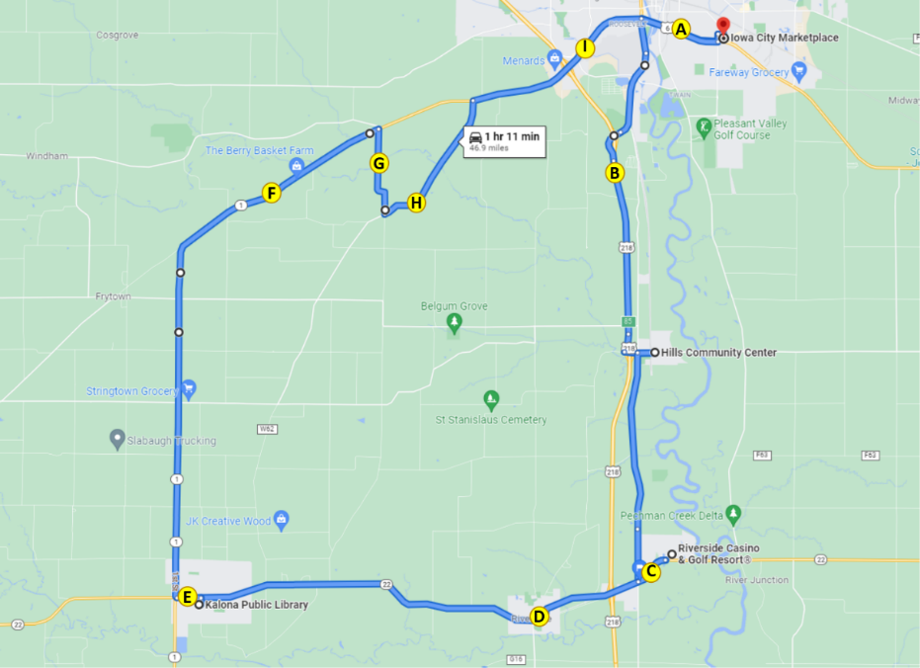
Figure 48. Map indicating locations of anxiety ratings
The average ratings of anxiety across the drive for each participant ranged from 0 to 7.8 with an average across all participants of 1.2 (Figure 49). The location with the highest average ratings of anxiety was after the merge onto Hwy 218 (1.59). However, the urban portion of the route that contained the majority of traffic and lighted intersections (Highway 6 and Highway 1 in Iowa City) had the next highest average ratings (1.38 and 1.32, respectively, Figure 50).

Figure 49. Average ratings of anxiety by occupant
Figure 50. Average ratings of anxiety by location on route
Anxiety ratings were also examined for each occupant based on weather conditions, time of day, and starting location (Figure 51). The environmental conditions such as rain or driving at night may have had an impact on ratings of anxiety. On average, females rated their anxiety higher than males (1.53 vs. 0.86, respectively).

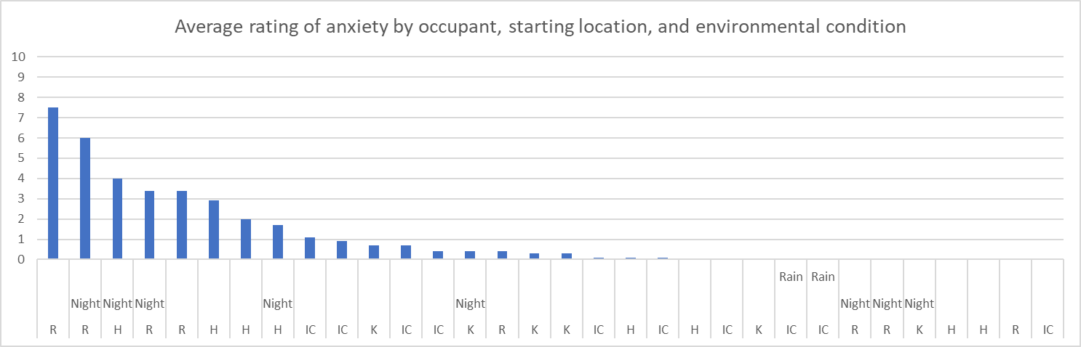
Figure 51. Average anxiety rating by occupant, starting location, and environmental conditions (H = Hills; IC = Iowa City; K = Kalona; R = Riverside)
It is important to remember that things like surrounding traffic and weather conditions may affect these ratings. Also, we are only looking at the data from this phase, which includes a small number of drives and riders. Therefore, additional analyses are needed at the end of the project, taking into account all of the variables that could impact anxiety.

Safety Drivers
There were three dedicated safety drivers for Phase 3. All three drivers are staff at NADS and have completed our safety driver training. Driver 1 drove six of the 16 drives, Driver 2 drove five, and the third driver, Driver 4, drove five. Each was asked to complete a post-drive survey immediately following their drive. These questions were related to their comfort using the automation at different points along the route or during certain environmental conditions.
For Phase 3, automation was used for most of the drive. Results of the survey showed that the drivers were comfortable using the automation on the freeway/highway portion of the route but felt less comfortable during the more urban roadway segments (Figures 52 and 53).

Figure 52. Safety driver perception of automation while driving on the freeway/highway

Figure 53. Safety driver perception of automation while driving on urban roadways through cities/towns
There were five drives completed at night as well as three drives completed when there was precipitation and wet roadways. The safety drivers either somewhat or strongly agreed that they were comfortable driving at night as well as while it was raining or the road was wet.
The safety drivers were also asked to indicate how concerned they were about different issues related to highly automated vehicles. Results showed that they were most concerned about the system being confused by unexpected situations and the ability of the system to drive as well as a human driver (Table 9).
Table 9. Safety driver concerns regarding the automation
How concerned are you about the safety consequences of equipment or system failure? | Percent of drives
Not at all concerned | 6%
Slightly concerned | 88%
Extremely concerned | 6%
How concerned are you about the vehicle's ability to interact with non-self-driving vehicles? | Percent of drives
Not at all concerned | 6%
Slightly concerned | 75%
Extremely concerned | 19%
How concerned are you about the vehicle's ability to interact with pedestrians and cyclists? | Percent of drives
Not at all concerned | 13%
Slightly concerned | 75%
Extremely concerned | 13%
How concerned are you about the system's performance in poor weather? | Percent of drives
Not at all concerned | 38%
Slightly concerned | 63%
Extremely concerned | 0%
How concerned are you about the system being confused by unexpected situations? | Percent of drives
Not at all concerned | 6%
Slightly concerned | 63%
Extremely concerned | 31%
How concerned are you about the system not driving as well as human drivers? | Percent of drives
Not at all concerned | 19%
Slightly concerned | 50%
Extremely concerned | 31%

Phase 3 Summary
A large portion of the route during this phase was able to be driven in automated mode, greater than ninety percent. This was possible because most of the route consists of the highway and urban roadways that made up Phases 1–3. As the project continues, we will introduce additional functionality to the vehicle that will allow it to drive the last remaining miles in automation as we include the smaller sections of the route, such as gravel roads and parking lots.
Data of specific interest in this phase included:
- How the vehicle responded to higher traffic densities across multiple lanes of traffic
- Vehicle performance at controlled intersections with traffic signals
- Interactions at controlled intersections with 2-way and 4-way stops
The ability of the vehicle to drive through cities and towns very much depended on the density of the traffic. Anecdotally, the safety drivers reported that less traffic surrounding the vehicle tended to correspond with fewer disengagements as the vehicle is more likely to be able to change lanes in automation as well as travel through controlled and uncontrolled intersections much easier. A video analysis could be used to determine location and density of traffic for particular types of disengagements to verify that statement. However, that is out of the scope of this demonstration project.
Other traffic being present in front of the vehicle while approaching traffic signals was helpful in reducing or eliminating the abrupt declarations felt when approaching lighted intersections. With traffic ahead, the vehicle’s LiDAR perception and planning would take over and bring the vehicle to a stop according to the rate of deceleration of the lead vehicle. Without traffic ahead, deceleration would begin when the traffic signal state was detected and at a rate that was pre-determined by the system, which was determined to be much too aggressive by the safety drivers. It should be noted that aggressive acceleration was also seen at the traffic signals as the vehicle would attempt to reach the posted speed in between signals. This aggressive acceleration followed by aggressive deceleration was commented on by occupants of the vehicle. Investigation into the max throttle will take place and inform any changes to be made to the system for Phase 4 to reduce the acceleration/deceleration profile.
The vehicle was unable to handle left turns at intersections with a blinking yellow arrow. The safety driver would either take the vehicle out of automation to complete it manually or wait for the traffic signal to cycle to a green arrow to proceed. An investigation into Apollo showed that the traffic light detection code only handles blinking lights for green or red lights. Therefore, the blinking yellow light is treated as the stage before a red light (i.e., one in which the vehicle comes to a stop) instead of treating it as an unprotected turn (e.g., only had a green light)—in which case the vehicle would proceed when safe to do so. For the next phase, the goal is to properly detect and mark the state for a blinking yellow light and to determine whether to implement this as a “Proceed with Caution” situation or “Unprotected Green Traffic Light” situation.
The vehicle was able to travel straight through a lighted intersection 95% of the time and to complete right or left turns at a traffic signal 60% of the time. There were ten instances in which the automation had an inappropriate response to a traffic signal. These included:
- 1 instance when the stopped vehicle started to go on a red light
- 3 instances when the vehicle did not appear to be stopping for a red light
- 2 instances when the vehicle did not appear to be stopping for a stale yellow light
- 2 instances when the vehicle appeared as though it was going to turn in front of oncoming traffic
- 2 instances when the vehicle did not go on a green arrow when it was safe to do so
One potential cause for these types of inappropriate responses could be the camera-based traffic signal detection system that is being used by the vehicle. It is possible that it could be seeing the wrong signal head (i.e., the traffic light to the right or left) depending on whether the vehicle is entering a turning lane or is offset in its lane to one side or the other. For example, the state of the signal for the rest of the lanes may be green while the state of the signal in the left turn lane may be red or flashing yellow. In either case, a different response would be expected by the vehicle.
There were also 24 instances in which the vehicle braked suddenly while attempting to make a turn at a traffic signal. The automation did not disengage, and the vehicle may have been able to proceed through the intersection. However, this braking would occur mid-turn and for the safety of the vehicle and other traffic, the safety driver took over from the automation in order to complete the maneuver. The reason for this behavior was determined to be the inability of the path planning module to be able to iteratively converge to a solution given its constraints, which caused it to “give up.”
Two-way and 4-way stop-controlled intersections were completed in automation successfully 23% and 83% of the time, respectively. The 2-way intersection encountered along the route required the vehicle to make a left turn after yielding to traffic approaching from the right and left at a speed of 55 mph. It was difficult for the vehicle to handle the speed of the approaching traffic and would often not perceive it or perceive it too late, requiring the safety driver to take the vehicle out of automation by braking to avoid pulling out in front of traffic. Four-way stops were much easier for the vehicle to handle, especially when the other traffic came to a complete stop and did not roll forward or tire of waiting for the tentative start of the Transit and enter the intersection.
The unexpected events that encountered in this phase included 3 system deactivations, including 2 instances when the vehicle placed itself into “park” and 1 where the automation disengaged during the middle of a turn. These events required intervention on the part of the safety driver, as the vehicle is not able to manage all conditions and has no fallback behavior that enables it to achieve a minimal risk condition. All three of these instances were investigated but no cause was determined. Other events that impacted drives during this phase included the PACMod faults that delayed the start of data collection, the dropping of data during three of the drives (35, 37, and 42), and the issue of the map overlapping itself in Hills, Riverside, and Iowa City. We also had an interesting interaction with sprinklers on the side of the road as well as construction along the route (both of which are discussed later in the report).

PACMod and Brake Booster Faults
During the testing leading up to the start of Phase 3, several brake booster faults were experienced. When the brake booster fails it loses its ability to amplify the force of your foot to the brake, requiring you to use significantly more pressure. These types of failures occurred when the automation was applying the brakes and the safety driver was attempting to take control from the automation, either via the brake or the button on the steering wheel. Clearing the fault could only be accomplished by cycling the ignition on and off. After more than a month of collecting data and investigating, AutonomouStuff discovered that the brake booster responds with a fault if the rate of change during brake release is above a certain rate. This rate is calculated over a short period of time, approximately 50ms. AutonomouStuff was able to provide an update to the PACMod firmware that would reduce the chances of the fault occurring in the first place and immediately reset the brake booster if it were to occur. During our own extensive testing, we experienced additional PACMod failures, however none resulted in loss of the brake booster. Satisfied with the results of the firmware update, data collection for Phase 3 was started.

Reductions in Data Rate
As described earlier in the report, during Drives 35 and 37 the data rate was severely reduced resulting in “stuttering” and missing data points. While the overall data was captured, including passenger video, the normal data rate was not achieved. Initial testing to determine the cause found that there was a misconfigured NFS network drive mount to the Quantum from the Spectra PC. However, the reason for the errors being intermittent and not consistent is still unknown.

Apollo and Route Options at Intersections
During Phase 2, automation was lost for several drives due to crossover or overlapping of the path in Kalona. To eliminate this issue for Phase 3, the route was split into two unique route segments. While this worked to eliminate the loss of automation in Kalona, additional issues were seen in Phase 3 that were due to map crossover or multiple route options at intersections (Figures 54, 55, and 56). These issues included abrupt braking at the point of crossover or activation of the turn signal at the incorrect point along the route. This occurs because in every path planning cycle, the planning module needs to determine the route segment that the vehicle is currently on. The candidate route segments for the search includes the whole list of route segments, from the current segment to the last routing segment. If one route segment exists more than once in the list because of crossover or overlapping, path planning may skip the route segments between them. To solve this issue, the loop will be broken into four individual routes. The copilot would then manually select the appropriate route at each of the four stops. This would eliminate any route crossing over itself and the vehicle wanting to make a wrong turn—similar to what was happening in Kalona.

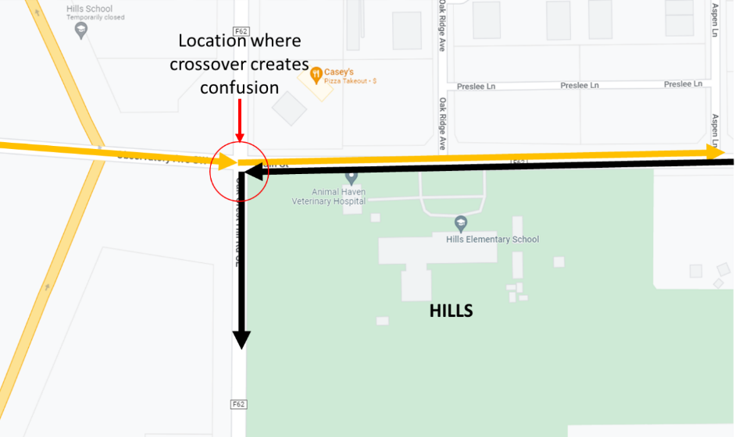
Figure 54. Map crossover issue in Hills
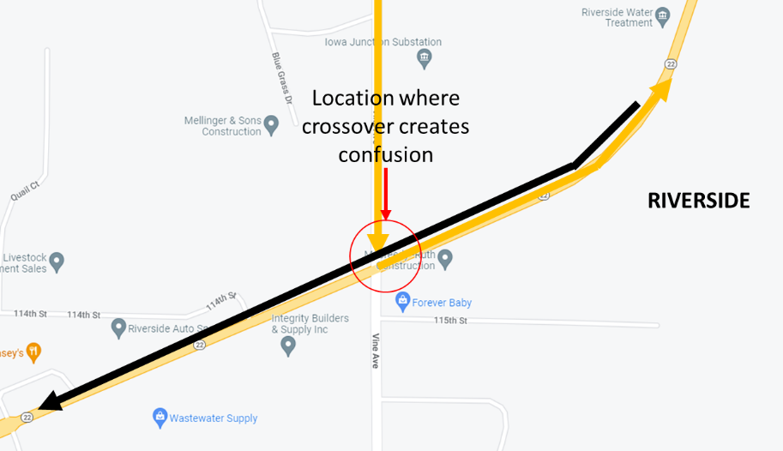
Figure 55. Map crossover issue in Riverside

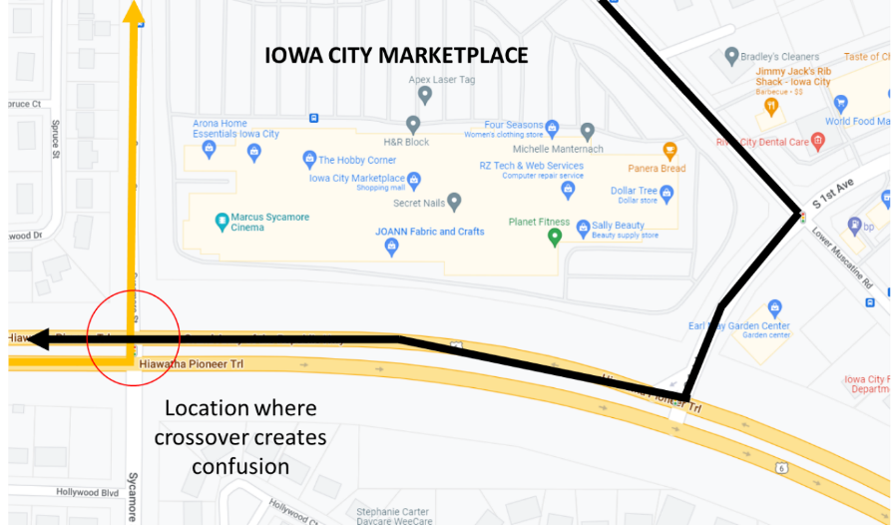
Figure 56. Map crossover issue in Iowa City

Point Cloud
The sprinklers were on at Riverside Casino during one of the drives blowing water across the road and the front of the vehicle as it was leaving and headed out of the parking area. Figure 57 shows the spray being detected by the LiDAR. A review of the video for this drive showed that on two occasions the vehicle does some fairly significant braking as it appears as though the vehicle was braking due to some sort of obstruction it thought it was “seeing” in the road.
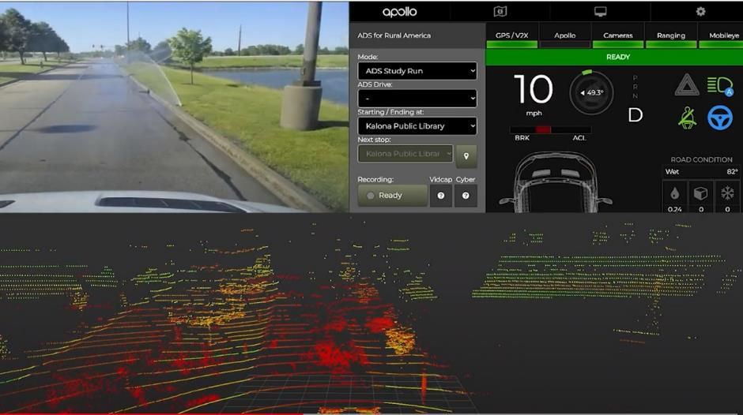
Figure 57. Point cloud

Road Construction Along Route
During Phase 3, the vehicle encountered road construction as it entered the town of Riverside. The construction included a temporary traffic signal that allowed one lane of traffic to travel through the work zone at a time. It is important to note that the vehicle uses an HD map to drive the route. Any physical changes to the roadway that alter this route require changes to the map. Therefore, because the vehicle was required to leave its lane and enter the oncoming lane to travel through the work zone, it was not able to navigate through road construction in automated mode.
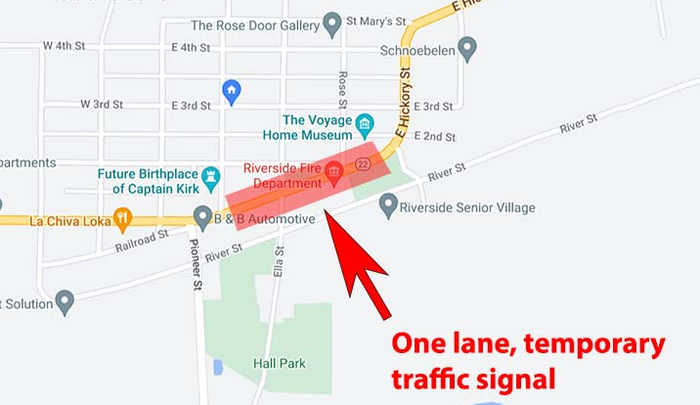
Figure 58. Road construction in Riverside

Accomplishments for Phase 3
The following improvements were made to the ADS in Phase 3:
- Full route was broken into two to avoid the loss of planning due to map crossover issues.
- Traffic light recognition cameras calibrated, and traffic light recognizer (TLR) enabled.
- The “STOP” time was reduced from 8 seconds to 5 seconds and the “CREEP” time was reduced from 10 seconds to five seconds. This was done to shorten the time the vehicle spends at stop signs.
- Turn signal activation before exit from Hwy 218 S at Hills.
- Added stop sign at railroad crossings to make vehicle stop (Apollo stack does not handle RR crossings).
- Verified that traffic light elements in the correct place and that their height was modified from ‘0’.
- Passenger side LiDAR was enabled and configured. This will be used to verify right turns are clear of obstacles.

Next Steps
As the project continues, we will introduce additional functionality to the vehicle that will improve performance through cities and towns as well as introduce automation to some of the most difficult challenges that exist in the rural environment: gravel roadways. This road type makes up a very small portion of the route; therefore, there will not be a substantial increase in the miles driven under automation for this next phase. However, the ability to drive on gravel roads under automation is paramount to ensuring that rural America is not left behind. Therefore, we have discussed making the following changes with our technology partners, AutonomouStuff and Mandli Communications, to the automation and digital map to help meet the needs of the next phase, which includes the gravel roadway portion of the route.

Map Issues to be Addressed
- Break loop into four routes with one leg between each stop.
- Casino exit to Hwy 22 lane needs to be widened so vehicle can make the right turn reliably (we have since learned this turn is not a map issue, but an Apollo path planning issue mentioned elsewhere).
- Location of stop line at Hwy 1 and Naples Ave SW needs to be moved closer to the intersection.
- Speed in Hills needs to be reduced by 5 mph.
- Speed near Welsh United Church on Sharon Center Rd needs to be reduced to 35 mph due to the blind hill.
- Speed entering Iowa City on eastbound Hwy 1 needs to be reduced from 50 mph to 40 mph to avoid hard braking at intersection.
- Speed limit needs to be increased from 25 mph to 35 mph for the lane-change maneuver into the left turn lane going into the casino.
- Need to shift Kansas Ave, a gravel road, approximately 18” to the left (from the southbound perspective) to enable the vehicle to drive more in the middle of the lane, as is typical for this road type.

Other Issues to be Addressed
- Acceleration is overly aggressive from driver perspective (RPM) and rider comments.
- Modifications still need to be made to reduce the stop time. By decreasing the amount of time that it takes for the vehicle to complete the stop and complete “creep” maneuvers, we hope to see more natural interactions with other vehicles at intersections.

For more information, please refer to the ADS for Rural America Safety Management Plan at adsforruralamerica.uiowa.edu/ADS-safety-plan

