Phase 2 (Two Lane Undivided Highway and On- and Off-ramps)

Evaluation Report
Author: Cher Carney, Project Research Lead, cher-carney@uiowa.edu
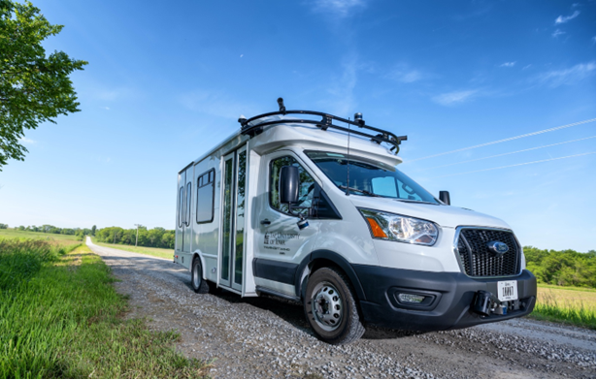

Contents
Introduction 1
Expected Capabilities of the Automation for Phase 2 2
Additional Capabilities of the Automation for Phase 2 3
Automation Engagement by Drive 9
Voluntary Takeover of the Automation 19
Forced Takeover of the Automation 21
Encounters with Vulnerable Road Users (VRUs) 21
Safety Critical Events 21
Occupants for Phase 1 22
Demographics 22
Survey Data 23
Biometric Data 27
Anxiety Ratings 27
Safety Drivers 30
Phase 2 Summary 32
Effect of Ice on Lidar 33
Loss of Planning in Kalona 34
Novatel Failure 35
Accomplishments for Phase 2 37
Next Steps 37
Map Issues to be Addressed 37
Other Issues to be Addressed 37

Introduction
This project is comprised of six phases shown in Table 1. Each phase will attempt to increase the percentage of the route that is driven under automation. The defined route will be driven in its entirety for each of the project’s phases to show how automation is increasing and to allow for comparison from one phase to the next. During each new phase, the ADS for Rural America project team will also be assessing the automation’s performance and using the data collected to inform improvements in successive project phases.
Phase 1 was completed in November of 2021 on controlled access highways and a divided highway/interstate. A large portion of the route during that phase was able to be driven in automated mode. This was due to a high percentage of the route being interstate/highway driving. However, several issues regarding merging and traveling at highway speeds were identified during that phase. Phase 2 built upon Phase 1, introducing increased levels of automation under varying driving conditions. The focus of Phase 2 was vehicle navigation along 2-lane undivided highways as well as on- and off-ramps. The traffic on undivided highways travels in opposite directions, has more variable vehicle speeds, and has vehicles that may pass in oncoming traffic lanes. On- and off-ramps were seen as a unique challenge due to the variable geometries and vast differences in speeds of vehicles entering and exiting the highways as well as the unpredictability of driver behavior that can occur in these locations.
Table 1. Project phases
Phase | Description | Drives Planned | Drives Completed | Date | Status
1 | Controlled Access Roadways | 10 | 10 | 11/2021 | Complete
2 | Highways & Ramps | 20 | 17* | 03/2022 | Complete
3 | Urban Areas | 10 |  | 07/2022 | Planning
4 | Unmarked Roads | 10 |  | 10/2022 | Planning
5 | V2X | 10 |  | 01/2023 | Planning
6 | Parking Areas / Full Route | 20 |  | 05/2023 | Planning
Total |  | 80 | 27
*A total of eighteen drives were started in this phase. However, two are missing a portion of the data (Drive 15 and Drive 30). Because data for Drive 15 is missing due to a researcher error, this drive is not counted in the total number of completed drives. On the other hand, data for Drive 30 is missing because of an equipment failure. We are counting this drive as being complete because this failure is representative of the failures that could be associated with operating an ADS vehicle in real-world conditions. Therefore, only 17 drives were counted for Phase 2.
Twenty drives were planned as part of Phase 2, and 17 were completed before data collection was stopped. These drives took place between February 11 and March 8, 2022. They occurred at different times of day and during varying lighting and weather conditions.
Data of specific interest in Phase 2 includes:
- How the vehicle responded to mixed traffic, which included heavy trucks, slow-moving vehicles, and vulnerable road users
- The vehicle’s ability to merge onto the divided highway
- The vehicle’s reaction to cut-ins (i.e., other vehicles passing and then entering the lane ahead of the AV)

This report will begin by describing vehicle performance along the entire route, both what was expected for Phase 2, as well as what additional capabilities were seen. The data collected for each drive will be summarized, including mileage in automation and figures showing the location of automation activation. A summary of voluntary takeovers by the safety driver, encounters with vulnerable road users (VRUs), and any safety critical events is provided. Data regarding the occupants of the vehicle includes demographic information, survey data, biometrics, and anxiety ratings. A summary of the safety driver survey results, including their perceptions of the automation’s performance is provided as well.

Expected Capabilities of the Automation for Phase 2
For Phase 2, the vehicle was expected to maintain lateral and longitudinal position via automation that utilized on-board sensors and a high-definition (HD) map of the route. Safety drivers engaged automation by pressing the “Engage” button on the steering wheel. The driver made sure the following conditions were met:
- The vehicle was just below Apollo’s target speed to avoid excessive braking or accelerations.
- The vehicle was in the center of the lane.
- The steering wheel was straight.
- They deemed it safe. (Considerations for safety include number/proximity of vehicles in the lane and oncoming or adjacent lanes, weather, functionally of automated systems, etc.)

The goal was to use automation during all divided highway (i.e., U.S. Highway 218 S) and undivided highway portions of the route (i.e., State Highway 22 and State Highway 1) as well as the merge onto U.S. Hwy 218 located just south of Iowa City and the exit from U.S. Highway 218 at Hills (Figure 1). Also included in this phase was Vine Ave, located between Hills and Highway 22. This north-south roadway is considered a major collector but was deemed a good candidate for Phase 2 given its 55 mph speed limit and wide shoulders. It should be noted that updated automation software allowed the vehicle to travel at highway speeds of up to 65 mph for Phase 2 of the project. This was previously limited to 50 mph by the automation software in Phase 1.

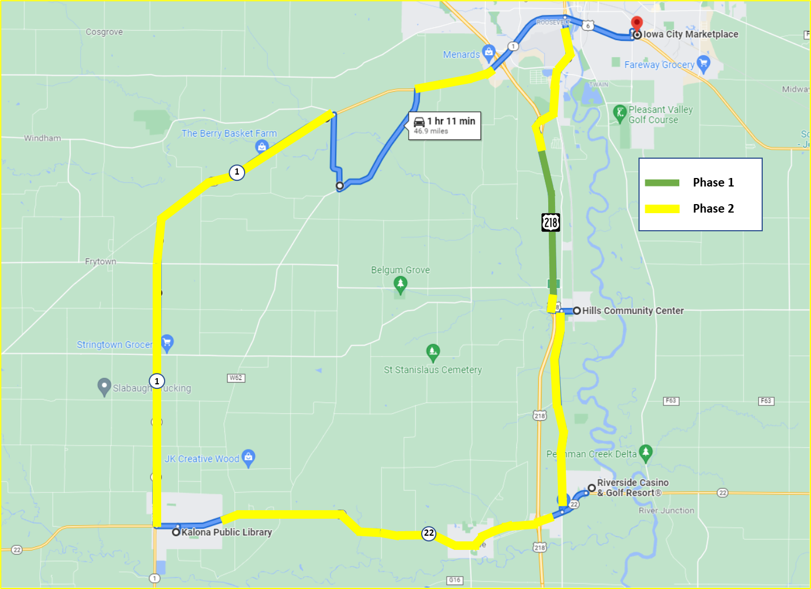
Vine Ave
N
Figure 1. Expected capabilities of the automation (combination of Phases 1 and 2)

Additional Capabilities of the Automation for Phase 2
During the extensive pre-Phase 2 testing conducted by the safety drivers, additional automation capabilities that exceeded the goals of Phase 2 were tested. These capabilities included the ability to make right and left turns as well as navigating 4-way stops. The safety driver was able to allow the vehicle to complete these maneuvers at several of the intersections and felt comfortable doing so. Therefore, these additional capabilities were included in Phase 2. It’s important to note that the safety driver was prepared to take over from the automation when they felt that the automation was about to engage in an unsafe maneuver (e.g., pull out in front of oncoming traffic) or if it was taking too long to perform the maneuver and could have potentially caused another vehicle to behave in an unsafe way (e.g., drive aggressively or pass in an intersection). Automation can be intentionally disengaged by the safety driver using multiple methods, which include pressing a button on the steering wheel, taking over steering, or pressing the accelerator or brake pedal. It is important to note that using the automation at these intersections was explored and tested extensively by the safety drivers during pre-Phase 2 test drives. The intersections included are shown in Figure 2 and are described below.

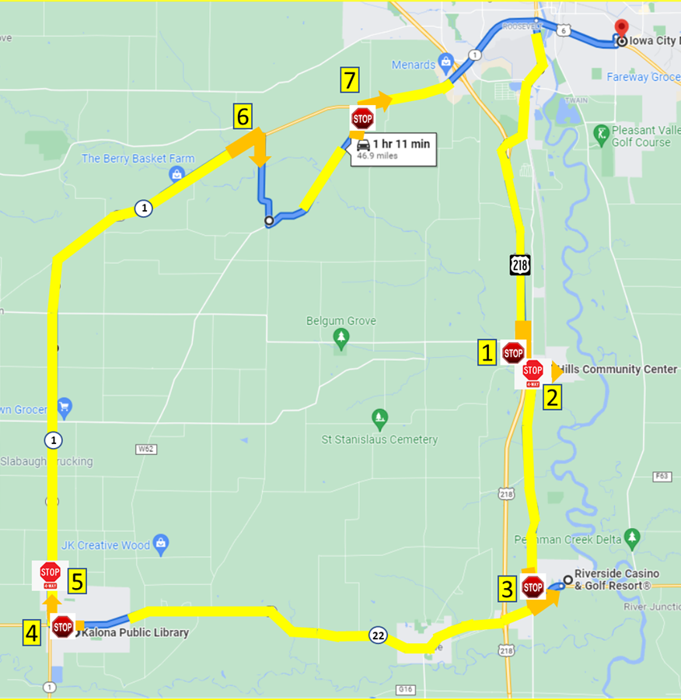
Figure 2. Additional capabilities of the automation for Phase 2

Turns and Intersections completed under automation:
- The vehicle activated the turn signal and exited Hwy 218. At the end of the off-ramp, the vehicle stopped at the stop sign. If it was considered safe to allow it to do so, the vehicle may have completed the left turn onto Observatory Avenue SW. If not, the automation was disengaged and re-engaged after the turn.
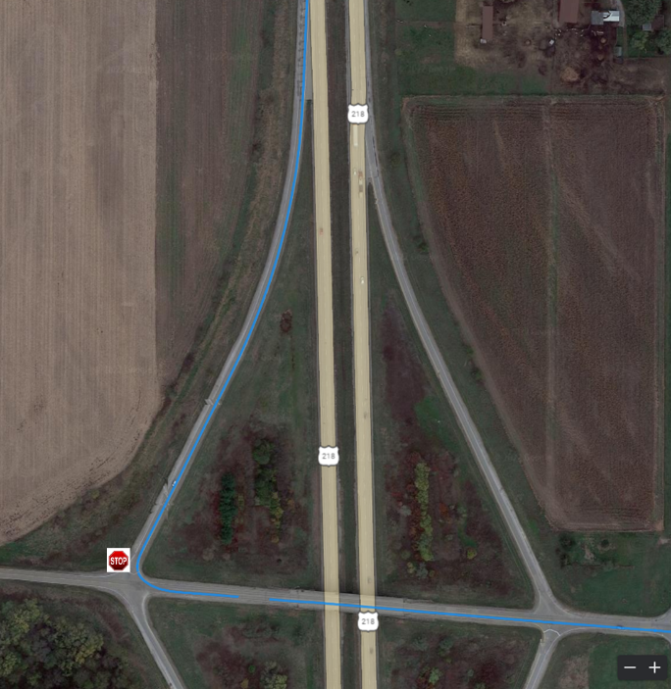
N
Observatory Ave SW
Intersection 1. Left turn after off-ramp
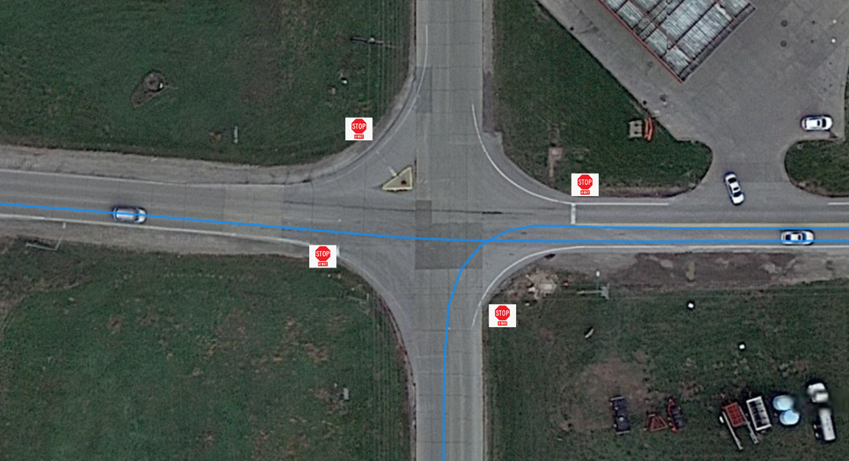
- After the turn onto Observatory Avenue SW, the vehicle stopped at the 4-way stop sign at the intersection of W Main St and Oakcrest Hill Rd SE. If it was considered safe to allow it to do so, the vehicle may have traveled through the intersection under automation. If not, automation was disengaged. It was not re-engaged until making the left turn leaving Hills and heading south on Oakcrest Hill Rd SE.
Observatory Ave SW
W Main St
Oakcrest Hill Rd SE

N

Intersection 2. 4-way stop entering Hills

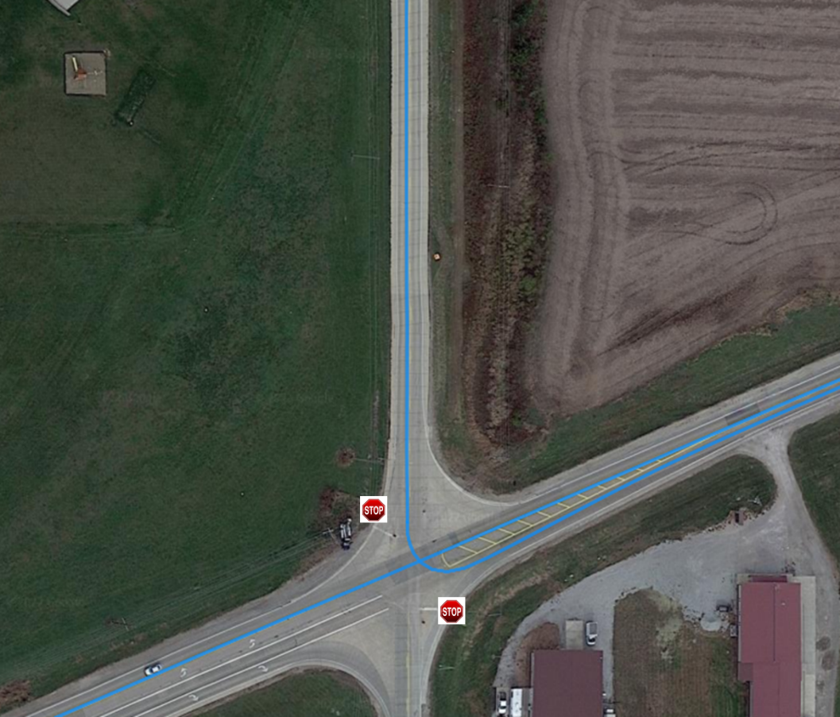
- The vehicle activated the turn signal and stopped at the stop sign at the intersection of Vine Ave and Hwy 22. If it was considered safe to allow it to do so, the vehicle may have completed the left turn onto Highway 22. If not, the automation was disengaged and re-engaged after the turn.
Vine Ave
N
Hwy 22

Intersection 3. Left turn onto Highway 22

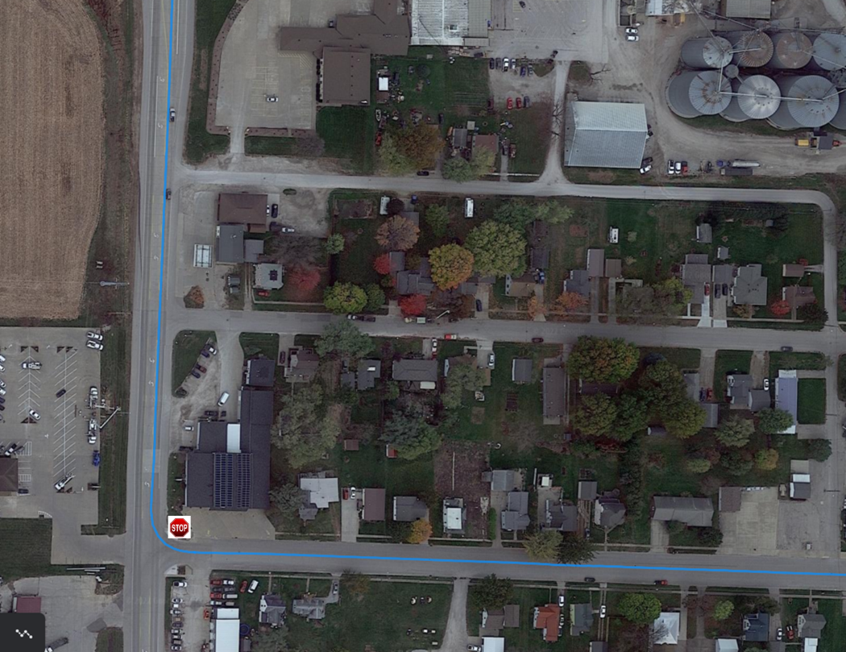
- The vehicle activated the turn signal and stopped at the stop sign at the intersection of B Ave and Hwy 1 while leaving the town of Kalona. If it was considered safe to allow it to do so, the vehicle may have completed the right turn onto Hwy 1. If not, the automation was disengaged and re-engaged after the turn.
Hwy 1

B Ave
N

Intersection 4. Right turn onto Highway 1
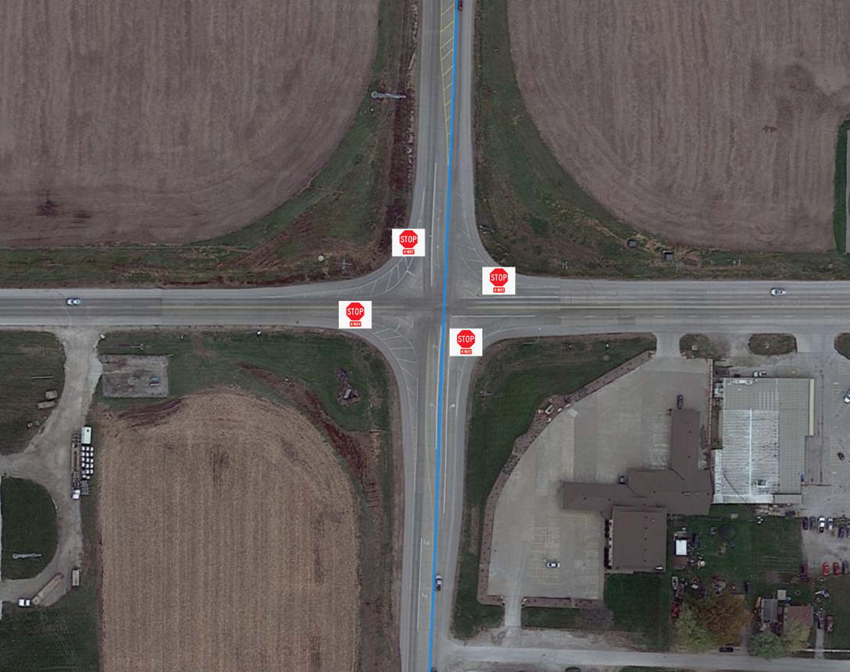
- After the turn onto Hwy 1, the vehicle stopped at the 4-way stop sign at the intersection of Hwy 1 and Hwy 22/E Ave. If it was considered safe to allow it to do so, the vehicle may have traveled through the intersection. If not, automation was disengaged. It was re-engaged once it reached the appropriate speed.
Hwy 22/E Ave
N
Hwy 1

Intersection 5. 4-way stop in Kalona
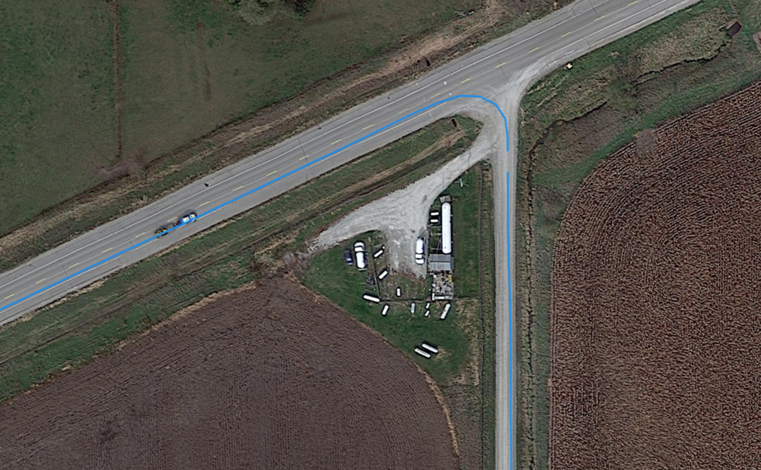
- The vehicle activated the turn signal and slowed on Hwy 1 to make a right turn onto Kansas Ave (gravel road). Automation was disengaged as soon as the turn was completed and was not re-engaged on this roadway.
N
Hwy 1
Kansas Ave

Intersection 6. Right turn onto gravel road
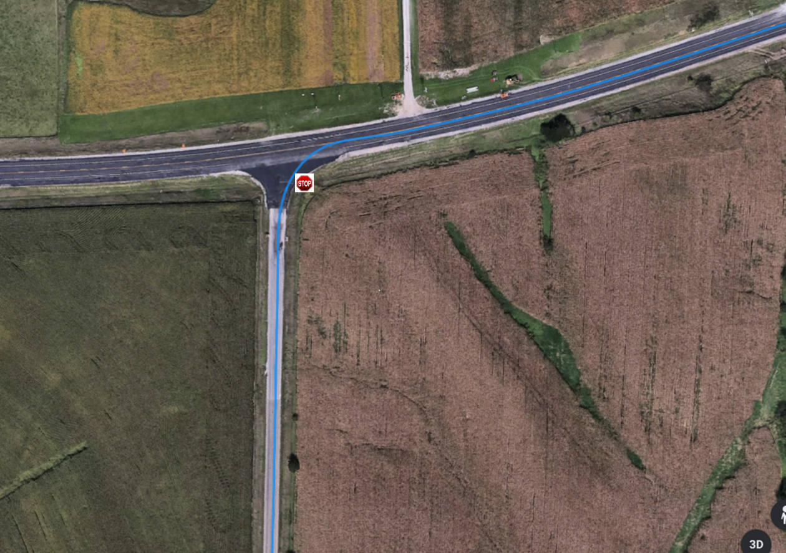
- The vehicle activated the turn signal and stopped at the stop sign at the intersection of Sharon Center Rd and Hwy 1. If it was considered safe to allow it to do so, the vehicle may have completed the right turn onto Highway 1. If not, the automation was disengaged and re-engaged once the vehicle reached the appropriate speed.
N
Hwy 1
Sharon Center Rd

Intersection 7. Right turn onto Hwy 1
The number of turns and intersections the vehicle was able to complete in automation for the 18 drives is shown in Table 2. The ability of the automation to complete the turns was due in a large part to the amount and speed of other traffic.
Table 2. Turns and intersections driven in automated mode
 | Turn/Intersection | Number Completed Under Automation (out of 18 drives)
1 | Left turn from off-ramp to Observatory Avenue | 9
2 | 4-way stop in Hills | 2
3 | Left turn from Vine Ave to Hwy 22 | 2
4 | Right turn from B Ave to Hwy 1 | 6
5 | 4-way stop in Kalona | 5
6 | Right turn from Hwy 1 to Kansas Ave | 9
7 | Right turn from Sharon Center Rd to Hwy 1 | 2

The following areas were not considered for automation due to the limited capabilities of the automation during this phase.
- All parking lots
- Areas that have traffic signals, areas with street parking, or crosswalks present
- Gravel roads

Automation Engagement by Drive
Of the eighteen drives that were started in this phase, two are missing a portion of the data (Drive 15 and Drive 30). Because data for Drive 15 is missing due to a researcher error, this drive is not counted in the total number of completed drives. On the other hand, data for Drive 30 is missing because of an equipment failure. We are counting this drive as being complete because this failure is representative of the failures that could be associated with operating an ADS vehicle in real-world conditions. Therefore, only 17 drives were counted for Phase 2 (see Table 1). However, data from all 18 of the drives will be included in the publicly-available dataset and are used in the evaluation of this phase.
Maps showing the locations that automation was engaged are shown below for Drives 13 through 30 (Figures 3 through 20). Roadways where the automation was used are shown in blue. Locations driven manually are shown in green if the safety driver took over from the automation using the button on the steering wheel and in orange if they took over by steering, braking, or accelerating. The percentage of the trip driven using automation varied from 39.2% in Drive 24 to 75.4% in Drive 17.
Start Location | Riverside
Number of miles recorded | 48.15
Number of miles recorded in automated mode | 33.23
Percent of drive recorded in automated mode | 69.00%
Amount of data collected (GB) | 89.1
Weather conditions | Avg temp: 30 (F)  Clouds: 100%,  Avg wind speed: 25.5 mph
Time of day | Mid-afternoon
Day of week | Weekday
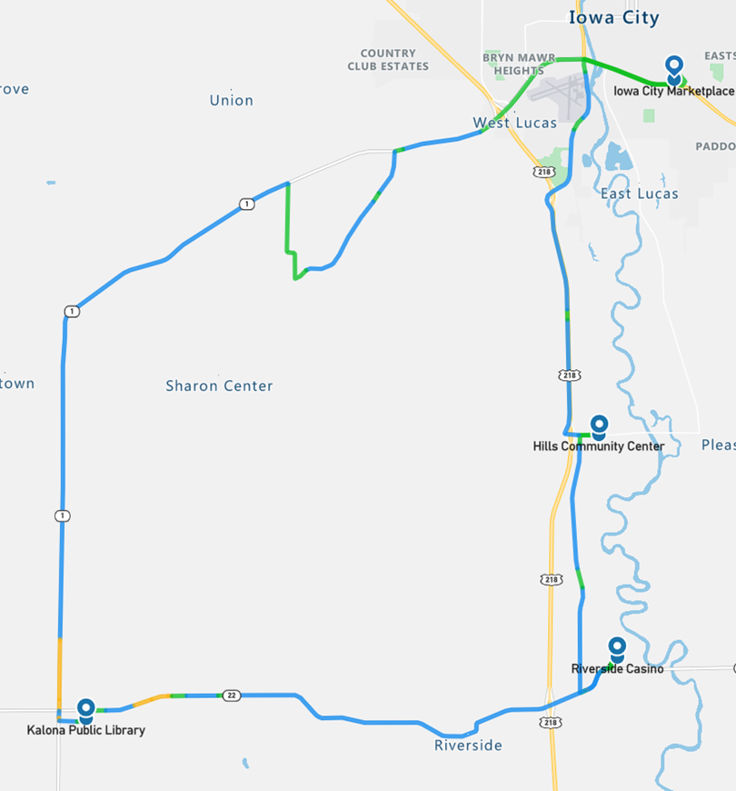
Figure 3. Drive 13 automation engagement (February 11, 2022)

Start Location | Iowa City
Number of miles recorded | 48.18
Number of miles recorded in automated mode | 34.65
Percent of drive recorded in automated mode | 71.90%
Amount of data collected (GB) | 85.7
Weather conditions | Avg temp: 14 (F) Clouds: 100%,  Avg wind speed: 9.8 mph
Time of day | Noon
Day of week | Weekend
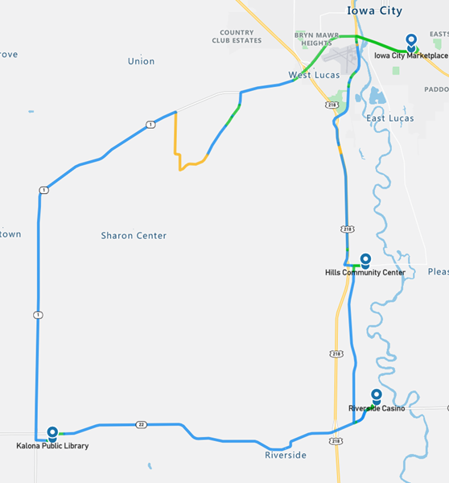
Figure 4. Drive 14 automation engagement (February 13, 2022)

Start Location | Hills
Number of miles recorded | 15.21
Number of miles recorded in automated mode | 13.64
Percent of drive recorded in automated mode | 89.70%
Amount of data collected (GB) | 21.5
Weather conditions | Avg temp: 24 (F) Clouds: 100%,  Avg wind speed: 0.2 mph
Time of day | Mid-morning
Day of week | Weekday
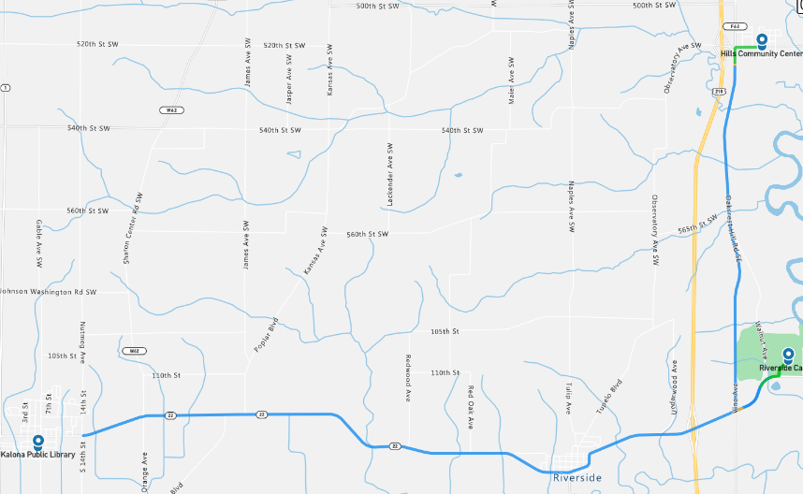
Figure 5. Drive 15 automation engagement (February 15, 2022)
As shown in the map in Figure 5, this drive was incomplete. The co-pilots display became unavailable when the researcher unknowingly hit a power switch located behind their seat. This made it impossible for the co-pilot to monitor the automation and aid the safety driver. Therefore, the drive was stopped
early, and the subjects were returned to the starting location.
Start Location | Iowa City
Number of miles recorded | 48.16
Number of miles recorded in automated mode | 34.42
Percent of drive recorded in automated mode | 71.50%
Amount of data collected (GB) | 87.4
Weather conditions | Avg temp: 55 (F)  Clouds: 100%,  Avg wind speed: 13.9 mph
Time of day | Mid-morning
Day of week | Weekday
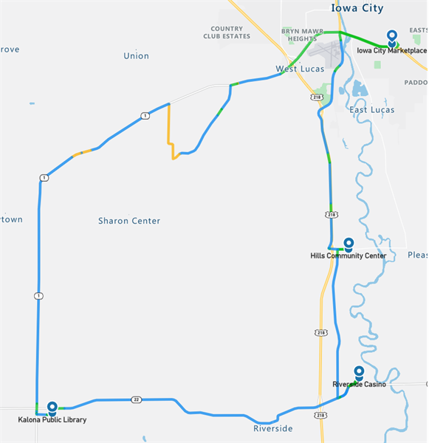
Figure 6. Drive 16 automation engagement (February 16, 2022)
Start Location | Hills
Number of miles recorded | 48.16
Number of miles recorded in automated mode | 36.29
Percent of drive recorded in automated mode | 75.40%
Amount of data collected (GB) | 91.1
Weather conditions:  Winter Weather Advisory | Avg temp: 20 (F) Clouds: 56%,  Snow: 44%,  Avg wind speed: 16.1 mph
Time of day | Mid-morning
Day of week | Weekday
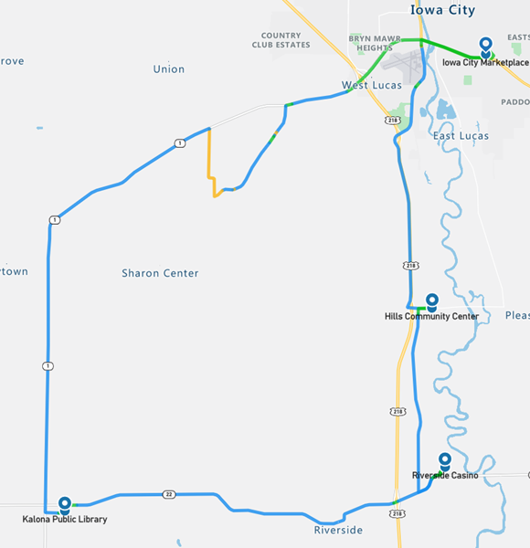
Figure 7. Drive 17 automation engagement (February 17, 2022)

Start Location | Hills
Number of miles recorded | 48.09
Number of miles recorded in automated mode | 25.6
Percent of drive recorded in automated mode | 53.20%
Amount of data collected (GB) | 93.1
Weather conditions | Avg temp: 43 (F) Clear: 100%,  Avg wind speed: 21.9 mph
Time of day | Mid-afternoon
Day of week | Weekday
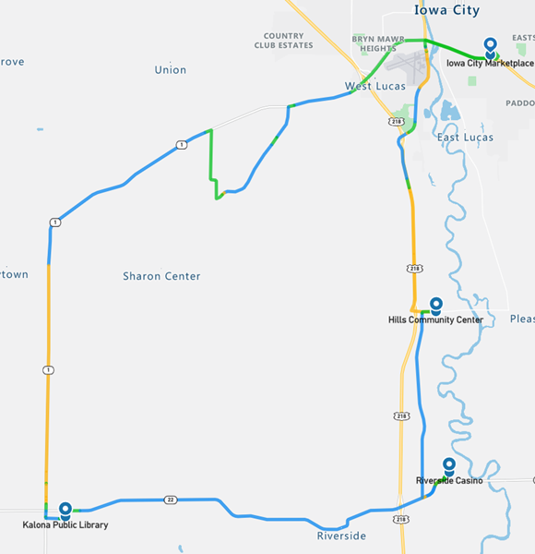
Figure 8. Drive 18 automation engagement (February 18, 2022)

Start Location | Kalona
Number of miles recorded | 48.09
Number of miles recorded in automated mode | 20.88
Percent of drive recorded in automated mode | 43.40%
Amount of data collected (GB) | 80.3
Weather conditions | Avg temp: 43 (F) Clear: 75%,  Clouds: 25%,  Avg wind speed: 4.3 mph
Time of day | Night
Day of week | Weekend
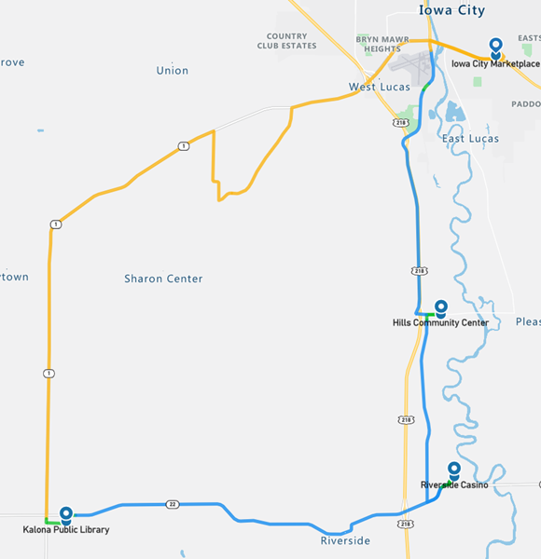
Figure 9. Drive 19 automation engagement (February 20, 2022)

Start Location | Hills
Number of miles recorded | 48.03
Number of miles recorded in automated mode | 25.35
Percent of drive recorded in automated mode | 52.80%
Amount of data collected (GB) | 87.8
Weather conditions | Avg temp: 56 (F) Clear: 67%, Clouds: 33%,  Avg wind speed: 15.9 mph
Time of day | Noon
Day of week | Weekday
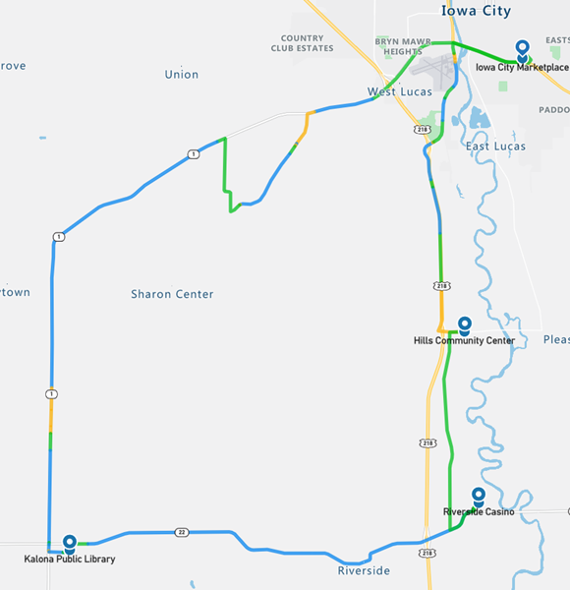
Figure 10. Drive 20 automation engagement (February 21, 2022)

Start Location | Iowa City
Number of miles recorded | 48.16
Number of miles recorded in automated mode | 20.26
Percent of drive recorded in automated mode | 42.10%
Amount of data collected (GB) | 82.7
Weather conditions:  Winter Weather Advisory | Avg temp: 26 (F) Clouds: 67%, Haze: 33%,  Avg wind speed: 16.6 mph
Time of day | Dawn
Day of week | Weekday
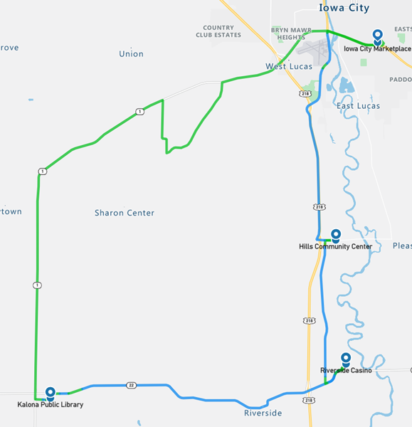
Figure 11. Drive 21 automation engagement (February 22, 2022)

Start Location | Riverside
Number of miles recorded | 48.16
Number of miles recorded in automated mode | 35.6
Percent of drive recorded in automated mode | 73.90%
Amount of data collected (GB) | 92.1
Weather conditions | Avg temp: 24 (F) Snow: 53%,  Clouds: 47%,  Avg wind speed: 11.6 mph
Time of day | Noon
Day of week | Weekday
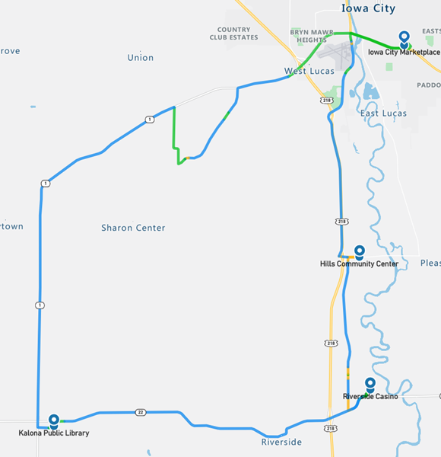
Figure 12. Drive 22 automation engagement (February 24, 2022)
Start Location | Iowa City
Number of miles recorded | 48.22
Number of miles recorded in automated mode | 35.36
Percent of drive recorded in automated mode | 73.30%
Amount of data collected (GB) | 83.2
Weather conditions | Avg temp: 16 (F) Clear: 85%, Clouds: 15%,  Avg wind speed: 8.7 mph
Time of day | Night
Day of week | Weekday
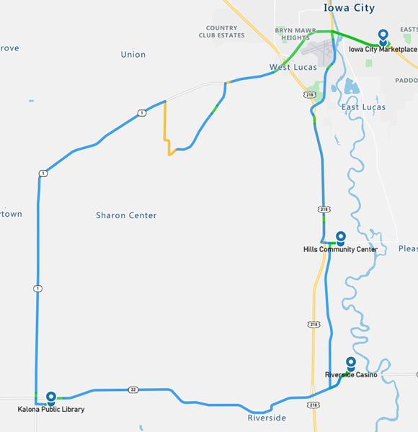
Figure 13. Drive 23 automation engagement (February 25, 2022)

Start Location | Kalona
Number of miles recorded | 48.09
Number of miles recorded in automated mode | 18.83
Percent of drive recorded in automated mode | 39.20%
Amount of data collected (GB) | 84.4
Weather conditions | Avg temp: 56 (F)  Clouds: 69%, Clear: 31%,  Avg wind speed: 11.0 mph
Time of day | Noon
Day of week | Weekday
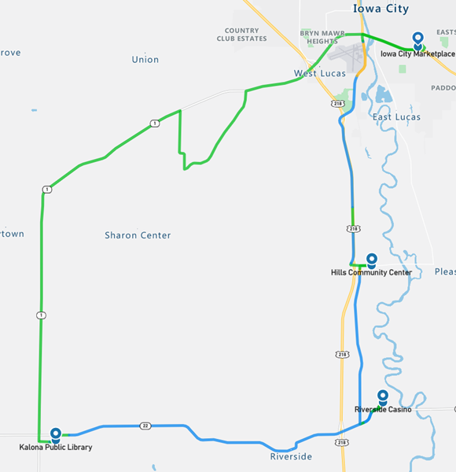
Figure 14. Drive 24 automation engagement (February 28, 2022)

Start Location | Hills
Number of miles recorded | 48.09
Number of miles recorded in automated mode | 35.67
Percent of drive recorded in automated mode | 74.20%
Amount of data collected (GB) | 88.1
Weather conditions | Avg temp: 46 (F) Clouds: 100%, Avg wind speed: 2.9 mph
Time of day | Dawn
Day of week | Weekday
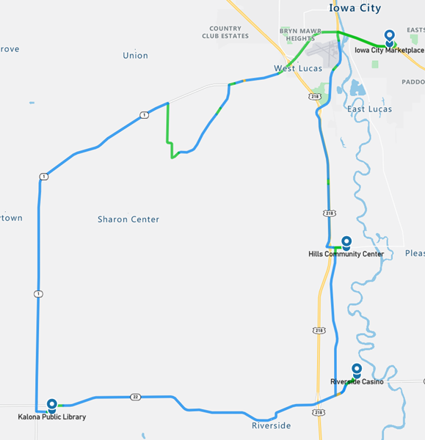
Figure 15. Drive 25 automation engagement (March 1, 2022)

Start Location | Kalona
Number of miles recorded | 48.03
Number of miles recorded in automated mode | 18.77
Percent of drive recorded in automated mode | 39.10%
Amount of data collected (GB) | 90.4
Weather conditions | Avg temp: 64 (F) Clear: 67%,  Clouds: 33%,  Avg wind speed: 9.8 mph
Time of day | Mid-afternoon
Day of week | Weekday
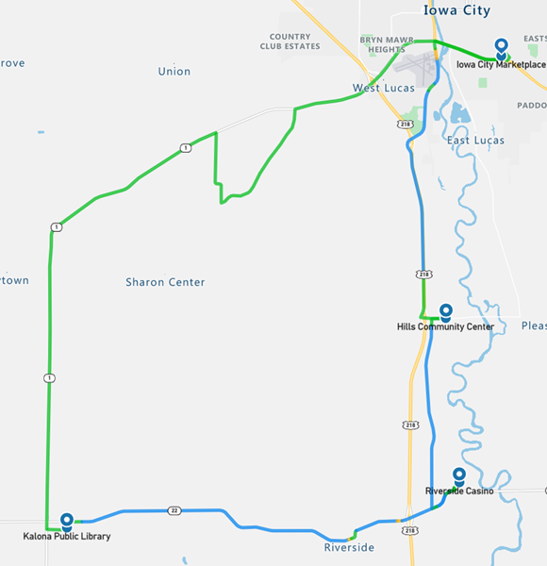
Figure 16. Drive 26 automation engagement (March 2, 2022)

Start Location | Riverside
Number of miles recorded | 48.16
Number of miles recorded in automated mode | 35.48
Percent of drive recorded in automated mode | 73.70%
Amount of data collected (GB) | 94.5
Weather conditions | Avg temp: 32 (F) Clouds: 51%, Snow: 49%  Avg wind speed: 11.0 mph
Time of day | Dawn
Day of week | Weekday
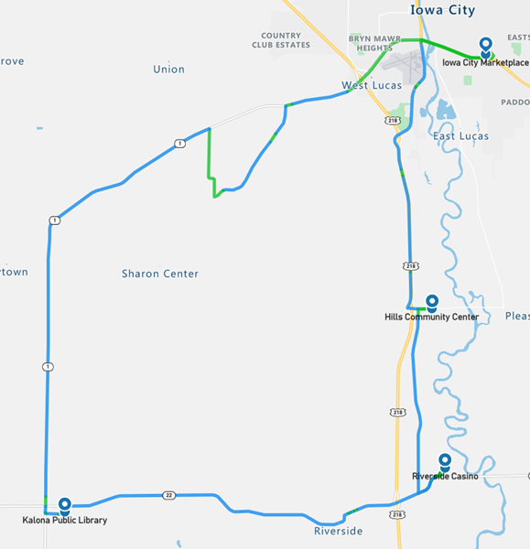
Figure 17. Drive 27 automation engagement (March 3, 2022)

Start Location | Riverside
Number of miles recorded | 48.09
Number of miles recorded in automated mode | 35.42
Percent of drive recorded in automated mode | 73.70%
Amount of data collected (GB) | 88.1
Weather conditions | Avg temp: 39 (F) Clouds: 100%, Avg wind speed: 17.0 mph
Time of day | Mid-morning
Day of week | Weekend
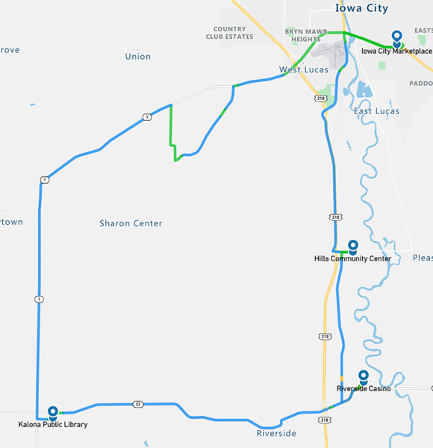
Figure 18. Drive 28 automation engagement (March 6, 2022)

Start Location | Iowa City
Number of miles recorded | 48.09
Number of miles recorded in automated mode | 19.26
Percent of drive recorded in automated mode | 40.00%
Amount of data collected (GB) | 88.0
Weather conditions | Avg temp: 32 (F) Clouds: 47%, Clear: 36%,  Snow: 17%,  Avg wind speed: 16.8 mph
Time of day | Mid-afternoon
Day of week | Weekday
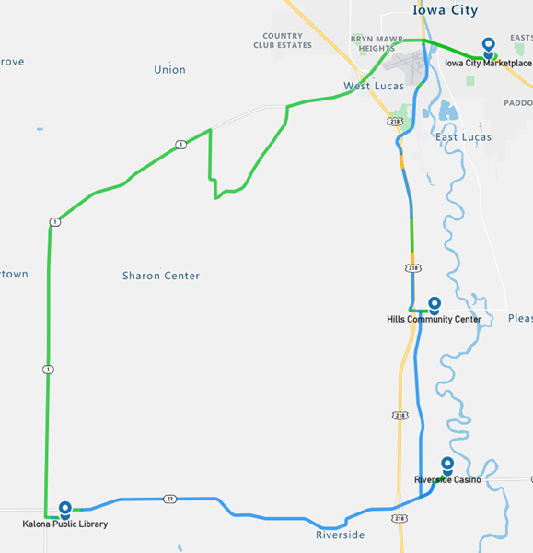
Figure 19. Drive 29 automation engagement (March 7, 2022)

Start Location | Kalona
Number of miles recorded | 48.09
Number of miles recorded in automated mode | 12.99
Percent of drive recorded in automated mode | 27.00%
Amount of data collected (GB) | 83.1
Weather conditions | Avg temp: 33 (F) Clear: 100%  Avg wind speed: 8.5 mph
Time of day | Mid-morning
Day of week | Weekday
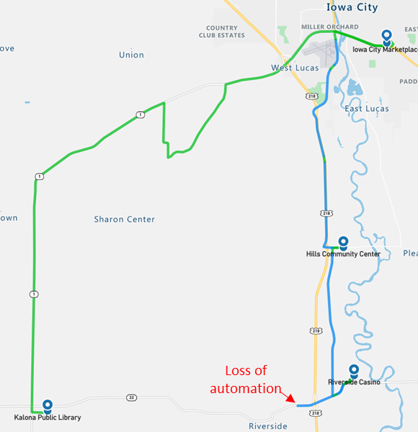
Figure 20. Drive 30 automation engagement (March 8, 2022)

As shown in the map in Figure 20, there was a loss of automation as the vehicle was entering Riverside. The communication between the GNSS receiver and the Spectra computer stopped. From that point forward, the localization module was no longer able to publish localization data to the stack, and thus all downstream modules stopped publishing. In essence, the safety driver was able to engage automation, but none of the automated systems were operable. In order to troubleshoot and develop a mitigation strategy, and not cause excessive delays to the project timeline, the final three drives that were planned for Phase 2 were not completed at this time but were pushed to Phase 3. The technology provider explored the reason for the loss of communication and attributed it to a transient failure which caused the NovAtel GNSS to reboot, resulting in a stopped flow of data. The reason for the NovAtel reboot remains unknown and has not been replicated despite extensive testing.
Overall, the number of miles driven in automation by federal function classification (FFC) of road types is shown per drive below (Figure 21). Note that the local roads, which included those through towns and the gravel portion of the route, have almost no miles driven in automation. The vehicle sometimes made the turn from the highway onto the gravel before being disengaged, which may account for the 0.2-mile average that is seen for that classification of roadway. The parking lots, which are considered “other” were not driven in automation. Additionally, during several of the drives (i.e., Drives 18, 19, 21, 24, 26, and 29) the automation “dropped out” after our stop at the Kalona library. The automation was not restarted until the next stop at the Iowa City Marketplace, which means that the Hwy 1 portion of the route, which is considered a principal arterial was driven manually by the safety driver. This is reflected in Figure 21, which shows fewer miles driven on that road type for those particular drives. These dropouts were a result of the limitation of the software and not a protocol error by study staff. Therefore, these drives are considered complete.
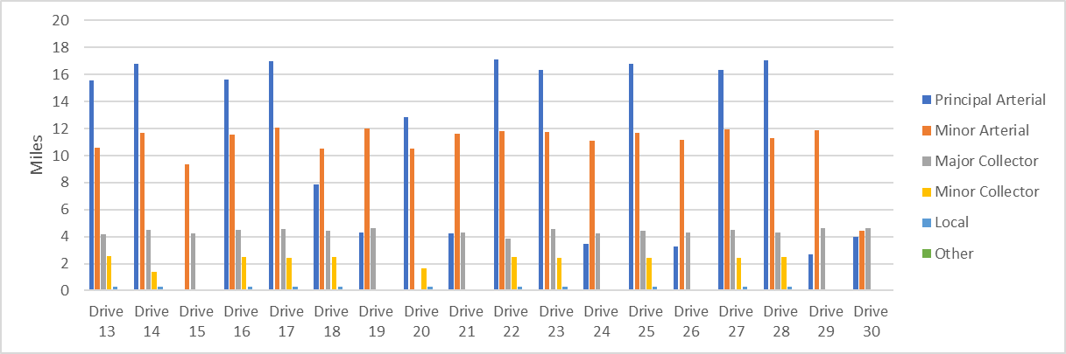
Figure 21. Miles driven in automated mode by FCC road type

Voluntary Takeover of the Automation
Safety drivers disengaged the automation for a variety of reasons. The preferred method of disengagement was to press the button located on the steering wheel. However, when necessary, turning the steering wheel, pressing the accelerator pedal, or pressing the brake pedal may have been a more suitable and safer method. When the automation was disengaged, the copilot would flag the data using the informational display and record the reason for the disengagement using a voice recorder. There were 171 voluntary takeovers flagged by the co-pilot.

Table 2. Frequency and type of voluntary takeovers
Reason for disengagement | Number of instances
To make a right/left turn | 46
- Left turn at a stop sign | 15
- Left turn at a traffic light | 16
- Right turn at a stop sign | 13
- Right turn- no traffic control device | 2
To stop at a traffic light | 27
Decrease in speed limit (not recognized by the system) | 15
The vehicle brakes abruptly due to another vehicle ahead cutting in front | 14
To navigate a 4-way stop | 12
Approaching a blind hill | 10
To drive the gravel road | 9
To stop at a stop sign (4-way) | 5
The vehicle brakes abruptly for unknown reason | 4
The vehicle responds late to lead vehicle braking | 4
The vehicle is traveling too close to vehicle ahead | 2
The vehicle crosses the center line | 2
Steering correction due to wind | 2
The vehicle is stuck at 50 mph on highway | 2
Safety concern – icy road | 2
To complete a lane change | 2
Too much traffic for merge | 2
Vehicle indicated turn at wrong location due to map crossover | 2
An object located on the roadway (e.g., carcass, tire, etc.) | 2
Strong winds cause a lane boundary excursion | 2
The vehicle crosses the right lane boundary | 1
Oncoming vehicle on narrow road | 1
The vehicle responds late to a vehicle crossing its path | 1
To stop for a stopped school bus | 1
The vehicle brakes abruptly for a large vehicle on shoulder | 1

The majority of the voluntary takeovers happened in instances where the automation was not mature enough to handle the road environment (e.g., gravel roads, blind hills) or specific traffic situations (e.g., turns at intersections, traffic signals, and unmapped speed limit reductions). The number of takeovers in these situations should lessen as the project progresses. There were also situations (e.g., aggressive braking behavior when other vehicles cut in ahead) that required the safety driver to take over control voluntarily from the automation for the sake of safety. These are the behaviors that are most interesting and will require further analysis to identify potential causes.

The most frequent takeovers occurred in order to safely complete a right or left turn. It should be noted that each of these turns was to occur after coming to a stop at a stop sign. After completing the stop, the vehicle would slowly creep out into the intersection and stop again before determining whether to go. It often had difficulty detecting the cross traffic that was traveling at high speeds and not required to stop. If the safety driver felt that the cross traffic was approaching too quickly and the vehicle had not yet begun to make the turn, the driver would take over from the automation and complete the turn in manual mode.
Traveling through a traffic light is not yet something that the automation is capable of handling. We will attempt this in Phase 3 of the project (Table 1). Therefore, when traffic lights were encountered while the vehicle was traveling in automation, the system was disengaged. This was also the case for the gravel road, which is not planned to be driven by the automation until Phase 4.
The safety driver also disengaged the automation when the system failed to slow for the reduced speed limits it encountered when entering certain towns. The automation gets speed limit information from the HD map. This issue can be fixed by either adding the correct speed limit into the map or moving the position of the speed reduction farther upstream so that the automation has enough time to slow the vehicle to the appropriate speed as it enters a town. Several locations requiring modification were identified through testing, and updates were made to the map between Phases 1 and 2, thus explaining the reduction in this type of takeover from 31 in Phase 1 to only 15 in Phase 2. Additional updates to the map will also be required in order for the vehicle to handle curves and blind hills at an appropriate speed. These speed limit updates are being planned for Phase 3.
Navigating a 4-way stop required the vehicle to recognize the stop sign and come to a complete stop. The vehicle would then slowly creep out into the intersection and stop again before determining whether to go. The amount of time that it took for the vehicle to make this determination sometimes created issues with other road users in that they took the hesitation as a sign that the vehicle did not intend to go, causing the driver of the other vehicle to enter the intersection. On many occasions, it was at this time that the vehicle would then start to move, requiring the safety driver to take over.

Forced Takeover of the Automation
Situations where the automation disengages on its own or becomes unavailable and requires the driver to intervene are called forced takeovers. There were five instances of these during Phase 2. On three occasions, the automation oversteered or steered aggressively, disengaging the system and forcing the driver to takeover. All three instances occurred at different locations and under diverse environmental conditions. The reason for one of the automation disengagements is still unknown. And the final takeover situation occurred after a failure of the NovaTel GNSS-IMU localization system (see description of Drive 30).

Encounters with Vulnerable Road Users (VRUs)
Flags were placed in the data to identify interactions with vulnerable road users (e.g., horse and buggies, ATVs, bicycles, pedestrians) located either within the lane boundary or on the shoulder on either side of the road. There were 30 interactions while the vehicle was traveling in automation and 66 while the vehicle was being driven manually (Table 3).
Table 3. Encounters with VRUs in automated and manual mode
In Automated Mode | In Manual Mode
- 17 horse and buggy  - 5 stopped vehicles  - 3 farm equipment  - 1 golf cart  - 1 animal  - 1 pedestrian  - 1 vehicle stopped  - 1 semi | - 31 pedestrians  - 17 horse and buggy  - 5 stopped vehicles  - 3 cyclists  - 2 stopped school buses  - 2 farm equipment  - 2 construction equipment  - 2 animals  - 1 sheriff (on side of road)  - 1 ATV

Identifying where these interactions occur allows a comparison between how these situations are handled by the driver in manual mode and how the automation handles them. Another important reason for identifying the VRU encounters is to be able to investigate how the perception module classifies these objects.

Safety Critical Events
These events include interactions that require abrupt accelerations/decelerations or large steering wheel reversals by the automated vehicle (AV), the safety driver, or another vehicle and may or may not be classified as a near crash. Crashes are also included in this category. There was one safety critical event recorded in Drive 30 of Phase 2, and no near-crashes or crashes. The safety critical event occurred on Highway 22 when the NovAtel unit re-booted and the vehicle lost the ability to operate in automated mode. There was no indication to the driver that this failure had taken place other than the vehicle was unable to navigate the curve in the road and began to leave the roadway. Additionally, the driver was able to engage the automation again, even though the modules for perception and path planning were not operational. Many hours of simulation and on-road testing have taken place since this failure, and it has not been reproduced. However, we now have safeguards in place to warn the driver and the co-pilot of this type of failure should it happen again. These safeguards include an auditory warning as well as flashing text on the co-pilot display.

Occupants for Phase 2

Demographics
Thirty-two adults over the age of 65 as well as those over the age of 25 with mobility or visual impairments were recruited to ride the vehicle. Table 4 provides the demographic breakdown by age, gender, and impairment. One occupant used a wheelchair and three reported using a walker, cane, or crutches. One of the occupants had a low vision impairment (i.e., visual acuity less than 20/70). Fifty-nine percent (19 out of 32) have some type of visual restriction on their driver’s license (glasses or corrective lenses). However, these restrictions are not severe enough to cause these occupants to be considered visually impaired. And 34% (11/32) reported having difficulty hearing.
Table 4. Demographics of occupants
Age | Unimpaired |  | Mobility Impaired |  | Visually Impaired |  | Hearing Impaired
 | Male | Female | Male | Female | Male | Female | Male | Female
25-34 | 0 | 0 | 0 | 0 | 0 | 0 | 0 | 0
35-44 | 0 | 0 | 0 | 0 | 0 | 0 | 0 | 0
45-54 | 0 | 0 | 0 | 0 | 0 | 0 | 0 | 0
55-64 | 0 | 0 | 1 | 1 | 0 | 0 | 1 | 0
65-74 | 12 | 9 | 0 | 1 | 0 | 1 | 4 | 3
75-84 | 3 | 2 | 0 | 0 | 0 | 0 | 0 | 1
85-94 | 0 | 1 | 1 | 0 | 0 | 0 | 1 | 1
Total | 15 | 12 | 2 | 2 | 0 | 1

The sample is highly educated, with 94% of occupants having some education beyond a high school degree, and 75% have a household income greater than $50,000. All occupants own or have access to a vehicle. Typically, occupants drive themselves where they need to go with approximately 53% reporting driving themselves daily and 34% driving themselves a few times a week. All but one of the occupants has a driver’s license. The occupant who does not have a license uses a wheelchair and relies primarily on family and friends to get them where they need to go.
Nearly 30% of the occupants in Phase 2 own or have access to a vehicle that has either adaptive cruise control (ACC) and/or lane keeping/lane centering. About 40 percent of those with ACC and about 80% with lane keeping reported using it frequently. A majority (69%) also reported that when it comes to trying new technology, they generally fall in the middle (e.g., not first or last to try). About 80% reported owning or using a smart phone. Slightly more than 90% reported that they own a desktop or laptop computer and have internet access. A majority, 63%, reported that they use some form of social media, and 75% own or use a tablet. Occupants agreed that they like to use technology to make tasks easier (78%) but were more split regarding whether they wanted a car with all of the latest technology features (22% disagree vs. 56% agree).

Survey Data
While riding in the AV, occupants were asked to complete both a pre- and post-drive survey regarding their trust and acceptance of highly automated vehicles. This type of vehicle was defined as one that is “capable of driving on its own in some situations but is aware of its limitations and calls for the driver to take over when necessary.” When asked to indicate how they felt about different statements, a greater percentage of occupants after their ride in the vehicle “somewhat or strongly agreed” that they could trust highly automated vehicles (41% pre-drive vs. 62% post-drive) and believed that they were reliable (44% pre-drive vs. 66% post-drive, Figures 22 and 23).

Figure 22. Trust in highly automated vehicles, pre- and post-drive

Figure 23. Reliability of highly automated vehicles, pre- and post-drive
After their ride in the vehicle, a greater percentage of occupants reported that they felt safe riding in a highly automated vehicle (65% pre-drive vs. 75% post-drive, Figure 24). However, fewer reported that they agreed AVs are safer than manually driven vehicles (50% pre-drive vs 41% post-drive), and a higher percentage believed that they might cause crashes (16% pre-drive vs. 22% post-drive, Figures 25 and 26).

Figure 24. Feel safe in highly automated vehicles, pre- and post-drive

Figure 25. AVs safer than manual vehicles, pre- and post-drive

Figure 26. AVs might cause crashes, pre- and post-drive
Phase 2 specifically focused on the ability to use automation on the highways and interstate. The safety driver used the automation on these road types whenever they deemed it safe to do so. Therefore, occupants were able to experience traveling on this type of road under both automated and manual driving during their trip. A larger percentage of occupants indicated that they “strongly agreed” or “somewhat agreed” that they would trust a highly automated vehicle on the interstate/highway after the drive was complete (78% pre-drive vs. 97% post-drive, Figure 27).

Figure 27. Trust of highly automated vehicle to drive on the highway pre- and post-drive
Phase 2 was also the first phase to see inclement weather in the form of snow, ice and freezing rain. There were differences in the pre- and post-drive responses with regard to concerns about the automated system’s performance in bad weather. While the two drives that took place during a winter weather advisory did not have passengers present, there were three drives total in which snow was either falling or on the roadway. Responses showed there was an increase in the percentage of occupants who reported that they would be “slightly concerned” about system performance in these situations (44% pre-drive vs. 66% post-drive, Figure 28)

Figure 28. Concern regarding the system performance in poor weather
Occupants were also asked questions about perceived usefulness and their intention to use highly automated vehicles. When asked to report whether they were “open to the idea of riding in a highly automated vehicle,” 91% of occupants both before and after the ride indicated that they somewhat or strongly agreed with the statement. However, the percentage who “strongly agreed” decreased by 15% post-drive (Figure 29).

Figure 29. Openness to riding in a highly automated vehicle
When asked whether they thought highly automated vehicles would allow them to stay more involved in their communities, a smaller percentage somewhat or strongly agreed that they would after they had ridden in the vehicle (56% pre-drive vs. 50% post-drive, Figure 30).

Figure 30. Ability of highly automated vehicles to allow me to stay involved in my community

Biometric Data
A medical grade wearable device was worn by each of the occupants as well as the safety driver for each of the eighteen drives. The device has a sensor which measures blood volume pulse (BVP), from which heart rate variability can be derived, as well as a sensor that measures the constantly fluctuating changes in certain electrical properties of the skin (galvanic skin response or GSR). Ten minutes of baseline data was collected before the start of each drive.

Heart Rate Variability (HRV)
Heart rate variability is said to indicate physiological stress or arousal, with increased stress being indicated by a low HRV.

Galvanic Skin Response (GSR)
Increases in GSR activity can indicate stress/anxiety as well as other emotions such as anger, disgust, fear, happiness, surprise, and extreme sadness.
This data will not be analyzed for this summary report; however, it will be available in its raw form through the data access portal.

Anxiety Ratings
Occupants were also asked to provide a rating of their anxiety level from 0 to 10, with 0 being “not at all anxious.” These ratings were given at nine specific locations along the drive and were the same for each participant, although they did vary in the order they were given depending on the starting location for the drive. Figure 31 is a map showing where each of these ratings occur along the drive. A pre-drive anxiety rating was obtained for everyone before the drive began. Rating locations included the following:
- Hwy 6 in Iowa City
- After merge onto Hwy 218
- After turn onto Hwy 22
- Business district of Riverside
- Downton Kalona
- Hwy 1 rural
- Gravel road
- Unmarked blacktop road
- Hwy 1 intersection
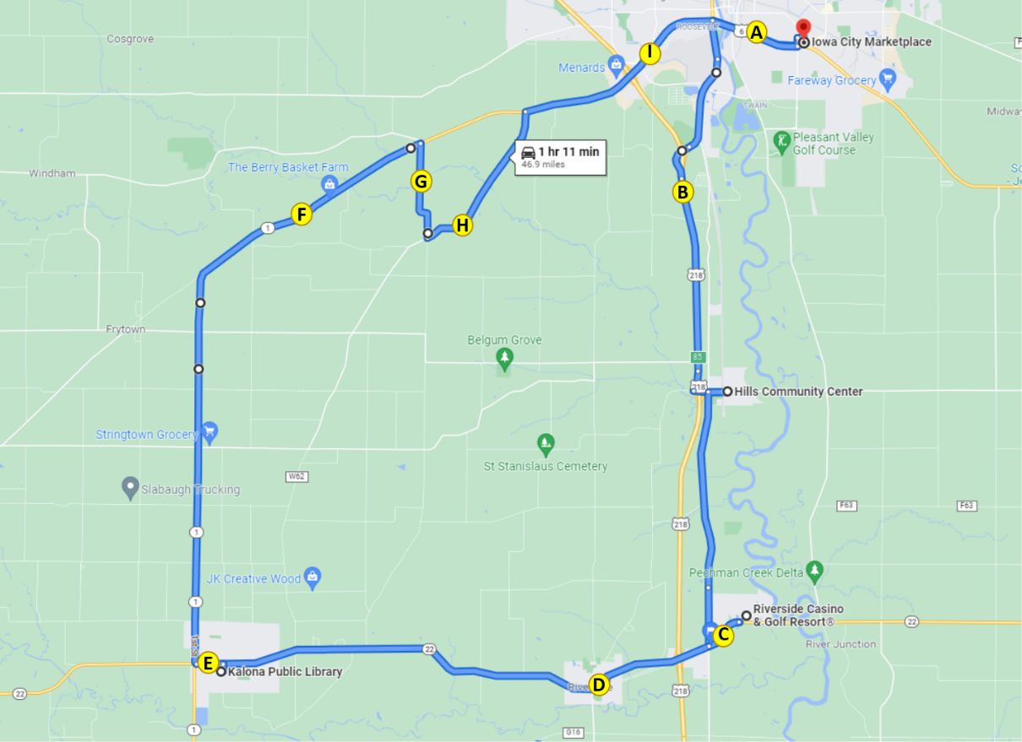
Figure 31. Map indicating locations of anxiety ratings
Across the entire drive, the ratings of anxiety were very low for this phase, ranging from 0 to 4 with an average of 0.7 (Figure 32). The locations with the highest average ratings of anxiety were after the turn onto Hwy 22 and after the merge onto Hwy 218 (1.0 and 1.1, respectively). During this phase, when it was safe to do so, these maneuvers were completed in automation. The merge was completed in automation for 78% of the drives, with riders’ average anxiety rating at this location ranging from 1.3 when the vehicle was being driven manually and 1.0 when it was in automation. The turn onto Hwy 22 was completed in automation for only one of drives that had passengers on board.

Figure 32. Average ratings of anxiety by location on route
Anxiety ratings were also examined for each occupant based on weather conditions, time of day, and starting location (Figure 33). The environmental conditions such as high winds and snow may have had an impact on ratings of anxiety. On average, females rated their anxiety higher than males (0.83 vs. 0.59, respectively).
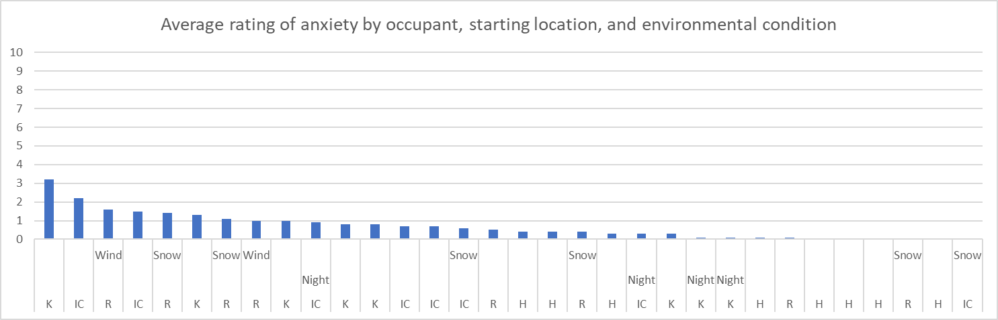
Figure 33. Average anxiety rating by occupant, starting location, and environmental conditions (H = Hills; IC = Iowa City; K = Kalona; R = Riverside)
It is important to remember that things like surrounding traffic and weather conditions may affect these ratings. Also, we are only looking at the data from this phase, which includes a small number of drives and riders. Therefore, additional analyses are needed at the end of the project, taking into account all of the variables that could impact anxiety.

Safety Drivers
There were three dedicated safety drivers for Phase 2. All three drivers are staff at NADS and have completed our safety driver training. Additionally, Driver 3 has extensive experience driving a bus as they were previously a driver for the UI campus bus service. Driver 1 drove seven of the 18 drives, Driver 2 drove six, and Driver 3 drove five. Each was asked to complete a post-drive survey immediately following their drive. These questions were related to their comfort using the automation at different points along the route or during certain environmental conditions. It should be noted that for three of the five drives for Driver 3, the automation lost path planning and was unable to be activated for a large portion of the route; this may account for some of the responses given on their post-drive survey.
For Phase 2, automation was used mainly on the highway portions of roadway, both divided and un-divided. Results of the survey showed that Drivers 1 and 2 were comfortable using the automation during these roadway segments and allowing it to complete the merge onto the highway (Figures 34 and 35), whereas Driver 3 reported they did not feel comfortable in these situations. When the number of miles driven in automation on principal arterials (i.e., divided and undivided highways for the drives that did not see automation “drop out”) was examined by driver, fewer miles were recorded for Driver 3 (12.9 miles) than for Drivers 1 and 2 (16.9 and 16.1, respectively). Additionally, in the 17 drives that included the merge (i.e., Drive 15 was incomplete and did not include this portion), Driver 1 allowed automation to complete the merge for 83% (5 of 6 drives), Driver 2 for 67% (4 of 6 drives), and Driver 3 for 60% (3 of 5 drives).

Figure 34. Safety driver perception of automation while driving on the freeway/highway

Figure 35. Safety driver perception of automation during merge onto highway
There were two drives completed at night as well as three drives completed when there was snow on the roadway. The safety drivers either somewhat or strongly agreed that they were comfortable driving at night. However, snow on the road produced various responses, from somewhat disagree to somewhat agree that they were comfortable driving.
The safety drivers were also asked to indicate how concerned they were about different issues related to highly automated vehicles. Results showed that they were most concerned about the system being unable to handle unexpected situations and its performance in poor weather (Table 4).
Table 4. Safety driver concerns regarding the automation
How concerned are you about the safety consequences of equipment or system failure? | Percent of drives
Not at all concerned | 0.0
Slightly concerned | 78%
Extremely concerned | 22%
How concerned are you about the vehicle's ability to interact with non-self-driving vehicles? | Percent of drives
Not at all concerned | 0.0
Slightly concerned | 67%
Extremely concerned | 33%
How concerned are you about the vehicle's ability to interact with pedestrians and cyclists? | Percent of drives
Not at all concerned | 6%
Slightly concerned | 67%
Extremely concerned | 28%
How concerned are you about the system's performance in poor weather? | Percent of drives
Not at all concerned | 6%
Slightly concerned | 56%
Extremely concerned | 39%
How concerned are you about the system being confused by unexpected situations? | Percent of drives
Not at all concerned | 0%
Slightly concerned | 39%
Extremely concerned | 61%
How concerned are you about the system not driving as well as human drivers? | Percent of drives
Not at all concerned | 11%
Slightly concerned | 61%
Extremely concerned | 28%

Phase 2 Summary
A large portion of the route during this phase was able to be driven in automated mode. This was due to a high percentage of the route being divided/undivided highway. Phase 2 also included the merge onto the highway. As the project continues, we will introduce additional functionality to the vehicle that will allow it to drive a larger portion in automation, but it will increase at a much slower rate as we include smaller sections of the route. Data of specific interest in this phase included:
- How the vehicle responded to mixed traffic, which included heavy trucks, wide loads, and slow-moving vehicles
- How the vehicle responded to merging or vehicle cut-ins
- How the vehicle reacted to unexpected events
The ability of the vehicle to drive on the highway in mixed traffic was much improved in Phase 2, as the maximum speed of the automation was increased from 50 to 65 mph. This eliminated the need for the safety driver to activate the flashers when driving this portion of the route and reduced the amount of traffic passing the AV at a high rate of speed. While driving in automation there was one instance where a heavy truck passing the AV caused it to drift outside of the lane boundary, contributing to a voluntary takeover from the automation. Other vehicles traveling slower than the AV did not create any issues. Even though the vehicle’s max speed was increased to 65 mph, the speed of the surrounding traffic was typically greater. Therefore, there were not many instances in which the AV encountered vehicles traveling slower than it within the lane of travel. In these instances, the automation simply slowed the AV as expected.

The merge was completed in automation for 12 of the 17 drives (Drive 15 was incomplete and did not include the merge). Merging onto the highway was typically more abrupt than if the driver was driving manually, with the vehicle steering and accelerating aggressively at the point of the merge. Once on the highway, the AV experienced cut-ins from other vehicles passing and then entering the lane ahead of the AV. There were instances where these cut-ins would trigger an inappropriate braking response from the AV that the safety driver deemed unsafe and thus resulted in them disengaging the automation. This braking behavior happened at least once for nearly every drive. However, it did not happen at any particular location or during any specific time of day or environmental condition. It also did not depend on the type of vehicle that was doing the passing (e.g., semi-trucks vs passenger cars).

The unexpected events that were encountered in this phase included one safety critical event (i.e., loss of communication from NovAtel GNSS receiver) and four system deactivations (i.e., oversteering by automation). Both types of events required intervention on the part of the safety driver, as the vehicle is not able to handle all conditions and has no fallback behavior that enables it to achieve a minimal risk condition. Other events that impacted drives during this phase included weather and the effects of ice on the lidar sensors, the loss of path planning in Kalona, and the failure of the Novatel GNSS and the associated mitigation efforts moving forward.

Effect of Ice on Lidar
As mentioned, the vehicle encountered winter weather during Phase 2 that included rain, freezing rain, and sleet during Drive 21. Figure 36 shows the fairly normal point cloud distribution from the clear lidar at the very beginning of the drive. Figure 37 shows the obscured lidar, after freezing rain had accumulated, about three quarters of the way through the drive. And Figure 38 shows the point cloud distribution from the obscured lidar. There is a large “wedge” in the forward-facing part of the point cloud that is almost completely empty. This is not normal and explains why Apollo’s perception engine was unable to classify objects straight ahead of the vehicle but was able to detect signs on the side of the road as well as objects that were slightly off-center.
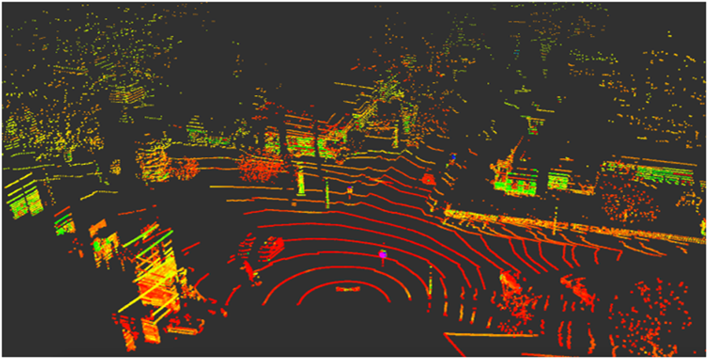
Figure 36. Point cloud from clear lidar, beginning of Drive 21
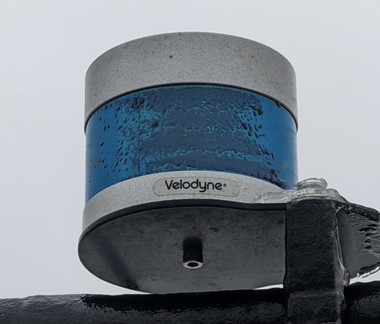
Figure 37. Obscured lidar located on the top of the AV
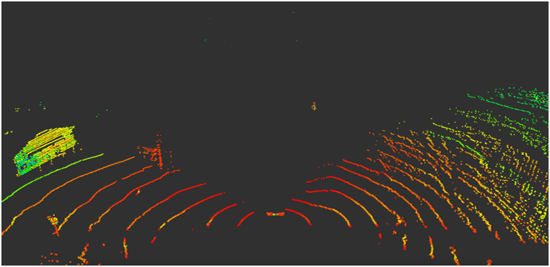
Figure 38. Point cloud from obscured lidar
Interestingly, the perception module does not realize that part of its visual field is occluded but instead assumes that there is simply nothing in front of it. Therefore, during this drive, the safety driver and co-pilot were seeing vehicles approaching in the oncoming lane that were not appearing in Apollo Dreamview (which is shown on the co-pilot display). Therefore, for safety reasons when the weather is such that ice may form on the sensors, the safety driver and co-pilot will be checking them at each stop. Also, if any degradation in perception is seen, the automation will not be activated.

Loss of Planning in Kalona
During Phase 2 there were six drives (out of 18) where the vehicle lost path planning in Kalona, including all four that began in Kalona. This meant that the automation could not be activated until the vehicle reached the next stop (i.e., the Iowa City Marketplace) and the system was rebooted. Therefore, the amount of driving on the undivided highway portion of the route was much lower for these drives due to the inability to use automation for much of Hwy 1.
The loss of automation has been investigated and it appears that in every path planning cycle, the planning module needs to determine the route segment that the vehicle is currently on. The candidate route segments for the search includes the whole list of route segments, from the current segment to the last routing segment. If one route segment exists more than once in the list because of crossover or overlapping (Figure 39), path planning may skip the route segments between them.
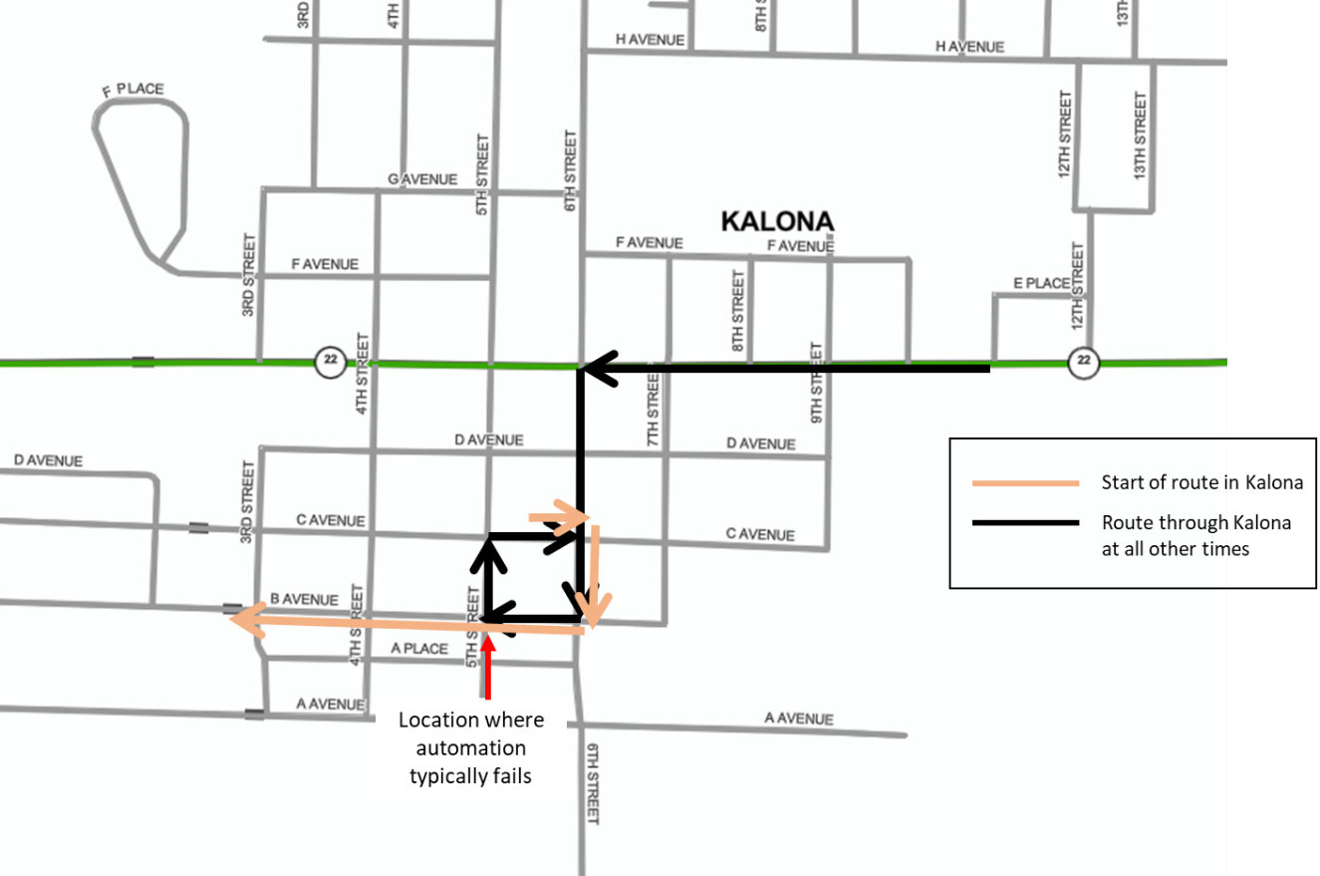
Figure 39. Overlapping route segments in Kalona
In order to address this, AutonomouStuff will cut down the candidate list to route segments that are within 350 m, so the chance of skipping one should be reduced. Another potential method for addressing this issue is to create four separate ADS routes, one for each starting location. Both methods are under investigation and the issue is planned to be resolved before the start of Phase 3.

Novatel Failure
As described earlier in the report, during Drive 30 the NovAtel unit rebooted due to a transient failure and stopped communicating with the automation computer, causing the vehicle to lose the ability to operate in automated mode. There was no indication to the driver that this failure had taken place other than the vehicle was unable to navigate the curve in the road and began to leave the roadway. Additionally, the driver was able to engage the automation again, even though the modules for perception and path planning were not operational. Many hours of simulation and on-road testing have taken place since this failure, and it has not been reproduced. However, we now have safeguards in place to warn the driver and the co-pilot of this type of failure should it happen again. These safeguards include an auditory tone as well as a flashing red indicator for the GPS on both the safety driver and co-pilot displays (Figures 40 and 41).
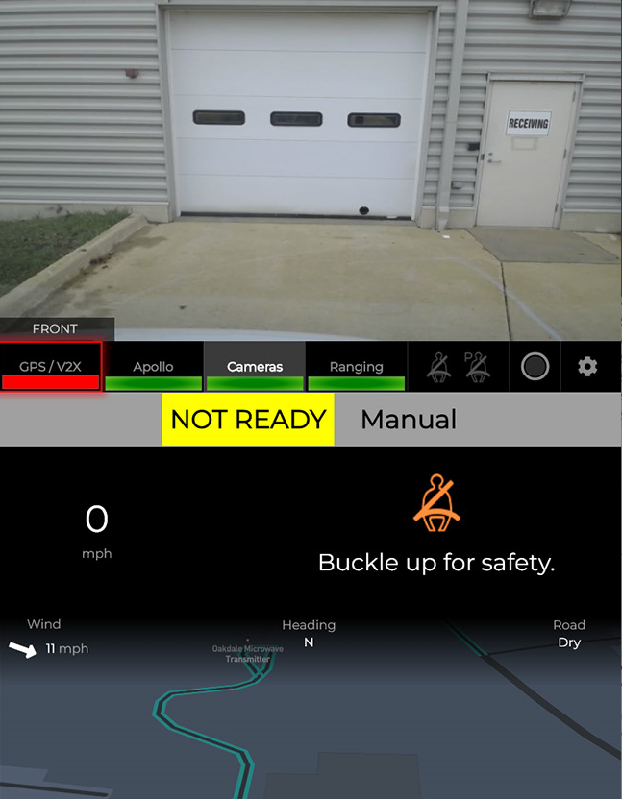
Figure 40. Safety driver display showing localization error
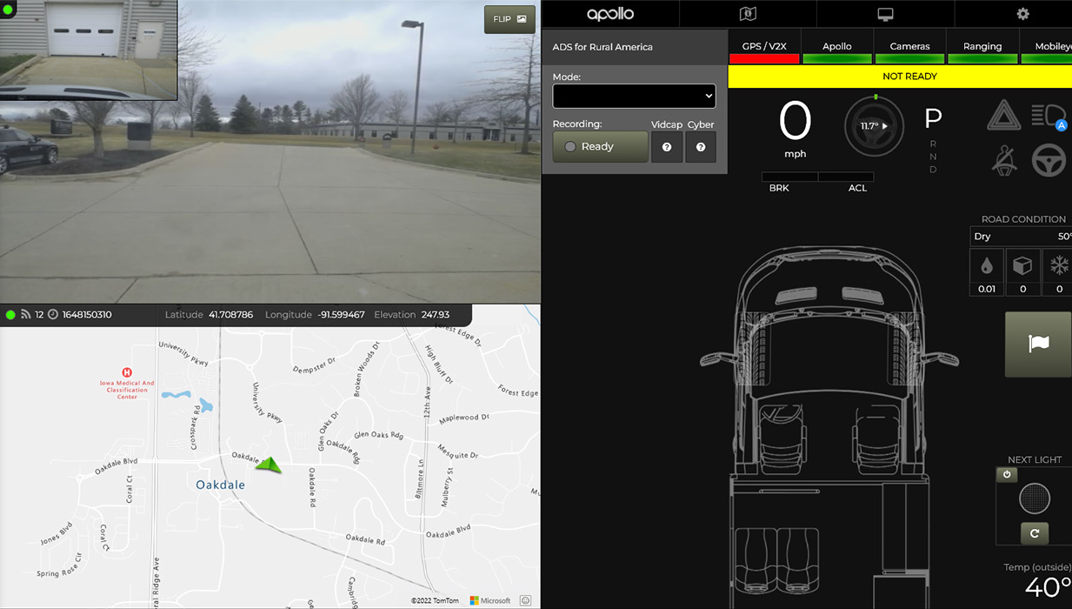
Figure 41. Co-pilot display showing localization error

Accomplishments for Phase 2
The following improvements were made to the ADS in Phase 2:
- Maximum speed increased to 65 mph
- Lane change maneuver improved
- Stopping behind the line at stop signs
- Lookahead distance increased to allow vehicles to stop earlier for stops (approaching stop signs at high speeds)
- Hugging left side of the lane at right turns/curves fixed
• PacMod buzzing sound fixed by replacing Watchdog

Next Steps
We have discussed making the following changes with our technology partners AutonomouStuff and Mandli Communications to the automation and digital map. These changes should increase the performance of the vehicle on the divided/undivided highway portions of the route (Phases 1 and 2) and help meet the needs of the next phase, which includes urban driving (e.g., traffic signals).

Map Issues to be Addressed
- Speed change in NADS test loop roundabout – current limit appears to be 25 mph but recommended speed sign shows 15 mph
- Sharon Center Rd, paved road section, the speed limit of the automation is set at 45-50 mph, which is too fast for the curves and blind hill located on this unmarked roadway
- Route lines may be off in certain areas of the map, causing crossing of the centerline
- On-ramp onto highway is still too aggressive
- Gravel road section uses far right instead of center right as typically driven by human-driven vehicles
- A stop sign needs to be added to the digital map at railroad intersections to make the vehicle stop
- Implement a gradual or stepped (55-45-35 mph) speed drop entering the towns of Riverside and Kalona
- Traffic light map elements all have '0' height; need to assign correct heights for Phase 3
- The vehicle crosses center or shoulder lane lines in consistent locations and needs to be corrected
- Speed limit leaving town of Riverside is too slow
- There is an extra stop sign in the map in Kalona on southbound 6th Street at C Ave, which needs to be removed
- Speed limit in Hills and Kalona is too fast for conditions

Other Issues to be Addressed
- Acceleration issues (accel and decel) on the highway needs to be tuned, including matching on-ramp speeds
- Calibrate traffic light recognition cameras and enable Traffic Light Recognizer (TLR)
- Planning line disappears in Kalona (from parking spot on side of road particularly)
- Enable passenger-side lidar for perception processing
- Unprotected turns in urban settings – test and evaluate performance
- Protected turns in urban settings – test and evaluate performance
- Vehicle cut-ins or disappearing lidar object causes slowdown
- Vehicle creeps too far or too slowly into intersections
- Coast to slow down, or slow down over longer distance (e.g., entering Riverside)
- No turn signal at all on 218 S to Hills off-ramp
- Cyber to ROS converter update to include traffic light state or detected information
- Kalona right turn routing issue (Figure 39)
- Follow distance is too short
- On-ramp – vehicle changes lanes abruptly
- Turn signals should be initiated before a lane change

For more information, please refer to the ADS for Rural America Safety Management Plan at adsforruralamerica.uiowa.edu/ADS-safety-plan

