Phase 1 (Controlled-Access Divided Highway/Interstate)

Evaluation Report
Author: Cher Carney
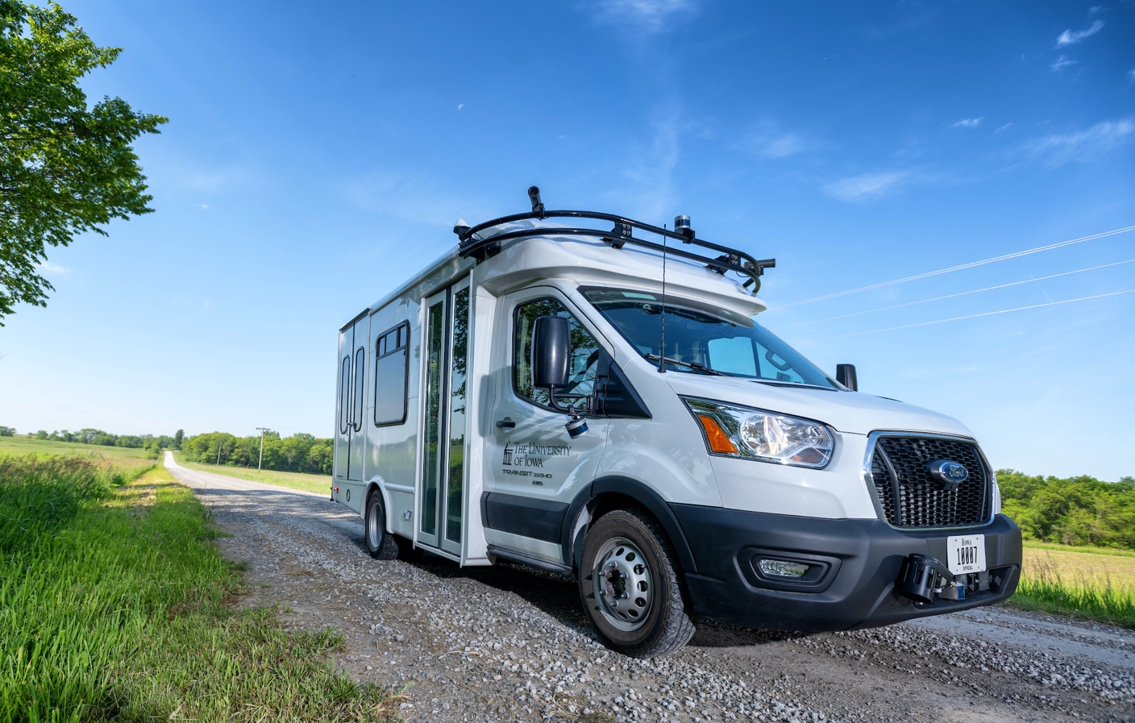

Table of Contents

Introduction 1
Expected Capabilities of the Automation for Phase 1 1
Additional Capabilities of the Automation for Phase 1 2
Automation Engagement by Drive 5
Voluntary Takeover of the Automation 12
Forced Takeover of the Automation 12
Encounters with Vulnerable Road Users (VRUs) 13
Safety Critical Events 13
Occupants for Phase 1 14
Demographics 14
Survey Data 14
Biometric Data 18
Anxiety Ratings 18
Safety Driver 21
Phase 1 Summary 23
Next Steps 23

Introduction
This project is comprised of eighty drives organized into multiple phases. Each phase will attempt to increase the percentage of the route that is driven under automation. Phase 1 focused on vehicle navigation along divided, controlled-access highways with mixed traffic. Traffic on these types of roadways travels in the same direction and generally adopts similar speeds due to geometric and speed limit constraints. For these reasons, controlled-access highways and interstates were considered to be the easiest candidates for implementing automation and were therefore adopted as the logical starting point for the project.
Twelve data collection drives were completed as part of Phase 1. These drives took place between October 19 and November 3, 2021. They occurred at different times of day and during varying lighting and weather conditions.
Data of specific interest in Phase 1 includes:
- How the vehicle responded to mixed traffic, which included heavy trucks, slow-moving vehicles, and vulnerable road users
- How the vehicle responded to merging or vehicle cut-ins
- The vehicle’s reaction to unexpected events

This report will begin by describing vehicle performance along the entire route, both what was expected for Phase 1 as well as what additional capabilities were seen. The data collected for each drive will be summarized, including mileage in automation and figures showing the location of automation activation. A summary of voluntary takeovers by the safety driver, encounters with vulnerable road users (VRUs), and any safety critical events is provided, as well. Data regarding the occupants of the vehicle includes demographic information, survey data, biometrics, and anxiety ratings. A summary of the safety driver survey results, including their perceptions of the automation’s performance is provided as well.

Expected Capabilities of the Automation for Phase 1
For Phase 1, the vehicle was expected to maintain lateral and longitudinal position via automation that utilized on-board sensors and a high-definition (HD) map of the route. Safety drivers engaged automation by pressing the “Engage” button. The driver made sure the following conditions were met:
- The automated vehicle (AV) was close to the target maximum speed for that roadway to avoid excessive braking or accelerations.
- The AV was in the center of the lane.
- The steering wheel was straight.
- It was deemed safe. (Considerations for safety include number/proximity of vehicles in the lane and oncoming or adjacent lanes, weather, functionally of automated systems, etc.)

The goal was to use automation during the U.S. Hwy 218 South portion of the route (i.e., a controlled-access highway), beginning after the vehicle merged onto the highway and before taking the off-ramp to Hills (Figure 1). It is important to note that, during our testing, we discovered that the maximum speed of the vehicle was 50 mph due to settings and/or limitations of the automation software (Apollo v5.0) that we are utilizing for this project. The posted speed limit on Hwy 218, however, is 65 mph. For this reason, the safety driver activated the hazard lights while on the entrance ramp to Hwy 218, and they remained active while the vehicle was traveling on Hwy 218.

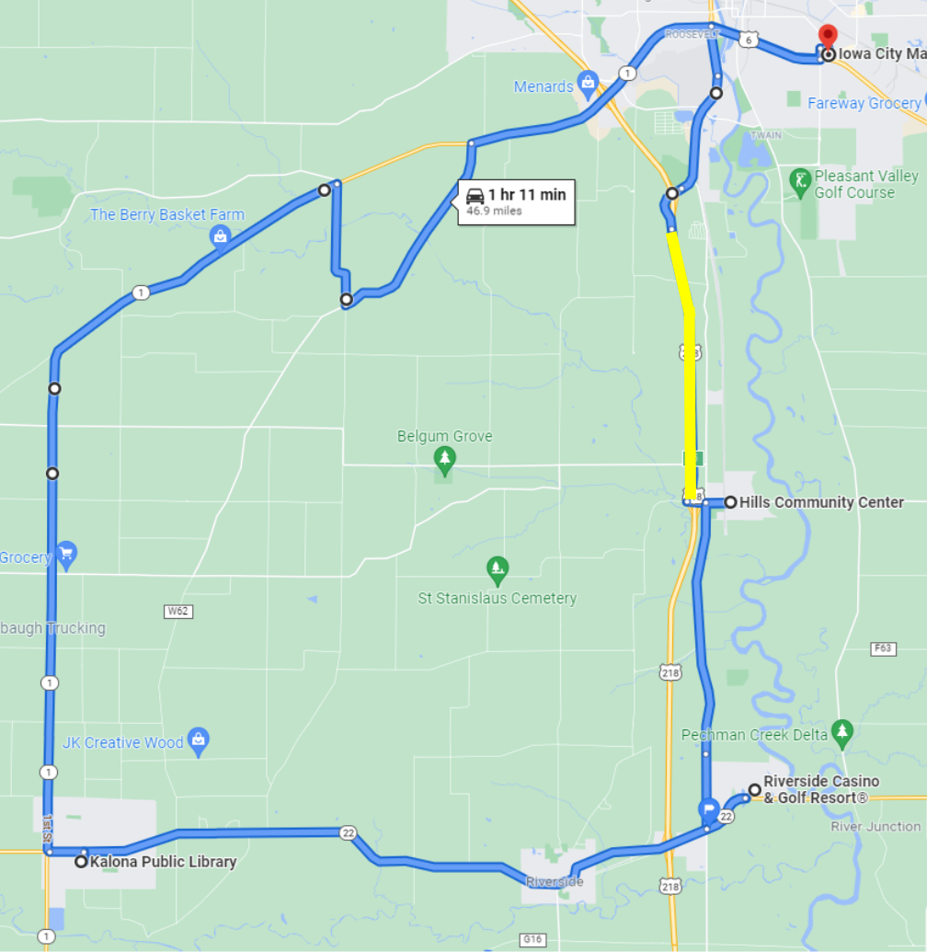
Figure 1. Expected capabilities of the automation for Phase 1 (shown in yellow)

Additional Capabilities of the Automation for Phase 1
The safety driver was able to engage automation on additional portions of the route (Figure 2). It’s important to note that the only way to engage automation is for the safety driver to intentionally engage it using a physical button. Automation can be intentionally disengaged by the safety driver using multiple methods which include pressing a button, taking over steering or pressing the brake pedal. These additional locations for automation engagement were identified by the safety driver during testing drives and include:
- On Riverside Drive, after the vehicle made the left turn from Hwy 6 and changed lanes into the right lane of travel, automation was engaged. Because the system could not identify traffic light signal state, automation was disengaged as the vehicle approached the intersection at the Mormon Trek Boulevard. The driver proceeded manually through the intersection. After having passed through the intersection, the driver re-engaged the automation. During some drives, the driver may have needed to disengage automation when the vehicle changed lanes to the left to allow faster moving traffic to pass and to prepare for the merge onto Hwy 218 South. If it was considered safe to do so, the vehicle may have completed the merge onto Hwy 218 in automated mode.
- After leaving the Hills Community center, automation was engaged once the safety driver turned onto Oakcrest Hill Road Southeast and the vehicle reached approximately 48 mph. Automation was disengaged as the vehicle reached the peak of the last hill. The driver slowed the vehicle manually to stop for the stop sign at the junction with Hwy 22.
- After leaving the Riverside Casino, when heading west on Hwy 22, automation was engaged around the Oakcrest Hill Road/Vine Avenue intersection once the vehicle reached approximately 48 mph. Automation was disengaged when the speed limit decreased from 55 mph to 35 mph entering the town of Riverside.
- On Hwy 22, after leaving the town of Riverside, automation was engaged once the vehicle navigated the first curve and reached approximately 48 mph. Automation was disengaged near the City of Kalona sign and driven manually to the Kalona Library.
- On Hwy 1, after leaving Kalona, automation was engaged once the vehicle reached approximately 48 mph. Automation was disengaged to slow and make the right turn onto Kansas Avenue SW. Due to the low max speed limit of the vehicle while under automation, automation was also disengaged on Hwy 1 in order to allow other vehicles to pass safely.
- On small, straight sections of Sharon Center Rd, automation was engaged once the vehicle had reached approximately 48 mph. Automation was disengaged for all of the curves and for the stop sign at the junction with Hwy 1.
- On Hwy 1, automation was engaged after turning from Sharon Center Rd and the vehicle reached 48 mph. Automation was disengaged as the vehicle approached the first traffic signal, entering Iowa City. Manual driving was required on Hwy 1 and Hwy 6 to the Iowa City Marketplace.

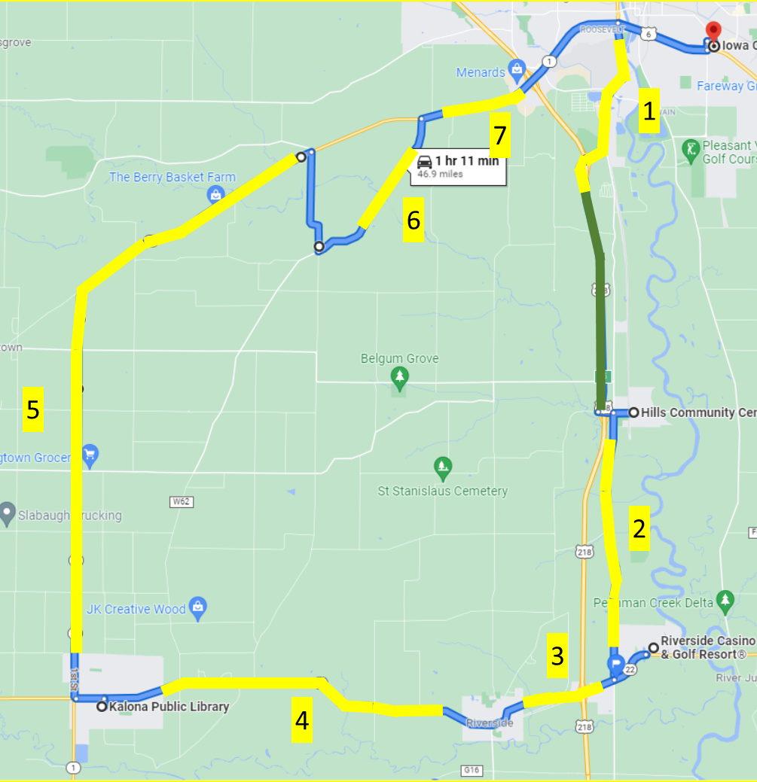
Figure 2. Actual capabilities of the automation for Phase 1 (shown in yellow)

The following areas were not considered for automation due to the limited capabilities of the automation during this phase.
- All parking lots
- Through towns that have traffic signals, intersections where turns were required or areas with pedestrians present (Iowa City, Hills, Riverside, Kalona)
- Gravel roads

Automation Engagement by Drive
Two of the ten planned drives were missing a portion of the data. In order to get ten full datasets, two additional drives were completed, for a total of twelve. We believe that the two drives with partial data still have value as most of the data is still available. Maps showing the locations that automation was engaged are shown below for Drives 1 through 12 (Figures 3 through 14). Roadways where the automation was used are shown in blue, while locations driven manually are shown in green. The percentage of the trip driven using automation varied from 35.7% in Drive 2 to 62.7% in Drive 12.

Number of miles recorded | 48.22
Number of miles recorded in automated mode | 25.97
Percent of drive recorded in automated mode | 53.90%
Amount of data collected (GB)* | 50.1
Weather conditions | Clear: 82%. Clouds: 18%
Time of day | Mid-morning
Day of week | Weekday
*Passenger video data did not record
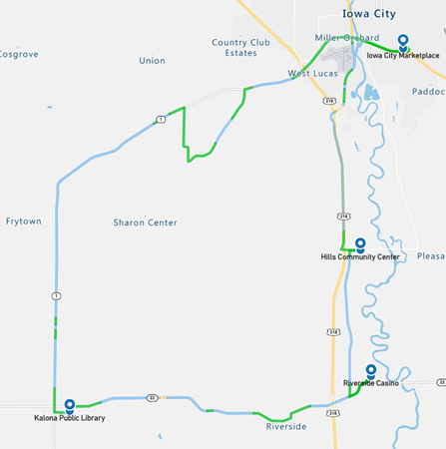
Figure 3. Drive 1 automation engagement

Number of miles recorded | 48.03
Number of miles recorded in automated mode | 17.65
Percent of drive recorded in automated mode | 36.70%
Amount of data collected (GB) | 87.2
Weather conditions | Clouds: 90%  Rain: 5%, Clear: 5%
Time of day | Noon
Day of week | Weekday
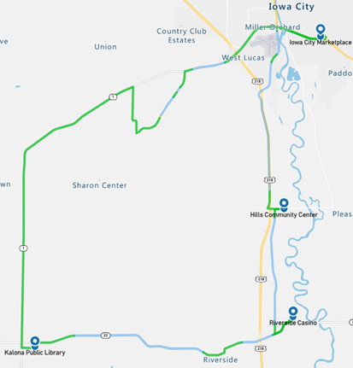
Figure 4. Drive 2 automation engagement

Number of miles recorded | 48.09
Number of miles recorded in automated mode | 29.89
Percent of drive recorded in automated mode | 62.20%
Amount of data collected (GB) | 73.4
Weather conditions | Clouds: 100%
Time of day | Night
Day of week | Weekday
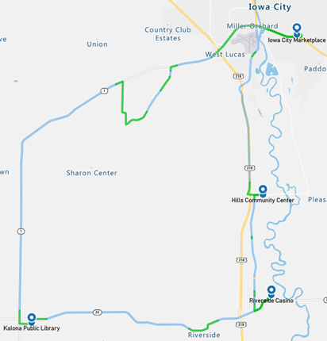
Figure 5. Drive 3 automation engagement
Number of miles recorded | 48.09
Number of miles recorded in automated mode | 28.65
Percent of drive recorded in automated mode | 59.60%
Amount of data collected (GB) | 84.7
Weather conditions | Clear: 82%, Clouds: 18%
Time of day | Dawn
Day of week | Weekday
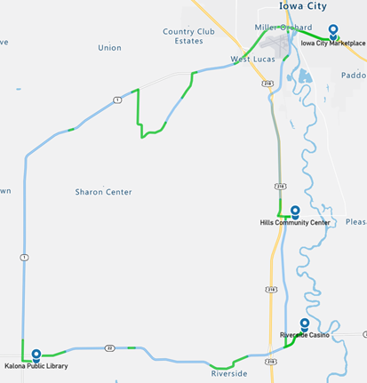
Figure 6. Drive 4 automation engagement
Number of miles recorded | 48.16
Number of miles recorded in automated mode | 30.07
Percent of drive recorded in automated mode | 62.40%
Amount of data collected (GB) | 67.7
Weather conditions | Rain: 99%, Mist: 1%
Time of day | Dawn
Day of week | Weekend
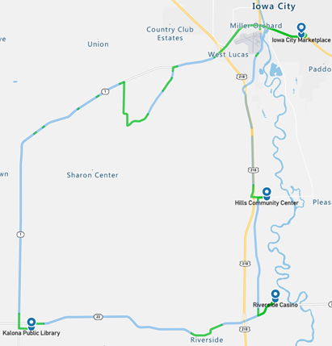
Figure 7. Drive 5 automation engagement

Number of miles recorded | 48.03
Number of miles recorded in automated mode | 28.09
Percent of drive recorded in automated mode | 58.50%
Amount of data collected (GB) | 78.2
Weather conditions | Clear: 57%, Clouds: 43%
Time of day | Mid-afternoon
Day of week | Weekday
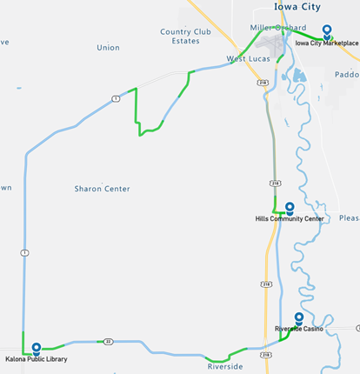
Figure 8. Drive 6 automation engagement

Number of miles recorded | 48.09
Number of miles recorded in automated mode | 29.95
Percent of drive recorded in automated mode | 62.30%
Amount of data collected (GB) | 83.3
Weather conditions | Clear: 100%
Time of day | Mid-morning
Day of week | Weekday
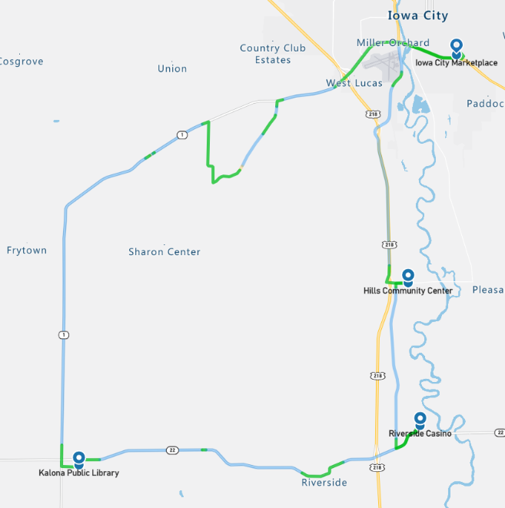
Figure 9. Drive 7 automation engagement

Number of miles recorded | 48.09
Number of miles recorded in automated mode | 28.65
Percent of drive recorded in automated mode | 59.60%
Amount of data collected (GB) | 85.5
Weather conditions | Clouds: 85%, Clear: 15%
Time of day | Night
Day of week | Weekday
Figure 10. Drive 8 automation engagement

Number of miles recorded | 48.09
Number of miles recorded in automated mode | 28.02
Percent of drive recorded in automated mode | 58.30%
Amount of data collected (GB) | 74.2
Weather conditions | Clouds: 32%, Rain: 37%, Mist: 31%
Time of day | Mid-afternoon
Day of week | Weekday
Figure 11. Drive 9 automation engagement

Number of miles recorded | 39.33
Number of miles recorded in automated mode | 23.12
Percent of drive recorded in automated mode | 58.88%
Amount of data collected (GB) | 71.1
Weather conditions | Clouds: 100%
Time of day | Noon
Day of week | Weekday
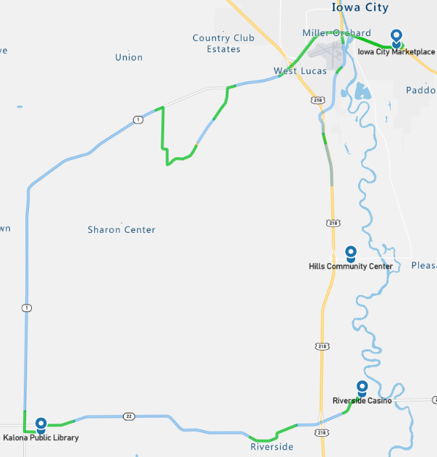
Figure 12. Drive 10 automation engagement

Number of miles recorded | 48.16
Number of miles recorded in automated mode | 30.07
Percent of drive recorded in automated mode | 62.40%
Amount of data collected (GB) * | 78.6
Weather conditions | Clear: 75%, Clouds: 25%
Time of day | Dawn
Day of week | Weekday
* Data recording was inadvertently stopped before the end of the drive
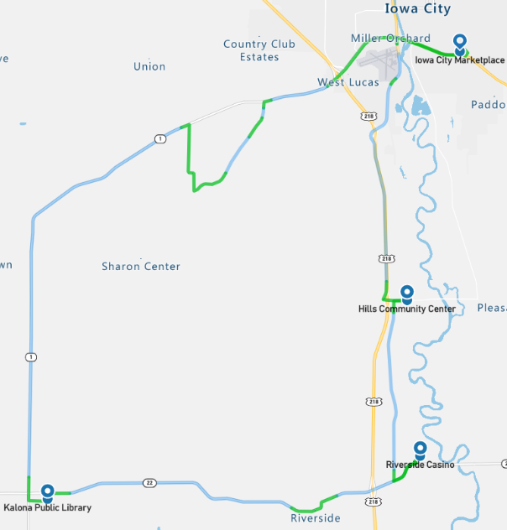
Figure 13. Drive 11 automation engagement

Number of miles recorded | 48.16
Number of miles recorded in automated mode | 30.2
Percent of drive recorded in automated mode | 62.70%
Amount of data collected (GB) | 79.4
Weather conditions | Clouds: 89%, Clear: 11%
Time of day | Mid-morning
Day of week | Weekday
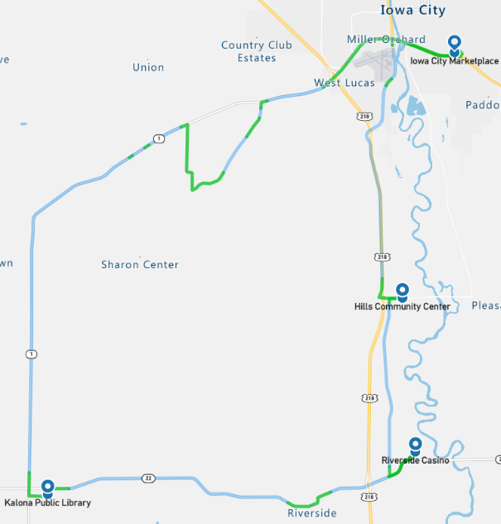
Figure 14. Drive 12 automation engagement

Overall, the number of miles driven in automation by federal function classification (FFC) of road types is shown per drive below (Figure 15). Note that the local roads, which included those through towns and the gravel portion of the route, were not driven in automation. The parking lots, which are considered “other” were also not driven in automation.

Figure 15. Miles driven in automated mode by FCC road type

Voluntary Takeover of the Automation
Safety drivers disengaged the automation for a variety of reasons. The preferred method of disengagement was to press the button located on the steering wheel. However, when necessary, turning the steering wheel, pressing the accelerator pedal, or pressing the brake pedal may have been a more suitable and safer method. When the automation was disengaged, the copilot would flag the data using the informational display and record the reason for the disengagement using a voice recorder. There were 137 voluntary takeovers flagged by the co-pilot. These were identified as potentially unsafe situations that required intervention (Table 1).

The majority of the voluntary takeovers happened in instances where the automation is not mature enough to handle the situation (e.g., speed limit reductions, traffic signals, and turns at intersections). The number of takeovers in these situations should lessen as the project progresses. There were also unexpected situations (e.g., aggressive braking behavior for unknown reason and crossing of lane lines) that required the safety driver to takeover control voluntarily from the automation for the sake of safety. These are the behaviors that are most interesting and will require further analysis to identify potential causes.

Table 1. Frequency and type of voluntary takeovers
Reason for disengagement | Number of instances
Decrease in speed limit (not recognized by the system) | 31
To stop at a traffic light | 19
A vehicle passing the AV in a no passing zone | 17
To stop at a stop sign | 13
To exit the highway | 12
The AV brakes inappropriately | 9
Approaching blind hill | 8
Too much traffic for merge | 6
To make a right turn from highway | 6
Traveling too fast for a curve | 3
An object located on the roadway (e.g., carcass, tire, etc.) | 3
The AV crosses the center line | 3
The AV responds late to lead vehicle braking | 2
An abrupt lane change | 2
The AV crosses the lane boundary near shoulder | 2
Aggressive cornering on on-ramp | 1

Forced Takeover of the Automation
Situations where the automation becomes unavailable and requires the driver to intervene are called forced takeovers. There was one instance of this during Phase 1, drive 6. A rapid system disengagement occurred on Highway 218. After reviewing the data and the video, it was determined that this occurred when the safety driver attempted to engage the automation while pressing the accelerator. Depressing the accelerator is one of the means of deactivation, therefore the system deactivated due to conflicting inputs from the safety driver and the automation stack.

Encounters with Vulnerable Road Users (VRUs)
Flags were placed in the data to identify interactions with vulnerable road users (e.g., horse and buggies, ATVs, bicycles, pedestrians) located on the shoulder. There were 41 interactions while the vehicle was traveling in automation and 23 while the vehicle was being driven manually (Table 2).
Table 2. Encounters with vulnerable road users in automated and manual mode
In Automated Mode | In Manual Mode
- 29 horse and buggy  - 3 cyclists  - 1 pedestrian  - 1 semi  - 4 farm equipment  - 3 stopped vehicles | - 4 horse and buggy  - 3 cyclists  - 10 pedestrians  - 1 semi  - 4 farm equipment  - 1 emergency vehicle

Safety Critical Events
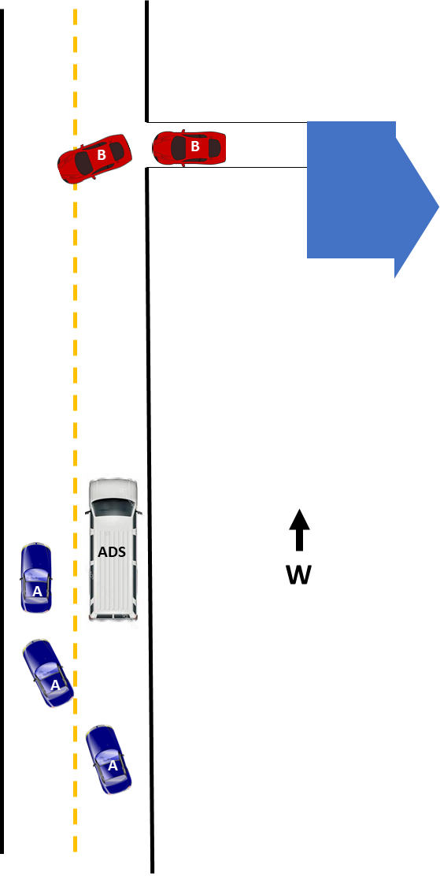
These events include interactions that require abrupt accelerations/decelerations or large steering wheel reversals by the AV or another vehicle and may or may not be classified as a near crash. Crashes are also included in this category. There was one safety critical event (Figure 16) recorded in Drive 1 of Phase 1, and no near-crashes or crashes. The safety critical event occurred on Highway 22 when vehicle A began to pass the AV as vehicle B pulled out of the driveway to head east. The ADS safety driver applied the brakes at this time to take the vehicle out of automation. Vehicle A slowed when it saw vehicle B enter the oncoming lane and fell in behind the AV.
Figure 16. Safety critical event

Occupants for Phase 1

Demographics
Adults over the age of 65 as well as those over the age of 25 with mobility or visual impairments were recruited to ride inside the AV. Table 3 provides the demographic breakdown by age, gender, and impairment. The sample is highly educated, with 96% of occupants having some education beyond a high school degree and 83% have a household income greater than $50,000. Two occupants reported using a walker, three reported trouble walking or climbing stairs, and nearly 30% (7/24) reported having difficulty hearing.
Table 3. Demographics of occupants
Age | Unimpaired |  | Mobility Impaired |  | Visually Impaired |  | Hearing Impaired
 | Male | Female | Male | Female | Male | Female | Male | Female
25-34 | 0 | 0 | 0 | 0 | 0 | 0 | 0 | 0
35-44 | 0 | 0 | 0 | 0 | 0 | 0 | 0 | 0
45-54 | 0 | 0 | 0 | 0 | 0 | 0 | 0 | 0
55-64 | 0 | 0 | 0 | 0 | 0 | 0 | 0 | 0
65-74 | 6 | 9 | 0 | 1 | 0 | 0 | 2 | 1
75-84 | 3 | 3 | 1 | 0 | 0 | 0 | 2 | 1
85-94 | 0 | 1 | 0 | 0 | 0 | 0 | 0 | 1
Total | 9 | 13 | 1 | 1 | 0 | 0 | 4 | 3

All occupants own or have access to a vehicle. They report that they typically drive themselves where they need to go and approximately 67% report driving themselves daily. All occupants have a driver’s license. Forty-six percent (11 out of 24) have some type of visual restriction (glasses or corrective lenses). However, none of these restrictions are severe enough to cause these occupants to be considered visually impaired.
Approximately 30% of the occupants in Phase 1 own or have access to a vehicle that has either adaptive cruise control (ACC) and/or lane keeping/lane centering. Seventy-five percent of those with these advanced systems reported using them often or frequently. A majority (75%) also reported that when it comes to trying new technology, they generally fall in the middle (e.g., not first or last to try). All but one occupant reported owning or using a smart phone. The same occupant reported that they did not use the internet or own a desktop computer. A majority, 88%, reported that they use some form of social media, and 67% own or use a tablet. Occupants overwhelmingly agreed that they like to use technology to make tasks easier (96%) but were more split regarding whether they wanted a car with all of the latest technology features (21% disagree vs. 58% agree).

Survey Data
While on the AV, occupants were asked to complete both a pre- and post-drive survey regarding their trust and acceptance of highly automated vehicles. This type of vehicle was defined one that is “… capable of driving on its own in some situations but is aware of its limitations and calls for the driver to take over when necessary.” When asked to indicate how they felt about different statements, a greater percentage of occupants after their ride in the vehicle “somewhat or strongly agreed” that they could trust highly automated vehicles (48% pre-drive vs. 78% post-drive) and believed that they were reliable (61% pre-drive vs. 87% post-drive, Figures 17 and 18).
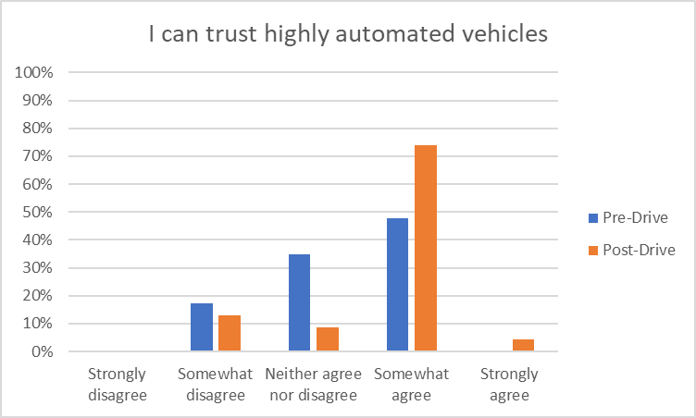
Figure 17. Trust in highly automated vehicles pre- and post-drive
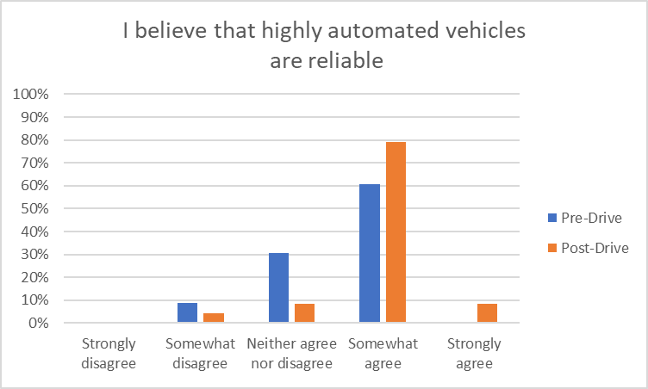
Figure 18. Reliability of highly automated vehicles pre- and post-drive
Phase 1 specifically focused on the ability to use automation on the highways and interstates. The safety driver used the automation on these road types whenever it was deemed safe to do so. Therefore, occupants were able to experience traveling on this type of road under both automated and manual driving during their trip. A larger percentage of occupants indicated that they “strongly or somewhat agreed” that they would trust a highly automated vehicle on the interstate/highway after the drive was complete (87% pre-drive vs. 96% post-drive, Figure 19).
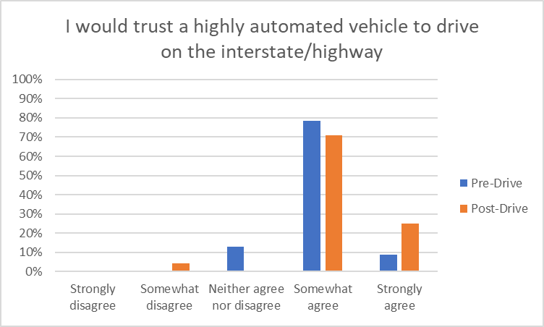
Figure 19. Trust of highly automated vehicle to drive on the highway pre- and post-drive
The biggest changes seen between the pre- and post-drive responses were with regard to concerns about the automated system’s performance in poor weather (Figure 20) and safety consequences of an equipment or sensor failure (Figure 21). There was an increase in the number of occupants who reported that they were “extremely concerned” about both of these things after having ridden in the vehicle.

Figure 20. Concern regarding the system performance in poor weather

Figure 21. Concern regarding the safety consequences of an equipment or system failure
Occupants were also asked questions about perceived usefulness and their intention to use highly automated vehicles. When asked to report whether they were “open to the idea of riding in a highly automated vehicle,” 100% of occupants indicated that they somewhat or strongly agreed with the statement before riding in the vehicle, while only 87% of occupants felt the same after the ride (Figure 22).

Figure 22. Openness to riding in a highly automated vehicle
When asked whether they thought highly automated vehicles would allow them to stay more involved in their communities, a greater percentage somewhat or strongly agreed that they would after they had ridden in the vehicle (61% pre-drive vs. 74% post-drive, Figure 23).

Figure 23. Ability of highly automated vehicles to allow me to stay involved in my community

Biometric Data
A medical grade wearable device was worn by each of the occupants as well as the safety driver for each of the twelve drives. The device has a sensor which measures blood volume pulse (BVP), from which heart rate variability can be derived as well as a sensor that measures the constantly fluctuating changes in certain electrical properties of the skin (galvanic skin response or GSR). Ten minutes of baseline data was collected before the start of each drive.

Heart Rate Variability (HRV)
Heart rate variability is said to indicate physiological stress or arousal, with increased stress being indicated by a low HRV.

Galvanic Skin Response (GSR)
Increases in GSR activity can indicate stress/anxiety as well as other emotions such as anger, disgust, fear, happiness, surprise, and extreme sadness.
This data will not be analyzed for this summary report; however, it will be available in its raw form through the data access portal.

Anxiety Ratings
Occupants were also asked to provide a rating of their anxiety level from 0 to 10, with 0 being “not at all anxious.” These ratings were given at nine specific locations along the drive and were the same for each participant, although they did vary in the order they were given depending on the starting location for the drive. Figure 24 is a map showing where each of these ratings occur along the drive. A pre-drive anxiety rating was obtained for everyone before the drive began. Rating locations included the following:
- Hwy 6 in town
- After merge onto Hwy 218
- After turn onto Hwy 22
- Business district of Riverside
- Downton Kalona
- Hwy 1 rural
- Gravel road
- Unmarked blacktop road
- Hwy 6 intersection
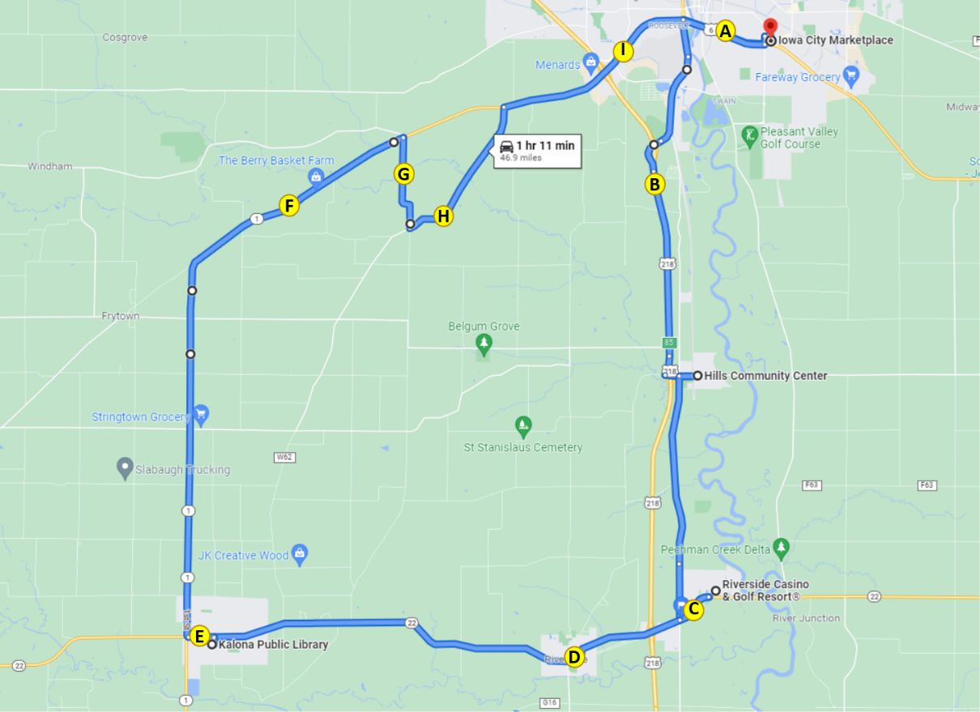
Figure 24. Map indicating locations of anxiety ratings
Overall, the average ratings of anxiety were very low for this phase, ranging from 0 to 4 with an average score of 0.7 (Figure 24). However, it should be noted that, for this phase, seven of the nine ratings were asked to be given when the vehicle was being driven manually. The two ratings that occupants were asked to give while automation was engaged were on Highway 1 (a rural two-lane highway) and after the vehicle had merged onto Highway 218. Interestingly, the average pre-drive rating of anxiety was higher than all other average ratings given during the drive, except for the average rating given after the merge onto Highway 218 (0.81 vs. 1.29, respectively).

Figure 24. Average ratings of anxiety by location on route
Anxiety ratings were also examined for each occupant based on weather conditions, time of day, and starting location (Figure 25). The combination of rain and nighttime driving seemed to produce an increase in average anxiety ratings. Also, occupants who began their drive in Hills (H) had higher average ratings than those who started in Iowa City (IC), Kalona (K), or Riverside (R). This may be due to the higher number of drives at night and in the rain that began in Hills. On average, males rated their anxiety higher than females (0.93 vs. 0.49, respectively).

Figure 25. Average anxiety rating by occupant, starting location, and environmental conditions (H=Hills; IC= Iowa City; K=Kalona; R=Riverside)

Safety Driver
There were 2 dedicated safety drivers for Phase 1, each one drove six of the twelve drives. They were asked to complete a post-drive survey after each of their drives. These questions were related to their comfort using the automation at different points during the drive or during certain environmental conditions. For Phase 1, automation was used mainly on the highway portions of roadway. Results of the survey showed that drivers were comfortable using the automation during these roadway segments (Figure 26). However, they were less comfortable when using the automation to complete the merge onto Highway 218 (Figure 27). There were a couple of instances of abrupt lane changes and inappropriate braking that may have led to these results.
Figure 26. Safety driver perception of automation during highway driving

Figure 27. Safety driver perception of automation during merge onto highway

There were two drives completed at night as well as two drives completed when the road was wet. The safety drivers either somewhat agreed (50%) or strongly agreed (50%) that they were comfortable driving under these conditions.
The safety drivers were also asked to indicate how concerned they were about different issues related to highly automated vehicles. Results showed that they were most concerned about the system being unable to handle unexpected situations and not being able to drive as well as human drivers (Table 4).
Table 4. Safety driver concerns regarding the automation
How concerned are you about the safety consequences of equipment or system failure? | Percent of drives
Not at all concerned | 25.0%
Slightly concerned | 58.3%
Extremely concerned | 16.7%
How concerned are you about the vehicle's ability to interact with non-self-driving vehicles? | Percent of drives
Not at all concerned | 16.7%
Slightly concerned | 66.7%
Extremely concerned | 16.7%
How concerned are you about the vehicle's ability to interact with pedestrians and cyclists? | Percent of drives
Not at all concerned | 8.3%
Slightly concerned | 83.3%
Extremely concerned | 8.3%
How concerned are you about the system's performance in poor weather? | Percent of drives
Not at all concerned | 8.3%
Slightly concerned | 83.3%
Extremely concerned | 8.3%
How concerned are you about the system being confused by unexpected situations? | Percent of drives
Not at all concerned | 0.0
Slightly concerned | 50.0%
Extremely concerned | 50.0%
How concerned are you about the system not driving as well as human drivers? | Percent of drives
Not at all concerned | 16.7%
Slightly concerned | 41.7%
Extremely concerned | 41.7%

Phase 1 Summary
A large portion of the route during this phase was able to be driven in automated mode. This was due to a high percentage of the route being interstate/highway driving. As the project continues, we will introduce additional functionality to the vehicle that will allow it to drive a larger portion in automation, but it will increase at a much slower rate as we include smaller sections of the route. Data of specific interest in this phase included:
- how the vehicle responded to mixed traffic, which included heavy trucks, wide loads, and slow-moving vehicles,
- how the vehicle responded to merging or vehicle cut-ins, and
- how the vehicle reacted to unexpected events.
Overall, the vehicle was able to handle driving along a controlled-access highway in mixed traffic fairly well. On several occasions, when being passed by a heavy truck or larger profile vehicles, the AV would brake abruptly. This type of behavior was also seen when vehicles entered the lane in front of the AV after passing. This occurred even when the passing vehicles were traveling at speeds greater than the AV and would not have triggered a braking response from a typical ACC system. This braking behavior did not happen for every drive, at any particular location, or during any specific time of day or environmental condition.

Slow moving vehicles that were driving on the shoulder did not cause any issues for the AV. However, in no instance was the AV required to move out of its lane to pass these vehicles. Since the traveling speed of the AV was lower than the speed limit for the controlled access highway portions of the drive, there were only a few instances in which the AV encountered vehicles traveling slower than it within the lane of travel. In these instances, ACC simply slowed the AV as expected.

The unexpected events that were encountered in this phase included one safety critical event and one system “failure” or deactivation. Both events required intervention on the part of the safety driver, as the vehicle is not able to handle all conditions and has no fallback behavior that enables it to achieve a minimal risk condition.

Next Steps
We have discussed making the following changes with AutonomouStuff in order to increase the performance of the vehicle on the controlled access divided highway portion of the route (Phase 1) and to meet the needs of the next phase, which includes the two-lane undivided highway and on/off ramps.
- Merging onto the highway should be smoother, steering less abrupt
- Top speed on the highway should be 55 mph or higher
- Speed adjustments need work (deceleration is too aggressive and acceleration is too slow currently):
  - Need to accelerate faster on the interstate to reach cruising speed
  - Need to react to lower speed limit signs sooner and utilize coasting, when possible, not just hard braking
- When we are being passed by another vehicle (even though the passing vehicle is accelerating away from the AV), the automation applies the brakes and slows us down even though the time to collision (TTC) to the other vehicle is increasing; this also causes more vehicles behind us to overtake or pass us. We would like this behavior improved.
- Path planning is often not available when leaving Kalona or when making the left turn from Vine Ave to Riverside Casino.
- Lane change should be less aggressive and turn signal should be activated before the lane change begins.
- In Iowa City, on Riverside Drive when two lanes merge into one, the steering behavior here can be very abrupt at times.
- The route line is not correct in some of the areas to be driven in automation for Phase 2 (i.e., Vine Ave, Hwy 1, Hwy 22).

